HP 200 Wireless Mouse/2.4GHz Wireless Connection /2 AAA Batteries/3 Years RTB Warranty, 2HU84AA(Pike Silver)

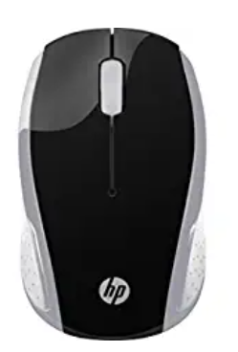

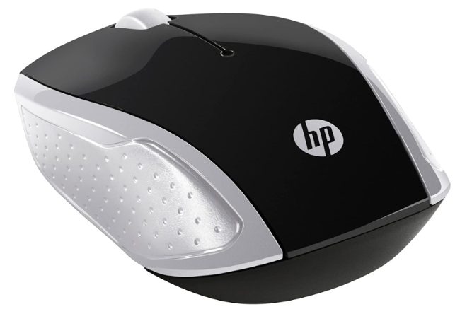

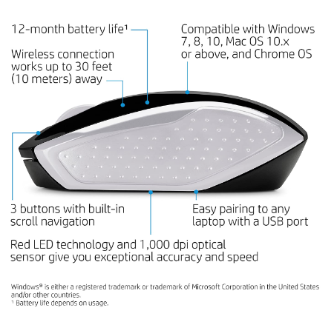

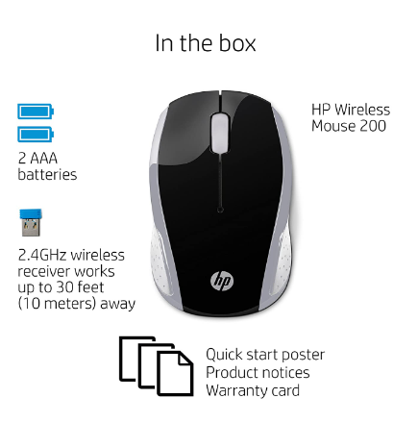

|  |  |
| --- | --- |
| M.R.P.: | ₹800 |
| Deal Price: | ₹599 |
| You Save: | ₹201 (25%) |
|  | Inclusive of all taxes |

### Product details

|  |  |
| --- | --- |
| Brand | HP |
| Colour | Pike Silver |
| Connector Type | Wireless |
| Special Feature | Wireless |
| Movement Detection Technology | Optical |
| Number of Buttons | 3 |

* No more wires with the reliable 2.4GHz wireless connection
* Strict HP standards and guidelines ensure long-lasting quality
* A contoured shape designed for all-day comfort in either hand
* With 2 AAA batteries included and no software to install you’re good to go
* Compatible with Windows 7 and above, Mac OS 10.x and above and Chrome OS