HP Z3700 Wireless Optical Mouse with USB Receiver and 2.4GHz Wireless Connection/ 1200DPI / 16 Months Long Battery Life /Ambidextrous and Slim Design (Black)

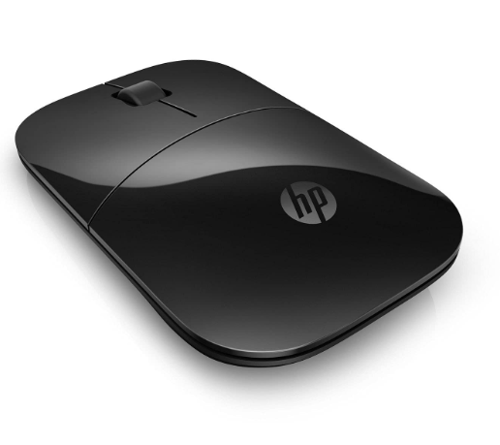

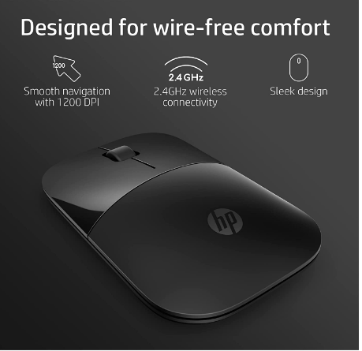

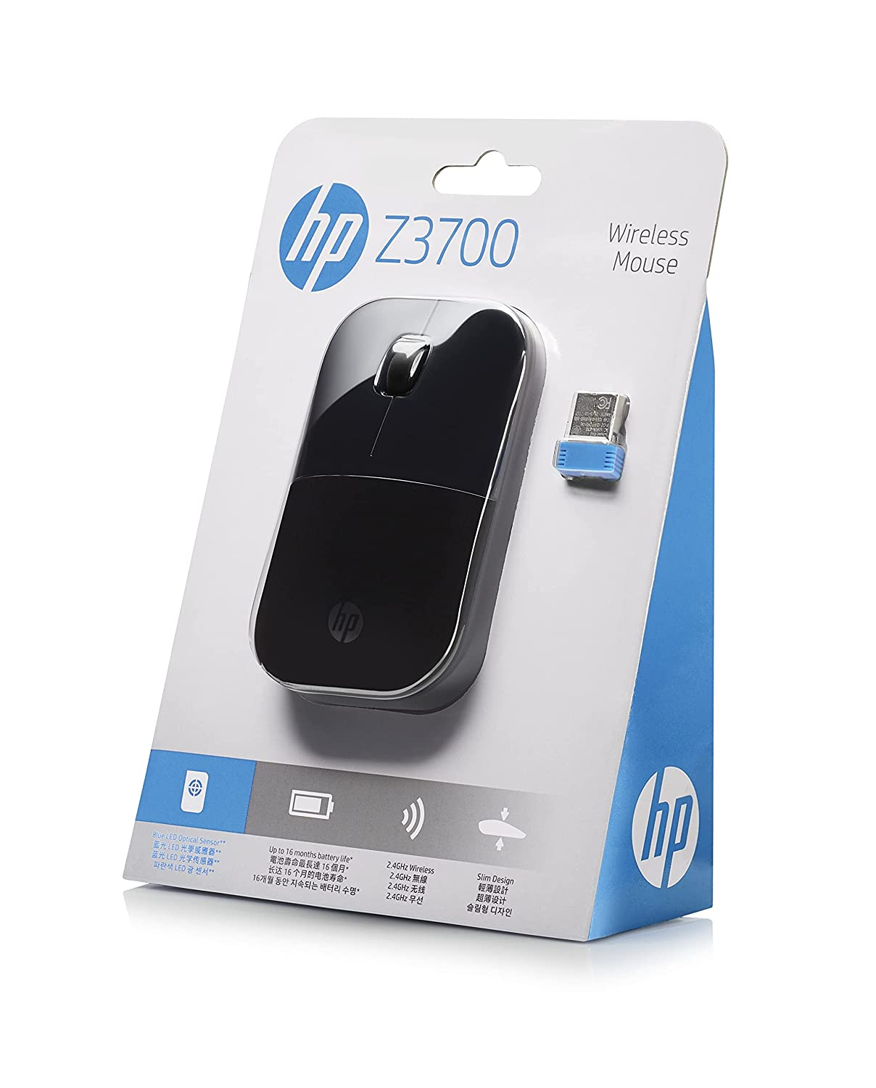

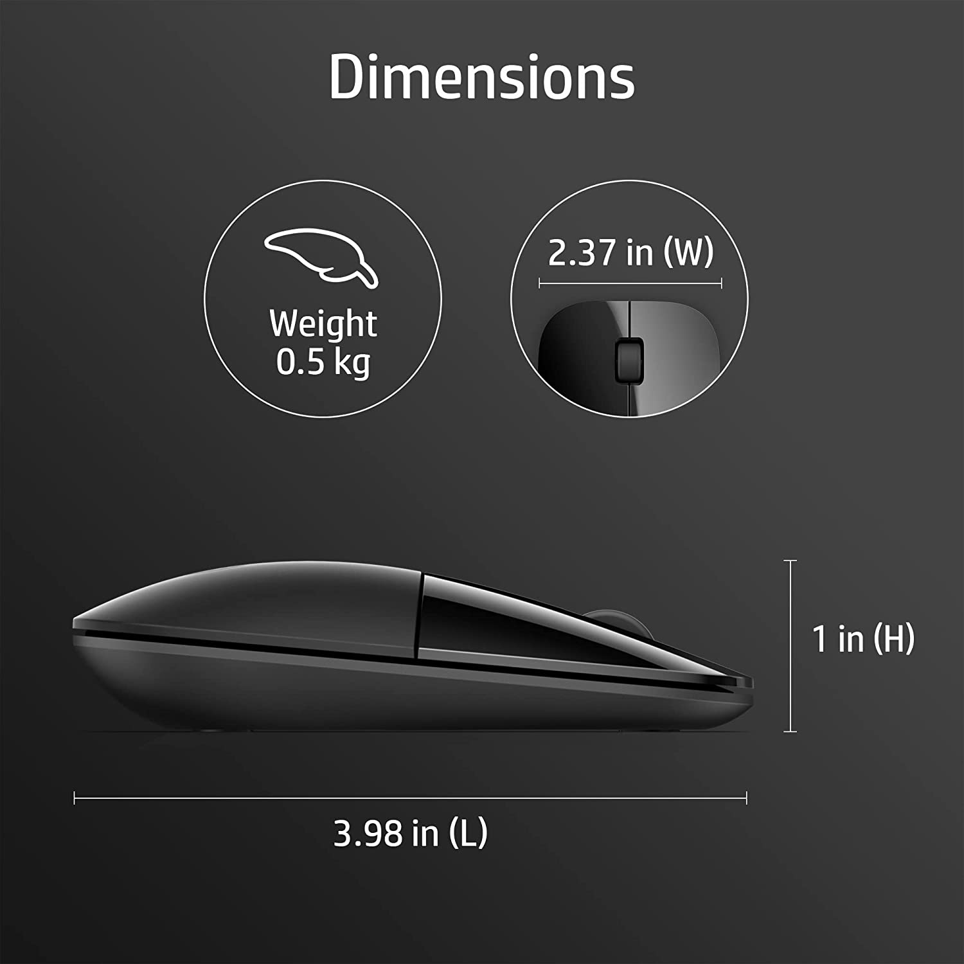

|  |  |
| --- | --- |
| M.R.P.: | ₹1,099₹1,099 |
| Deal of the Day: | ₹950  Ends in 02h 09m 54s |
| You Save: | ₹149 (14%) |
|  | Inclusive of all taxes |

### Product details

|  |  |
| --- | --- |
| Brand | HP |
| Colour | Black |
| Connector Type | Wireless |
| Special Feature | Wireless, Optical |
| Movement Detection Technology | Optical |
| Number of Buttons | 3 |

* Designed with flair, the sleek design complements your favorite HP devices and fits comfortably anywhere
* The 2.4GHz wireless connection reliably keeps you hooked up
* With up to 16 months of life on a single AA battery, this mouse was designed to push the limits
* Blue LED technology lets your mouse function on a wide range of surfaces, so you can work from almost anywhere
* 1200DPI optical sensor give you exceptional accuracy and incredible speed
* Just pop in the battery, plug in the USB receiver and you’re good to go
* The USB receiver fits conveniently inside the mouse, for effortless portability
* Supports Windows 7, Windows 8, Windows 10, Mac OS 10.3 or later and Chrome OS