HP 280 USB Wireless Mouse, 2.4GHz Connection , 19U64AA Black

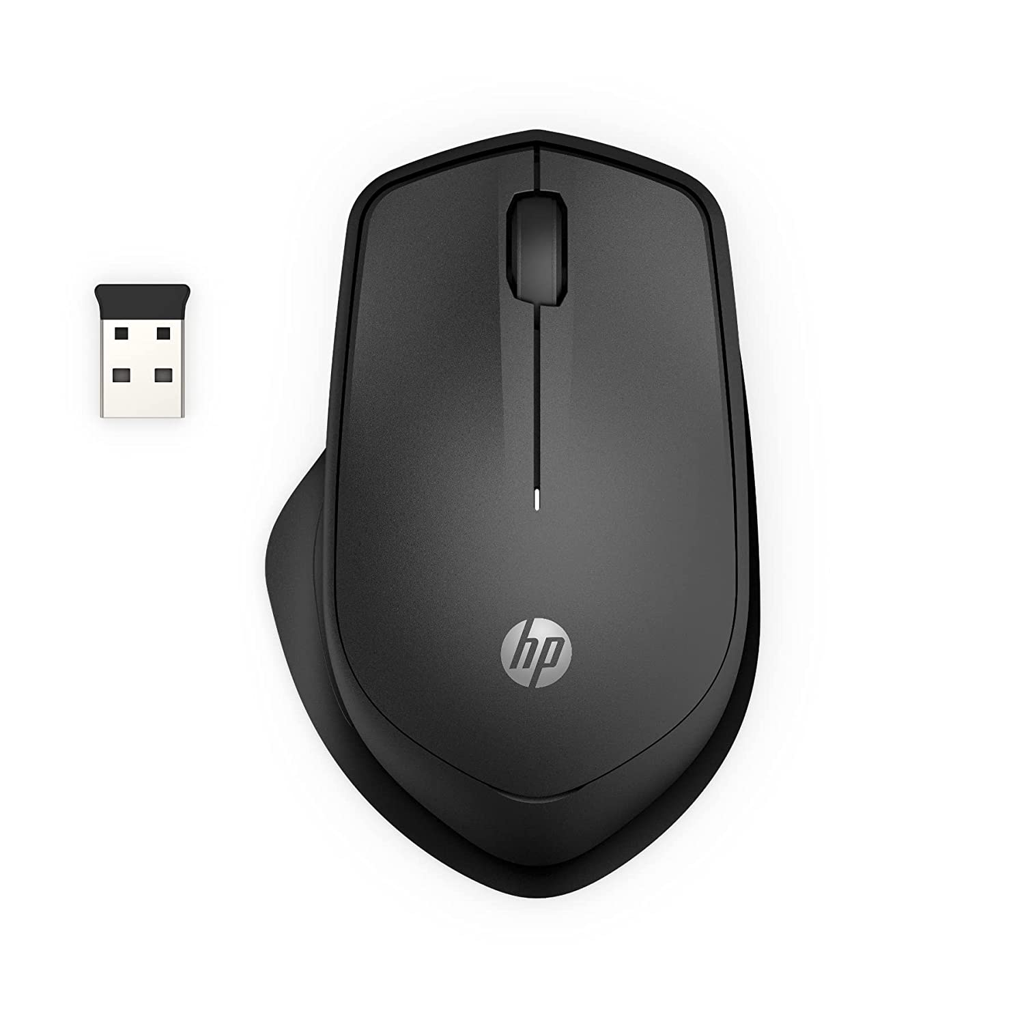

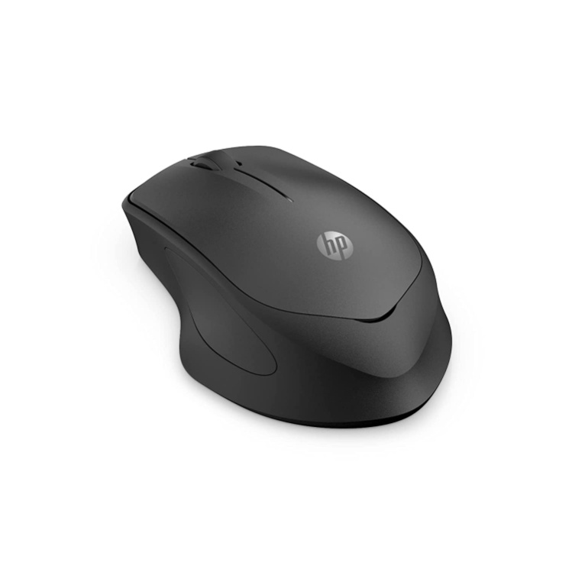

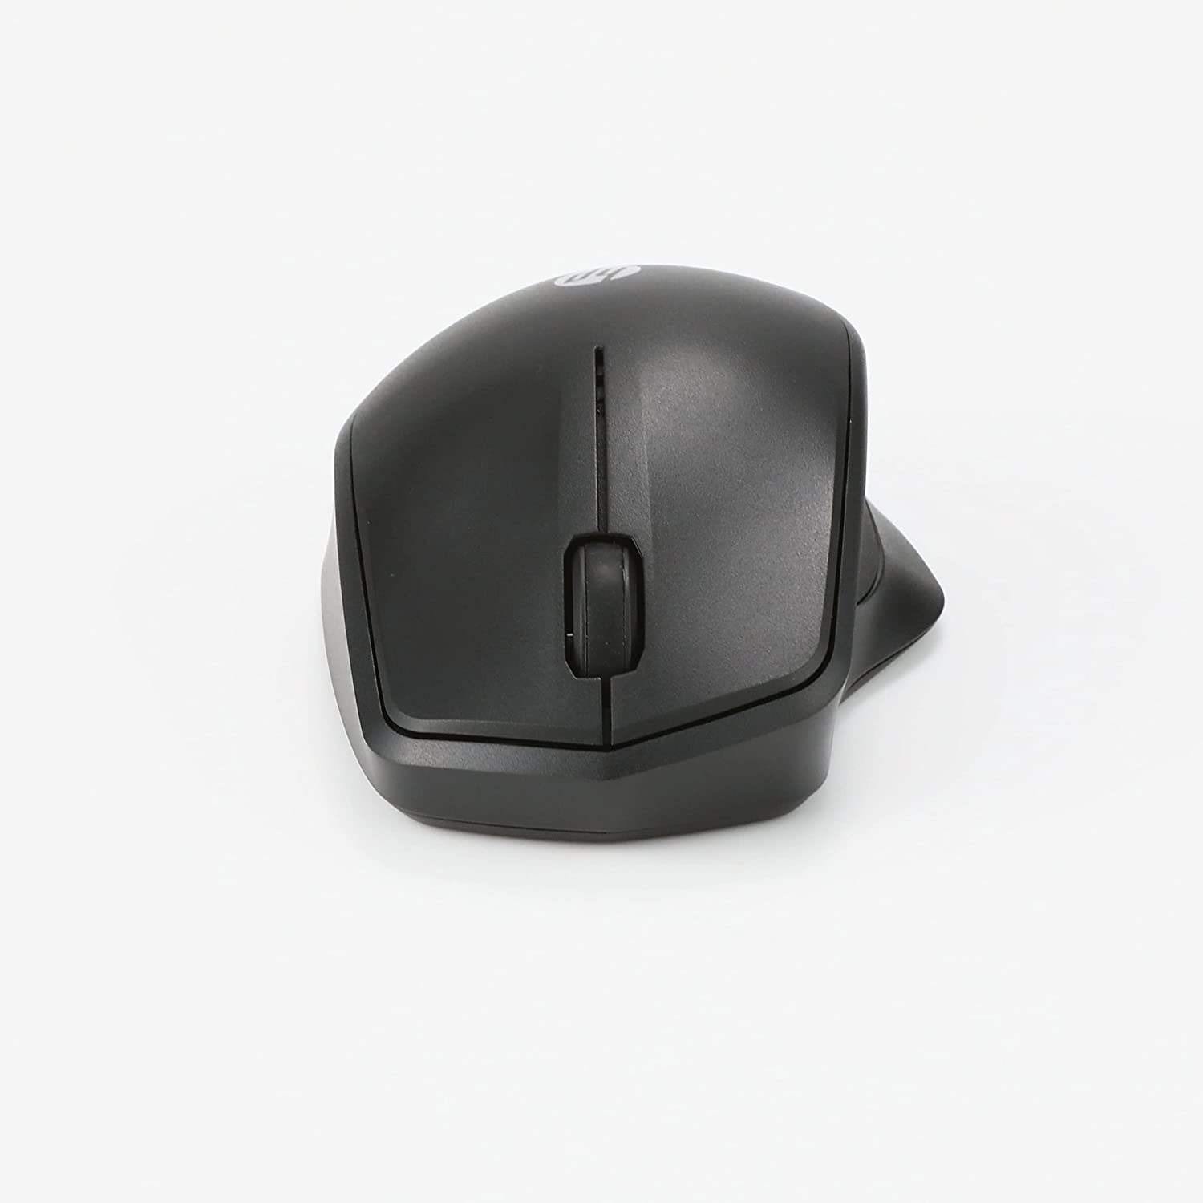

|  |  |
| --- | --- |
| M.R.P.: | ₹1,998 |
| Deal of the Day: | ₹999  Ends in 02h 06m 03s |
| You Save: | ₹999(50%) |

### Product details

|  |  |
| --- | --- |
| Brand | HP |
| Colour | Black |
| Connectivity Technology | USB |
| Special Feature | Wireless |
| Movement Detection Technology | Laser |
| Number of Buttons | 4 |

* Designed with flair, the sleek design complements your favorite HP devices and fits comfortably anywhere
* The 2.4GHz wireless connection reliably keeps you hooked up
* With up to 16 months of life on a single AA battery, this mouse was designed to push the limits
* Supports Windows 11; Windows 10; Windows 8; Windows 7; macOS 10.1 or higher
* Importer details: HP India Sales Pvt limited, 24 salarpuria arena, hosur main road, adugodi, Bangalore -560030.