Zebronics Zeb-Transformer-M Optical USB Gaming Mouse with LED Effect(Black)

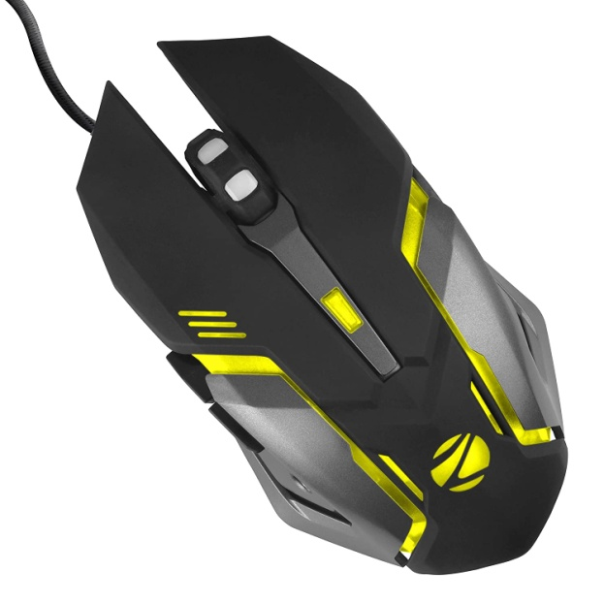

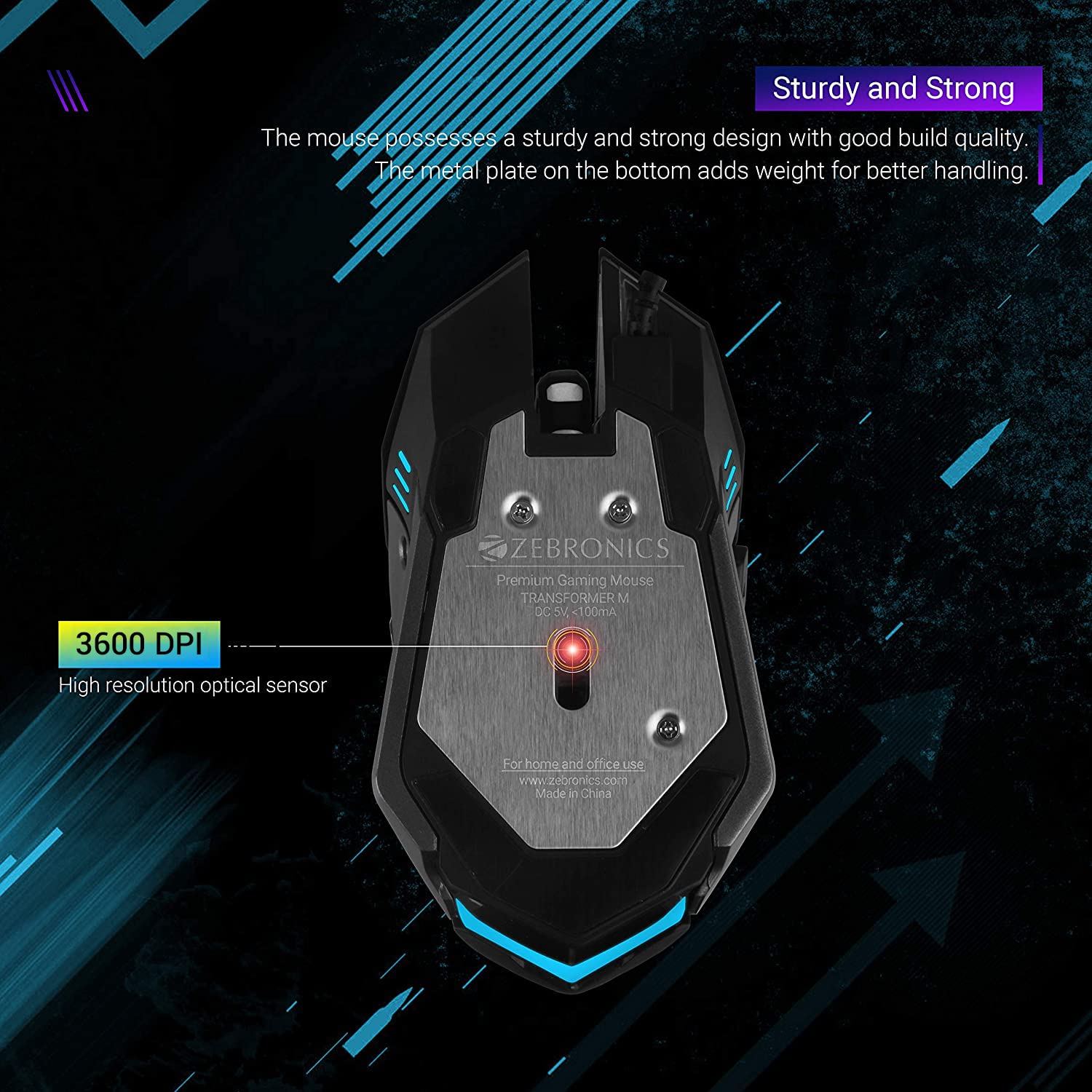

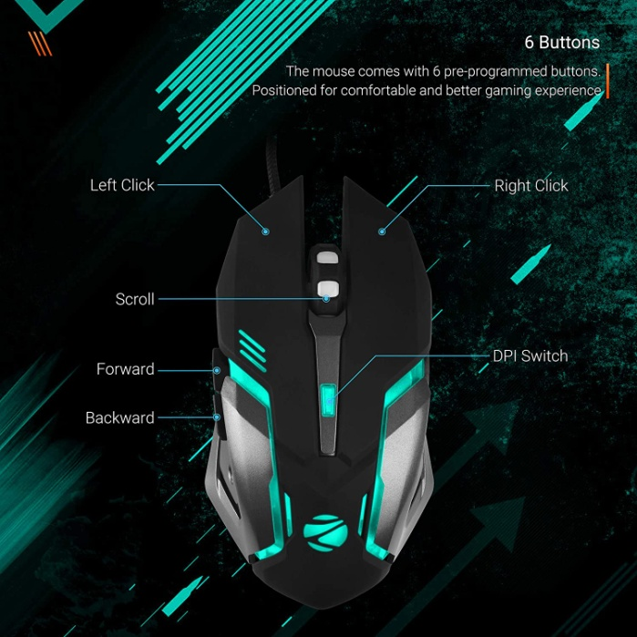

|  |  |
| --- | --- |
| M.R.P.: | ₹549 |
| Deal of the Day: | ₹299  Ends in 02h 00m 44s |
| You Save: | ₹250 (46%) |

### Product details

|  |  |
| --- | --- |
| Brand | ZEBRONICS |
| Colour | Black |
| Connectivity Technology | USB-A |
| Special Feature | Wireless, Ergonomic Design, LED Lights |
| Movement Detection Technology | Optical |
| Number of Buttons | 6 |

* Zeb-Transformer-M is a Optical USB Gaming Mouse with 7 Colors LED Effect. It has High Quality Button,High Precision and Gold Plated USB. It includes Dedicated buttons for DPI,Forward and Backward. Button life : 2.5 Million Times
* It has Compact & Ergonomic Design. Cable type : Braided cable. Bluetooth:No.
* Interface : USB. Sensor : Optical. Power Consumption : DC 5V,<100mA. Gaming mouse: ZEB-Transformer-M premium gaming mouse is designed for gamers who want the perfect fusion of high DPI, precision gaming along with LED lights.