MEETION MT-M990S Black Transformer Style Wired Gaming Mouse, 500-4000 DPI, 8+1 Buttons, 4000 fps, Pro Gaming Sensor, 125-1000 Hz/ms Polling Rate, 60 ips Tracking Speed, RGB Lights, Macro Programmable

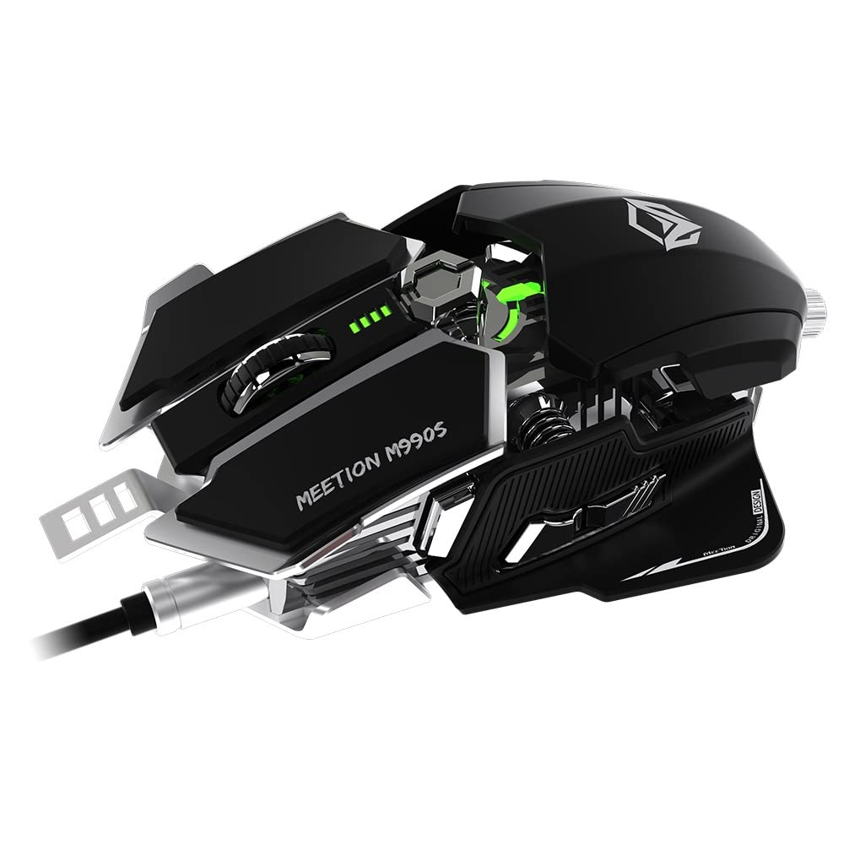

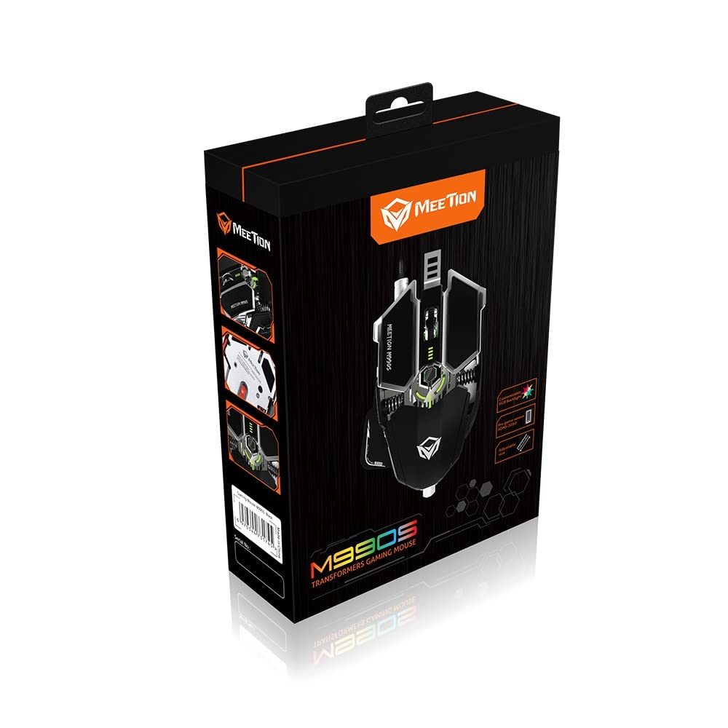

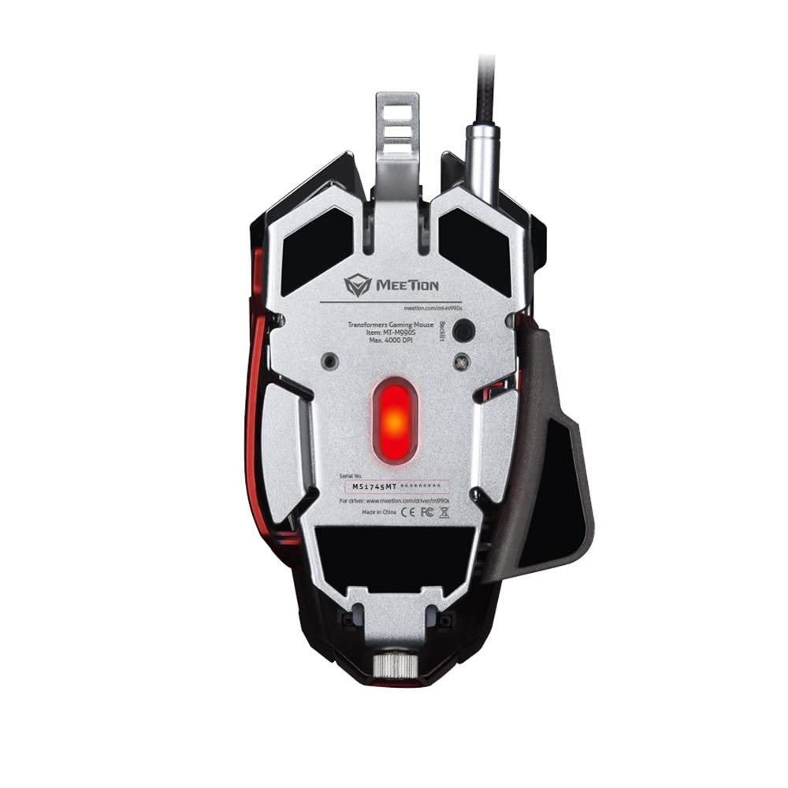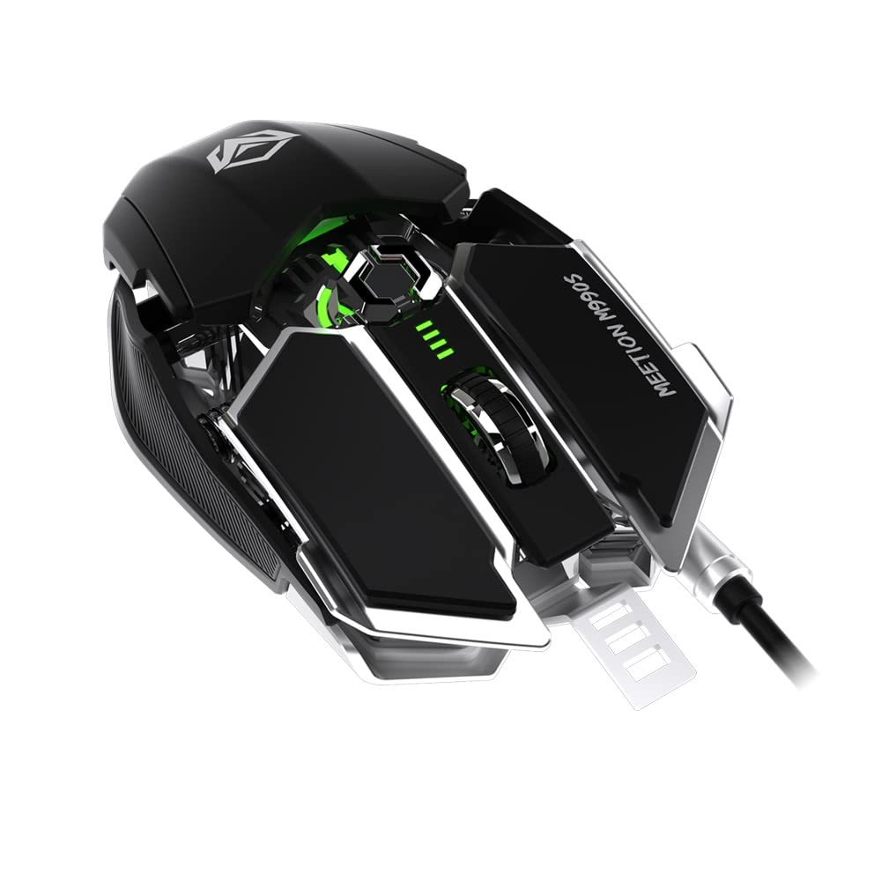

-65% ₹1,999

M.R.P.: ₹5,699

Inclusive of all taxes

### Product details

|  |  |
| --- | --- |
| Brand | MEETION |
| Colour | Black |
| Connectivity Technology | USB |
| Special Feature | Ergonomic Design, LED Lights |
| Number of Buttons | 10 |
| Recommended Uses For Product | Gaming |

* Macro Programmable - Support button customization and macro recording achieve the same continuation of the operation of masters. Various configurations can be directly imported and exported.
* Pro Game Chip - ADNS 3050 gaming chip enable 4000 frames per second in 4000 DPI resolution.
* Fast Button Response - The button is crisp and responsive and the rebound responds quickly to enable the next gaming action just as quickly
* Transformer Gaming Style - The design and experience are close to the sci-fi science fiction chariot that’s about to conquer the world.