Logitech G G102 USB Light Sync Gaming Mouse with Customizable RGB Lighting, 6 Programmable Buttons, Gaming Grade Sensor, 8K DPI Tracking, 16.8mn Color, Light Weight - Black

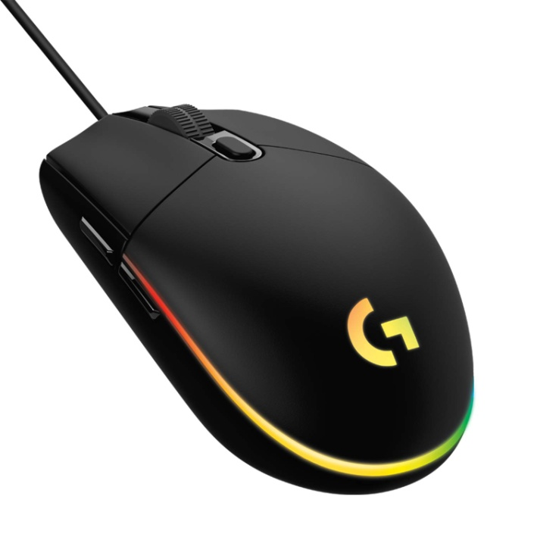

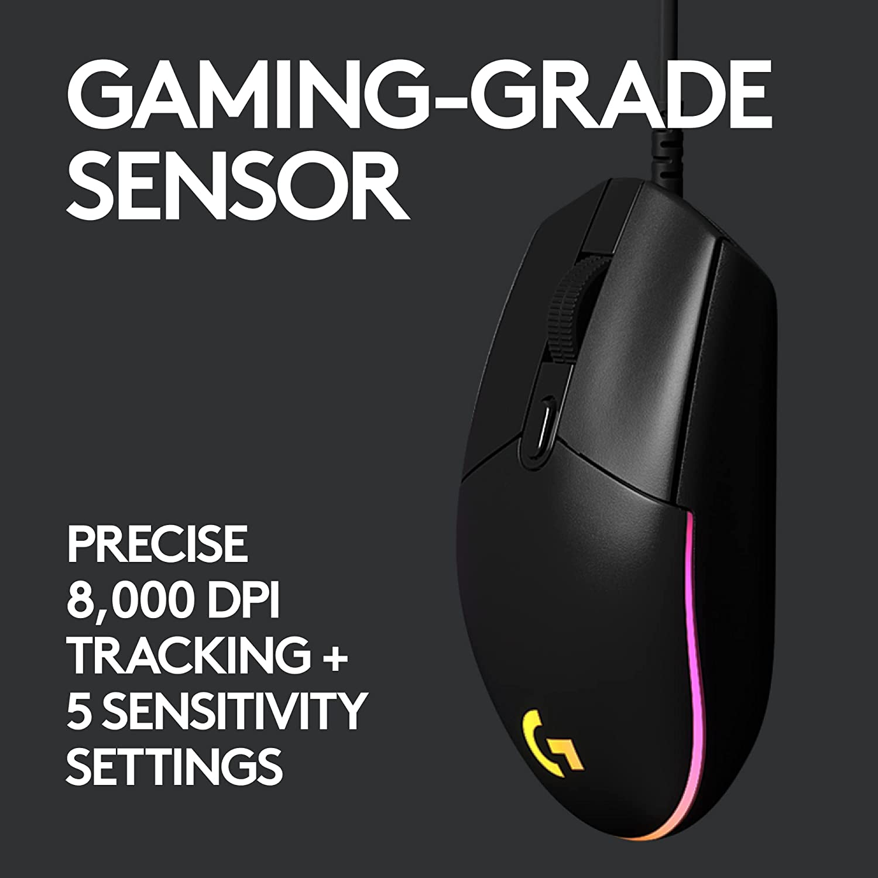



|  |  |
| --- | --- |
| M.R.P.: | ₹1,995 |
| Deal of the Day: | ₹1,395  Ends in 01h 43m 28s |
| You Save: | ₹600 (30%) |
|  | Inclusive of all taxes |

### Product details

|  |  |
| --- | --- |
| Brand | Logitech G |
| Colour | Black |
| Connector Type | USB |
| Special Feature | Lightweight |
| Movement Detection Technology | Optical |
| Number of Buttons | 6 |

* COLORFUL LIGHTSYNC RGB : Play in colour with our most vibrant LIGHTSYNC RGB featuring colour wave effects that are customisable across 16.8 million colours. 8,000 DPI sensor.
* CLASSIC,GAMER TESTED DESIGN : Play comfortably and with total control. The simple 6-button layout and classic gaming shape form a comfortable, time-tested and loved design
* MECHANICAL SPRING BUTTON TENSIONING: Primary buttons are mechanical and tensioned with durable metal springs for reliability, performance and an excellent feel
* CUSTOMIZABLE SETTINGS : To suit the sensitivity you like with Logitech G HUB gaming software and cycle easily through up to 5 DPI settings
* SYSTEM REQUIREMENTS : Windows 7 or later, macOS 10.11 or later, Chrome OSTM, USB port, Internet access for Logitech Gaming Software (optional). USB report rate: 1000 Hz (1ms)