Dell 570-AAMH WM126 USB Optical LED 3-Button Mouse, Black

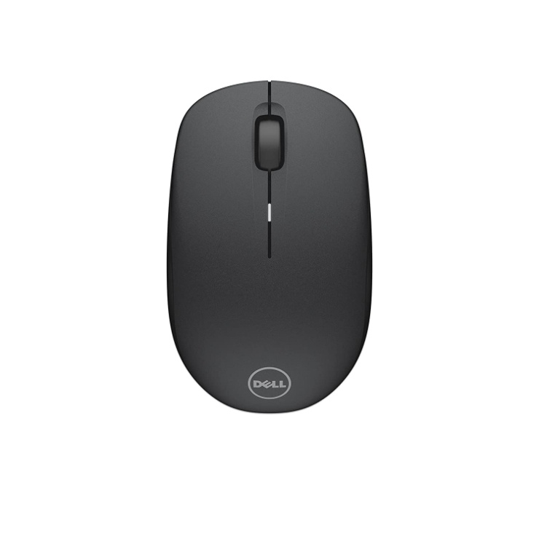

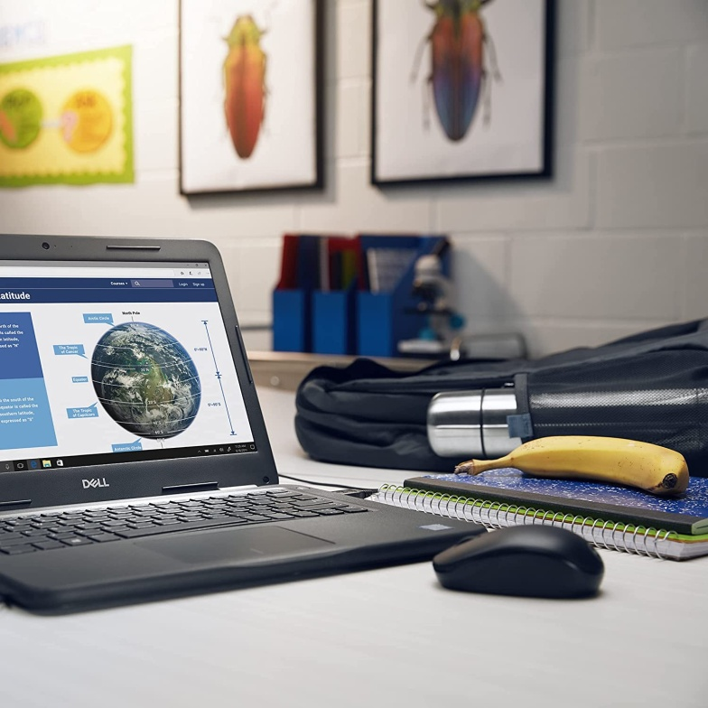

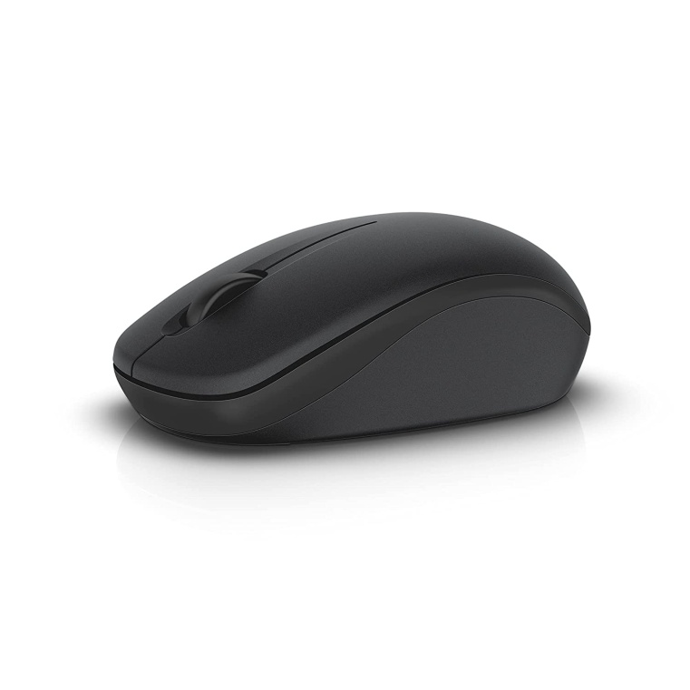

**MRP: 700**

**Product details**

|  |  |
| --- | --- |
| Brand | Dell |
| Colour | BLACK |
| Connectivity Technology | USB |
| Special Feature | Wireless |
| Movement Detection Technology | Optical |
| Number of Buttons | 3 |