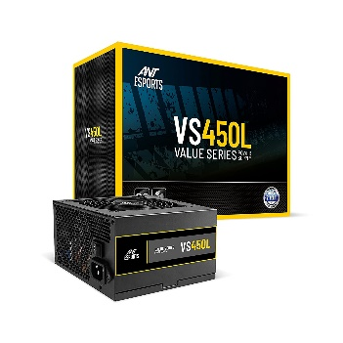

Inner

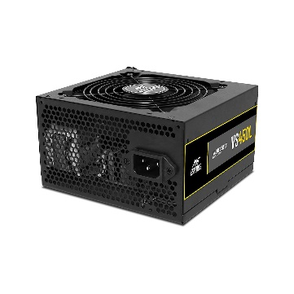

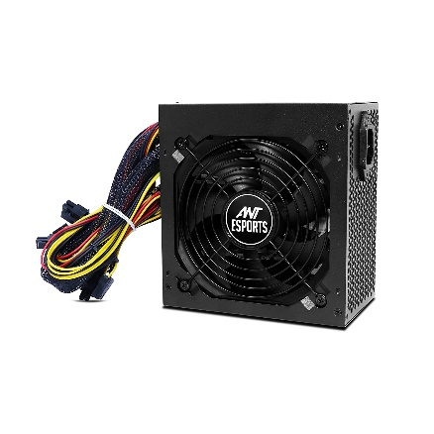

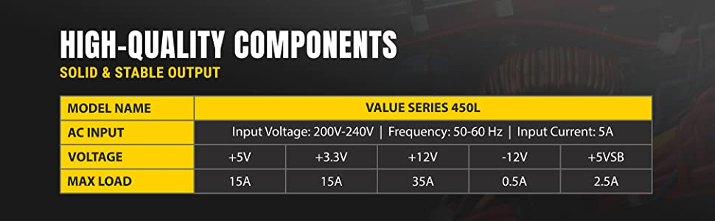

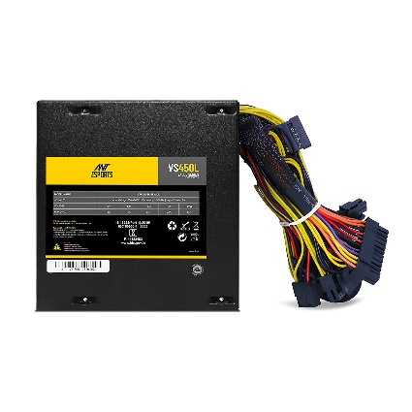

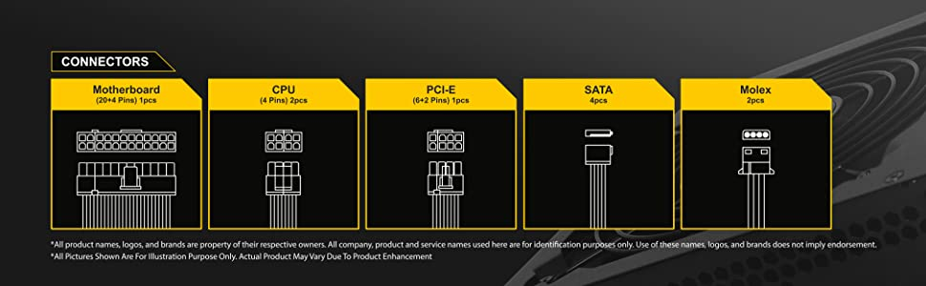

Ant Esports VS450L 450 Watt Power Supply

-33% ₹1,599.00₹1,599.00

M.R.P.: ₹2,399.00₹2,399.00

### Product details

|  |  |
| --- | --- |
| **Brand** | Ant Esports |
| **Connector Type** | ATX |
| **Audio Wattage** | 450 Watts |
| **Form Factor** | ATX12V, ATX |
| **Wattage** | 450 Watts |
| **Cooling Method** | Air |

* Delivers lower noise, less power consumption and cooler temperatures
* 100,000 Hours MTBF, Supports ATX12V 2.3 and EPS12V 2.92 standards, Input Voltage 200-240V
* ATX 24-Pin Connectors- 1,EPS 4+4 Pin Connectors-1, PCIe (6+2) Connectors-1, SATA Connectors-4,Peripheral 4-Pin Connectors-2
* 120 mm, Operating temperature-0-40C
* 2 Year Brand Warranty