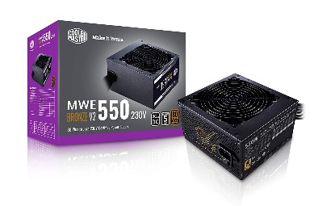

Inner

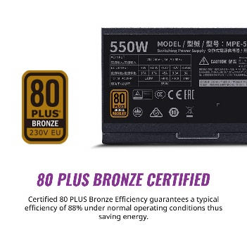

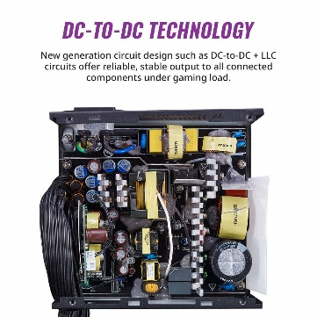

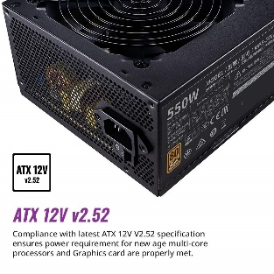

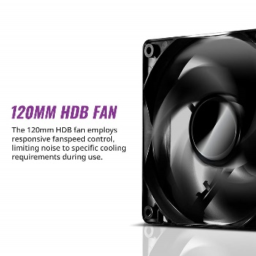

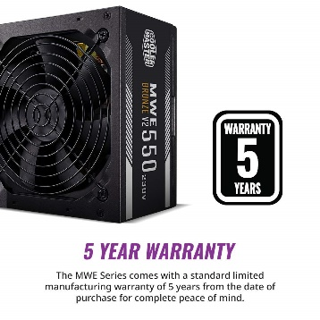

Cooler Master MWE 550 Bronze V2 230v, 80 Plus Bronze Certified, Non-Modular Power Supply – Black

40% ₹3,899.00₹3,899.00

M.R.P.: ₹6,499.00₹6,499.00

**Product details**

|  |  |
| --- | --- |
| **Model Name** | MWE 550 Bronze V2 230v |
| **Brand** | Cooler Master |
| **Connector Type** | ATX |
| **Form Factor** | ATX12V |
| **Wattage** | 550 Watts |
| **Cooling Method** | Air |

* Compliance with latest ATX 12V V2.52 specification ensures power requirement for new age multi-core processors and Graphics card are properly met.
* New generation circuit design such as DC-to-DC + LLC circuits offer reliable, stable output to all connected components under gaming load.
* Certified 80 PLUS Bronze Efficiency guarantees a typical efficiency of 88% under normal operating conditions thus saving energy.
* All flat cables take up less space and are easier to manipulate within the chassis improving ease of build and air airflow.
* The MWE Series comes with a standard limited manufacturing warranty of 5 years from the date of purchase for complete peace of mind.