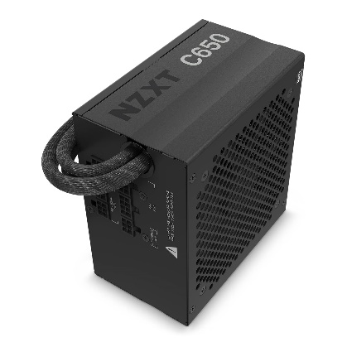

Inner

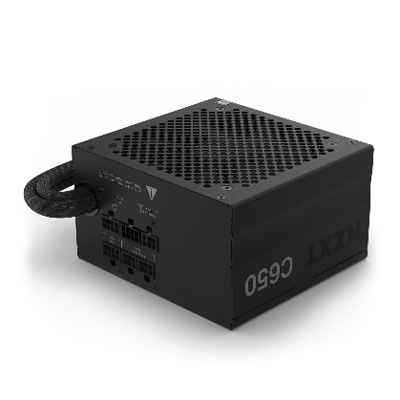

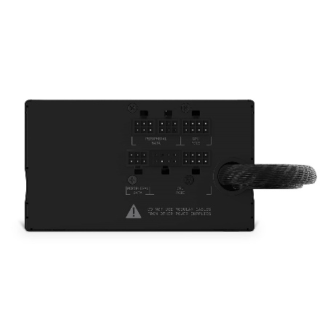

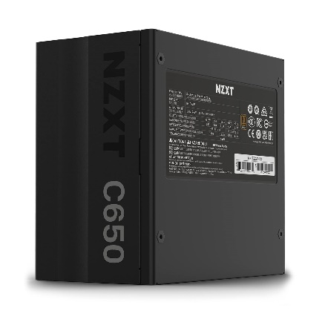

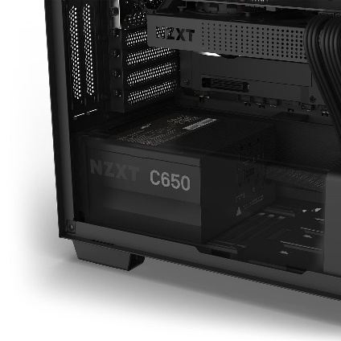

NZXT C650 Bronze, 650 Watt, 80 Plus Bronze Semi-Modular ATX Power Supply/PSU for Gaming PC - PA-6B1BB-IN

-28% ₹6,500.00₹6,500.00

M.R.P.: ₹8,999.00₹8,999.00

**Product details**

|  |  |
| --- | --- |
| **Brand** | Nzxt |
| **Connector Type** | ATX |
| **Audio Wattage** | 650 Watts |
| **Form Factor** | ATX |
| **Wattage** | 650 Watts |
| **Item Dimensions LxWxH** | 14 x 15 x 8.6 Centimeters |

* 80+ BRONZE CERTIFIED: This series gives you the safe and reliable power you need while generating less heat to keep your system quiet and efficient
* SILENT OPERATION: The 120mm FDB silent fan ensures the power supply can silently operate at high load. Capacitors, transformers, and coils have undergone treatment to reduce electromagnetically induced acoustic noise.
* COMPATIBLE AND EFFICIENT: The C Series Bronze fits any case supports ATX PSU, supporting most of the latest NVIDIA 30 series and AMD 6000 series GPUs.
* BUILT FOR BUILDERS: The semi-modular design ensures easier installation and less clutter. The stylish matte black sleeved main cables resist heat damage and fraying, delivering better durability and longevity.
* MAXIMUM EFFICIENCY: At 50% Load, power conversion efficiency reaches 2% higher than 80 plus Bronze Standard.