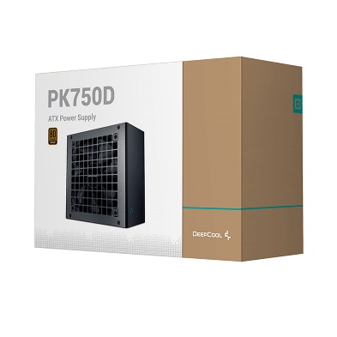

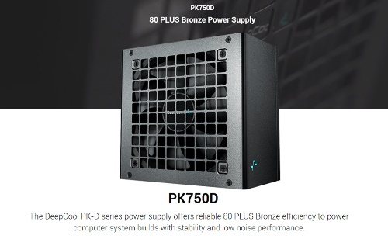

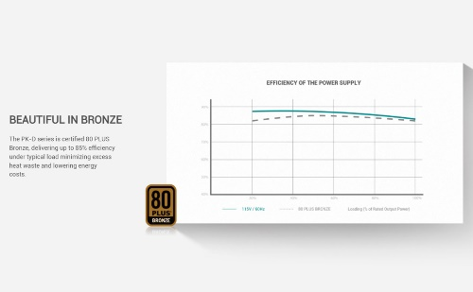

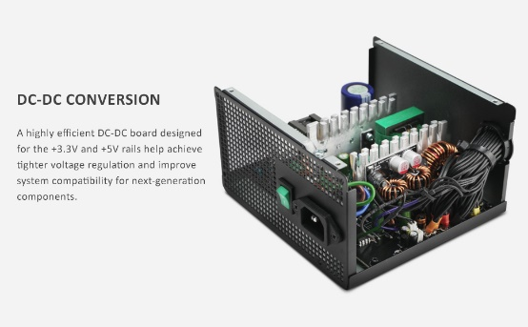

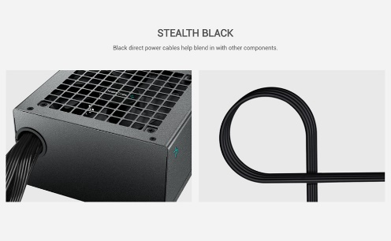

Deepcool PK750D, 750 Watt, 80 Plus Bronze Certified Power Supply/PSU for Gaming PC - R-PK750D-FA0B-UK

-42% ₹5,255.00₹5,255.00

M.R.P.: ₹8,999.00₹8,999.00

### Product details

|  |  |
| --- | --- |
| **Brand** | DEEPCOOL |
| **Connector Type** | ATX |
| **Audio Wattage** | 750 Watts |
| **Form Factor** | ATX12V, ATX |
| **Wattage** | 750 Watts |
| **Cooling Method** | Air |

* 750 Watt 80 PLUS Bronze Certifications
* 100,000 Hours MTBF, Supports ATX12V V2.4 , ≥16ms (80% Load) Hold Up Time
* ATX 24-Pin Connectors- 1, EPS 4+4 Pin Connectors-4, PCIe (6+2)- 2, SATA Connectors- 4, Peripheral 4-Pin Connectors-4
* Fan Size : 120mm, Operation Temperature : 0 - 40 °C
* 5 Years Brand Warranty