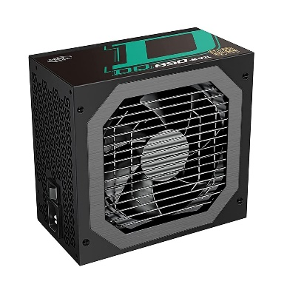

Inner

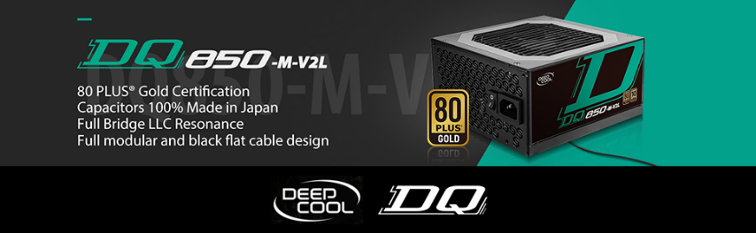

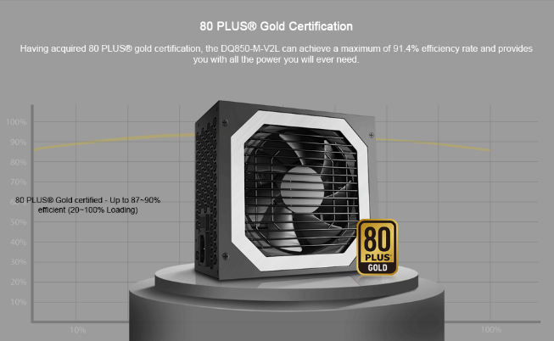

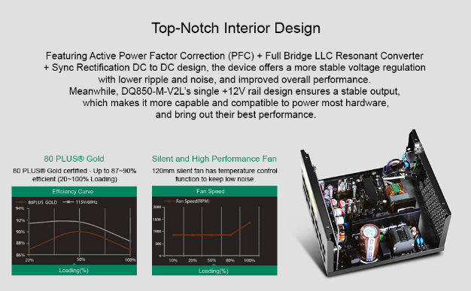

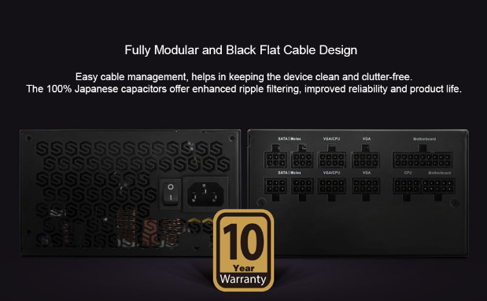

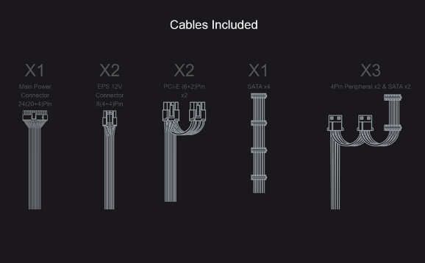

Deepcool DQ850-M V2L, 850 Watt, 80 Plus Gold Full Modular Power Supply/PSU for Gaming PC - DP-GD-DQ850-M-V2L

-44% ₹8,499.00₹8,499.00

M.R.P.: ₹15,099.00₹15,099.00

### Product details

|  |  |
| --- | --- |
| **Model Name** | DQ |
| **Brand** | DEEPCOOL |
| **Compatible Devices** | Personal Computer |
| **Connector Type** | ATX, EPS, SATA |
| **Audio Wattage** | 850 |
| **Form Factor** | ATX12V |

* 80 PLUS GOLD certified - Up to 87 90% efficiency, 850W, Full modular
* MTBF100,000 Hours, ATX 12V V2.31, Input Voltage 100-240V, Input Frequency Range 47-63Hz
* Main Power Connector 24(20+4)Pin x 1 , EPS 12V Connector 8(4+4)Pin x 2, PCI-E (6+2)Pin x 2, SATA x 1 , 4Pin Peripheral x 3
* Fan Size - 120mm, Operation Temperature - 0-40°C
* 10 years Brand warranty