1. Write a program to check if two given String s1 and s2 are rotations of another. For example if s1 = "IndiaUSAEngland" and s2= "USAEnglandIndia" then your program should return true but if s2="IndiaEnglandUSA" then it should return false.

2.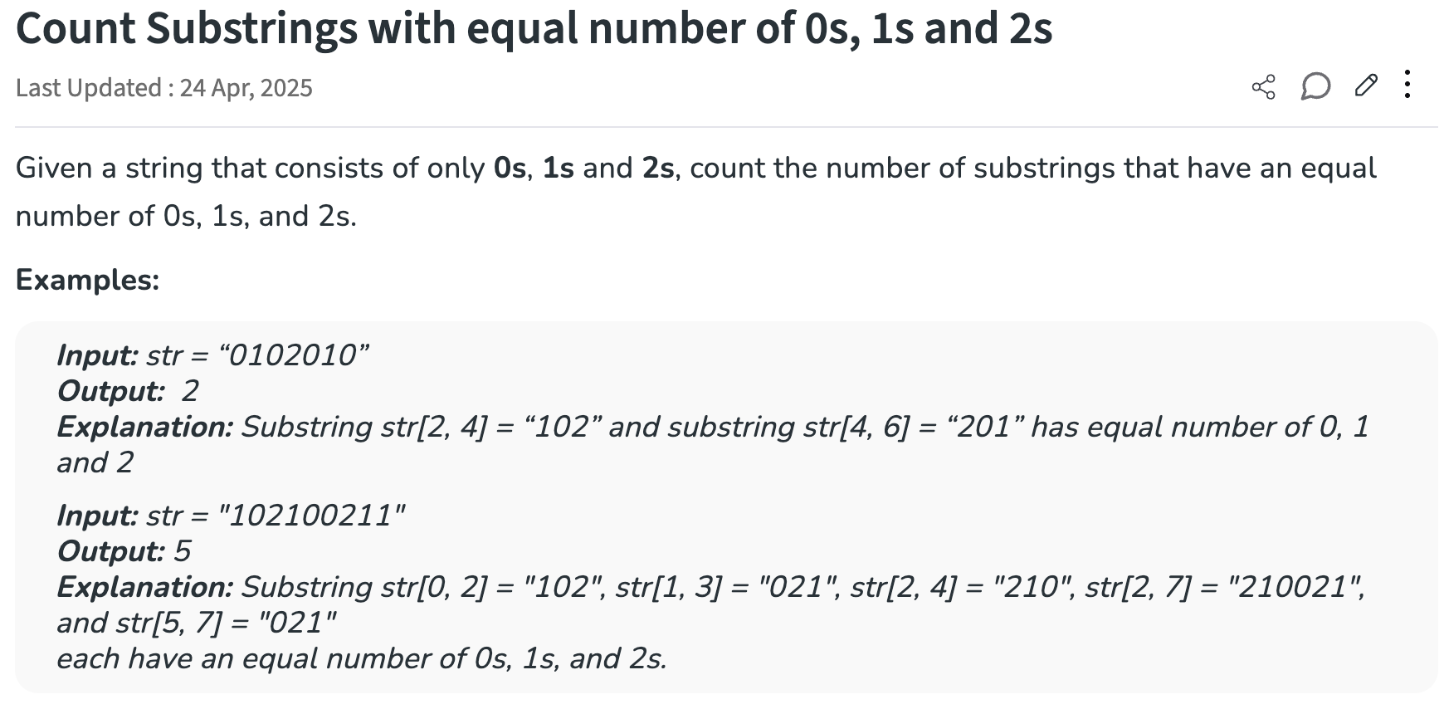

3.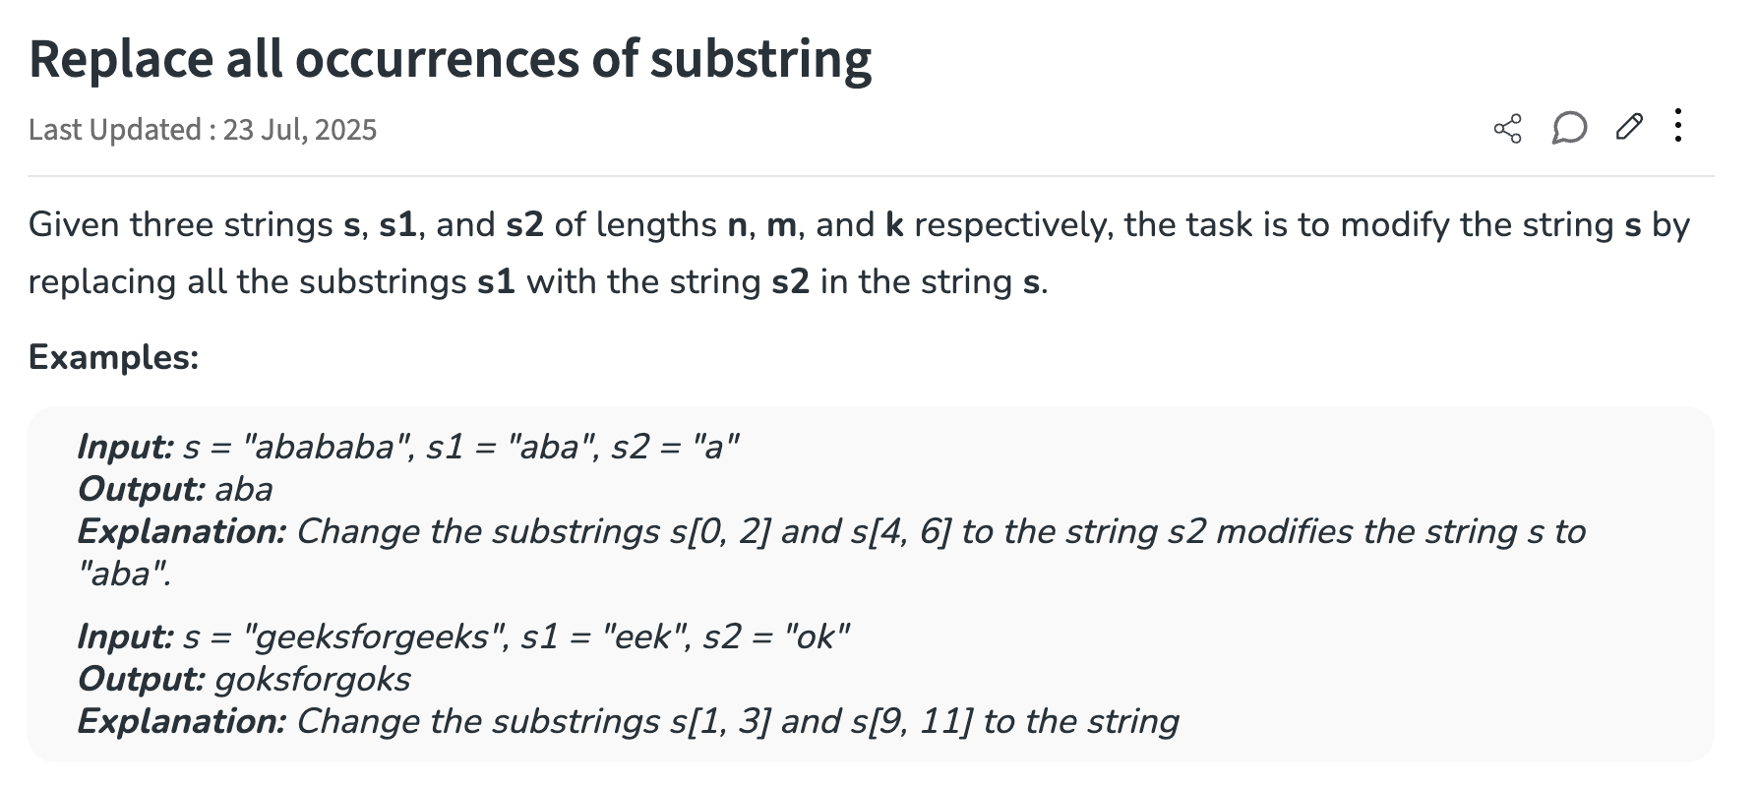

4.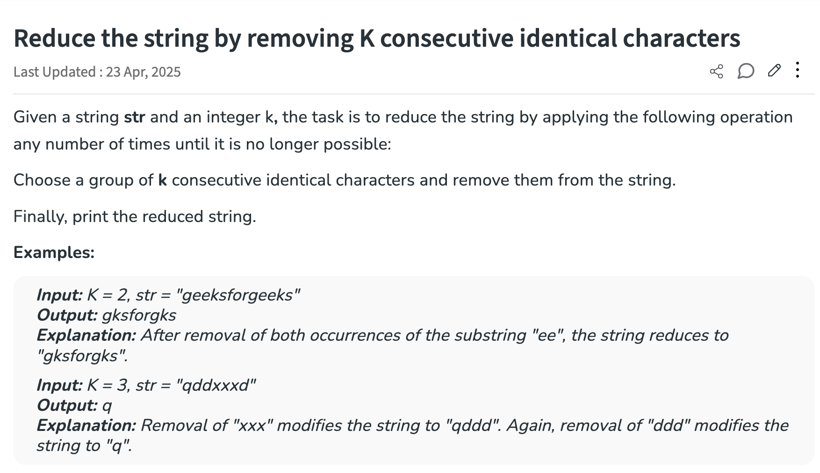

5.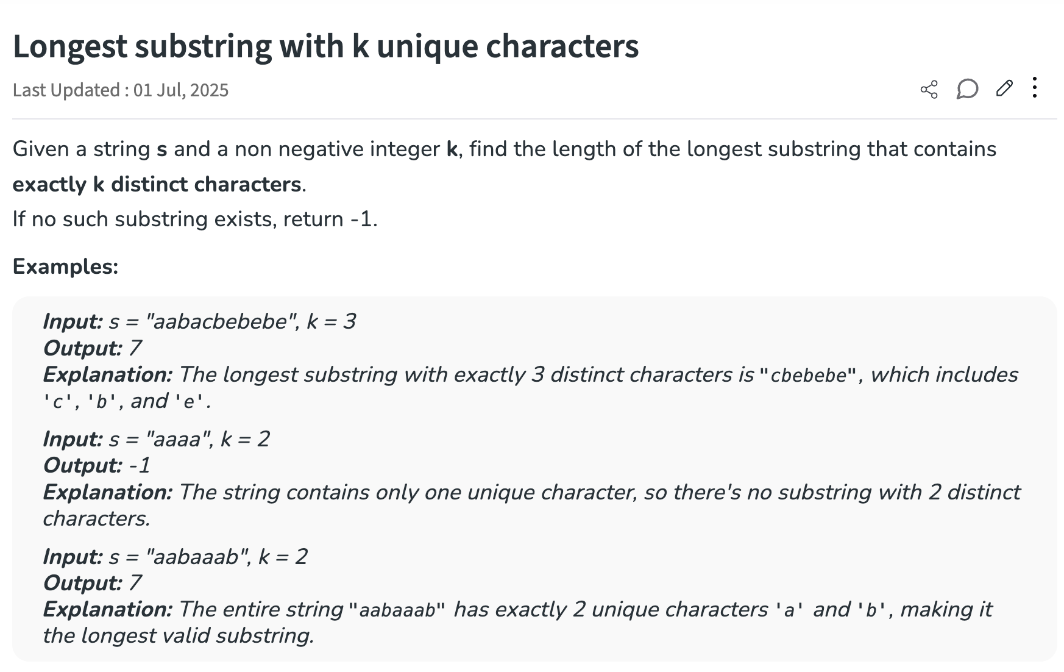
6.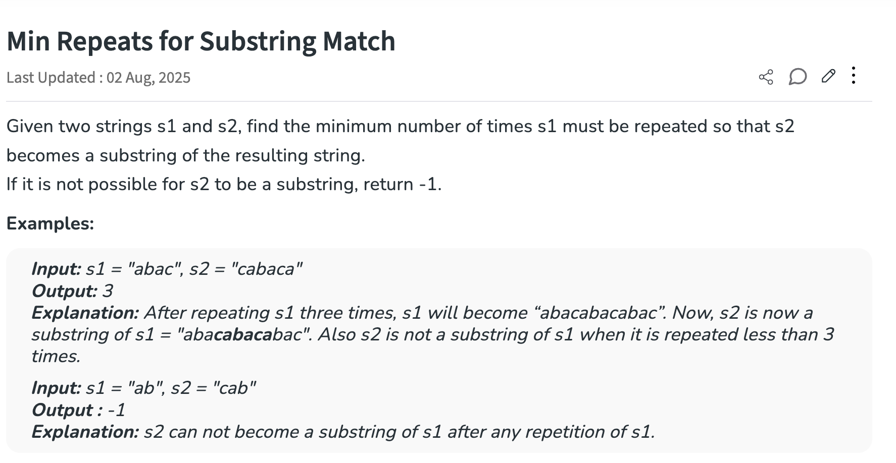

7.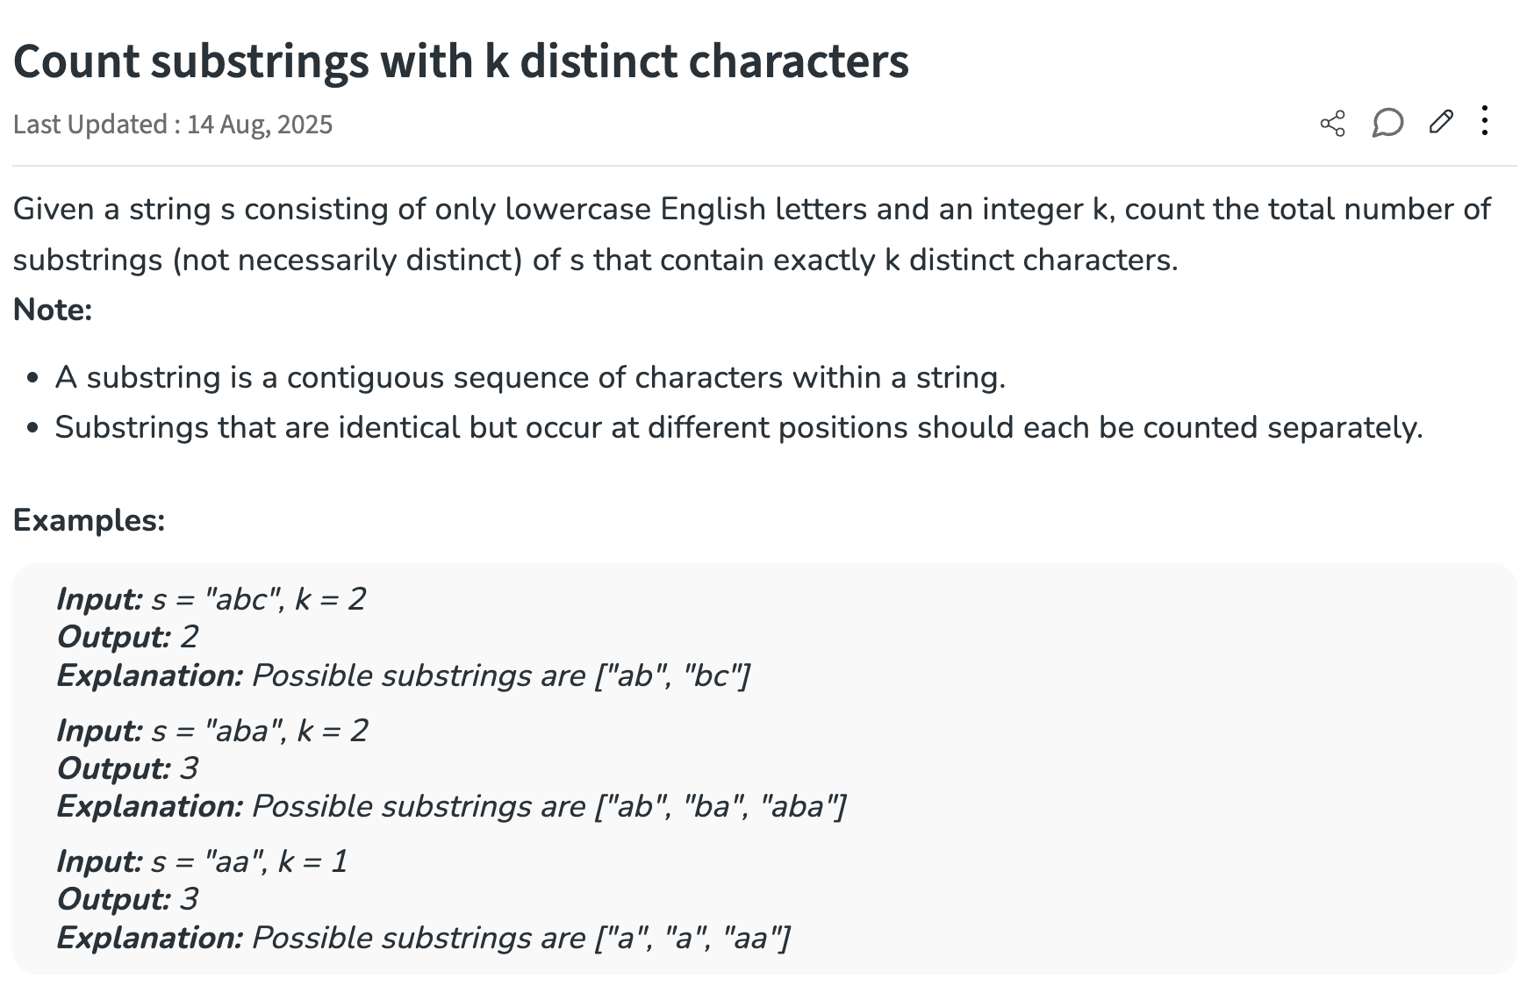

8.