Seat Control System (SCS) Edge Controller
Modelling, Simulation and Verification using MATLAB/Simulink
Project Report
Prepared by: AMITH JOHN KOSHY
Register No.: 25BEC0091
Software: MATLAB / Simulink (R2025a model format)
September 2026

Contents
1. Introduction 3
1.1 Objective 3
1.2 Scope 3
2. System Description 3
2.1 Functional Requirements 3
2.2 Inputs and Outputs 3
3. Simulink Model 4
3.1 Model Overview 5
3.2 Block Description 6
3.3 Control Logic 6
3.4 Parameters and Simulation Settings 6
4. Work Carried Out 7
4.1 Model Construction 7
4.2 Issues Identified and Resolved 7
4.3 Automated Verification 7
4.4 Result Generation 7
4.5 Version Compatibility 7
5. Verification and Test Results 8
5.1 Test Cases 8
5.2 Test Script Output 8
6. Simulation Results 9
6.1 Scenario A - Nominal Operation 9
6.2 Scenario B - Fault Interlock 10
7. How to Run 10
7.1 Project Files 10
7.2 Steps 11
8. Conclusion 11
Appendix A: seat_control_scs_model.m 12
Appendix B: test_seat_control_scs.m 14
Appendix C: generate_figures.m 15

1. Introduction

1.1 Objective
The objective of this project is to model, simulate and verify the control logic of a Seat Control System (SCS) edge controller for a one-axis automotive power seat. The controller drives the seat forward or backward in response to driver switch inputs, stops the motion at the mechanical end positions using front and rear limit switches, disables the motor when a conflicting command is detected, and shapes the motor command with a comfort ramp so that the seat starts and stops smoothly.

1.2 Scope
- Development of a complete Simulink model of the controller and a simplified seat mechanism, built programmatically from a MATLAB script.
- Configuration of a fixed-step solver with a 10 ms step to represent the periodic scan cycle of an embedded controller.
- Automated verification of travel limits, fault detection and command slew rate using an assertion-based MATLAB test script.
- Simulation of a nominal operating sequence and a fault sequence, with results presented and analysed.
- Delivery of the model in MATLAB/Simulink R2025a file format.

2. System Description
The power seat moves along a single axis over a travel range of 0 mm (fully rearward) to 100 mm (fully forward). Two momentary switches, Forward and Backward, are operated by the driver. End-of-travel is detected by a front limit switch at 100 mm and a rear limit switch at 0 mm. The controller evaluates these inputs every scan cycle and produces a signed motor command.

2.1 Functional Requirements
ID | Requirement
R1 | The seat shall move forward while the Forward switch is pressed and backward while the Backward switch is pressed.
R2 | Seat travel shall be limited to 0 to 100 mm. Motion towards an end position that has already been reached shall be inhibited.
R3 | Pressing both switches at the same time shall be treated as a fault, and the motor shall be disabled for as long as the fault is present.
R4 | The motor command shall change at no more than 2 units/s (comfort ramp), so that start and stop are smooth.
R5 | The controller shall execute on a fixed 10 ms scan cycle.

2.2 Inputs and Outputs
Signal | Type | Description
Fwd_Switch | Input (0/1) | Driver forward switch
Bwd_Switch | Input (0/1) | Driver backward switch
Front_Limit_Sensor | Internal (boolean) | True when seat position is at or above 100 mm
Rear_Limit_Sensor | Internal (boolean) | True when seat position is at or below 0 mm
Motor command | Output (-1 to +1) | Signed, ramp-limited motor command (+1 forward, -1 backward)
Motor enable | Output (0/1) | True when motion in either direction is permitted
Fault flag | Output (0/1) | True when both switches are pressed together
Seat position | Output (mm) | Simulated seat position

3. Simulink Model
The model, named SeatControlSCS, is created entirely by the script seat_control_scs_model.m. The script creates a new model, sets the solver configuration, adds and parameterises every block, connects all signal lines, saves the model and runs the simulation. Because the model is generated from source, it can be rebuilt identically at any time. The complete model is shown in Figure 1 on the following page.

3.1 Model Overview
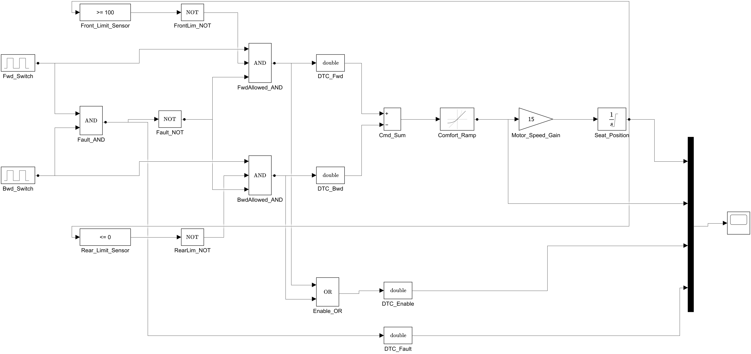
Figure 1: Simulink model SeatControlSCS (complete block diagram)
Signal flow runs from left to right: the driver switches and limit sensors feed the fault check and allowed-direction logic, which produce a signed command. The command passes through the comfort ramp and motor gain into the seat position integrator. The seat position is fed back to the limit sensors, closing the loop. Position, command, enable and fault are multiplexed to a Scope for observation.

3.2 Block Description
Block | Simulink library block | Function
Fwd_Switch, Bwd_Switch | Pulse Generator | Simulate driver switch presses (period 30 s; forward 30 % width from 0 s; backward 20 % width from 15 s)
Front_Limit_Sensor | Compare To Constant (>= 100) | Front end-of-travel detection
Rear_Limit_Sensor | Compare To Constant (<= 0) | Rear end-of-travel detection
FrontLim_NOT, RearLim_NOT | Logical Operator (NOT) | Convert limit state into a "not at limit" permission
Fault_AND | Logical Operator (AND) | Fault when both switches are pressed
Fault_NOT | Logical Operator (NOT) | "No fault" permission
FwdAllowed_AND, BwdAllowed_AND | Logical Operator (AND, 3 inputs) | Direction permitted = switch pressed AND not at limit AND no fault
Enable_OR | Logical Operator (OR) | Motor enable when either direction is permitted
DTC_Fwd, DTC_Bwd | Data Type Conversion | Boolean to double for the command sum
Cmd_Sum | Sum (+ -) | Signed command: forward minus backward
Comfort_Ramp | Rate Limiter | Limits command rate to +/- 2 units/s
Motor_Speed_Gain | Gain (15) | Converts command to seat speed in mm/s
Seat_Position | Integrator (limited 0 to 100) | Seat position in mm, with mechanical end stops
DTC_Enable, DTC_Fault | Data Type Conversion | Boolean to double so all Mux inputs share one data type
Mux, Scope | Mux (4 inputs), Scope | Display of position, command, enable and fault

3.3 Control Logic
The logic evaluated every scan cycle is:
- Fault = Fwd AND Bwd
- FwdAllowed = Fwd AND (NOT FrontLimit) AND (NOT Fault)
- BwdAllowed = Bwd AND (NOT RearLimit) AND (NOT Fault)
- Enable = FwdAllowed OR BwdAllowed
- Command = RateLimit(FwdAllowed - BwdAllowed, +/-2 per s)
- Position = Integral(15 x Command) dt, limited to [0, 100] mm
Because the fault term is included in both permission equations, a fault inhibits motion in both directions. Because each limit term is included only in its own direction, the seat can always be driven away from an end position that has been reached.

3.4 Parameters and Simulation Settings
Parameter | Value | Location
Travel range | 0 to 100 mm | Seat_Position saturation limits; limit sensor thresholds
Speed gain | 15 mm/s at full command | Motor_Speed_Gain
Comfort ramp slew rate | +2 / -2 units/s (0.5 s from 0 to full) | Comfort_Ramp
Solver | ode4 (Runge-Kutta), fixed step | Model configuration
Fixed step size | 0.01 s (10 ms scan cycle) | Model configuration
Stop time | 30 s | Model configuration

4. Work Carried Out

4.1 Model Construction
The model is constructed programmatically using the Simulink API functions new_system, add_block, set_param, add_line and save_system. Block positions are set explicitly so that the generated diagram is readable, and all connections use automatic line routing.

4.2 Issues Identified and Resolved
The initial version of the build script did not simulate. The following issues were identified from the MATLAB error messages and corrected:
# | Observed problem | Cause | Resolution
1 | Simulation stopped with: "The FixedStepDiscrete solver cannot be used to simulate block diagram SeatControlSCS because it contains continuous states". | The Integrator and Rate Limiter are continuous-time blocks. The discrete-only solver cannot integrate continuous states. | Solver changed to ode4 with the same fixed 10 ms step. Execution remains periodic, as in an embedded scan cycle, while the continuous seat dynamics are integrated correctly.
2 | Data type mismatch at Mux input 2 (boolean expected, double supplied). | Mux combined double signals (position, command) with boolean signals (enable, fault). A Mux output must have a single data type. | Data Type Conversion blocks DTC_Enable and DTC_Fault added to convert enable and fault to double before the Mux.
3 | Block labels overlapped in the block diagram. | Blocks were placed too close together. | Block positions re-spaced. No change to functionality.

4.3 Automated Verification
An assertion-based test script, test_seat_control_scs.m, was written. It builds the model, enables signal logging on the relevant block outputs at run time, runs two simulations and checks the logged data with assert statements. Any failed check stops the script with a descriptive error message. The test cases and their results are given in Section 5.

4.4 Result Generation
The script generate_figures.m rebuilds the model, exports the block diagram (Figure 1), runs the nominal and fault scenarios, and plots all key signals (Figures 2 and 3). It also prints the key numerical results quoted in Section 6.

4.5 Version Compatibility
The model file SeatControlSCS.slx is saved in MATLAB/Simulink R2025a format using Simulink.exportToVersion, so it opens directly in R2025a. The scripts use only standard functions available in earlier releases. The one theme-related call in generate_figures.m (theme) is executed only on releases that support it, using isMATLABReleaseOlderThan. Running seat_control_scs_model.m in any supported release rebuilds the model natively in that release.

5. Verification and Test Results

5.1 Test Cases
Scenario A uses the default switch timing (the switches never overlap). Scenario B changes the phase delay of Bwd_Switch to 0 s so that both switches are pressed together during the first 6 s, which exercises the fault interlock.
ID | Scenario | Check | Pass criterion | Result
T1 | A - Nominal | Travel range | 0 <= position <= 100 mm at every step | PASS (min 0.00, max 100.00 mm)
T2 | A - Nominal | Comfort ramp | |change in command| <= 2 x 0.01 = 0.02 per step | PASS (max 0.0200)
T3 | B - Fault | Fault detection | Fault flag = (Fwd AND Bwd) at every step, and the fault occurs at least once | PASS (fault active 6.01 s)
T4 | B - Fault | Limits under fault | T1 and T2 criteria also hold during the fault scenario | PASS

5.2 Test Script Output
>> test_seat_control_scs
Model built and simulated: SeatControlSCS
PASS T1: position within [0, 100] mm (min 0.00, max 100.00)
PASS T2: max command change per step 0.0200 <= limit 0.0200
PASS T3: fault flag active exactly when both switches pressed (6.01 s)
PASS T4: range and slew limits hold during fault scenario
All SeatControlSCS tests passed.

All four test cases passed. The maximum command change of 0.0200 per step equals the configured limit exactly, which confirms that the comfort ramp is active and is the limiting factor during every start and stop.

6. Simulation Results

6.1 Scenario A - Nominal Operation
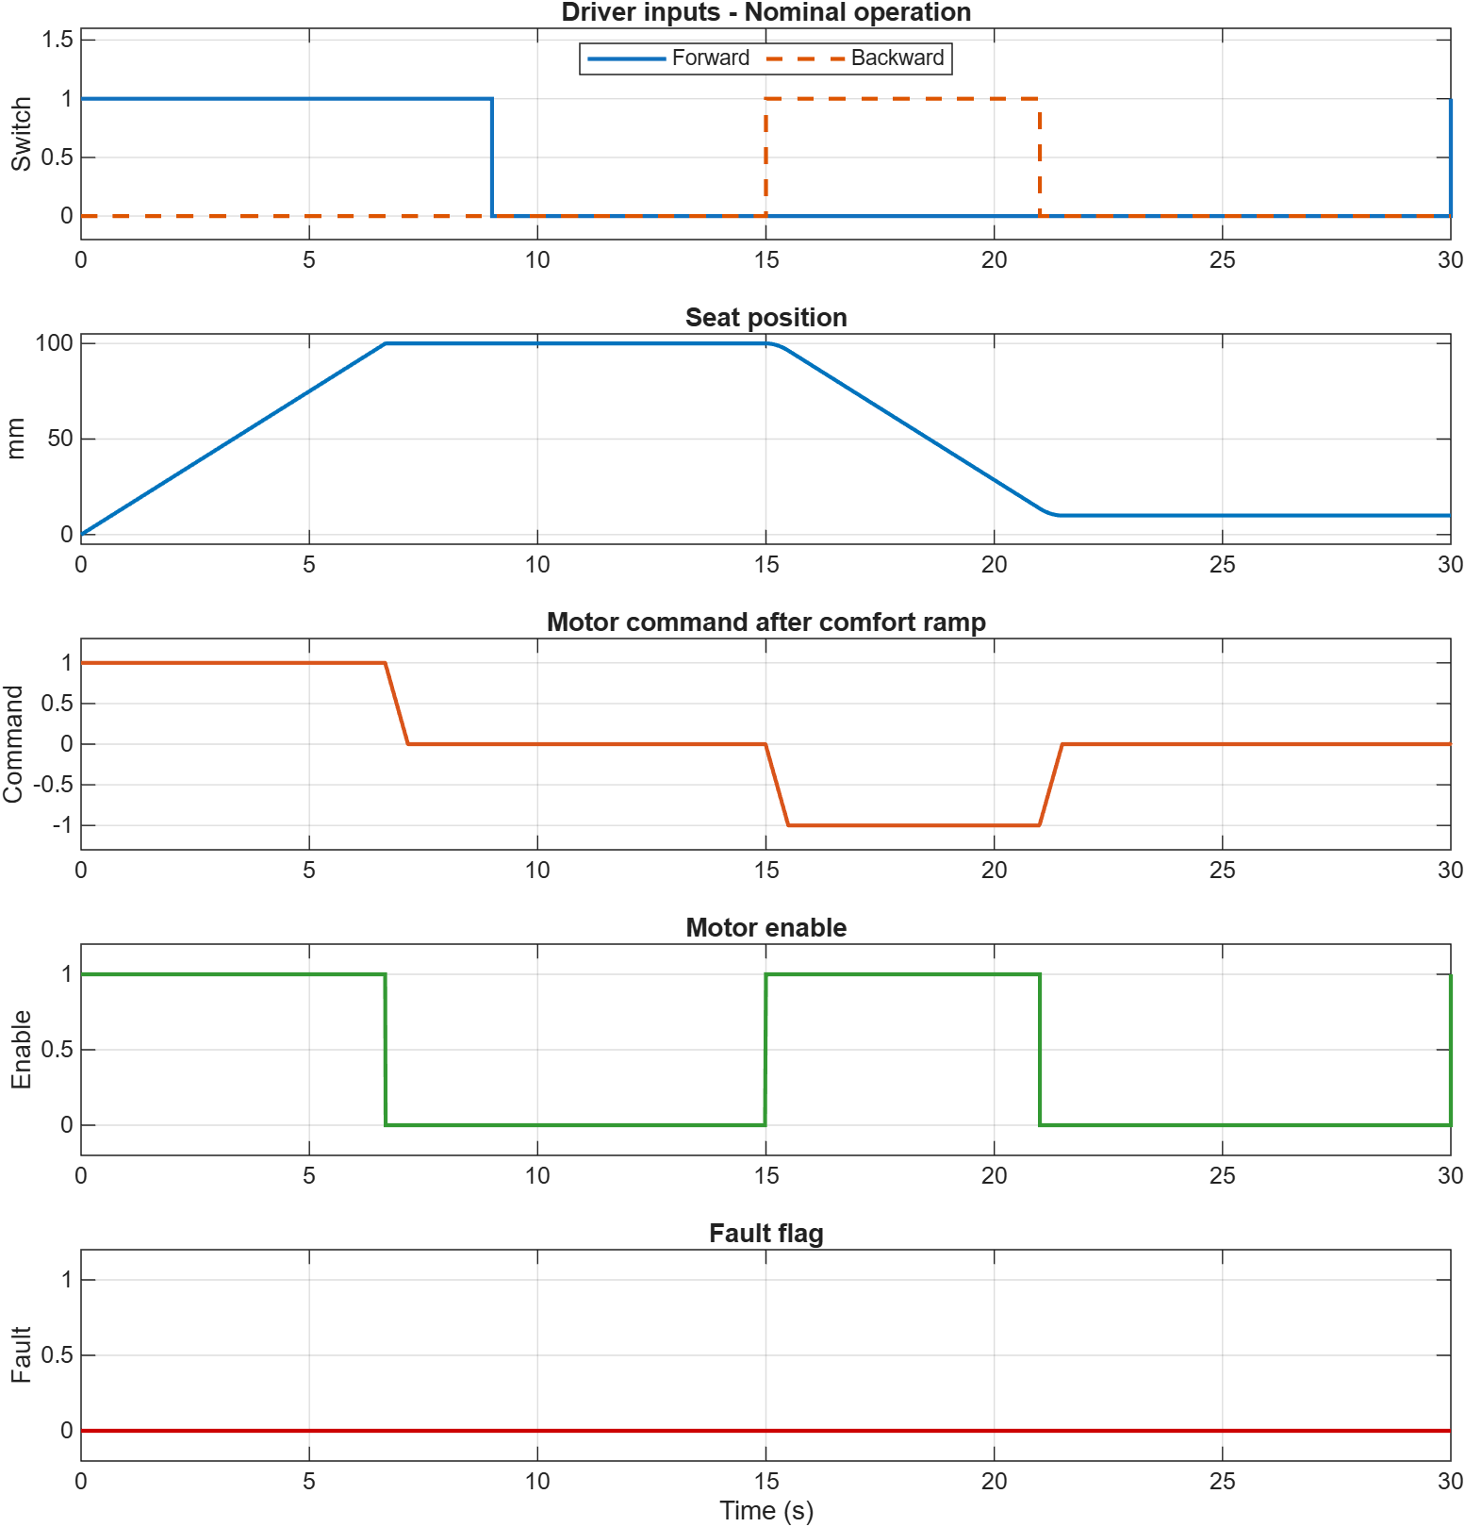
Figure 2: Nominal operation - switch inputs, seat position, motor command, enable and fault
- 0 to 9 s (Forward pressed): the command ramps to +1 and the seat moves forward at 15 mm/s. It reaches the front limit of 100 mm at t = 6.67 s (100 mm / 15 mm/s). The front limit sensor removes forward permission, the enable drops to 0 and the command ramps down to 0 in 0.5 s. The position is held at 100 mm.
- 9 to 15 s (no switch pressed): the seat remains stationary at 100 mm.
- 15 to 21 s (Backward pressed): the command ramps to -1 in 0.5 s and the seat moves rearward at 15 mm/s. When the switch is released at 21 s the command ramps back to 0. The final position is 10.00 mm, a net travel of 90 mm (6 s x 15 mm/s).
- Fault flag: remains 0 throughout, because the two switches are never pressed together.
- t = 30 s: the Forward pulse generator begins its next period, which appears as a rise in the switch and enable signals at the last sample.

6.2 Scenario B - Fault Interlock
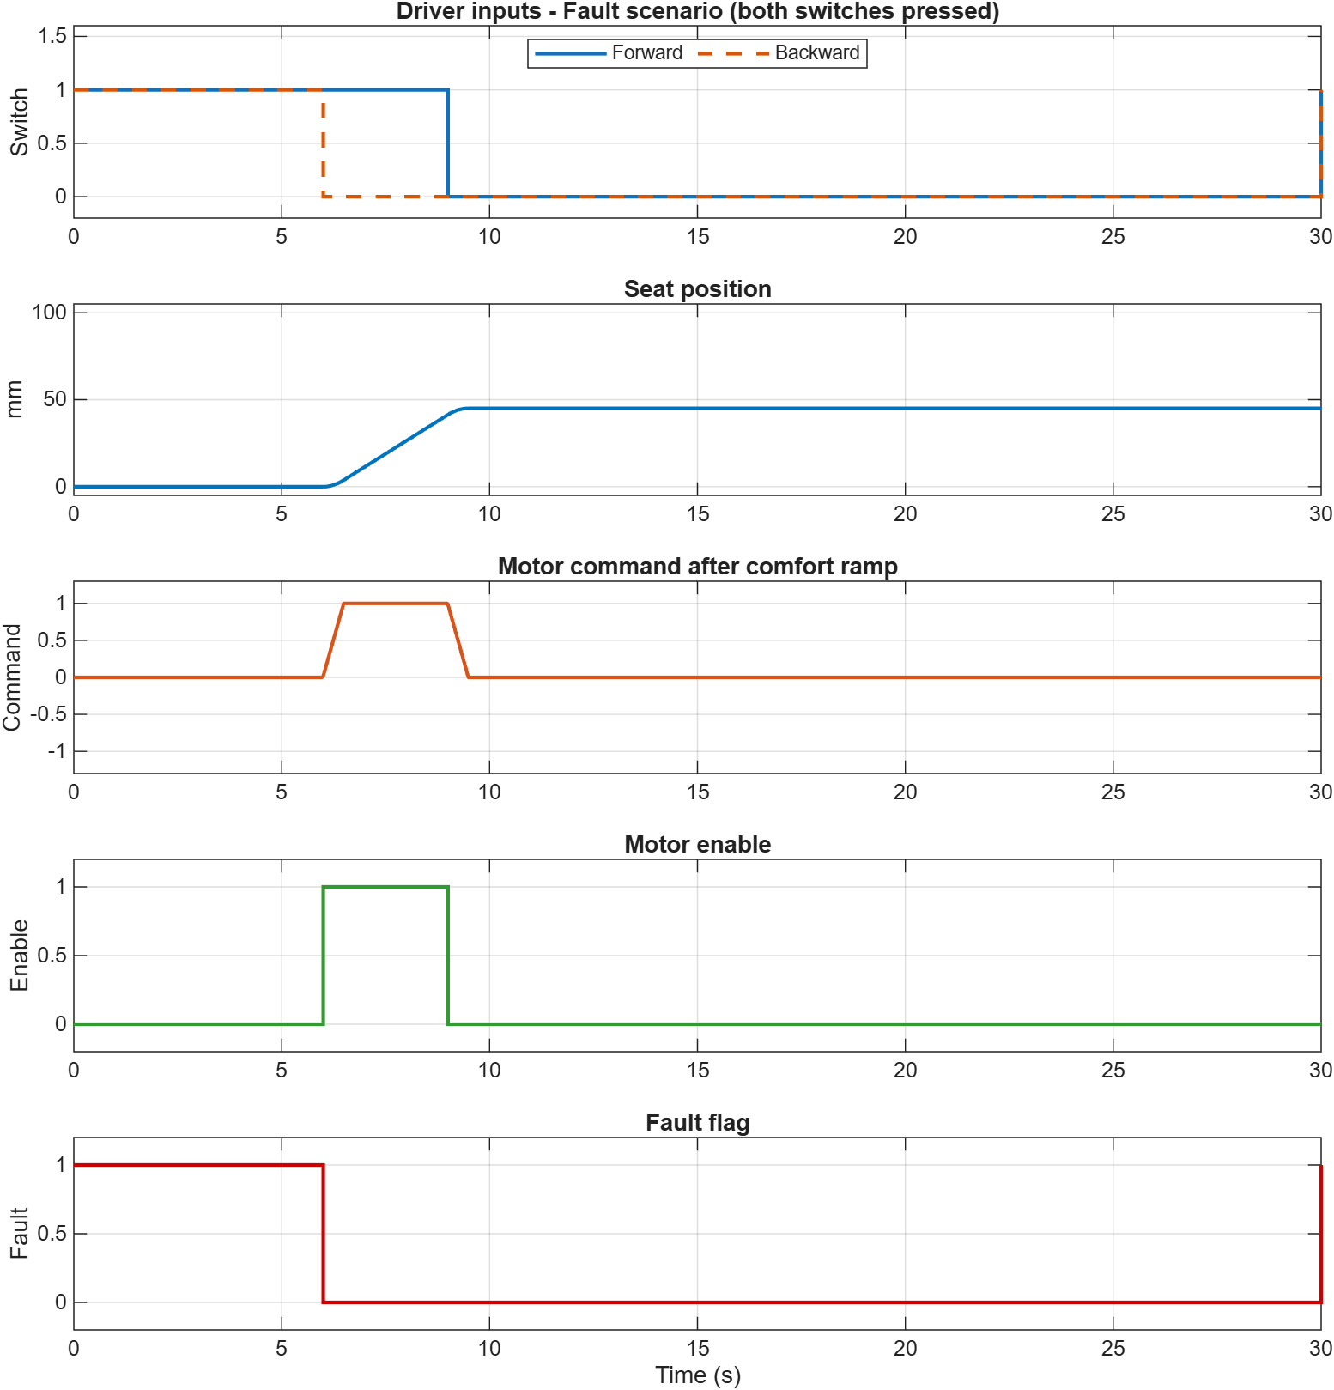
Figure 3: Fault scenario - both switches pressed together from 0 to 6 s
- 0 to 6 s (both switches pressed): the fault flag is 1 for the full 6 s. Both direction permissions are removed, the enable stays at 0, the command stays at 0 and the seat remains at 0 mm.
- 6 to 9 s (Forward only): the fault clears when Backward is released. Forward motion is permitted, the command ramps to +1 and the seat moves forward.
- After 9 s: Forward is released, the command ramps to 0 and the seat stops at 45.00 mm (3 s x 15 mm/s).
The result confirms requirement R3: a conflicting input disables the motor completely, and normal operation resumes as soon as the conflict is removed. Position and slew rate limits continue to hold during the fault.

7. How to Run

7.1 Project Files
File | Description
seat_control_scs_model.m | Builds, saves and simulates the SeatControlSCS model
test_seat_control_scs.m | Assertion-based verification (test cases T1 to T4)
generate_figures.m | Exports the block diagram and the result plots to the figures folder
SeatControlSCS.slx | Simulink model, R2025a format
figures/ | fig1_simulink_model.png, fig2_nominal_response.png, fig3_fault_response.png
SeatControlSCS_Report.docx / .pdf | This report

7.2 Steps
- Open MATLAB and set the current folder to the project folder.
- Build and simulate the model: seat_control_scs_model
- Double-click the Scope block to view position, command, enable and fault.
- Run the verification tests: test_seat_control_scs
- Regenerate the figures: generate_figures
To observe the fault interlock interactively, open the Bwd_Switch block, set Phase delay to 0 and run the simulation again.

8. Conclusion
A Seat Control System edge controller for a one-axis power seat was modelled in Simulink and simulated on a 10 ms fixed-step scan cycle. Two build errors, a solver incompatible with continuous states and a data type mismatch at the Mux, were identified and corrected. An automated test script verifies that seat travel remains within 0 to 100 mm, that the fault flag is raised exactly when both switches are pressed and that the motor command never exceeds the comfort ramp slew rate. All tests passed. The simulation results show correct end-of-travel stopping at 6.67 s, smooth 0.5 s command ramps and a complete motor inhibit during the fault condition. The model is delivered in R2025a format together with the scripts needed to rebuild, test and plot it.

Appendix A: seat_control_scs_model.m
modelName = 'SeatControlSCS';

if bdIsLoaded(modelName)
close_system(modelName, 0);
end
new_system(modelName);
open_system(modelName);

set_param(modelName, 'SolverType', 'Fixed-step');
set_param(modelName, 'Solver', 'ode4');
set_param(modelName, 'FixedStep', '0.01');
set_param(modelName, 'StopTime', '30');

add_block('simulink/Sources/Pulse Generator', [modelName '/Fwd_Switch'], ...
'Position', [40 105 100 135], 'Amplitude', '1', 'Period', '30', ...
'PulseWidth', '30', 'PhaseDelay', '0');

add_block('simulink/Sources/Pulse Generator', [modelName '/Bwd_Switch'], ...
'Position', [40 305 100 335], 'Amplitude', '1', 'Period', '30', ...
'PulseWidth', '20', 'PhaseDelay', '15');

add_block('simulink/Logic and Bit Operations/Compare To Constant', ...
[modelName '/Front_Limit_Sensor'], 'Position', [180 15 270 45], ...
'relop', '>=', 'const', '100');

add_block('simulink/Logic and Bit Operations/Compare To Constant', ...
[modelName '/Rear_Limit_Sensor'], 'Position', [180 415 270 445], ...
'relop', '<=', 'const', '0');

add_block('simulink/Logic and Bit Operations/Logical Operator', ...
[modelName '/Fault_AND'], 'Position', [180 195 220 245], ...
'Operator', 'AND', 'Inputs', '2');

add_block('simulink/Logic and Bit Operations/Logical Operator', ...
[modelName '/Fault_NOT'], 'Position', [320 205 360 235], ...
'Operator', 'NOT');

add_block('simulink/Logic and Bit Operations/Logical Operator', ...
[modelName '/FrontLim_NOT'], 'Position', [360 15 400 45], ...
'Operator', 'NOT');

add_block('simulink/Logic and Bit Operations/Logical Operator', ...
[modelName '/RearLim_NOT'], 'Position', [360 415 400 445], ...
'Operator', 'NOT');

add_block('simulink/Logic and Bit Operations/Logical Operator', ...
[modelName '/FwdAllowed_AND'], 'Position', [480 85 520 155], ...
'Operator', 'AND', 'Inputs', '3');

add_block('simulink/Logic and Bit Operations/Logical Operator', ...
[modelName '/BwdAllowed_AND'], 'Position', [480 285 520 355], ...
'Operator', 'AND', 'Inputs', '3');

add_block('simulink/Logic and Bit Operations/Logical Operator', ...
[modelName '/Enable_OR'], 'Position', [600 500 640 550], ...
'Operator', 'OR', 'Inputs', '2');

add_block('simulink/Signal Attributes/Data Type Conversion', ...
[modelName '/DTC_Fwd'], 'Position', [600 105 650 135], ...
'OutDataTypeStr', 'double');

add_block('simulink/Signal Attributes/Data Type Conversion', ...
[modelName '/DTC_Bwd'], 'Position', [600 305 650 335], ...
'OutDataTypeStr', 'double');

add_block('simulink/Math Operations/Sum', [modelName '/Cmd_Sum'], ...
'Position', [720 200 750 240], 'Inputs', '+-', ...
'IconShape', 'rectangular');

add_block('simulink/Discontinuities/Rate Limiter', [modelName '/Comfort_Ramp'], ...
'Position', [820 200 880 240], 'RisingSlewLimit', '2', ...
'FallingSlewLimit', '-2');

add_block('simulink/Math Operations/Gain', [modelName '/Motor_Speed_Gain'], ...
'Position', [960 200 1020 240], 'Gain', '15');

add_block('simulink/Continuous/Integrator', [modelName '/Seat_Position'], ...
'Position', [1100 200 1150 240], 'LimitOutput', 'on', ...
'UpperSaturationLimit', '100', 'LowerSaturationLimit', '0');

add_block('simulink/Signal Attributes/Data Type Conversion', ...
[modelName '/DTC_Enable'], 'Position', [720 510 770 540], ...
'OutDataTypeStr', 'double');

add_block('simulink/Signal Attributes/Data Type Conversion', ...
[modelName '/DTC_Fault'], 'Position', [720 590 770 620], ...
'OutDataTypeStr', 'double');

add_block('simulink/Signal Routing/Mux', [modelName '/Mux'], ...
'Position', [1260 250 1270 560], 'Inputs', '4');

add_block('simulink/Sinks/Scope', [modelName '/Scope'], ...
'Position', [1330 385 1370 425]);
set_param([modelName '/Scope'], 'NumInputPorts', '1');
open_system([modelName '/Scope']);

add_line(modelName, 'Fwd_Switch/1', 'Fault_AND/1', 'autorouting', 'on');
add_line(modelName, 'Bwd_Switch/1', 'Fault_AND/2', 'autorouting', 'on');
add_line(modelName, 'Fault_AND/1', 'Fault_NOT/1', 'autorouting', 'on');

add_line(modelName, 'Front_Limit_Sensor/1', 'FrontLim_NOT/1', 'autorouting', 'on');
add_line(modelName, 'Rear_Limit_Sensor/1', 'RearLim_NOT/1', 'autorouting', 'on');

add_line(modelName, 'Fwd_Switch/1', 'FwdAllowed_AND/1', 'autorouting', 'on');
add_line(modelName, 'FrontLim_NOT/1', 'FwdAllowed_AND/2', 'autorouting', 'on');
add_line(modelName, 'Fault_NOT/1', 'FwdAllowed_AND/3', 'autorouting', 'on');

add_line(modelName, 'Bwd_Switch/1', 'BwdAllowed_AND/1', 'autorouting', 'on');
add_line(modelName, 'RearLim_NOT/1', 'BwdAllowed_AND/2', 'autorouting', 'on');
add_line(modelName, 'Fault_NOT/1', 'BwdAllowed_AND/3', 'autorouting', 'on');

add_line(modelName, 'FwdAllowed_AND/1', 'Enable_OR/1', 'autorouting', 'on');
add_line(modelName, 'BwdAllowed_AND/1', 'Enable_OR/2', 'autorouting', 'on');

add_line(modelName, 'FwdAllowed_AND/1', 'DTC_Fwd/1', 'autorouting', 'on');
add_line(modelName, 'BwdAllowed_AND/1', 'DTC_Bwd/1', 'autorouting', 'on');
add_line(modelName, 'DTC_Fwd/1', 'Cmd_Sum/1', 'autorouting', 'on');
add_line(modelName, 'DTC_Bwd/1', 'Cmd_Sum/2', 'autorouting', 'on');

add_line(modelName, 'Cmd_Sum/1', 'Comfort_Ramp/1', 'autorouting', 'on');
add_line(modelName, 'Comfort_Ramp/1', 'Motor_Speed_Gain/1', 'autorouting', 'on');
add_line(modelName, 'Motor_Speed_Gain/1', 'Seat_Position/1', 'autorouting', 'on');

add_line(modelName, 'Seat_Position/1', 'Front_Limit_Sensor/1', 'autorouting', 'on');
add_line(modelName, 'Seat_Position/1', 'Rear_Limit_Sensor/1', 'autorouting', 'on');

add_line(modelName, 'Seat_Position/1', 'Mux/1', 'autorouting', 'on');
add_line(modelName, 'Comfort_Ramp/1', 'Mux/2', 'autorouting', 'on');
add_line(modelName, 'Enable_OR/1', 'DTC_Enable/1', 'autorouting', 'on');
add_line(modelName, 'DTC_Enable/1', 'Mux/3', 'autorouting', 'on');
add_line(modelName, 'Fault_AND/1', 'DTC_Fault/1', 'autorouting', 'on');
add_line(modelName, 'DTC_Fault/1', 'Mux/4', 'autorouting', 'on');
add_line(modelName, 'Mux/1', 'Scope/1', 'autorouting', 'on');

save_system(modelName);
sim(modelName);

disp('Model built and simulated: SeatControlSCS');
disp('Open the Scope block to see seat position, motor command, enable, and fault signals.');

Appendix B: test_seat_control_scs.m
seat_control_scs_model;
mdl = 'SeatControlSCS';

sigs = { ...
'Seat_Position', 'pos_log'; ...
'Comfort_Ramp', 'cmd_log'; ...
'Fault_AND', 'fault_log'; ...
'Fwd_Switch', 'fwd_log'; ...
'Bwd_Switch', 'bwd_log'};

for i = 1:size(sigs, 1)
ph = get_param([mdl '/' sigs{i, 1}], 'PortHandles');
set_param(ph.Outport(1), 'DataLogging', 'on', ...
'DataLoggingNameMode', 'Custom', 'DataLoggingName', sigs{i, 2});
end
set_param(mdl, 'SignalLogging', 'on', 'SignalLoggingName', 'logsout');

getData = @(logs, name) logs.getElement(name).Values.Data;

fixedStep = str2double(get_param(mdl, 'FixedStep'));
slewLimit = str2double(get_param([mdl '/Comfort_Ramp'], 'RisingSlewLimit'));
maxStepChange = slewLimit * fixedStep;

outA = sim(mdl);
logsA = outA.get('logsout');
posA = getData(logsA, 'pos_log');
cmdA = getData(logsA, 'cmd_log');

assert(all(posA >= -1e-9) && all(posA <= 100 + 1e-9), ...
'Seat position exceeded [0, 100] mm travel range.');
fprintf('PASS T1: position within [0, 100] mm (min %.2f, max %.2f)\n', min(posA), max(posA));

assert(all(abs(diff(cmdA)) <= maxStepChange + 1e-9), ...
'Motor command jumped by more than the configured slew rate in one step.');
fprintf('PASS T2: max command change per step %.4f <= limit %.4f\n', max(abs(diff(cmdA))), maxStepChange);

set_param([mdl '/Bwd_Switch'], 'PhaseDelay', '0');
outB = sim(mdl);
logsB = outB.get('logsout');
faultB = getData(logsB, 'fault_log');
fwdB = getData(logsB, 'fwd_log');
bwdB = getData(logsB, 'bwd_log');
posB = getData(logsB, 'pos_log');
cmdB = getData(logsB, 'cmd_log');

bothPressed = (fwdB > 0.5) & (bwdB > 0.5);
assert(any(bothPressed), ...
'Overlap input failed to press both switches.');
assert(isequal(logical(faultB), bothPressed), ...
'Fault flag did not match "both switches pressed" condition.');
fprintf('PASS T3: fault flag active exactly when both switches pressed (%.2f s)\n', sum(bothPressed) * fixedStep);

assert(all(posB >= -1e-9) && all(posB <= 100 + 1e-9), ...
'Seat position exceeded travel range during fault scenario.');
assert(all(abs(diff(cmdB)) <= maxStepChange + 1e-9), ...
'Motor command exceeded slew rate during fault scenario.');
fprintf('PASS T4: range and slew limits hold during fault scenario\n');

disp('All SeatControlSCS tests passed.');

Appendix C: generate_figures.m
seat_control_scs_model;
mdl = 'SeatControlSCS';

figDir = fullfile(pwd, 'figures');
if ~exist(figDir, 'dir')
mkdir(figDir);
end

print(['-s' mdl], '-dpng', '-r200', fullfile(figDir, 'fig1_simulink_model.png'));

sigs = { ...
'Seat_Position', 'pos_log'; ...
'Comfort_Ramp', 'cmd_log'; ...
'Enable_OR', 'en_log'; ...
'Fault_AND', 'fault_log'; ...
'Fwd_Switch', 'fwd_log'; ...
'Bwd_Switch', 'bwd_log'};

for i = 1:size(sigs, 1)
ph = get_param([mdl '/' sigs{i, 1}], 'PortHandles');
set_param(ph.Outport(1), 'DataLogging', 'on', ...
'DataLoggingNameMode', 'Custom', 'DataLoggingName', sigs{i, 2});
end
set_param(mdl, 'SignalLogging', 'on', 'SignalLoggingName', 'logsout');

outA = sim(mdl);
logsA = outA.get('logsout');
plotResponse(logsA, 'Nominal operation', fullfile(figDir, 'fig2_nominal_response.png'));
reportNumbers(logsA, 'Nominal');

set_param([mdl '/Bwd_Switch'], 'PhaseDelay', '0');
outB = sim(mdl);
logsB = outB.get('logsout');
plotResponse(logsB, 'Fault scenario (both switches pressed)', fullfile(figDir, 'fig3_fault_response.png'));
reportNumbers(logsB, 'Fault');

disp('Figures written to the figures folder.');

function plotResponse(logs, titleText, fileName)
v = @(n) logs.getElement(n).Values;
fwd = v('fwd_log'); bwd = v('bwd_log'); pos = v('pos_log');
cmd = v('cmd_log'); en = v('en_log'); flt = v('fault_log');

f = figure('Position', [100 100 900 900], 'Color', 'w', 'Visible', 'off');
if ~isMATLABReleaseOlderThan('R2025a')
theme(f, 'light');
end

subplot(5, 1, 1);
stairs(fwd.Time, double(fwd.Data), 'LineWidth', 1.5); hold on;
stairs(bwd.Time, double(bwd.Data), '--', 'LineWidth', 1.5);
grid on; ylim([-0.2 1.6]); ylabel('Switch');
legend('Forward', 'Backward', 'Location', 'north', 'Orientation', 'horizontal');
title(['Driver inputs - ' titleText]);

subplot(5, 1, 2);
plot(pos.Time, pos.Data, 'LineWidth', 1.5, 'Color', [0 0.45 0.74]);
grid on; ylim([-5 105]); ylabel('mm'); title('Seat position');

subplot(5, 1, 3);
plot(cmd.Time, cmd.Data, 'LineWidth', 1.5, 'Color', [0.85 0.33 0.1]);
grid on; ylim([-1.3 1.3]); ylabel('Command'); title('Motor command after comfort ramp');

subplot(5, 1, 4);
stairs(en.Time, double(en.Data), 'LineWidth', 1.5, 'Color', [0.2 0.6 0.2]);
grid on; ylim([-0.2 1.2]); ylabel('Enable'); title('Motor enable');

subplot(5, 1, 5);
stairs(flt.Time, double(flt.Data), 'LineWidth', 1.5, 'Color', [0.8 0 0]);
grid on; ylim([-0.2 1.2]); ylabel('Fault'); xlabel('Time (s)'); title('Fault flag');

exportgraphics(f, fileName, 'Resolution', 200);
close(f);
end

function reportNumbers(logs, label)
pos = logs.getElement('pos_log').Values;
cmd = logs.getElement('cmd_log').Values;
flt = logs.getElement('fault_log').Values;
tFront = pos.Time(find(pos.Data >= 100 - 1e-6, 1));
if isempty(tFront), tFront = NaN; end
dt = mean(diff(cmd.Time));
fprintf('[%s] front limit reached at t = %.2f s\n', label, tFront);
fprintf('[%s] final position = %.2f mm, min = %.2f, max = %.2f\n', ...
label, pos.Data(end), min(pos.Data), max(pos.Data));
fprintf('[%s] max command change per step = %.4f\n', label, max(abs(diff(cmd.Data))));
fprintf('[%s] fault active for %.2f s\n', label, sum(logical(flt.Data)) * dt);
end

