Tables
Takes about 2 hours2 hoursLanguages
Import, manage, and manipulate tabular data.

What Are Tables?
The table data type in MATLAB is designed to hold data that follows a common tabular format:
- Each row corresponds to an observation, which has the same measured variables.
- Each variable is a particular data type, which is the same for all observations.
- The different variables can be different data types.
- The meaning of the variables is important, but the ordering isn't.

In this course, you:
- Import tabular data into MATLAB as a table.
- Sort the data by specified variables.
- Perform calculations.
- Create new variables.
- Merge tables of related data.
- Rename, convert, reorder, and remove variables.

Introduction

Course OVerview
A lot of data sets come in the form of a table of measured variables for different individuals or observations. In an ecological study, you might record the ID tag, species, location, various body measurements, and date of observation for individual animals. Or to track faults reported by your field technicians, you might record the time, the location, the kind of problem, the type and the serial number of the equipment that failed, and any notes made by the technician.
In these applications, the data follows a common tabular form. Each row corresponds to an observation, which has the same measured variables. Each variable is a particular data type, which is the same for all observations. But the different variables can be different data types-- numbers for some variables, dates for others, text, discrete categories, and so on. It's also common with this kind of data that the meaning of the variables is important, but the ordering isn't. Beak length has meaning, and whether it's the third or the seventh variable in the table, well, doesn't.
If you have this kind of data, the table data type in MATLAB is for you. It provides some key benefits. You can store multiple variables within a table, and each variable can be of any data type. You can refer to the variables by name, rather than just by number. And because all the data is stored together as a table, the observations-- the rows of the table-- are kept together consistently. That means your data won't get scrambled if you reorder, add, or delete observations.
In this course, you'll import data from the 2015-2016 season of the English Premier League. The results table contains the team names and their home and away records. The names are text, but the results are numeric. To work with this data, you'll need to perform calculations, create new variables in the table, sort the teams, and so on. This is a perfect time to store the data as a table. There's also a table of team information, such as the name of the manager of each team and when they were hired as manager.
When working with tabular data, it's common that you need to join information from multiple sources. You'll learn how to merge the data from these two tables and operate on the combined table to ensure the variables have the names you want and are stored in the best data type. Does a team perform better with a long serving manager or if they spend more money? Does defense really win championships? Once you have your data organized in a table, you can answer such questions and achieve your data analysis goals.

Learning Outcomes and Prerequisites
What You Will Learn

In this course, you will learn to:
- Import and export tabular data.
- Store tabular data in the table data type.
- Add, remove, reorder, rename, and convert variables in a table.
- Extract portions of a table and data within a table.
- Sort data in a table.
- Combine data from multiple tables.
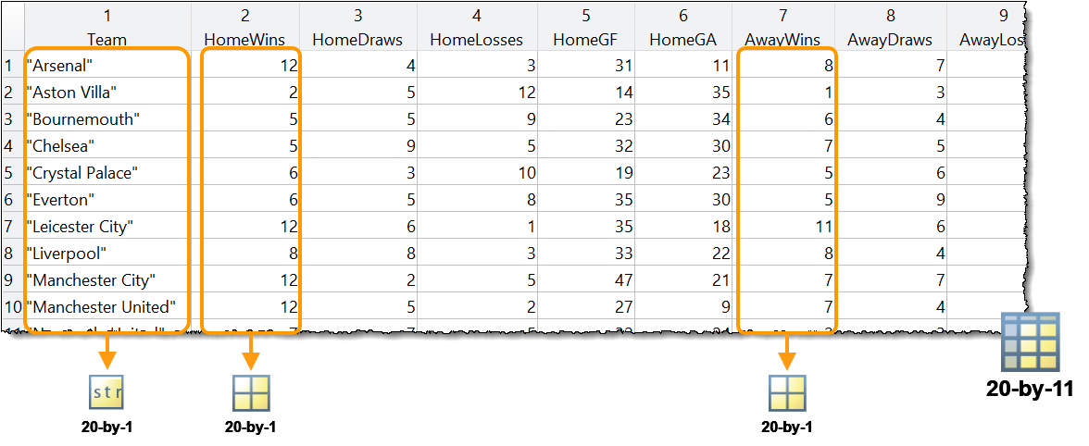

New to MATLAB?
This course assumes basic MATLAB skills. If you have never used MATLAB before or want to refresh your skills, you can take MATLAB Onramp.
MATLAB Onramp — Get started quickly with the basics of MATLAB.
Want to brush up on indexing in MATLAB?
Working with tables involves array and matrix manipulation skills, such as concatenation and indexing. You can get through this course with the array skills covered in MATLAB Onramp, but the more familiar you are with these skills, the easier you will find it to work with tables. You can learn more about array manipulation in detail by taking the course Make and Manipulate Matrices.
Make and Manipulate Matrices — Create and manipulate array data effectively using concatenation, creation functions, reshaping, and indexing.
Work with TablesIntroduction(1/2) MATLAB Data Types

2 Work with Tables

Introduction

(1/2) MATLAB Data Types
MATLAB Data Types
The different data types in MATLAB have different uses.
Each data type is intended to store data with a characteristic organization. In this course, you use the table data type to store tabular data where the rows are observations, which all have the same set of measured variables, but the different variables (columns) can be of different types.
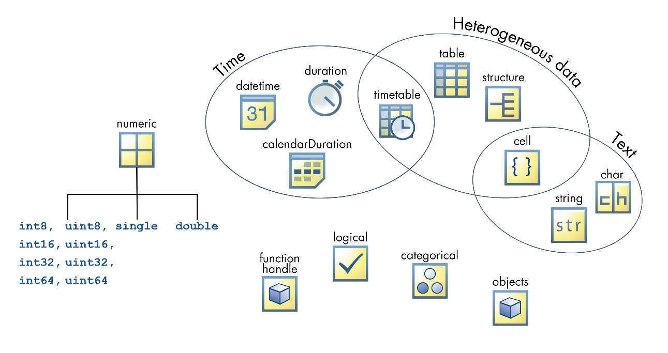

(2/2) Determine League Standings from Season Results

What can you do with a table?
As with many sports leagues, the English Premier League assigns points to teams for their results throughout the season—3 points for each win, 1 point for each draw (tie), and 0 points for any losses. The total points earned by a team determines its place in the final standings. Teams with equal points are ranked by tie-breaking criteria, such as overall goal difference. Goal difference is the number of goals for minus the number of goals against.
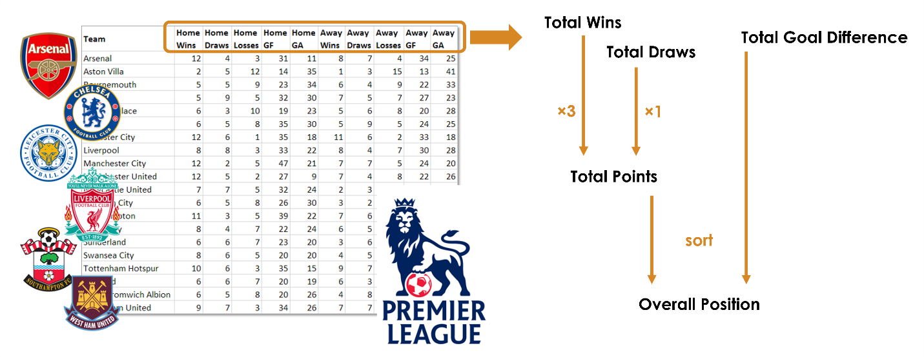
Given the table of home and away results, how do you put the teams in order of their final standings? If the table variables were stored as individual vectors, you would use array arithmetic to calculate total points, storing this information as a new vector.
totalwins = homewins + awaywins
totaldraws = homedraws + awaydraws
totalpoints = 3*totalwins + totaldraws
You would then need to sort the total points vector and use that ordering to sort all the other vectors accordingly.
With tables, you can add new information (such as total points) to the table and sort all the data together.
In this module, you learn how to perform common table operations such as extracting data, performing calculations, adding new variables, and sorting.

Store Data in a Table

(1/3) Introduction
How do you import data as a table?
If you have tabular data in a spreadsheet or text file, how can you read it into a table in MATLAB?
Team Home Wins Home Draws Away Wins Away Draws
Arsenal 12 4 8 7
Chelsea 5 9 7 5
Leicester City 12 6 11 6
Manchester United 12 5 7 4
You can use the Import Tool, and select the Table option.
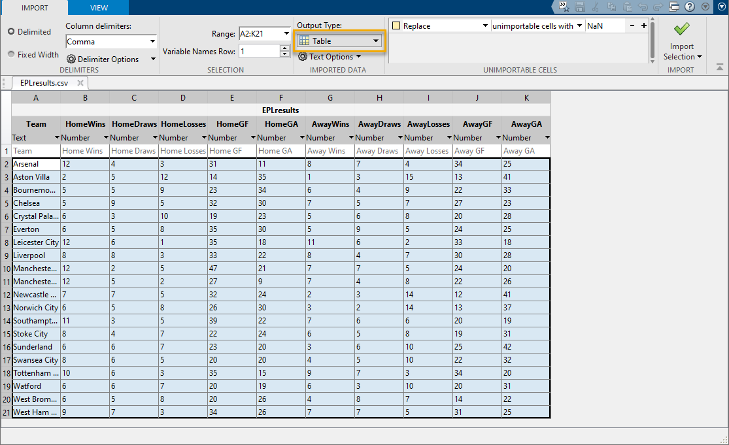
Alternatively, you can import the data programmatically using the readtable function.
>>
EPL = readtable("EPLresults.csv")
EPL | MATLAB table that contains the imported data
Outputs

"EPLresults.csv" | Name of the file to import, entered as text
Inputs

readtable
Import a spreadsheet or delimited text file into MATLAB

(2/3) Import Table Data
English Premier League Data
The English Premier League is a professional men's association football (soccer) league in England and Wales. The file EPLresults.csv contains English Premier League data from the 2015–16 season.

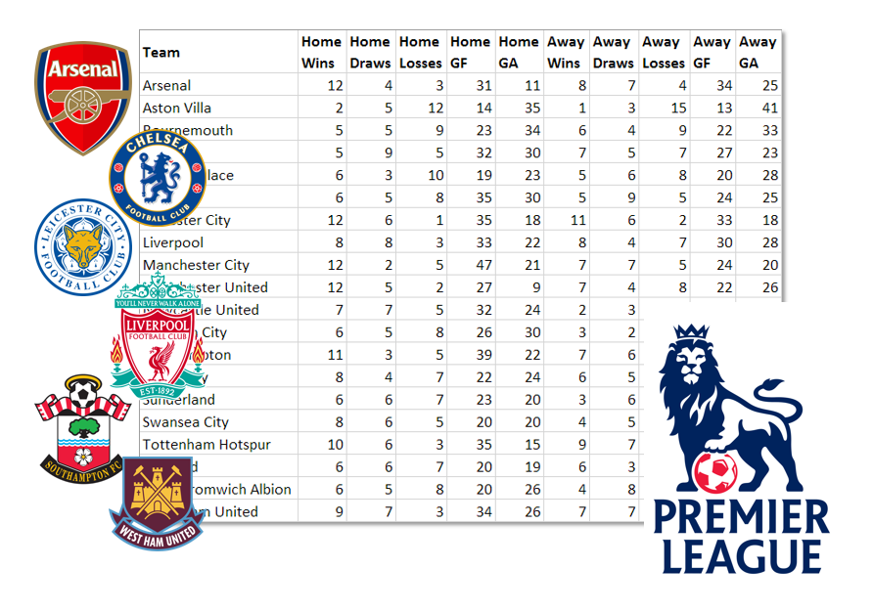

Each row, which is a mix of numeric and text data, contains the season's data for one team.

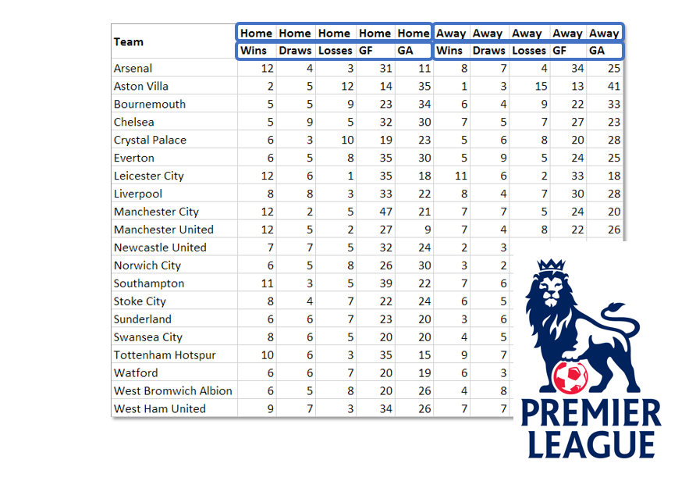
Labeled columns contain the teams' records for the season: wins, draws, losses, goals for, and goals against, in home and away games.

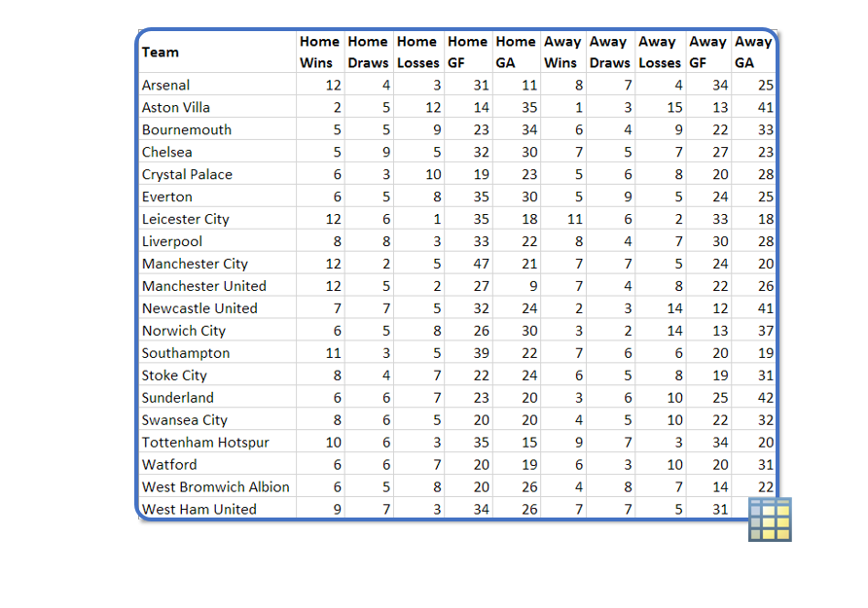

When working with the English Premier League data, you want to keep the team names together with the labeled, numeric statistics about each team. Importing data as a table keeps this mixed, labeled data together in a single variable.

Import Table Data
Instructions are in the task pane to the left. Complete and submit each task one at a time.

Task 1
EPL = readtable("EPLresults.csv")

Task 2
EPL = readtable("EPLresults.csv", TextType="string")

Task 3
summary(EPL)

Sort Table Data

You can organize your workspace variables into a table by using the table function. For example, this code creates the table tbl with variables a, b, and c.
tbl = table(a,b,c)

Task
Create a table named teamWins with variables team and w.

You can convert a matrix to a table by using the array2table function. For example, this code creates a table named tbl from the matrix A.
tbl = array2table(A)

Task
Convert the matrix WDL to a table named stats.

To create custom variable names in the converted table, specify the VariableNames name-value argument as a string array of the variable names you want.
For instance, this code creates a table named tbl with custom variable names X and Y.
tbl = array2table(A, ...
VariableNames=["X" "Y"])

Task
Create a table named stats from the matrix WDL using custom variable names Wins, Draws, and Losses.

Did you know that table output in a live script is interactive? Leave off the semicolon to display teamWins in the output panel. Then try clicking the drop-down arrow next to the variable name w.
Remember that you can execute your script by clicking the Run or Run Section button in the MATLAB Toolstrip.
When you're finished practicing, you can move on to the next section.

How do you sort rows of a table?
When you import the 2015–2016 English Premier League data, the teams are ordered as they were in the spreadsheet, which in this case is alphabetical. If you sort by the number of wins, you can get a general idea of how each team performed.
Team | HomeWins | HomeDraws | AwayWins | AwayDraws
Arsenal | 12 | 4 | 8 | 7
Aston Villa | 2 | 5 | 1 | 3
Bournemouth | 5 | 5 | 6 | 4
Chelsea | 5 | 9 | 7 | 5
Crystal Palace | 6 | 3 | 5 | 6
Everton | 6 | 5 | 5 | 9
Leicester City | 12 | 6 | 11 | 6

Background
Task
Read the file EPLresults.csv into a table named EPL. Set TextType to "string".

You can sort a table by a specific variable using the sortrows function.
tblSort = sortrows(tbl,"VarName")
By default, the rows are sorted by that variable in ascending order.
Task
Create a variable named winners that contains the EPL table sorted by HomeWins, from least to greatest.

To put the top teams at the top of the table, you need to sort in descending order.
You can use the "descend" option to sort in descending order.
tblSort = sortrows(tbl, ...
"VarName","descend")
Task
Now, create the variable winners so that it contains the EPL table sorted by HomeWins with the greatest number of wins at the top of the table.

To sort by two or more variables, specify the variable names in order as a string array in the sortrows function call.
tblSort = sortrows(tbl, ...
["VarName1" "VarName2"],"descend")
Task
Now create winners so that it contains the EPL table sorted by HomeWins first, then AwayWins, with the greatest number of wins at the top of the table.

Now Leicester City is at the top. However, the ordering still doesn't differentiate between Manchester City and Manchester United, which have the same numbers of home and away wins.
Try adding additional sorting variables: HomeDraws and AwayDraws.

How are ties ordered?
HomeWins doesn't differentiate between the top four teams. After being sorted by HomeWins, the table shows these four teams in the same order as in the original table.
Team | HomeWins | HomeDraws | AwayWins | AwayDraws
Arsenal | 12 | 4 | 8 | 7
Leicester City | 12 | 6 | 11 | 6
Manchester City | 12 | 2 | 7 | 7
Manchester United | 12 | 5 | 7 | 4
Southhampton | 11 | 3 | 7 | 6
Tottenham Hotspur | 10 | 6 | 9 | 7
West Ham United | 9 | 7 | 7 | 7
To order these teams by the total number of wins, you can specify AwayWins as the secondary variable to sort by.

Sort Data by Variable Values
Instructions are in the task pane to the left. Complete and submit each task one at a time.

Task 1
EPL = readtable("EPLresults.csv", "TextType","String")

Task 2
winners = sortrows(EPL,"HomeWins")

Task 3

winners = sortrows(EPL,"HomeWins", "descend")

Task 4

winners = sortrows(EPL,["HomeWins" "AwayWins"], "descend")

Further Practice

winners = sortrows(EPL,["HomeWins" "AwayWins" "AwayDraws"], "descend")

Extract Portions of a Table
How do you extract portions of a table?
Some tables contain more data than you need for your particular analysis. To extract a smaller portion of your data, you can index into a table using standard array indexing with parentheses. As with array indexing, the result is the same data type. In this case, you get another table with each variable (column) having the same data type as it did in the original table.

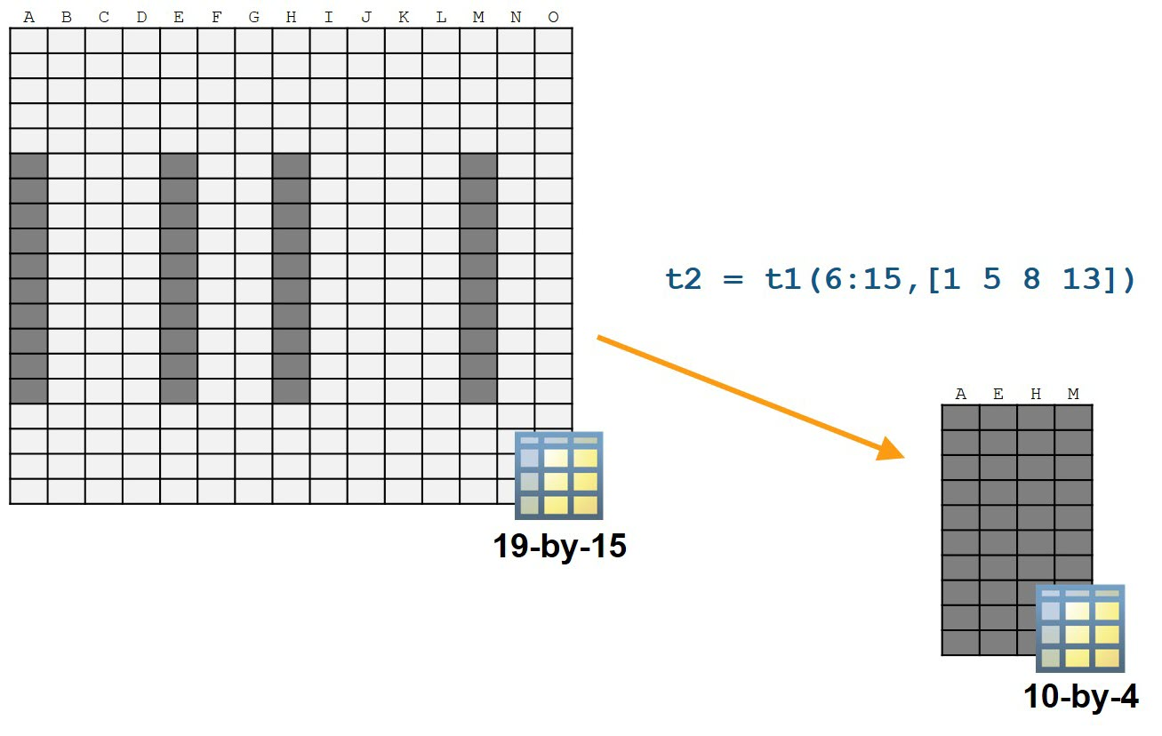

How do you extract variables containing the number of wins?
In the table of team records, not all of the variables are necessary to calculate the total wins—only the variables with the numbers of home and away wins.
Team | Home Wins | Home Draws | Home Losses | Home GF | Home GA | Away Wins | Away Draws | Away Losses | Away GF | Away GA
Leicester City | 12 | 6 | 1 | 35 | 18 | 11 | 6 | 2 | 33 | 18
Arsenal | 12 | 4 | 3 | 31 | 11 | 8 | 7 | 4 | 34 | 25
Manchester City | 12 | 2 | 5 | 47 | 21 | 7 | 7 | 5 | 24 | 20
Manchester United | 12 | 5 | 2 | 27 | 9 | 7 | 4 | 8 | 22 | 26
Southampton | 11 | 3 | 5 | 39 | 22 | 7 | 6 | 6 | 20 | 19
Tottenham Hotspur | 10 | 6 | 3 | 35 | 15 | 9 | 7 | 3 | 34 | 20
West Ham United | 9 | 7 | 3 | 34 | 26 | 7 | 7 | 5 | 31 | 25
In this activity, you extract the rows with the top teams and the corresponding variables that contain the number of wins.

You can create a subset of the original table using standard array indexing with parentheses.
winningTeams = EPL(1:4,1)
winningTeams =
Team
___________________
"Leicester City"
"Arsenal"
"Manchester City"
"Manchester United"
Task
Create a variable named top6 that contains all variables in the first six rows of EPL.

The extracted table has so many variables that you may not be able to see the rightmost variables.
In the table display in the output pane, you can use the scroll bar to view variables further to the right.
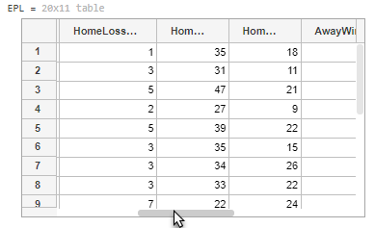
Task
Scroll through the table to figure out which variable (column) numbers correspond to the team name, home wins, and away wins.
Create a table named teamWins that contains those variables from the EPL table.

Leicester City, who had never won the Premier League, is at the top of the table sorted by wins followed by three of the founding teams.
Manchester City and Manchester United have the same number of home and away wins. To differentiate between the two rivals, you can include the home and away draws, which are in the 3rd and 8th variables.
Task
Create a table named top3founders that contains the 2nd, 3rd, and 4th rows, and the 1st, 2nd, 3rd, 7th, and 8th variables from the EPL table.

The same four teams (Arsenal, Manchester City, Manchester United, and Chelsea) dominated the Premier League for the previous two decades. But Chelsea is not visible in the preview of teamWins in the output pane.
In the table display in the output pane, you can use the scroll bar to view rows further down.
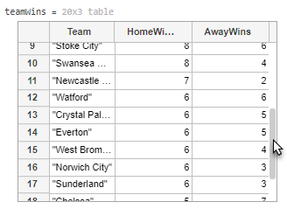
Task
Scroll down the EPL table to find the row index of Chelsea.
Create a table named compareTeams that contains the rows for Leicester City, Arsenal, Manchester City, Manchester United, and Chelsea, and the same variables as top3founders.

If the wins matter more to you than the draws, you can have the win variables appear closer to the left.
You can extract rows and variables in any order. For instance, this code extracts the first three rows of M, but the 2nd and 3rd rows are swapped.
M([1 3 2],:)
Task
Create a table named teamsWD that contains the variables for team name, home wins, away wins, home draws, and away draws (in that order) for all teams.

Once you create compareTeams and teamsWD, you can extract from either one just like you did from the EPL table.
Task
Create a table named reverseCompareTeams that has the same variables as teamsWD and the same rows as compareTeams, but in the reverse order: Chelsea, Manchester United, Manchester City, Arsenal, and Leicester City.

One way to adjust the preview to see more table variables is to make the output pane larger, which you can do by dragging the divider line between the live script and the output pane.
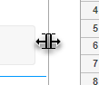

Index by Number
Instructions are in the task pane to the left. Complete and submit each task one at a time.

This code sets up the activity.
EPL = readtable("EPLresults.csv",TextType="string");
EPL = sortrows(EPL,["HomeWins" "AwayWins"],"descend")

Task 1
top6 = EPL(1:6, :)

Task 2

teamWins = EPL(:, [1, 2, 7])

Task 3
top3founders = EPL([2, 3, 4], [1,2,3,7,8])

Task 4
compareTeams = EPL([1:4, 18], [1,2,3,7,8])

Task 5
teamsWD = EPL(:, [1 2 7 3 8])

Task 6
reverseCompareTeams = EPL([18 4:-1:1],[1 2 7 3 8])

How do you extract table variables using their names?

Team | Home Wins | Away Wins | Home Draws | Away Draws
Leicester City | 12 | 11 | 6 | 6
Arsenal | 12 | 8 | 4 | 7
Manchester City | 12 | 7 | 2 | 7
Manchester United | 12 | 7 | 5 | 4
Southampton | 11 | 7 | 3 | 6
Tottenham Hotspur | 10 | 9 | 6 | 7
West Ham United | 9 | 7 | 7 | 7

In the previous activity, you created teamsWD to hold the team names and the numbers of wins and draws. The two rival Manchester teams had exactly the same numbers of wins and the same total number of draws.

Team | Home Wins | Home Draws | Home Losses | Home GF | Home GA | Away Wins | Away Draws | Away Losses | Away GF | Away GA
Leicester City | 12 | 6 | 1 | 35 | 18 | 11 | 6 | 2 | 33 | 18
Arsenal | 12 | 4 | 3 | 31 | 11 | 8 | 7 | 4 | 34 | 25
Manchester City | 12 | 2 | 5 | 47 | 21 | 7 | 7 | 5 | 24 | 20
Manchester United | 12 | 5 | 2 | 27 | 9 | 7 | 4 | 8 | 22 | 26
Southampton | 11 | 3 | 5 | 39 | 22 | 7 | 6 | 6 | 20 | 19
Tottenham Hotspur | 10 | 6 | 3 | 35 | 15 | 9 | 7 | 3 | 34 | 20
West Ham United | 9 | 7 | 3 | 34 | 26 | 7 | 7 | 5 | 31 | 25
Slide 2 of 2
In the English Premier League, ties like this are broken by goal difference, which is goals for (GF) minus goals against (GA).
When a table has lots of variables, keeping track of variable numbers can be difficult. In this activity, you learn to index using the variable names.

When indexing into a table, it's often easier to remember a variable name as opposed to figuring out the specific column number.
As an alternative to numeric indexing, you can index using the variable name in double quotes.
hmWins = EPL(:,"HomeWins")
Task
Create a table named hmGF that contains only the HomeGF variable of EPL.

It's easier to compare the home goals for if the team names are included. You can extract multiple variables by name using a string vector of variable names.
wins = EPL(:,["HomeWins" "AwayWins"])
Task
Create a table named teamHGF that contains the variables Team and HomeGF (in that order) from EPL.

You can also index into a table using a combination of numbers and names.
fhw = EPL(2:2:8,["Team" "HomeWins"])
Task
Create a table named manchester that contains the variables Team, HomeGF, and AwayGF for Manchester City and Manchester United.

It looks like Manchester City scored a lot more goals this season than Manchester United. However, the goal difference is what matters, so home and away goals against are also important for breaking this tie.
Task
Create a table named teamsGFA that contains the variables Team, HomeGF, AwayGF, HomeGA, and AwayGA for the first four teams in EPL.

In the original EPL table, all of the home data appears before all of the away data. Using the variable names for indexing can not only make extracting data easier but also make reordering easier. You may not have even noticed that you extracted the variables out of order.
Try creating teamsGFA using numeric indexing.

Index by Variable Name
Instructions are in the task pane to the left. Complete and submit each task one at a time.

This code sets up the activity.
EPL = readtable("EPLresults.csv",TextType="string");
EPL = sortrows(EPL,["HomeWins" "AwayWins"],"descend")

Task 1
hmGF = EPL(:,"HomeGF")

Task 2
teamHGF = EPL(:,["Team" "HomeGF"])

Task 3
manchester = EPL([3, 4], ["Team" "HomeGF" "AwayGF"])

Task 4
teamsGFA = EPL([1:4], ["Team", "HomeGF", "AwayGF", "HomeGA", "AwayGA"])

Quiz
(Select all that apply.) Which of the following commands create a table named ht that contains the data in the ID and Z variables from the table A?

A

ID | X | Y | Z
B1 | 0 | 4 | –8
B2 | 5 | 19 | 17
C1 | –2 | 6 | 1
C2 | 1 | 2 | 7
C3 | –12 | 5 | 0
D1 | 7 | –5 | 2
D2 | –6 | 0 | 3

Correct! The columns can be either a vector of strings containing the variable names, ["var1" "var2" "var3"], or a vector of numbers, [num1 num2 num3].

How do you access data in a table for calculations and visualizations?
Tables are a convenient way to hold your entire data set. However, to perform analysis, you will often want to extract the data from a specific variable in the table, and then pass this data to a function, such as mean.
You can index into a table using dot notation with the variable name to access the contents of a table variable.
variableData = tableName.VariableName
Accessing data using dot notation extracts the contents of the specified table variable. The result is, therefore, of the same size and type as the data in the table variable.

Display the original table. |  | EPL  EPL =  Team HW HD HL AW AD AL  ___________________ __ __ __ __ __ __  "Leicester City" 12 6 1 11 6 2  "Arsenal" 12 4 3 8 7 4  "Manchester City" 12 2 5 7 7 5  "Manchester United" 12 5 2 7 4 8  "Southampton" 11 3 5 7 6 6  "Tottenham Hotspur" 10 6 3 9 7 3  "West Ham United" 9 7 3 7 7 5
Extract the Team variable using dot notation. Because the Team variable contains text data, the result is a string array. |  | EPL.Team  ans =  7x1 string array  "Leicester City"  "Arsenal"  "Manchester City"  "Manchester United"  "Southampton"  "Tottenham Hotspur"  "West Ham United"
Because the HW variable contains numeric data (the number of home wins), the result is a numeric array. |  | EPL.HW  ans =  12  12  12  12  11  10  9

Access Data in a Table

Do most teams win more at home than away? To answer this question, access the numeric data stored in the HomeWins and AwayWins variables of the EPL table.
You can use dot notation to access the data in a table variable. It can be convenient to save the data in new variables in your workspace.
newvar = tbl.VariableName
Task
Create a numeric array named hw that contains the HomeWins variable from the EPL table.
Similarly, create another numeric array named aw that contains the AwayWins variable.

hw and aw are numeric arrays. You can now use any standard logical operators to compare them.
Task
Determine how many teams have more home wins than away wins.
- First, create a new logical variable named homeAdv that has the value true whenever hw is greater than aw.
- Then, use the nnz or sum function to create a variable named numHA that contains the number of teams with more home wins than away wins.

Almost all the teams have more wins at home than away. Which teams go against this trend?
You can combine standard array indexing and dot indexing into table variables. For example, the following syntax is equivalent to accessing the variable VariableX in the table tbl and then indexing into the first 10 elements of the result.
first10X = tbl.VariableX(1:10)
Combining the two indexing operations in this way means that you do not need to save VariableX in a separate variable in your workspace.
Task
Use both dot indexing and logical indexing to create a string array named noHAteams that contains the names of the four teams that do not have more home wins than away wins.
The names of all the EPL teams are contained in the Team variable of the table EPL. The logical variable homeAdv, created in the previous task, has the value true where teams have more home wins than away wins.

Accessing table variable data using dot notation is also useful for plotting. Try using the scatter function to create a scatter plot with the EPL table variable HomeWins on the x-axis and AwayWins on the y-axis.
scatter(EPL.HomeWins,EPL.AwayWins)
You can add a diagonal line to your plot to better see how many teams win more often away than at home.
hold on
plot([1 12],[1 12])
hold off

Access Individual Variables
Instructions are in the task pane to the left. Complete and submit each task one at a time.

This code imports a table of EPL season results by team.
EPL = readtable("EPLresults.csv",TextType="string");
EPL = sortrows(EPL,["HomeWins" "AwayWins"],"descend")

Task 1
hw = EPL.HomeWins
aw = EPL.AwayWins

Task 2
homeAdv = hw > aw
numHA = sum(homeAdv)

Task 3
noHAteams = EPL.Team(~homeAdv)

Further Practice
scatter(EPL.HomeWins,EPL.AwayWins)
hold on
plot([1 12],[1 12])
hold off

Quiz
Which of the following commands changes the Leicester City value in AwayWins to 10?
EPL

Team | HomeWins | HomeDraws | AwayWins | AwayDraws
Leicester City | 12 | 6 | 11 | 6
Arsenal | 12 | 4 | 8 | 7
Manchester City | 12 | 2 | 7 | 7
Manchester United | 12 | 5 | 7 | 4
Southampton | 11 | 3 | 7 | 6
Tottenham Hotspur | 10 | 6 | 9 | 7
West Ham United | 9 | 7 | 7 | 7

Course Quick Reference

Work with TablesAccess Data in a Table(4/6) Add New Variables to a Table
You can add a new variable to a table using dot notation.
tbl.NewVarName = newData
Task
First, create an array named totWins that contains the sum of HomeWins and AwayWins in EPL.
Then add a variable named TotalWins to EPL that contains the values in totWins.

Task
Add a variable named TotalDraws to EPL that contains the sum of HomeDraws and AwayDraws.

When you calculate a team's points, each win is worth three points and each draw is worth one point.
Task
Add a variable named Points to EPL that contains the sum of 3×TotalWins and TotalDraws.
Then sort EPL in descending order based on the values in Points.

If teams have the same number of points, like Manchester City and Manchester United, the next measure of rank is determined by goal difference. You will calculate goal difference in the next activity.

Add New Variables to a Table
Instructions are in the task pane to the left. Complete and submit each task one at a time.

This code imports a table of EPL season results by team.
EPL = readtable("EPLresults.csv",TextType="string");
EPL = sortrows(EPL,["HomeWins" "AwayWins"],"descend")

Task 1
totWins = EPL.HomeWins + EPL.AwayWins
EPL.TotalWins = totWins

Task 2
EPL.TotalDraws = EPL.HomeDraws + EPL.AwayDraws

Task 3
EPL.Points = 3*EPL.TotalWins + EPL.TotalDraws
EPL = sortrows(EPL, "Points", "Descend")

How do you extract a numeric matrix from a table?
In the table of team records, you need four numeric columns to calculate the goal difference for each team. Extracting portions of the table as a numeric matrix rather than another table allows you to perform calculations using functions intended for numeric arrays.
Team | Home Wins | Home Draws | Home Losses | Home GF | Home GA | Away Wins | Away Draws | Away Losses | Away GF | Away GA
Leicester City | 12 | 6 | 1 | 35 | 18 | 11 | 6 | 2 | 33 | 18
Arsenal | 12 | 4 | 3 | 31 | 11 | 8 | 7 | 4 | 34 | 25
Manchester City | 12 | 2 | 5 | 47 | 21 | 7 | 7 | 5 | 24 | 20
Manchester United | 12 | 5 | 2 | 27 | 9 | 7 | 4 | 8 | 22 | 26
Southampton | 11 | 3 | 5 | 39 | 22 | 7 | 6 | 6 | 20 | 19
Tottenham Hotspur | 10 | 6 | 3 | 35 | 15 | 9 | 7 | 3 | 34 | 20
West Ham United | 9 | 7 | 3 | 34 | 26 | 7 | 7 | 5 | 31 | 25
You do not need to extract four variables individually to calculate goal difference. Instead, you can extract the two "goals for" variables together and then use that matrix to calculate total goals for. You can then do the same with the two "goals against" variables. Once you have total goals for and against, you can calculate goal difference and use it as a tiebreaker for teams with the same number of points.

To access data from multiple variables at once, you can index using curly braces.
Inside the curly braces, you can specify the desired variables by index or variable name. For example, this code creates two equivalent arrays from EPL.
winsTop3 = EPL{1:3,[2 7]}
winsTop3 = EPL{1:3,["HomeWins" "AwayWins"]}
Task
Create a numeric matrix named GF that contains the data in the HomeGF and AwayGF variables of the EPL table.

The variable GF is a 20-by-2 numeric matrix. Now you can use statistical functions, like sum, that work on matrices.
To calculate the total number of goals for, find the sum of each row. Statistical functions, like mean and sum, can operate along the rows by specifying the second dimension as an additional input.
sumRows = sum(M,2)
Task
Create a 20-element column vector named totGF that contains the total number of home and away goals for.

Task
Now find the goals scored against each team.
- Create a numeric matrix named GA that contains the data in the HomeGA and AwayGA variables of the EPL table.
- Create a 20-element column vector named totGA that contains the total number of home and away goals against.

Task
Calculate the total goal difference (total goals for minus total goals against) for each team, and add this data to the EPL table as a new variable named GoalDiff.
Then sort the EPL table by Points in descending order, then by GoalDiff also in descending order.

You can also use curly braces to add multiple variables to a table. Specify the new variable names with a string array.
t{:,["Rand1" "Rand2"]} = randn(20,2);
For example, add the total goals for and against to the EPL table.
% Go back to alphabetical order
EPL = sortrows(EPL,"Team")
% Add goals for and against to table
totG = [totGF totGA] % Create a matrix
EPL{:,["TotalGF" "TotalGA"]} = totG
You can use either numeric or named indexing with curly braces.
EPL{:,[2 3 end]}
What happens if you extract variables with different data types, such as the first three variables?
EPL{:,1:3}

Access Data in Multiple Table Variables
Instructions are in the task pane to the left. Complete and submit each task one at a time.

This code imports a table of EPL season results by team and calculates their points.
EPL = readtable("EPLresults.csv",TextType="string");
EPL = sortrows(EPL,["HomeWins" "AwayWins"],"descend");
EPL.Points = 3*(EPL.HomeWins + EPL.AwayWins) + (EPL.HomeDraws + EPL.AwayDraws)

Task 1
GF = [EPL.HomeGF EPL.AwayGF]

Task 2
totGF = EPL.HomeGF + EPL.AwayGF

Task 3
GA = [EPL.HomeGA EPL.AwayGA]
totGA = EPL.HomeGA + EPL.AwayGA

Task 4
EPL.GoalDiff = totGF - totGA
EPL = sortrows(EPL,["Points" "GoalDiff"],"descend");

Further Practice

Quiz
(Select all that apply.) Which of the following commands store the HomeWins and AwayWins data for Manchester City and Manchester United from EPL in a numeric array named mw?
EPL

Team | HomeWins | HomeDraws | AwayWins | AwayDraws
Leicester City | 12 | 6 | 11 | 6
Arsenal | 12 | 4 | 8 | 7
Manchester City | 12 | 2 | 7 | 7
Manchester United | 12 | 5 | 7 | 4
Southampton | 11 | 3 | 7 | 6
Tottenham Hotspur | 10 | 6 | 9 | 7
West Ham United | 9 | 7 | 7 | 7

Course Quick Reference

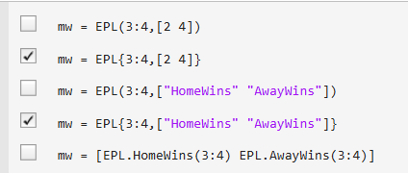
How do you export a table to a file?
Once you've formatted the data, you can use the writetable function to export the table to a delimited text file or spreadsheet. If you specify a filename, writetable uses the file extension to determine the appropriate output format.
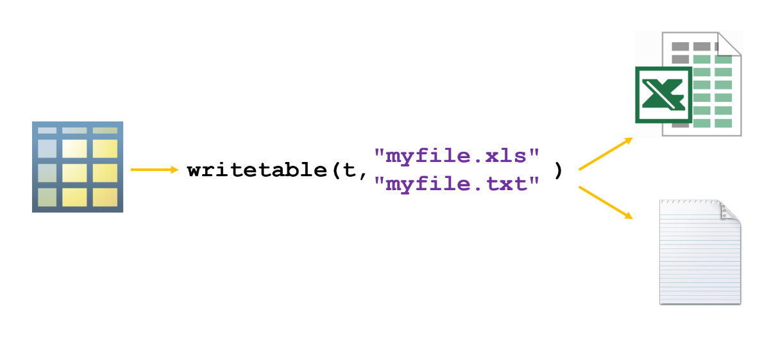
The writetable function does not return any outputs.
writetable
Export a table to a file.

You can write a table to a file by using the writetable function.
writetable(tbl,"fileName")
Task
Write the EPL table to a comma-separated values (CSV) file named EPL2015-16.csv.

You can specify a delimiter, such as tab, when creating the file.
writetable(tbl,"fileName.txt", ...
Delimiter="\t")
Task
Write the EPL table to a tab-delimited text file named EPL2015-16.txt.

You can specify a delimiter, such as tab, when creating the file.
writetable(tbl,"fileName.txt", ...
Delimiter="\t")
Task
Write the EPL table to a tab-delimited text file named EPL2015-16.txt.

Try importing your saved table using the readtable function.
t = readtable("EPL2015-16.csv", ...
TextType="string")
Export a Table to a Delimited Text File
Instructions are in the task pane to the left. Complete and submit each task one at a time.

This code sets up the activity.
load EPLtable
EPL

Task 1
writetable(EPL,"EPL2015-16.csv")

Task 2
writetable(EPL,"EPL2015-16.txt",Delimiter="\t")

Further Practice
t = readtable("EPL2015-16.csv",TextType="string")

The file tallest_bldgs.txt contains data on the world's tallest buildings as of the year 2009.
Task
Import the data in the file tallest_bldgs.txt and save it to a table named buildings. Set TextType to "string".
Leave off the semicolon to display the table in the output pane. Scroll through the table contents to familiarize yourself with the data.

Task
Add a variable named height_m to the buildings table that contains the heights of all the buildings converted to meters.
(1 ft = 0.3048 m)

Task
Sort the values in buildings in order of decreasing height.

Task
Create a table named fiveTallest that contains the data for the five tallest buildings.

Task
Write the contents of fiveTallest to a file named tallBldgs.txt.

When were the tallest buildings built? Try making a scatter plot of height vs. year from the table buildings.

World's Tallest Buildings
Instructions are in the task pane to the left. Complete and submit each task one at a time.

Task 1
buildings = readtable("tallest_bldgs.txt", TextType="string")

Task 2
buildings.height_m = buildings.height_feet*0.3048

Task 3
buildings = sortrows(buildings,"height_m", "descend")

Task 4

fiveTallest = buildings(1:5,:)

Task 5
writetable(fiveTallest,"tallBldgs.txt")

Further Practice
scatter(buildings.height_feet, buildings.year)

The file weeklyGasPrices.csv contains the average price of gasoline (petrol) in seven different countries for each week between 1996 and 2005.
Task
Create a table named gas from the file weeklyGasPrices.csv.

Task
Modify gas so that it contains just the data for 1996 and 1997 (the first 91 rows).

The first variable of gas contains the dates of the recorded gasoline prices. The remaining variables of the table each correspond to one country. The first six countries are in Europe, and the last country is the US.
Task
Add a new variable to gas named EuroAvg that contains the average European price for each week. The European countries are in variables 2 through 7.

Try creating a scatter plot by using the scatter function with the US prices on the x-axis and the average European prices on the y-axis.
You can annotate your plot to improve its readability.
xlabel("Price in the US ($US/gal)")
ylabel("Average Price in Europe ($US/gal)")
title("Weekly Gasoline Prices")
grid on

Weekly Gasoline Prices
Instructions are in the task pane to the left. Complete and submit each task one at a time.

Task 1
gas = readtable("weeklyGasPrices.csv")

Task 2
gas = gas(1:91,:)

Task 3
gas.EuroAvg = mean(gas{:,2:7},2)

Further Practice
scatter(gas.US, gas.EuroAvg)

xlabel("Price in the US ($US/gal)")
ylabel("Average Price in Europe ($US/gal)")
title("Weekly Gasoline Prices")
grid on

Summary: Work with Tables
Store Data in a Table

The readtable function creates a table in MATLAB from a data file. |  | EPL = readtable("EPLresults.csv",TextType="string");
The table function can create a table from workspace variables. |  | teamWins = table(team,wins)  teamWins =  Team Wins  ___________________ ____  "Arsenal" 20  "Chelsea" 12  "Leicester City" 23  "Manchester United" 19
The array2table function can convert a numeric array to a table. Specify the VariableNames name-value argument as a string array of variable names for the table. |  | stats = array2table(WDL, ...  VariableNames=["Wins" "Draws" "Losses"])  stats =  Wins Draws Losses  ____ _____ ______  20 11 7  12 14 12  23 12 3  19 9 10
The summary function displays summary statistics for variables in a table. |  | summary(EPL)
Sort Table Data

The sortrows function sorts the table by the specified variable in ascending order, by default. |  | EPL = sortrows(EPL,"HomeWins");
Use the optional "descend" parameter to sort the table in descending order. |  | EPL = sortrows(EPL,"HomeWins","descend");
You can also sort by multiple variables, in order, by specifying a string array of variable names. |  | EPL = sortrows(EPL,["HomeWins" "AwayWins"],"descend");
Extract Portions of a Table

Display the original table. |  | EPL  EPL =  Team HW HD HL AW AD AL  ___________________ __ __ __ __ __ __  "Leicester City" 12 6 1 11 6 2  "Arsenal" 12 4 3 8 7 4  "Manchester City" 12 2 5 7 7 5  "Manchester United" 12 5 2 7 4 8  "Southampton" 11 3 5 7 6 6  "Tottenham Hotspur" 10 6 3 9 7 3  "West Ham United" 9 7 3 7 7 5
To extract a portion of the table, index into it by using parentheses and the table row and variable numbers. |  | EPL(2:4,[1 2 5])  ans =  Team HW AW  ___________________ __ __  "Arsenal" 12 8  "Manchester City" 12 7  "Manchester United" 12 7
You can also index using the variable names. To reference more than one variable, use a string array containing the variable names. |  | EPL(2:4,["Team" "HW" "AW"])  ans =  Team HW AW  ___________________ __ __  "Arsenal" 12 8  "Manchester City" 12 7  "Manchester United" 12 7
Access Data in a Table

Display the original table. |  | EPL  EPL =  Team HW HD HL AW AD AL  ___________________ __ __ __ __ __ __  "Leicester City" 12 6 1 11 6 2  "Arsenal" 12 4 3 8 7 4  "Manchester City" 12 2 5 7 7 5  "Manchester United" 12 5 2 7 4 8
You can use dot notation to access data for use in calculations or plotting. |  | tw = EPL.HW + EPL.AW  tw =  23  20  19  19
You can also use dot notation to create new variables in a table. |  | EPL.TW = EPL.HW + EPL.AW  EPL =  Team HW HD HL AW AD AL TW  ___________________ __ __ __ __ __ __ __  "Leicester City" 12 6 1 11 6 2 23  "Arsenal" 12 4 3 8 7 4 20  "Manchester City" 12 2 5 7 7 5 19  "Manchester United" 12 5 2 7 4 8 19
To extract multiple variables, index using curly braces. |  | draws = EPL{:,["HD" "AD"]}  draws =  6 6  4 7  2 7  5 4
Specify row indices to extract specific rows. |  | draws13 = EPL{[1 3],["HD" "AD"]}  draws13 =  6 6  2 7
Export Tables
You can use the writetable function to create a file that contains the table data.
writetable(tableName,"myFile.txt",Delimiter="\t")
The file format is based on the specified file extension, such as .txt, .csv, or .xlsx. For delimited text files, you can also specify a delimiter.

How do you best organize tabular data?
Data sets can contain many different kinds of information, and the information can come from multiple sources.
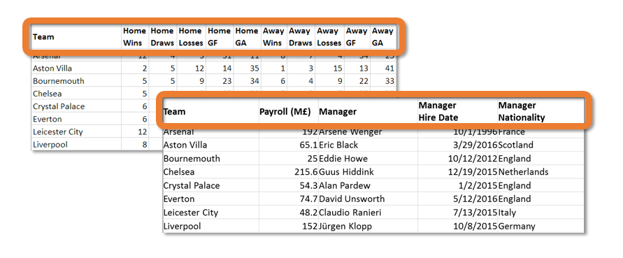
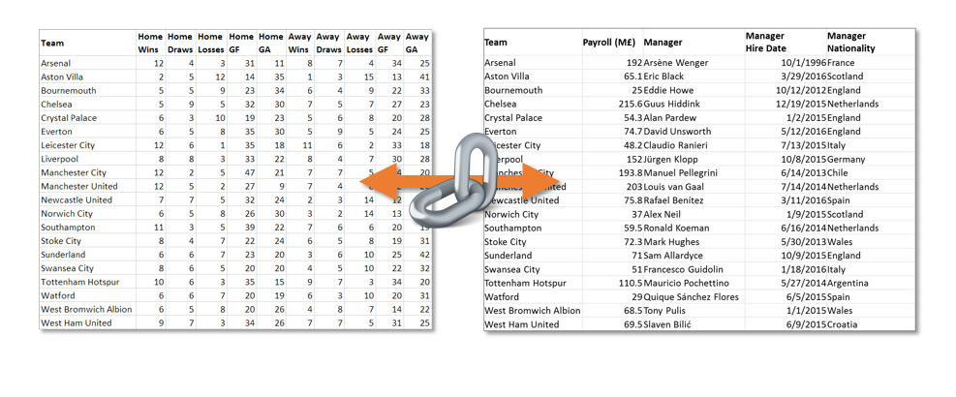
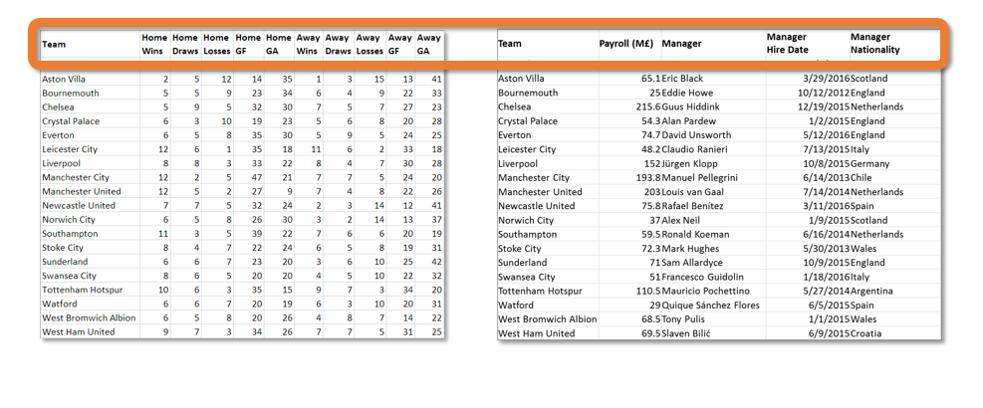
Slide 3 of 3
This information is best stored in MATLAB as a table. How can you merge these two tables to form one complete data set?
How can you modify the metadata, like table variable names?
In this module, you learn how to merge and organize your tabular data.

Manage Tables of Data

Combine tables
The table EPL contains information about the results for each team in the 2015–16 season. The table teamInfo contains additional team information, such as the team payroll and the manager.
To answer a question such as "do teams perform better if they spend more?", first combine the information from both tables.
You can merge data from two tables by using the join function. Rows are matched up using key variables, which are, by default, variables that have the same name in both tables.
newTable = join(table1,table2)
join retains all the variables from the first table and adds the non-key variables from the second table.
Task
Add the data in teamInfo to the data in EPL. (That is, join EPL and teamInfo and assign the result back to EPL.)
The EPL table now contains both the variable Points, which gives a measure of team performance, and the variable Payroll_M__, which gives a measure of team spending.
You can plot table data using the scatter function. For example, this code creates a scatter plot where the x and y data are variables in a table.
scatter(tbl.XVarName,tbl.YVarName)
Task
Create a scatter plot of Payroll_M__ on the x-axis and Points on the y-axis.
Another table in the workspace, managers, contains more information about the team managers. What happens if you try to add that information to EPL?
EPL = join(EPL,managers)
Both tables contain the same set of manager names, but the two tables use different variable names for this common data (EPL.Manager and managers.Name). As a result, MATLAB doesn't know which variables to use to perform the join. In this case, you can specify the key variables using name-value arguments.
EPL = join(EPL,managers, ...
LeftKeys="Manager",RightKeys="Name")
Join Tables
Instructions are in the task pane to the left. Complete and submit each task one at a time.

This code loads and displays tables of English Premier League data.
load EPLData.mat
EPL
teamInfo

Task 1
EPL = join(EPL, teamInfo)

Task 2
scatter(EPL.Payroll_M__, EPL.Points)
managers

Further Practice
EPL = join(EPL,managers, ...
LeftKeys="Manager",RightKeys="Name")

Manage Tables of DataModify Variable Names, Types, and Locations(1/3) Manage Variables in a Table

When you import a table of data from a spreadsheet or delimited text file, MATLAB uses the headers as the table variable names. To make valid variable names, MATLAB removes any spaces and replaces other non-alphanumeric characters with the underscore character.
In the English Premier League data, one of the table headers was "Payroll (M£)". When you import the data, the resulting table variable name is Payroll_M__.
You can rename table variables by using the renamevars function.
tbl = renamevars(tbl,"CurrentName","NewName")
Task
Rename the Payroll_M__ variable of EPL to Payroll.

MATLAB can store text data in tables as either cell arrays of character vectors—{'Hello';'world!'}—or string arrays—["Hello";"world!"].
String arrays are often more efficient for working with text data. Either way, it's usually preferable to have all text data use the same data type. Currently, the EPL table has a mixture.
You can convert the data type of table variables by using the convertvars function.
tbl = convertvars(tbl,"VarName","datatype")
Task
Convert the Manager variable of EPL to a string array (specified as a data type of "string").

Rather than manually specify variables to convert, you can convert all variables that fit a criterion (such as being numeric). To do this, specify a function that returns a value of true when applied to the variables you want to convert (and returns false otherwise). Typically, the "is" functions, such as isnumeric, isstring, and iscellstr, are useful.
For example, this code converts all numeric variables of tbl to double.
tbl = convertvars(tbl,@isnumeric,"double")
The function isnumeric is specified as a function handle by prepending the @ symbol to the function name. Use a function handle to pass a function to another function in MATLAB.
Task
Convert all EPL variables that are cell arrays of text to string arrays. The iscellstr function identifies cell arrays of text.
You can also convert individual variables by overwriting them.
tbl.textvar = string(tbl.textvar)
This syntax is useful when the conversion requires more than calling the appropriate conversion function. For example, the ManagerHireDate variable of EPL is currently text, but datetime values would make more sense. However, the variable is not in a format immediately recognized by the datetime function.
EPL = convertvars(EPL, ...
"ManagerHireDate","datetime") % error!
So, you can manually overwrite the variable using the datetime function with extra inputs.
tbl.datevar = datetime(tbl.datevar, ...
InputFormat="dd-MM-yyyy", ...
Locale="en_GB")
Task
Convert the ManagerHireDate variable of EPL to a datetime variable. Specify InputFormat as "dd MMM yyyy" and Locale as "en_GB".

Because you can refer to table variables by name, the variables can be in any order. You can rearrange the variables to organize your table according to your preference.
You can move table variables by using the movevars function.
tbl = movevars(tbl,"VarName")
movevars moves the specified variables to the end (right side) of the table.
Task
Move the Payroll variable to the end of the EPL table.
You can move a variable to a specific location relative to other variables.
tbl = movevars(tbl,"VarName", ...
Before="OtherVarName")
Task
Move the GoalDifference variable of EPL after Losses.

Although the manager nationality and continent variables currently contain strings, they represent finite sets of possibilities. As such, a better choice of data type is categorical. For example, you can visualize the distribution of nationalities.
You can use a string array of variable names to specify multiple variable names to rename, convert, or move.
EPL = convertvars(EPL, ...
["ManagerNationality" "Continent"], ...
"categorical")
donutchart(EPL.ManagerNationality)

Manage Variables in a Table
Instructions are in the task pane to the left. Complete and submit each task one at a time.

This code loads a table of English Premier League team results and information.
load EPLData
EPL

Task 1
EPL = renamevars(EPL,"Payroll_M__","Payroll")

Task 2
EPL = convertvars(EPL,"Manager","string")

Task 3
EPL = convertvars(EPL,@iscellstr,"string")

Task 4
EPL.ManagerHireDate = datetime(EPL.ManagerHireDate,InputFormat="dd MMM yyyy",Locale="en_GB")

Task 5
EPL = movevars(EPL,"Payroll")

Task 6
EPL = movevars(EPL,"GoalDifference", After ="Losses")

Further Practice
EPL = convertvars(EPL, ...
["ManagerNationality" "Continent"], ...
"categorical")
donutchart(EPL.ManagerNationality)

Export Tables

Projects

Summary

Manage Tables of Data

Manage Tables of DataModify Variable Names, Types, and Locations(2/3) Table Properties

Identify Variables by Name Patterns
Tables allow you to access variables by name, rather than position. This capability makes your code more readable and more robust—if the table is rearranged, your code still refers to the intended variable.
However, referring to a large number of variables by name can be tedious. In many cases, variable names follow predictable patterns that you can use to find variables, rather than list them manually. For example, the Premier League results data has the same variables for home and away results, such as HomeWins, AwayWins, HomeLosses, AwayLosses, and so on.
Regardless of how the variables in the EPL table are ordered, to calculate the overall results, you need to extract all the home results and all the away results and then add these two sets of data together.
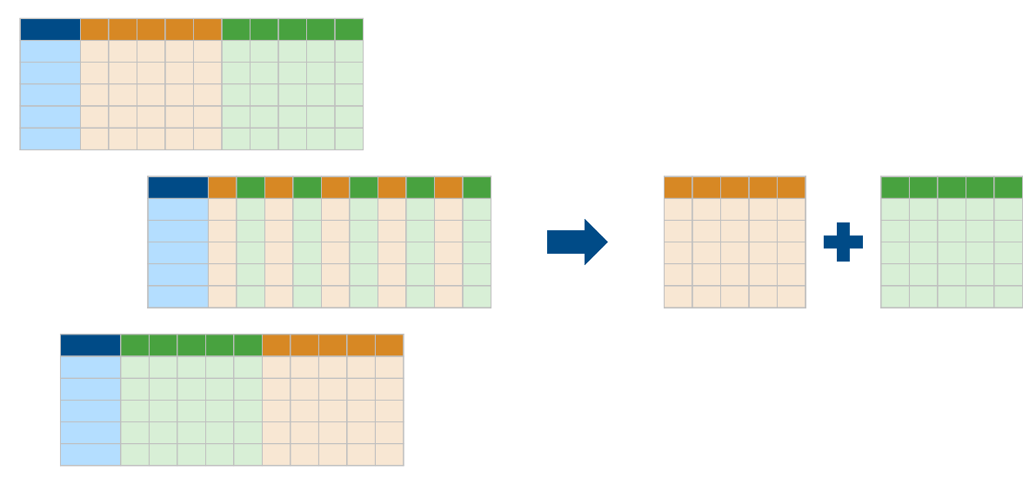
Given the pattern of the variable names, how can you extract the data for all the variables with names starting with "Home" or "Away"?
- First, get the variable names from the table.
- Then, use that information to identify the variables to extract.
- Finally, index into the table to extract the data you want.

Background
A table also stores metadata, such as the names and units of the variables, in a property named Properties.
You can use dot notation to access this information.
tableName.Properties
Task
Use dot notation to extract Properties of EPL into a new variable named props.

The variable props contains several properties of the table, such as VariableNames and VariableUnits. You can use dot notation again to access any individual property.
props = tbl.Properties
props.VariableNames
You can also access an individual property directly by combining both dot-notation operations.
tbl.Properties.VariableNames
Task
Extract the variable names of the EPL table into a new variable named vnames.

MATLAB stores the variable names as a cell array of character vectors, which is one of two standard ways to store arrays of text. The other way is as a string array.
MATLAB provides many functions for matching patterns within text. These functions all accept either form of text arrays. For example:
contains(textarray,"Hello world")
The functions contains, startsWith, and endsWith return a logical array the same size as the input text array. The result has the value true for each element of the text array that contains, starts with, or ends with the specified text.
Task
Create a logical array named ishomestat that has the value true where the variable names (vnames) start with "Home".

Remember that you can use curly braces to extract data from multiple table variables into an array.
M = tbl{rows,vars}
You can use any form of indexing for the variables: numeric, named, or logical.
Task
Use the logical array ishomestat to extract the data from all the "Home" variables of EPL into a matrix named homestats.

Task
Repeat the process for the "Away" variables.
- Create a logical array isawaystat to identify the variables with names starting with "Away".
- Index into EPL to extract the away data into a matrix named awaystats.

Task
Create a matrix named totalstats that is the sum of homestats and awaystats.

You now have a matrix totalstats, but you can put this data back into tabular form, either as a separate table or added to the existing EPL table.
When you create a table from a matrix, you can specify variable names. In this case, the variable names follow the same pattern as the home and away variable names. You can therefore use text manipulation to create the variable names rather than list them manually:
- Extract the variable names that start with "Home".
- Make new variable names by changing "Home" to "Total".
Task
Use the logical array ishomestat to save the variable names in vnames that start with "Home" as a new text array named hnames.

You can replace all instances of one text pattern with another by using the replace function.
newtxt = replace(oldtxt, ...
"text to replace","replacement text")
Task
Replace all instances of "Home" in the text array hnames with "Total". Assign the result to a variable named tnames.

You know you can access the data in multiple variables by indexing with curly braces. You can also assign data this way.
vars = ["Var1" "Var2"]
tbl{:,vars} = matrixOfData
Remember that if you assign values to elements of an array that do not currently exist, MATLAB expands the array as necessary. You have also seen this behavior with tables.
tbl.NewVariable = data
You can combine all these concepts to assign data to multiple new table variables.
newvars = ["NewVar1" "NewVar2"]
tbl{:,newvars} = matrixOfData
Task
Use curly brace indexing to assign the data in totalstats to new variables of EPL with variable names specified by tnames.

The text functions described in this example work with text in the form of a cell array of character vectors or a string array. However, some text operations work best with string arrays. You can use the string function to convert any text array to a string array.
myText = string(myText)
With strings, you can use string concatenation (+) to append the same string to every element of a string array.
vnames = string(EPL.Properties.VariableNames)
EPL.Properties.VariableNames = vnames + "_2015"

Table Properties
Instructions are in the task pane to the left. Complete and submit each task one at a time.

This code loads and displays a table of English Premier League team results.
load EPLResults.mat
EPL

Task 1
props = EPL.Properties

Task 2
vnames = EPL.Properties.VariableNames

Task 3
ishomestat = startsWith(vnames, "Home")

Task 4
homestats = EPL{:,ishomestat}

Task 5
isawaystat = startsWith(vnames, "Away")
awaystats = EPL{:,isawaystat}

Task 6
totalstats = homestats + awaystats

Task 7
hnames = vnames(ishomestat)

Task 8

tnames = replace(hnames, "Home", "Total")

Task 9

EPL{:,tnames} = totalstats

Further Practice

vnames = string(EPL.Properties.VariableNames)
EPL.Properties.VariableNames = vnames + "_2015"

Manage Tables of DataModify Variable Names, Types, and Locations(3/3) Remove Table Variables

Having created new variables to represent total wins, draws, losses, and so on, you might decide you do not need the separate home and away statistics anymore. Although a table can have any number of variables, a smaller table can be easier to manage.
You can remove variables from a table by using the removevars function to.
tblSmaller = removevars(tbl,"varname")
Task
Remove the HomeDraws variable from the EPL table.

Rather than remove variables by name manually, you can remove all variables with names that start with "Home" or "Away".
As with many variable-management functions, you can specify a single variable or multiple variables by name, number, or logical condition.
tblSmaller = removevars(tbl,["var1" "var2"])
Remember that you can use table properties to extract an array of the variable names and then use text-processing functions to identify variable names based on a pattern. The functions contains, startsWith, and endsWith can all take multiple patterns to match (and return a value of true whenever the text matches any of the patterns).
v = tbl.Properties.VariableNames
idx = contains(v,["text1" "text2"])
Task
Create a logical array named nottotal that represents whether the variable names of EPL start with either "Home" or "Away".

Task
Remove all the variables from EPL with names that start with "Home" or "Away".

As with elements of matrices, you can remove table variables by assigning the empty array ([]).
EPL.TotalGoalDiff = EPL.TotalGF - EPL.TotalGA;
EPL.TotalGF = [];
EPL.TotalGA = []

Remove Table Variables
Instructions are in the task pane to the left. Complete and submit each task one at a time.

This code loads and displays a table of English Premier League team results.
load EPLResultsTotalled.mat
EPL

Task 1
EPL = removevars(EPL,"HomeDraws")

Task 2
nottotal = contains(EPL.Properties.VariableNames,["Home" "Away"])

Task 3
EPL = removevars(EPL, nottotal)

Further Practice
EPL.TotalGoalDiff = EPL.TotalGF - EPL.TotalGA;
EPL.TotalGF = [];
EPL.TotalGA = []

The file tallest_bldgs.txt contains data on the world's tallest buildings as of 2009. The file new_bldgs.txt has the same information for buildings constructed after 2009. The data sets have been imported and concatenated, with the result stored in the table buildings.
Task
Change the name of the Height_feet_ variable of buildings to HeightFeet.

The original files of building heights were sorted by height. However, having appended the two data sets, the combined data is no longer in sorted order.
Task
Sort the values in buildings in order of decreasing height.

The table namesYears contains building names and their year of completion. Both buildings and namesYears contain a common variable BuildingName that uniquely identifies the buildings.
Task
Combine the data in buildings with the construction year information in namesYears. Assign the result back to buildings.

The cities in the buildings table form a finite set, some of which appear multiple times in the data. You can represent this information as a categorical variable.
Task
Convert the City variable of buildings to be of type "categorical".

Having the cities as a categorical variable enables you to perform analyses, such as visualizing the distribution of building locations.
donutchart(buildings.City)
You can even perform calculations by city, such as finding the height of the tallest building in each city.
groupsummary(buildings,"City", ...
"max","HeightFeet")

Manage Tables of DataProject

Conclusion

Summary: Manage Tables of Data
Combine Tables
You can combine two tables by merging them with a join. In a join, rows with matching values in common variables are merged.
The join function combines tables with a common variable. |  | top3 = join(uswntTop3,posTop3)  top3 =  Player Goals Position  ___________________ ______ ___________________  "Alex Morgan" 6 "forward"  "Megan Rapinoe" 6 "forward"  "Rose Lavelle" 3 "midfielder"
Table Properties

Display the table properties. |  | EPL.Properties  ans =  Table Properties with properties:  Description: ''  UserData: []  DimensionNames: {'Row' 'Variable'}  VariableNames: {1×11 cell}  VariableDescriptions: {1×11 cell}  VariableUnits: {}  VariableContinuity: []  RowNames: {}  CustomProperties: No custom properties are set.
You can access an individual property of Properties using dot notation. |  | EPL.Properties.VariableNames  ans =  1×11 cell array  Columns 1 through 4  {'Team'} {'HomeWins'} {'HomeDraws'} {'HomeLosses'}  Columns 5 through 8  {'HomeGF'} {'HomeGA'} {'AwayWins'} {'AwayDraws'}  Columns 9 through 11  {'AwayLosses'} {'AwayGF'} {'AwayGA'}
Manage Table Variables

convertvars
Convert variables to specified data type.
renamevars
Rename variables.
movevars
Reorder variables.
removevars
Remove variables.
You can use text functions, such as contains, startsWith, endsWith, and replace, to identify and modify variables based on patterns in variable names. For more information about text functions, see Search and Replace Text in the documentation.

Next Steps
Congratulations! You can now work with tabular data using the MATLAB table data type.
Go to My Courses to print or share a certificate and explore other available courses.
Note: Submitting the survey at the end of the course is required for 100% completion.

Documentation
Detailed reference for working with tables, including examples

Related Topics
A Tour of MATLAB Data Types
Familiarize yourself with the various data types in MATLAB and choose the right one for your application.

Managing Time-stamped Tabular Data with Timetable
If you have tabular data with timestamps, the timetable data type may be a good way for you to store your data.

Further Training
 | Self-Paced Online Courses — Learn MATLAB interactively and at your own pace. |  | Instructor-Led Courses — Take an in-person class from an experienced MATLAB instructor.

