Cooperative Caching Using Game Theory
  - Design implementation and evaluation of selective edge caching
Project report
Prepared by Vidhur Vaibhav
Registration number [Enter registration number]
Department [Enter department]
Institution [Enter institution]
Supervisor [Enter supervisor name]
October 2026

Report overview
This report documents a Python-based edge-caching simulator, a simplified game-inspired retrieval policy, a Random Forest extension, and an HTTP proof of concept. The results chapter uses the supplied 120-run Wikimedia-informed experiment. It explains both the gains relative to unconditional sharing and the latency advantage of independent caching for the evaluated small-object workload.
The experiments use real article popularity counts with generated request sequences and partially estimated article sizes. They are not measurements of Wikipedia’s production cache infrastructure or a replay of chronological user requests. Institutional certificate and declaration pages should be supplied using the approved college forms.

Abstract
Edge caching can reduce repeated access to an origin server by storing content near users. Sharing cached content between nearby edges can further reduce origin traffic, but locating and retrieving a peer copy introduces coordination and transfer costs. This project investigates whether selective cooperation improves the trade-off between cache hit rate, delivery latency, payload traffic, and origin access. A reproducible Python simulator represents users, edge servers, regional points of presence, and an origin. Four strategies are compared: independent caching, always-cooperative caching, a game-inspired payoff policy, and an ML-cooperative extension based on a Random Forest popularity predictor.
The evaluation contains 120 runs covering three peer-link conditions, four strategies, and ten random seeds, with 1,000 demands per run. The supplied catalog contains 20 Wikipedia articles and aggregate popularity counts. Requests are sampled from these counts. Eleven article-size entries match the downloader’s average-size fallback; consequently, size provenance is treated as a limitation rather than assumed to be entirely measured. Demand, peer-query, and synchronous prefetch costs are accounted for explicitly. The ML evaluation clock continues after training to keep recency features temporally consistent.
The selective policy reduces latency relative to always-cooperative sharing by a mean paired 1.98% under fast links, 48.32% under slow links, and 40.73% under mixed links. Nevertheless, independent caching has the lowest mean latency in all three conditions: 83.73 ms, compared with 84.37, 110.40, and 100.38 ms for the selective policy. Cooperation reduces origin accesses and payload traffic, demonstrating a multi-objective trade-off rather than universal superiority. The ML extension does not improve average latency over the selective policy in the tested workload. The contribution is a transparent implementation and comparative evaluation that identifies when cooperation costs outweigh retrieval benefits. No claim of global optimality, formal incentive compatibility, or production-network performance is made.
Keywords: edge caching; cooperative caching; payoff-based retrieval; Random Forest; Wikimedia; coordination overhead; reproducible simulation.

Contents and navigation
1 Introduction 4–5
2 Literature Review 6–9
3 Methodology 10–23
4 Results and Discussion 24–32
5 Conclusion 33
6 References 34–36

Figures
1 System architecture
2 Demand-processing flow
3 ML training and evaluation workflow
4 Peer retrieval sequence
5 Mean latency by scenario
6 Cache hit rate by scenario
7 Payload traffic by scenario
8 Total origin accesses by scenario
9 Peer coordination overhead
10 Per-seed latency comparison
Numbered tables describe objectives, related work, topology, the supplied catalog, strategies, payoffs, corrections, software modules, experimental settings, metrics, and measured outcomes. NC denotes non-cooperative caching, AC always-cooperative caching, SP the selective payoff policy, and ML the ML-cooperative extension.

1 Introduction

1.1 Motivation and problem statement
A cache stores a reusable copy of content so that a later request can avoid a more expensive retrieval path. In an edge network, the first useful location is the server directly connected to a user. A local miss does not necessarily imply that the origin is the only possible source: another edge in the same region may already hold the content. This creates an opportunity to share storage across several nodes, but also creates a decision problem. The nearest available copy in a logical topology is not guaranteed to be the fastest source once lookup and coordination are included.
Consider a small article that would take little time to transmit from the origin. A peer may offer a lower propagation delay, yet the requesting edge may first need to ask whether the article is cached. An unsuccessful query adds delay and still leaves the origin transfer necessary. With several peers, repeated misses can dominate the request cost. In contrast, a large object may justify coordination because avoiding a slower long-distance data transfer saves substantial time. A useful policy must therefore be evaluated under the object sizes and network conditions it actually encounters.
The problem addressed here is how to compare independent, unconditional, selective, and predictive caching fairly while charging the work each strategy performs. The project asks whether a simplified payoff-based route choice avoids expensive peer transfers without discarding the traffic-saving benefit of cooperation. It also asks whether a popularity predictor improves cache placement enough to justify its prefetching behavior. These questions are experimental; the project does not assume that either game-inspired selection or ML must win.
HTTP defines the interaction between clients, intermediaries, and origins, while HTTP caching specifies reuse and freshness rules [5], [6]. The simulator uses a narrower abstraction: content identifiers, capacities, link delays, and transfer volumes. A separate Flask demonstration exchanges actual HTTP requests. Separating these two implementations prevents modeled delay from being confused with a measured service response time.

1.2 Objectives and project scope
The primary objective is an interpretable comparison in which every strategy receives the same user and content requests for a given seed. Implementation correctness is part of that objective: a selected peer must be the peer that serves the item, every attempted lookup must be charged, and predictive prefetching must not create cost-free content. The report evaluates the completed mechanisms without adding a new agreement protocol or changing the model to obtain a favorable outcome.
Table 1. Objectives and observable evidence
Objective | Evidence
Model edge delivery | Origin, regional, edge, user and peer links
Compare ordinary sharing | NC and AC controls on matched request streams
Evaluate selective retrieval | SP versus both NC and AC across three scenarios
Evaluate prediction | ML extension with accounted prefetch and eviction
Support reproducibility | Seeds, raw metrics, trace hashes and summary files
Demonstrate networking | Separate origin and edge HTTP processes

Included functions are cache lookup, LRU replacement, selected-peer retrieval, origin fallback, pairwise payoff evaluation, demand prediction, scenario evaluation, and presentation of metrics. The network is a graph rather than a packet simulator. Regional nodes forward modeled traffic but do not hold a separate regional cache. Cache capacity counts objects, not bytes. Users are assigned to edges by the topology builder rather than inferred from Wikipedia user geography.
Excluded functions include packet retransmissions, queueing, congestion control, cache expiry, content invalidation, authentication, inter-provider payments, and global optimization. These exclusions keep the work within a college networking-project scope. They also constrain the conclusion: an experimentally useful route-selection rule does not establish a complete CDN design or a stable economic agreement between independent providers.

2 Literature Review

2.1 Cooperative caching and lookup overhead
Dahlin, Wang, Anderson, and Patterson studied cooperative file caches through trace-driven simulation [1]. Their work demonstrates the underlying idea of using remotely cached data as an additional resource. Its setting is a networked file system, not this project’s HTTP-style edge network. It provides motivation for comparing a shared-cache system with independent caches, but its reported performance cannot be transferred to a different workload or topology.
Sarkar and Hartman investigated decentralized cooperative caching using hints [2]. Their emphasis on low coordination overhead is directly relevant to interpreting failed lookups. A cached copy has value only when finding it does not consume more resources than the retrieval saves. The present project does not implement their hint protocol. Instead, it explicitly charges sequential peer queries so that the overhead remains visible in the results.
The Internet Cache Protocol specification and its application document describe communication between cache systems [3], [4]. They are historical protocol references that help distinguish discovery of a copy from transfer of that copy. The live demonstration in this project uses its own HTTP endpoints rather than implementing ICP. This distinction matters because a project can adopt the conceptual query-and-fetch structure without claiming protocol compliance.
Table 2. Caching literature and relevance
Source | Main idea | Use in this project
Dahlin et al. [1] | Cooperative use of remote caches | Motivates sharing baseline
Sarkar and Hartman [2] | Low-overhead discovery using hints | Motivates explicit lookup cost
RFC 2186 [3] | Cache query protocol | Conceptual peer-check separation
RFC 2187 [4] | Deployment and application of ICP | Context for peer selection

The project-specific inference is that lookup cost should be measured separately from payload delivery. A peer miss is an outcome of the discovery process, not an event that can be deleted from the latency total. This principle is reflected in the request trace fields and in the coordination-overhead graph.

2.2 Game theory and retrieval decisions
Nash’s equilibrium formulation concerns strategy choices in games with payoffs that depend on the combination of players’ actions [7]. It supplies a conceptual foundation for asking whether a player would change its action given the other player’s choice. It does not say that an equilibrium minimizes a network-wide latency metric. A report must distinguish the payoff selected by a designer from an experimentally observed system objective.
Kim and colleagues describe mean-field game-theoretic edge caching for dense networks, addressing interactions among many small base stations and uncertain demand [8]. Their framework is substantially more sophisticated than a two-action pairwise lookup rule. The current project does not implement a mean-field approximation, solve a population game, or inherit its equilibrium guarantees. The reference is useful for locating the project within the wider study of strategic caching decisions.
In this implementation, COOPERATE means trying a peer route and DEFECT means preferring origin retrieval. A peer that prefers origin for its own demands remains able to serve content to another edge. This clarification is essential: interpreting DEFECT as a refusal to share would make the original payoff definitions inconsistent with the actual retrieval behavior. The project deliberately retains a simplified route-choice interpretation rather than introducing a new bilateral agreement mechanism.
The pairwise update starts from both players preferring peer retrieval and uses best responses for up to ten iterations, stopping when actions no longer change. The requesting edge’s action determines whether a peer query is attempted. This finite update rule is an implementation choice. The project does not claim a formal convergence proof across arbitrary games, and the subsequent experiment evaluates the behavior it produces rather than treating the name of the method as evidence of optimality.
A conventional cost-aware heuristic could also reject slow routes. Therefore, comparing selective payoff retrieval with always-cooperative sharing demonstrates the value of the whole selective policy, including peer ordering. It does not isolate the benefit of game-theoretic machinery. This is an explicit limit on the research claim and a focused direction for future comparison.

2.3 Learning for cache placement
Shuja and colleagues survey machine-learning methods for edge caching, including popularity prediction and placement decisions [9]. Nomikos and colleagues survey reinforcement-learning-aided caching and discuss several network objectives [10]. These sources establish that learning can be applied to different parts of a caching system. They do not imply that a supervised model trained on a small generated history will improve latency in every workload. This project uses supervised classification rather than reinforcement learning.
Breiman introduced Random Forests as an ensemble of randomized tree predictors [11]. The scikit-learn library provides accessible implementations of machine-learning estimators [12], including RandomForestClassifier [13]. The project selects that classifier to produce per-content scores from request history. Its configured model contains 100 trees with maximum depth eight. These are implementation settings, not values obtained by a reported hyperparameter search.
The prediction problem differs from the network objective. A classifier labels which content was requested; the simulation measures elapsed delivery time and traffic. A highly probable small object can be less valuable to cache than a moderately probable expensive object. Including size among the input features does not automatically change a classification target into expected latency saved. The mapping from model score to prefetch and eviction is therefore part of the policy being evaluated.
Avoiding leakage is necessary for a meaningful evaluation. Features must be constructed from information that precedes the labeled request. scikit-learn’s guidance identifies leakage and inconsistent preprocessing as sources of misleading performance [14]. In the project, history counters are updated after feature extraction, and evaluation timestamps continue beyond training. The model is fitted once; only the counters evolve during evaluation. It is not an online-retrained forest.
The literature suggests promising extensions, but they are outside the completed experiment: training on chronological traces, comparing against LFU, evaluating prediction quality independently, and choosing objects by expected net retrieval savings. They are presented as future work rather than silently attributed to the current classifier.

2.4 Research gap and design synthesis
The gap addressed by this project is primarily experimental and educational. It combines network-dependent retrieval costs, an unconditional sharing control, a selective policy, and a predictor in one reproducible workflow. The contribution is not a new theoretical game or a new learning algorithm. Its value is that the mechanisms can be inspected, tested, and compared using the same request sequence and explicit cost accounting.
Table 3. Position of the project relative to prior work
Dimension | Established direction | Current implementation
Cooperative storage | Remote copies can reduce origin or disk access [1] | Peer copies available inside each region
Discovery cost | Hints and protocols reduce lookup burden [2–4] | Sequential queries with charged overhead
Strategic caching | Equilibria and population interactions [7–8] | Simplified pairwise route preferences
Learning | Prediction and adaptive cache decisions [9–10] | Fixed Random Forest with updated counters
HTTP semantics | Freshness and message semantics [5–6] | Abstract simulation and separate HTTP demo
Evaluation | Workload and metric dependent outcomes | Matched seeds and multi-objective reporting

Three design decisions follow. First, the baseline must include always-cooperative sharing: a comparison only against isolated caches would confound the value of sharing with the value of selection. Second, metrics must include total origin accesses and traffic from prefetching. Otherwise the ML policy could appear to reduce origin load simply by moving origin accesses outside the demand counter. Third, results must retain unfavorable outcomes so that the model’s assumptions can be examined.
The Wikimedia-informed evaluation is particularly useful because object sizes are far smaller than the initial video workload. It exposes a regime in which fixed coordination costs are large relative to payload transmission. This does not invalidate cooperative caching in general. It establishes that the evaluated implementation needs a workload-specific justification before being preferred for latency-sensitive small-object delivery.

3 Methodology

3.1 System architecture
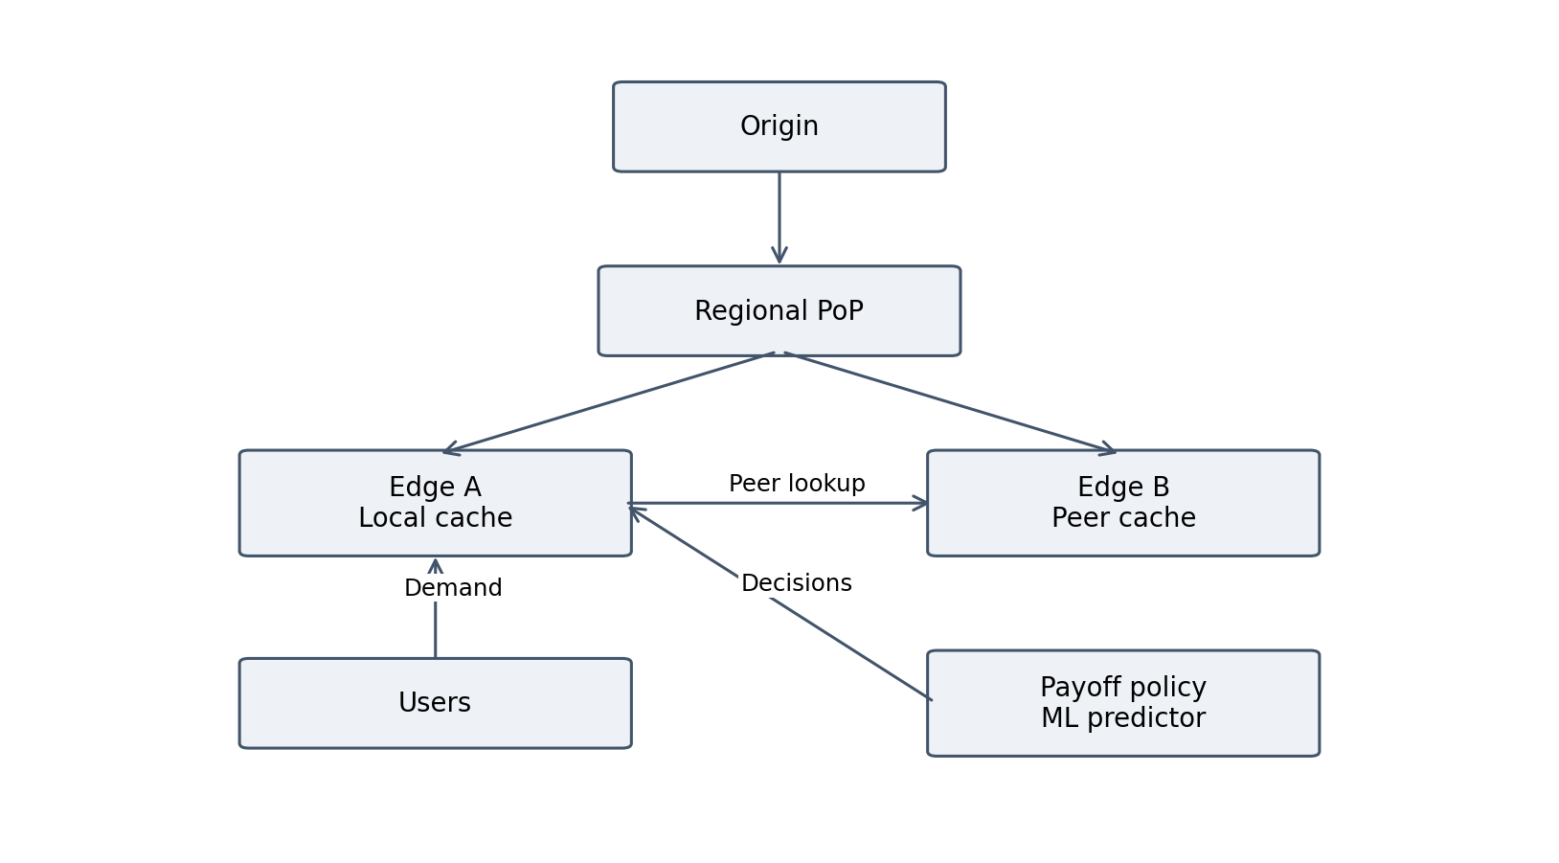
Figure 1. System architecture showing modeled forwarding paths and decision modules
Figure 1 shows one representative region. The evaluation instantiates four regions, each with three edge caches and six users. A single origin is connected through regional nodes. Cooperative links connect edges within the same region; the model does not search every edge worldwide. The ML and payoff modules act on the requesting edge’s decision process and are not independent packet-forwarding nodes.
A local copy requires only the user–edge delivery path. A peer copy crosses the cooperative link and then the user access link. An origin copy crosses origin–region, region–edge, and edge–user links. These path definitions determine payload traffic as well as latency. No regional cache is inserted implicitly. NetworkX stores the topology and attributes used by all strategies [17].
The architecture separates workload, topology, decisions, and measurement. This allows peer-link settings to change without changing the demand sequence. It also makes a failure trace interpretable: the record identifies the chosen source, attempted peers, coordination delay, prefetch expense, and final demand outcome.

3.2 Topology and cache state
Table 4. Modeled topology and cache attributes
Entity | State or parameters | Role
Origin | One origin node | Source when caches cannot serve
Region | Four regional PoPs | Origin-to-edge forwarding
Edge | Three per region; three-item cache | Local and peer content service
User | Six per region | Demand source
Link | Latency, bandwidth, type | Transfer cost calculation
Peer link | Within-region edge pair | Optional cooperative retrieval
Cache | Ordered content keys | LRU or ML-guided eviction

The topology builder uses geographic reference coordinates for regions and coordinate jitter for other nodes. Link settings outside the controlled peer scenarios are produced by model formulas based on distance. The formulas are assumptions; they are not measurements of routers, fiber paths, or available throughput. Geographic grounding makes the graph interpretable but does not turn the simulation into a calibrated Internet topology.
Cache capacity is expressed as an item count. Every article consumes one slot even if its size differs. This keeps the replacement mechanism simple but means that capacity three cannot be interpreted as a fixed memory budget in bytes. Each evaluation starts with empty edge caches. The training history informs the predictor but does not warm the physical caches before evaluation.
LRU state is maintained with ordered keys. A hit moves the item to the recent end, and insertion into a full cache evicts the least recent item when ML is disabled. Serving a peer also refreshes recency at the serving edge. Python’s ordered container support is suitable for this representation [22]. The use of an ordered structure avoids arbitrary eviction caused by removing an element from an unordered set.

3.3 Supplied Wikipedia article catalog
Table 5. Catalog supplied for the reported evaluation
No. | Article | Views | Bytes | Size field
1 | Christa Pike | 333,405 | 87,394 | 0.0833
2 | Wikimedia Foundation | 269,550 | 159,018 | 0.1517
3 | 2026 Brazilian general election | 247,828 | 153,471 | 0.1464
4 | Digger (2026 film) | 245,758 | 56,644 | 0.0540
5 | Drishyam: The Conclusion | 226,584 | 37,450 | 0.0357
6 | Lanterns (TV series) | 225,799 | 151,394 | 0.1444
7 | .xxx | 218,299 | 24,087 | 0.0230
8 | East of Eden (novel) | 180,516 | 32,137 | 0.0306
9 | East of Eden (2026 miniseries) | 165,714 | 21,344 | 0.0204
10 | Dakota Johnson | 149,574 | 80,326 | 0.0766
11 | Deaths in 2026 | 142,771 | 80,326 | 0.0766
12 | Lizzie Borden | 142,750 | 80,326 | 0.0766
13 | Flávio Bolsonaro | 128,855 | 80,326 | 0.0766
14 | Robert Kelker-Kelly | 126,211 | 80,326 | 0.0766
15 | Dennis Hastert | 120,839 | 80,326 | 0.0766
16 | Karl Deisseroth | 112,054 | 80,326 | 0.0766
17 | Verity (film) | 109,971 | 80,326 | 0.0766
18 | Bryce Young | 109,390 | 80,326 | 0.0766
19 | Ted Kaczynski | 108,775 | 80,326 | 0.0766
20 | Jeffrey Archer | 106,298 | 80,326 | 0.0766

Source: wikipedia_content_catalog.csv, retained with the experiment results. The size field is named size_mb in the implementation. The downloader divides bytes by 1,048,576, so it is numerically MiB even though output labels say MB. Values are reproduced as recorded; no size or popularity entry has been silently corrected for this report.

3.4 Data provenance and workload construction
The downloader obtains top-article view counts through Wikimedia’s pageview analytics interface and requests article information through the MediaWiki API [15], [16]. Aggregate view counts provide relative sampling weights. They are not a chronological list of user requests, and the catalog contains no client region or arrival timestamp. The evaluation therefore combines real popularity statistics with generated requests and a simulated user-to-edge mapping.
The experiment summary records 20 articles but does not preserve an acquisition date or API URL. The recorded outputs do not establish the acquisition date, so no particular date is treated as verified dataset metadata. A future dataset manifest should retain the exact command, retrieval timestamp, project domain, and API responses. The current report preserves the supplied article names, counts, sizes, and metrics without claiming direct revalidation against the external service.
Size estimation is a material limitation. The first nine byte sizes have a mean of 80,326.56 bytes. The integer part, 80,326, is repeated for the remaining eleven entries. The downloader uses the average of previously collected sizes when a size lookup fails; successive fallback entries leave that integer average unchanged. The supplied pattern is therefore strongly consistent with fallback imputation, although per-article API logs were not supplied. At least the repeated values should be treated as estimated rather than independently measured.
For each demand, the simulator samples a user and an article. The article probability equals its view count divided by the sum of counts in this truncated catalog. The top article is more likely than the twentieth, but the popularity distribution does not change with time or region. Training uses a separate random stream with the same distribution. Python’s pseudorandom sampling supports controlled repetitions through seeds [23]; a seed makes an experiment repeatable, not a realistic user trace.
The latest production loader rejects missing, empty, malformed, duplicate, or nonpositive catalog entries instead of substituting synthetic videos. This improves provenance visibility. It does not eliminate estimated article sizes or make the generated sequence a real trace. Those distinctions are preserved throughout the results chapter.

3.5 Four caching strategies
Table 6. Policy comparison used in every scenario
Property | NC | AC | SP | ML
Local lookup | Yes | Yes | Yes | Yes
Peer query | No | First available | Approved and ranked | Approved and ranked
Payoff decision | No | No | Yes | Yes
Replacement | LRU | LRU | LRU | Predicted score
Prefetch | No | No | No | One top item if room
Origin fallback | Yes | Yes | Yes | Yes
Cost accounting | Demand | Demand and queries | Demand and queries | Demand, queries, prefetch

Non-cooperative caching is the no-sharing control. Every local miss goes to origin and inserts the returned item into the requesting edge. Always-cooperative caching is the sharing control. It checks connected peers in their existing order, retrieves the first available copy, and falls back to origin if no peer succeeds. It makes no payoff calculation and uses LRU replacement.
The selective payoff strategy keeps LRU but evaluates peer-route utility. Candidate peers are ordered by estimated payload delivery plus query cost. Only approved peers are queried, and the transfer helper can retrieve content from exactly the selected peer. An unsuccessful query is charged before proceeding to another candidate. The policy uses known link metadata when deciding whether to query; it does not inspect all peer caches for free.
ML-cooperative keeps the selective retrieval mechanism and changes cache decisions. A Random Forest ranks content for prefetching into a free slot and selects an eviction candidate when needed. The model scores all catalog items. It does not directly choose whether a peer is permitted to serve; that remains the retrieval policy’s role. This separation makes the extension understandable but means that comparing ML with SP measures the combined effect of predictive prefetch and predictive eviction, not either mechanism alone.

3.6 Demand processing and peer selection
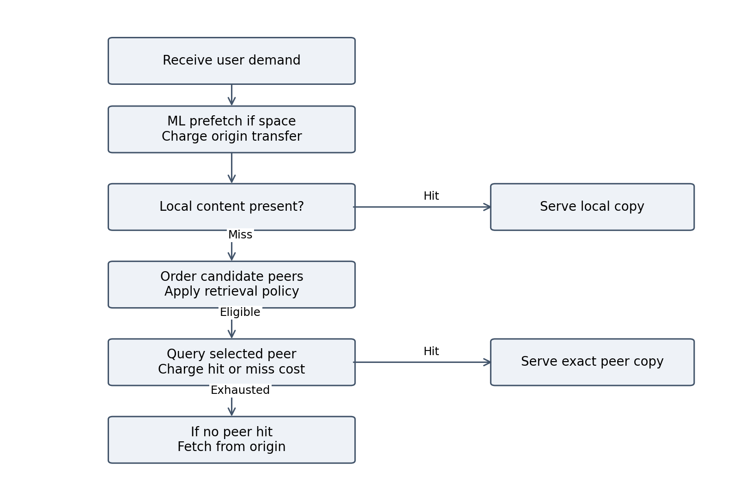
Figure 2. Demand-processing flow with local service peer lookup and origin fallback
Figure 2 summarizes the branch structure. The prefetch branch is active only for ML and only when capacity remains. Local service is checked next. A prefetch of the currently requested item is identified as an origin miss even though the item is present by the subsequent local check. This prevents a just-in-time download from being reported as an ordinary hit.
For selective retrieval, an approved peer may still miss because approval is based on network cost, not an oracle of cache contents. The next candidate can then be considered. Origin service includes the costs of all preceding queries. The final record distinguishes payload delay, coordination delay, and prefetch delay so that a low payload time cannot conceal expensive discovery.

3.7 Payoff definitions and their interpretation
Let B denote the modeled origin-backend transfer time minus the peer payload-transfer time for the requesting edge. Let C denote one modeled peer round trip plus fixed coordination overhead. Let b be the mutual-preference bonus, set to 2 ms-equivalent utility. The requesting player’s payoffs are given in Table 7. The other player’s entries are calculated with its own origin path and role reversed.
Table 7. Requesting edge payoff under the implemented route-choice game
Own choice | Other edge prefers peer | Other edge prefers origin
Try peer retrieval | B − C + b | B − C
Use origin | 0 | 0

These actions represent retrieval preferences, not willingness to provide service. Thus an edge can retrieve from a peer even when that peer would use origin for its own requests. Connected peers remain available to serve cached objects. The pairwise calculation adds strategic dependence only through the small bonus when both prefer peer retrieval. A positive modeled benefit is not a prediction that the requested item is present.
The benefit and cost are based on the shared transfer-time function, so changing object size changes the estimated saving. However, the rule is conditional on a successful peer retrieval. It does not multiply the saving by the probability of a cache hit. That omission is particularly important for a 20-object catalog with only three slots at each edge: a locally attractive peer route can still produce many unsuccessful checks.
The fixed bonus is a modeling assumption, not time physically removed from a response. It is not subtracted from measured latency. The current implementation is therefore described as a simplified game-inspired payoff policy. It is not a proof of optimal caching, a fairness contract, or a bilateral participation agreement. This precise description avoids assigning stronger semantics to the code than it implements [7], [8].

3.8 Transfer and coordination accounting
The simulator uses the same scalar transfer model in its retrieval handlers and payoff calculation. For an object size S, link bandwidth W, and link latency L, the modeled transfer time in milliseconds is T = L + 8,000S/W. The implementation treats the size field as MB when applying this expression, although the downloader derives it using binary MiB conversion. This unit mismatch is small compared with the dominant lookup cost here but is a documented numerical limitation; the results are reported exactly as supplied.
A local hit contributes one object-size unit of payload traffic across the user access link. A peer hit contributes two: peer to requesting edge, then edge to user. An origin retrieval contributes three: origin to region, region to edge, then edge to user. The resulting traffic metric sums payload volume across modeled links. It is neither an instantaneous bandwidth measurement nor an Internet billing total.
Each attempted peer query adds C = 2Lpeer + 10 ms. In the fast scenario this is 14 ms; in the slow scenario it is 90 ms. Both successful and failed checks are charged. Always-cooperative and selective strategies use the same cost function, avoiding a built-in accounting advantage for selection. A rejected candidate is a local decision from existing link metadata and sends no query. Model-inference CPU time and payoff computation time are not included in the network latency.
For an ML prefetch, origin-to-region and region-to-edge payload transfers are charged before demand processing. No user hop is charged until content is delivered to the user. This is synchronous prefetch: there is no assumed overlap with idle time or other traffic. If the prediction is wrong, the demand may require another origin access. If it is the current item, that origin access is counted once and classified as a demand miss. This conservative scheduling choice is part of the evaluated policy.
Total latency equals demand payload latency plus accumulated peer-query latency plus any prefetch delay. A complete-object store-and-forward abstraction is used across hops. Real transport may pipeline data, share bandwidth, incur queueing, and overlap transfers. These effects are excluded, so the calculated latency is a model output rather than a full TCP or HTTP timing prediction.

3.9 Machine learning workflow
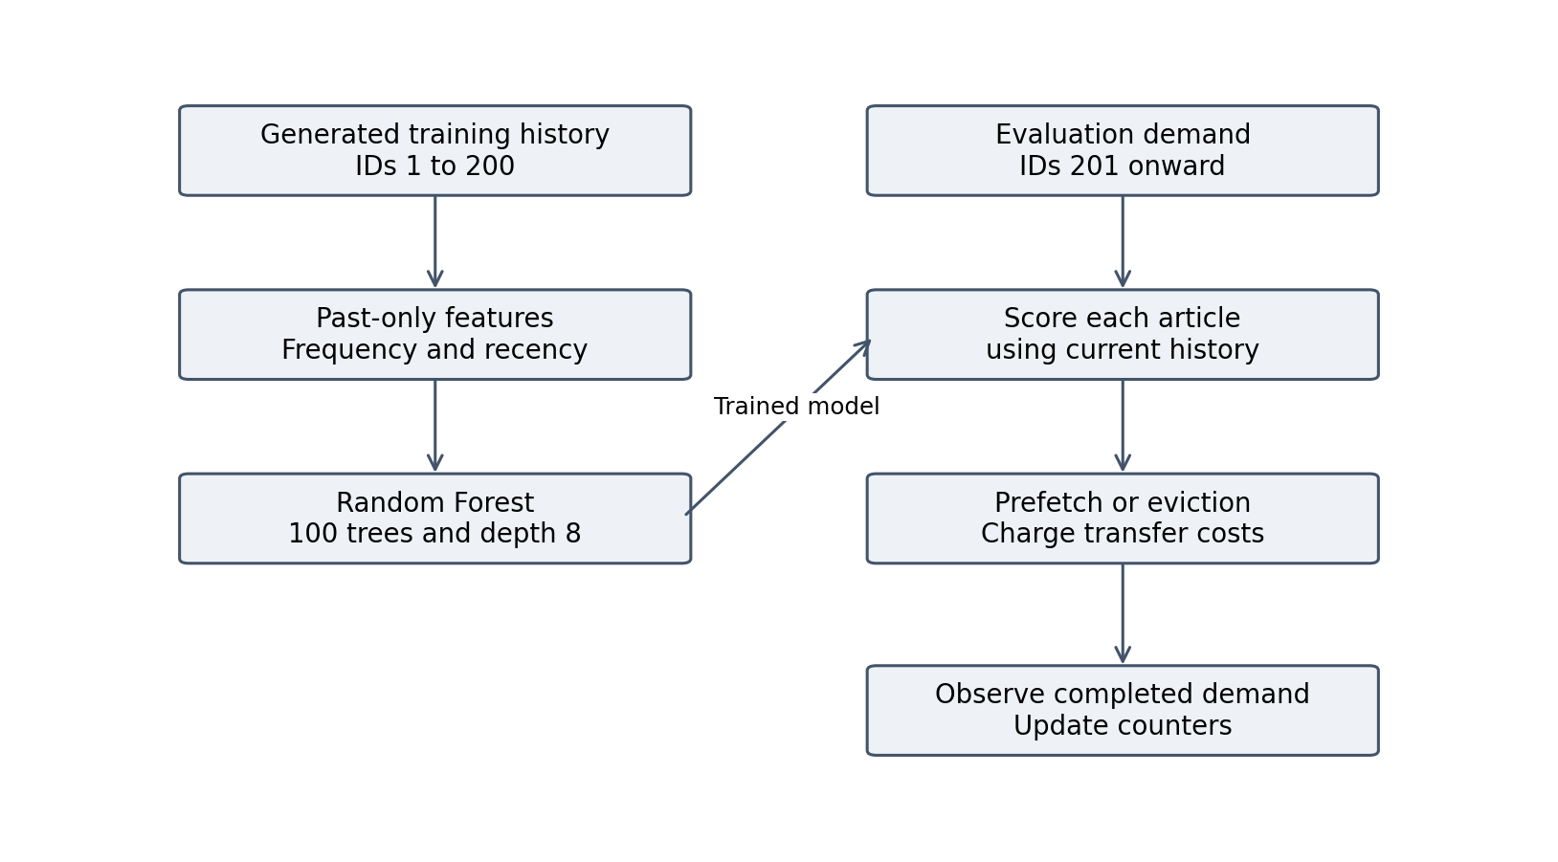
Figure 3. ML workflow with past-only features and a continuous request timeline
The training history contains 200 generated requests. For each request, one row is constructed for every catalog article. The requested article receives label one and other articles label zero. Features include edge identity, content identity, frequency so far, recency gap, and object size. pandas supplies the tabular and categorical encoding workflow [18]; scikit-learn supplies the estimator [12], [13].
Evaluation timestamps start after the end of training, so request 201 follows training request 200. User-facing demand IDs remain 1 through 1,000. Frequency and last-seen counters update after the actual demand, and the same clock is used for prediction, eviction, and observation. A previously observed item can no longer appear to have been seen in the future. The forest itself remains fixed after fitting.
Top-ranked content is prefetched only into free space. Eviction uses the least likely cached candidate rather than an explicit byte- or delay-weighted score. Because requests are sampled from static global popularity, the model has no real temporal burst or user-locality signal to discover. The experiment tests this modest predictor honestly rather than attributing unimplemented adaptation to it.

3.10 Correctness and measurement safeguards
Table 8. Corrections and verification targets
Issue | Correction | Verification target
Wrong peer could serve | Exact selected-peer transfer | Rejected peer cannot provide copy
Ignored lookup misses | Charge every attempted query | Origin fallback retains overhead
Free prefetch content | Charge two payload hops and origin | Unused prediction still costs
Artificial current-request hit | Classify just-in-time fetch as miss | Origin counted once
Negative recency | Continue model time after training | No future last-seen values
Unclear strategy semantics | Route preference wording | No claim of sharing refusal
Hidden catalog substitution | Strict Wikipedia CSV loading | Missing data raises clear error

The recorded development validation included 68 passing tests after the ML accounting and timeline corrections. Additional loader checks covered missing, empty, malformed, duplicate, and valid catalog cases after the synthetic fallback was removed. These checks establish behavior for specified cases; they are not proof that every possible workload or parameter combination is correct. pytest is the automated test framework [25].
The uploaded evaluation was independently checked at the results-file level for this report. It contains 120 distinct scenario–strategy–seed combinations. Each run has 1,000 demands. Recomputed aggregate means agree with the supplied summary. For each seed, request-sequence hashes agree across the twelve scenario–strategy combinations. Those hashes check matched demands, not integrity of every local software dependency or external API response.
The accounting identities distinguish outcomes from operations. Demand local hits plus demand peer hits plus demand-origin misses equal the number of user requests. Total origin accesses instead equal actual demand fetches plus prefetch accesses. These totals can exceed user demands. A model that conflates the two quantities can mistakenly label prefetch work as reduced origin load.

3.11 Live HTTP demonstration
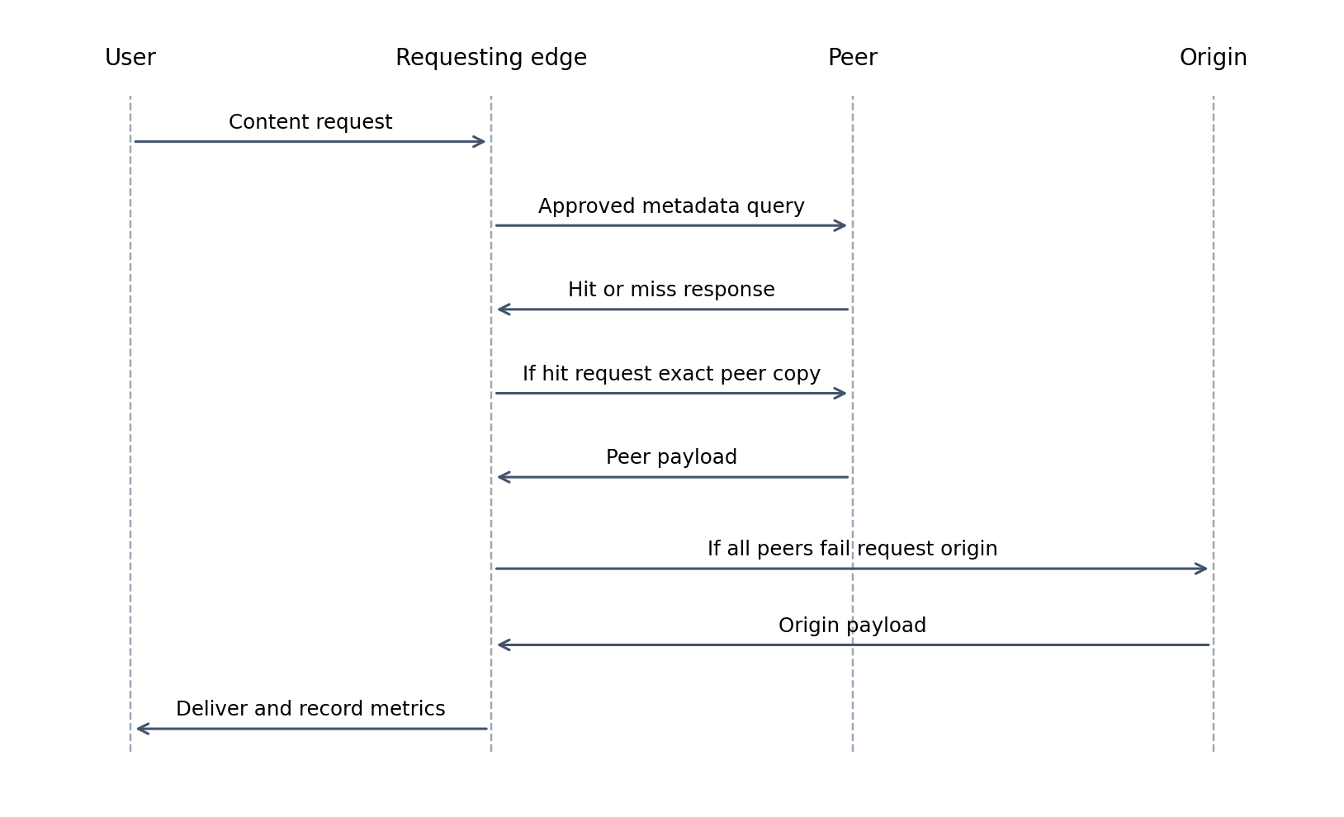
Figure 4. Sequence of demand query payload retrieval and fallback in the HTTP proof of concept
The live folder contains separate Flask origin and edge processes, a thread-safe LRU cache, and a load generator. A requesting edge checks its local store, asks configured peers whether they hold an article, and retrieves a peer copy or origin content. The peer-facing endpoint does not recursively search other peers. Flask provides endpoint handling and Requests provides HTTP client calls [20], [21].
The live policy uses measured health-endpoint round trips together with assumed bandwidths and fixed overhead. It is a related retrieval heuristic, not the identical pairwise best-response rule used in the simulator. Health checks do not measure the origin’s full Wikipedia retrieval delay. The demo returns a content preview to the user while caching full content internally. Consequently, its user-facing timing should not be interpreted as the simulator’s complete-object delivery time.
The origin can fetch Wikipedia content or return clearly labeled placeholder content when the external request fails. That live fallback is separate from the removed synthetic-video simulation catalog. No live-server benchmark was supplied for this report. Figure 4 describes implemented interactions; it is not a recorded packet trace or evidence of deployment performance.

3.12 Implementation modules and execution
Table 9. Software modules and responsibilities
Module | Responsibility
topology.py | Build graph, attributes, caches and transfer calculation
simulation.py | Load catalog, process demands and account for work
game_theory.py | Pairwise payoffs and retrieval approval
demand_predictor.py | Feature construction, fitting and content scoring
main_analysis.py | CLI comparison and plots
app.py and templates | Configurable dashboard and result presentation
evaluate_peer_scenarios.py | Matched fast, slow and mixed experiments
data/fetch_wikipedia_dataset.py | Create catalog from external APIs
live/ and tests/ | HTTP demonstration and correctness checks

The repository uses Python as the main implementation language. NetworkX represents the graph, pandas prepares learning features, scikit-learn fits the Random Forest, and Matplotlib draws analysis charts [17–19]. Flask and the HTML template support an interactive comparison. These tools are implementation dependencies, not evidence that a particular policy is superior. Their current documentation is cited for API context rather than as a record of the package versions installed during evaluation.
The normal workflow is to create a virtual environment, install the declared requirements, fetch the Wikipedia catalog, and run either the dashboard or the scenario evaluator. The strict catalog loader stops if required fields are missing or values are invalid. Python’s CSV interface supplies dictionary-based row parsing [26]. The report does not include an authentication token or require a relational database.
For reproducibility, the submitted repository should preserve the exact CSV, raw JSON, summary JSON, source revision, dependency lock information, and invocation command. The supplied experiment files support recomputation of the reported aggregates. They do not identify a Git commit or hardware configuration, so those details are not invented here. Runtime or energy efficiency cannot be evaluated from the recorded network metrics.

3.13 Experimental design
Table 10. Controlled evaluation settings
Setting | Value
Strategies | NC, AC, SP and ML
Scenarios | Fast, slow and mixed peer links
Seeds | 0 through 9
Demands per run | 1,000
Total runs | 4 × 3 × 10 = 120
Topology | 4 regions, 3 edges and 6 users per region
Cache capacity | 3 objects per edge
Catalog | 20 supplied Wikipedia articles
Training | 200 generated requests; independent stream
Fast peer links | 2 ms latency and 1,000 Mbps
Slow peer links | 40 ms latency and 50 Mbps
Mixed region | 1 fast and 2 slow links per edge triangle

Only peer-link latency and bandwidth are overridden by the scenario definition. Non-peer topology settings remain generated from the same seed. In the mixed case, an independent seeded generator rotates which of the three regional peer links is fast. This avoids always privileging the same edge pair while preserving repeatability. It is not a measurement of real link diversity.
Each strategy builds a fresh network with empty caches. All twelve comparisons for one seed use an identical sequence of user and content pairs. Because no inter-arrival times are modeled, the workload is a sequence rather than a time-based offered load. The test therefore measures cache and path decisions under fixed link assumptions, not throughput saturation.
The design provides ten independent seeded configurations for each scenario and strategy. It supports paired comparisons within seeds and descriptive variation across seeds. The results do not include a cache-capacity sweep, bandwidth continuum, alternative classifier, or chronological trace replay. None of those unperformed experiments is represented as a completed graph.

3.14 Metrics and statistical treatment
Table 11. Metric definitions and interpretation
Metric | Definition | Interpretation
Hit rate | 100 × (local hits + peer hits) / N | Demand outcomes only
Mean latency | Sum of demand-associated latency / N | Includes query and prefetch delay
Payload traffic | Sum of size over traversed links | Volume, not instantaneous bandwidth
Origin accesses | Demand fetches + prefetch fetches | Total origin work
Coordination delay | Sum of all attempted peer-query costs | Includes failures
Sample SD | Spread of run means with n − 1 divisor | Variation across ten seeds
Paired reduction | 100 × (baseline − candidate) / baseline | Computed per seed then averaged

The mean of ten run metrics is reported for each strategy and scenario. Error bars show sample standard deviation across run means, not per-request standard deviation and not a confidence interval. Python’s statistics functions define the corresponding sample calculations [24]. The per-seed latency figure complements aggregate bars by showing whether a difference is consistent across matched configurations.
A hit-rate difference is reported in percentage points. For example, 38.96% minus 17.28% equals 21.68 percentage points. This should not be confused with a 21.68% relative improvement. Similarly, the average of per-seed latency reductions need not exactly equal the reduction calculated from aggregate mean latencies. The paired method is used consistently in the comparison table.
For traffic, the report retains the implementation’s MB label and records the binary-size convention separately. For origin load, non-ML demand misses coincide with origin accesses, but ML includes additional prefetch fetches. This distinction is retained in every chart. Result values are rounded for presentation only; recomputation uses the supplied full-precision JSON records.

4 Results and Discussion

4.1 Latency across peer conditions
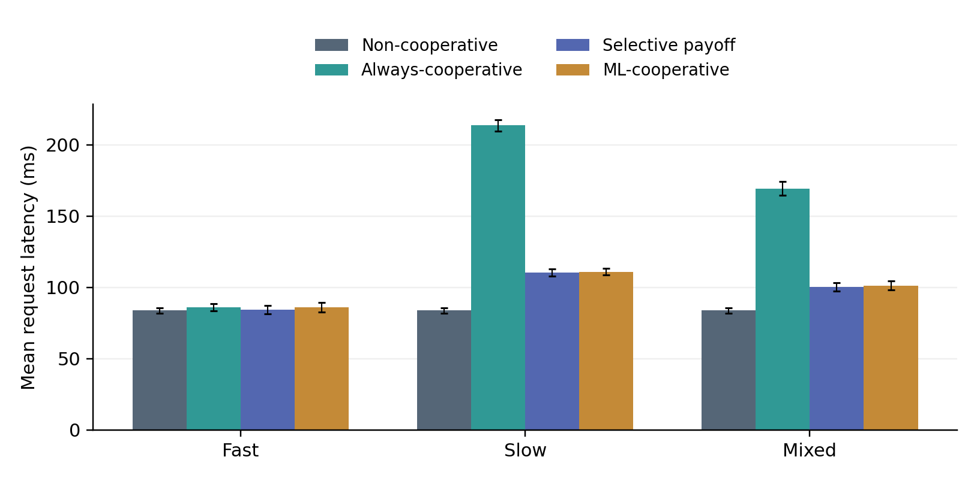
Figure 5. Mean demand latency with sample SD across ten seeds using the supplied Wikipedia catalog
Non-cooperative caching records 83.73 ms mean latency in all three scenarios because it never uses the altered peer links. The selective payoff policy records 84.37 ms with fast peers, 110.40 ms with slow peers, and 100.38 ms with mixed peers. Always-cooperative latency rises from 86.07 ms to 213.62 ms and 169.37 ms respectively. The ML extension records 86.13, 110.95, and 101.23 ms. Figure 5 therefore does not support a claim that cooperation is the lowest-latency policy for this catalog.
The selective policy does avoid much of the penalty of unconditional sharing. Relative to always-cooperative, the average paired reduction is 1.98% for fast links, 48.32% for slow links, and 40.73% for mixed links. These improvements are comparisons against a particular baseline. Relative to no sharing, the same selective policy increases paired mean latency by 0.75%, 31.86%, and 19.87%. Both sets of comparisons are necessary to describe the result honestly.
Small objects limit the time saved by a faster payload path, while sequential peer discovery still incurs fixed overhead. The result is consistent with a policy that estimates the advantage of a successful peer transfer but does not price its cache-miss probability before probing. This is an interpretation of the implementation and aggregate evidence, not a causal attribution established by an ablation experiment.

4.2 Cache hit rate
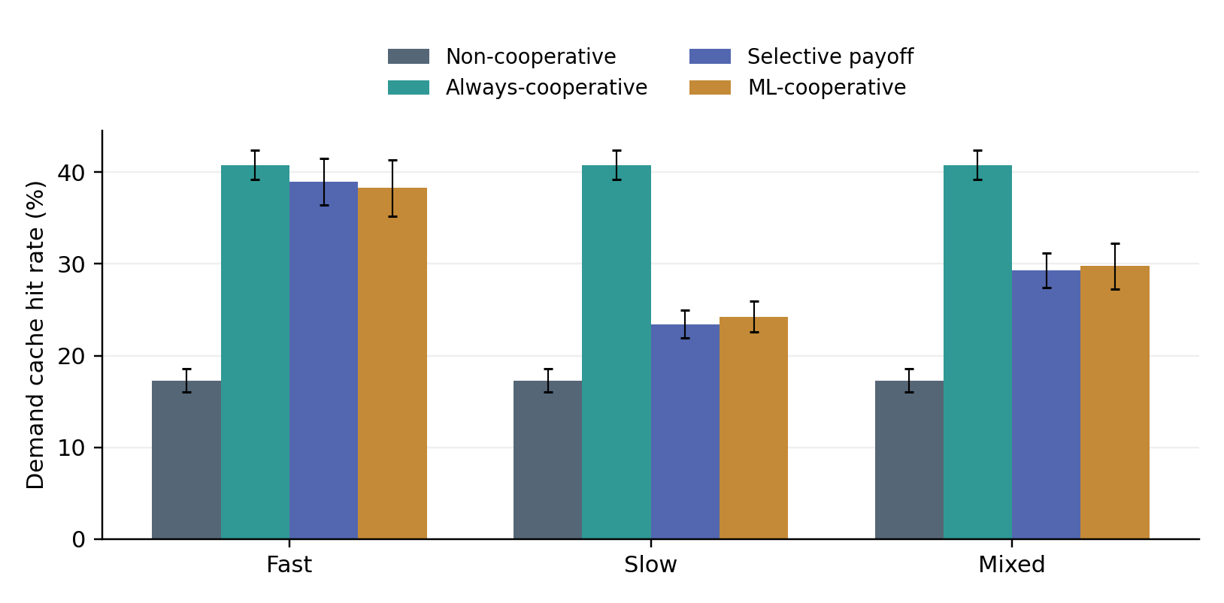
Figure 6. Demand hit rate including local and peer hits with sample SD across ten seeds
Independent caching achieves 17.28% mean demand hit rate. Always-cooperative reaches 40.80% in every link scenario. The same value across scenarios is expected: its peer order and cache updates do not depend on link quality, so changing latency and bandwidth changes transfer cost without changing its demand outcomes. This provides an internal consistency check on the experiment.
The selective policy reaches 38.96% with fast links, 23.44% with slow links, and 29.28% with mixed links. Restricting expensive peer routes reduces the set of copies that can satisfy a miss. The ML policy gives 38.29%, 24.26%, and 29.75% respectively. Its small hit-rate increases over SP in slow and mixed conditions do not translate into a lower mean delivery latency. Figure 6 must therefore be read alongside Figure 5 rather than treated as a standalone ranking of system quality.
Cache capacity is only three items out of twenty at each edge. Cooperation expands the set of reachable objects but is not equivalent to a perfect nine-item regional cache: duplicate copies, local insertions, LRU order, and eligibility affect what is actually available. The supplied popularity distribution is also less concentrated than the former five-video test. Cross-workload changes cannot be attributed to the policy alone because catalog size and object size changed together.

4.3 Payload traffic
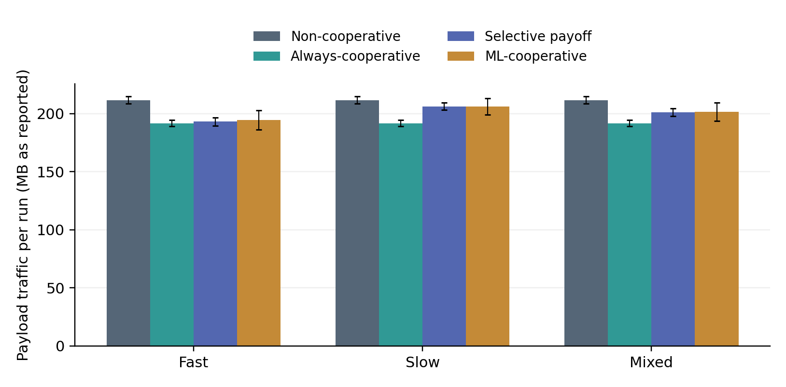
Figure 7. Total modeled payload volume across links per run including ML prefetch traffic
The non-cooperative strategy transfers 211.649 reported MB per 1,000-demand run. Always-cooperative transfers 191.705 MB regardless of peer-link condition. Selective retrieval transfers 193.093 MB with fast peers, 206.253 MB with slow peers, and 201.087 MB with mixed peers. ML transfers 194.347, 206.220, and 201.448 MB respectively. These values count payload across every modeled hop, not unique bytes downloaded by users.
The selective strategy reduces traffic relative to independent caching by mean paired 8.77%, 2.55%, and 4.99% across fast, slow, and mixed conditions. It uses more traffic than always-cooperative because some demands that could take a two-hop peer route instead take a three-hop origin route. The paired increases relative to always-cooperative are approximately 0.72%, 7.59%, and 4.89%. The latency benefit over unconditional sharing therefore comes with a traffic trade-off.
A small traffic advantage does not imply a large latency advantage. Traffic counts size and hop count, while the latency model additionally charges propagation and query overhead. Control-message bytes themselves are not included in the traffic metric. Consequently, a configuration with numerous peer misses can look economical in payload MB while having high delay. Reporting both figures makes that distinction explicit.

4.4 Origin accesses
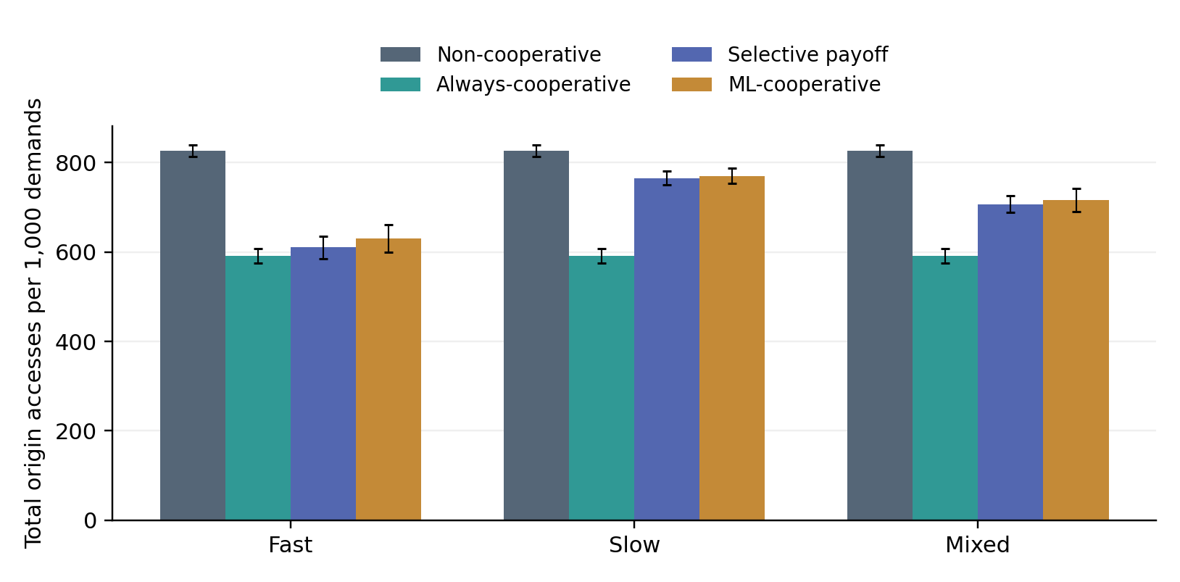
Figure 8. Total origin accesses per run including predictive prefetch operations
Independent caching makes 827.2 origin accesses per run on average, compared with 592.0 for always-cooperative. The selective policy makes 610.4 accesses with fast peers, 765.6 with slow peers, and 707.2 with mixed peers. These non-ML totals are also demand-origin miss counts. Sharing therefore substantially reduces origin work even when it is not the fastest delivery policy.
ML makes 630.3, 770.6, and 715.7 total origin accesses across the same scenarios. The totals include an average of 14.4 prefetch origin accesses per run. They should not be inferred by simply subtracting the hit count from 1,000. A prefetched current item is an origin miss counted once, while an unused prediction may create an extra fetch in addition to the demand fetch. The supplied raw fields retain the distinction between these cases.
If the project objective were to minimize origin requests subject to an acceptable latency budget, always-cooperative could be attractive within this model. If the objective were minimum mean latency for small articles, independent caching would be preferred on the observed averages. The experiment does not specify a combined economic weighting of these goals. It is therefore inappropriate to declare one strategy globally optimal from one chart.

4.5 Coordination overhead
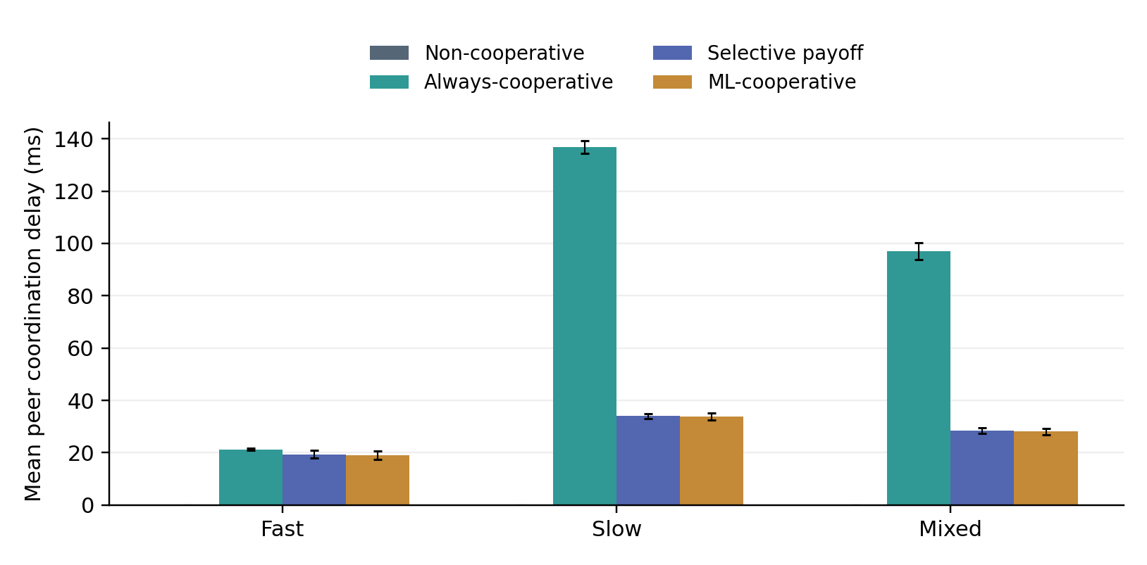
Figure 9. Mean modeled coordination delay including unsuccessful peer queries
Coordination explains much of the difference between payload savings and end-to-end latency. Always-cooperative makes an average of 1,520.8 peer checks per 1,000 demands in all scenarios. With a 14 ms fast-query cost, that is 21.291 ms per demand; with a 90 ms slow-query cost, it becomes 136.872 ms per demand. The observed arithmetic directly matches the recorded query counts and the shared cost model.
Selective retrieval reduces checks to 1,385.7 in the fast case, 378.6 in the slow case, and 737.3 in the mixed case. Its average coordination delays are 19.400, 34.074, and 28.425 ms. ML has corresponding delays of 19.068, 33.696, and 28.099 ms. Fewer checks than unconditional sharing are beneficial, but the remaining queries still cost enough that independent caching wins on mean latency.
The slow scenario does not cause the selective policy to reject every peer, unlike the earlier synthetic-video experiment. Eligibility depends on the regional origin path and the current object size as well as the peer link. A distant origin can leave a slow peer conditionally attractive, but the query may still miss. This illustrates why a successful-transfer benefit alone is not an estimate of expected lookup utility.

4.6 Variation across random seeds
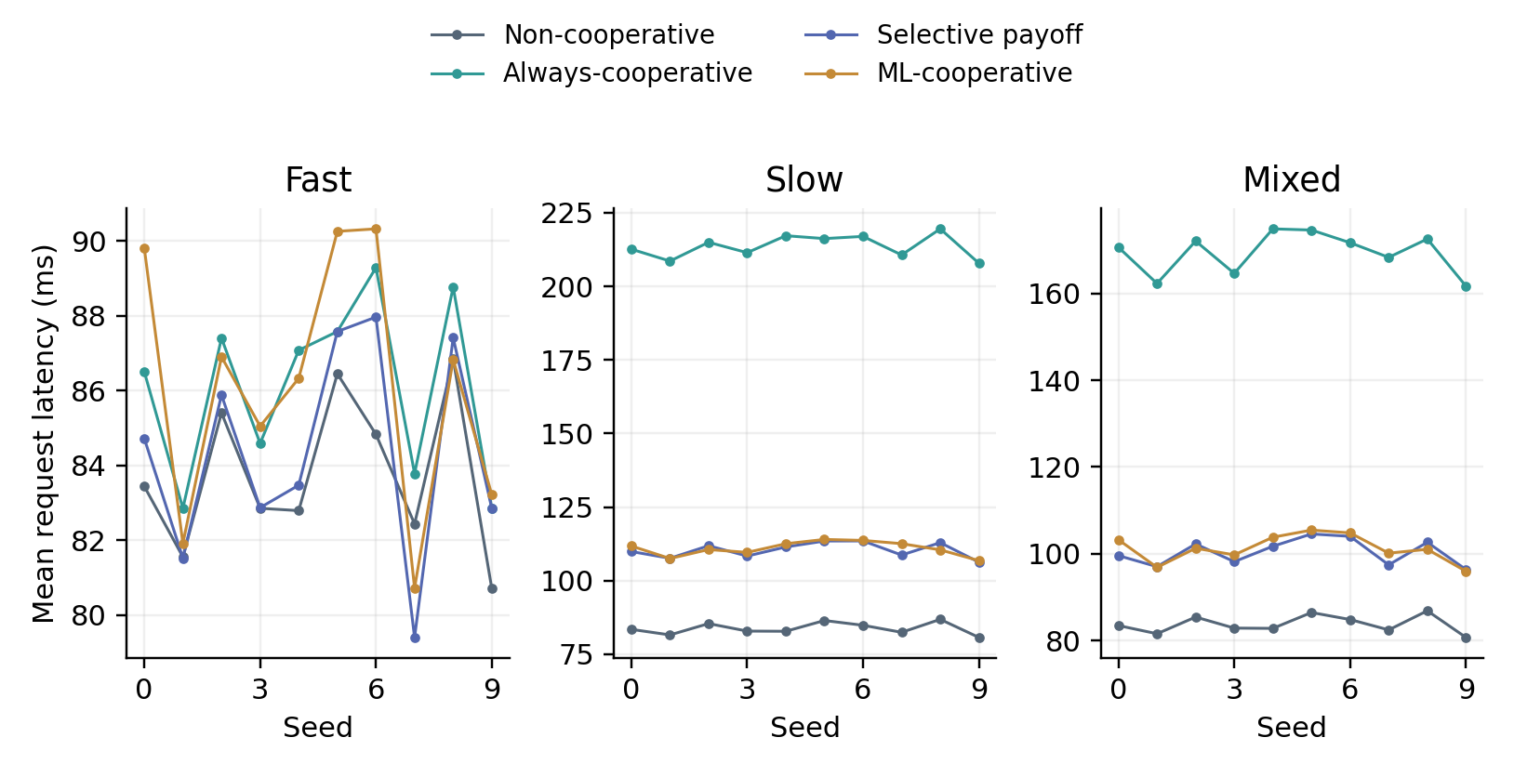
Figure 10. Per-seed mean latency for all strategies under fast slow and mixed links
Each point in Figure 10 is the mean of 1,000 demand-associated latencies for one seed. The lines connect seed labels only to aid comparison; they are not a time series or a trend in network load. Because requests and topology are paired within each seed, differences between strategies can be interpreted without the extra noise of unrelated workload draws.
Selective retrieval has lower latency than always-cooperative in eight of ten fast-link runs and ties in two. It wins that comparison in all ten slow-link runs and all ten mixed-link runs. Against non-cooperative caching it wins only two fast-link runs and loses the remaining eight. It loses to non-cooperative in every slow and mixed run. The direction of the main baseline trade-off is therefore not an artifact of a single selected seed.
The error bars in earlier figures describe variability across these run means. They do not quantify all uncertainty associated with the experiment: the catalog may be unrepresentative, article sizes may be estimated, and the network cost constants are assumed. Repeating random seeds within a fixed model improves repeatability but does not independently validate the model itself. No claim of statistical significance beyond these descriptive paired outcomes is made.

4.7 Numerical comparison and trade offs
Table 12. Mean outcomes from the recorded 120-run evaluation
Case | Policy | Hit % | Latency ms | Traffic MB | Origin
Fast | NC | 17.28 | 83.73 | 211.649 | 827.2
Fast | AC | 40.80 | 86.07 | 191.705 | 592.0
Fast | SP | 38.96 | 84.37 | 193.093 | 610.4
Fast | ML | 38.29 | 86.13 | 194.347 | 630.3
Slow | NC | 17.28 | 83.73 | 211.649 | 827.2
Slow | AC | 40.80 | 213.62 | 191.705 | 592.0
Slow | SP | 23.44 | 110.40 | 206.253 | 765.6
Slow | ML | 24.26 | 110.95 | 206.220 | 770.6
Mixed | NC | 17.28 | 83.73 | 211.649 | 827.2
Mixed | AC | 40.80 | 169.37 | 191.705 | 592.0
Mixed | SP | 29.28 | 100.38 | 201.087 | 707.2
Mixed | ML | 29.75 | 101.23 | 201.448 | 715.7

Table 12 consolidates the four main objectives. NC is consistently fastest on the aggregate means but makes the most origin accesses and transfers the largest payload volume. AC maximizes demand hits and minimizes origin accesses, but its latency penalty grows sharply on slow links. SP lies between these controls: it gives up some potential peer hits to avoid expensive discovery and transfer paths. ML makes small changes to hit rate without producing a latency advantage over SP.
These results support a conditional conclusion rather than a single winner. Relative to AC, SP is an effective way to reduce the cost of indiscriminate cooperation in this implementation. Relative to NC, SP trades delay for less origin work and payload traffic. The appropriate strategy depends on the system objective. A real deployment would need explicit latency targets, origin costs, freshness requirements, and measured link behavior before selecting a policy.

4.8 Paired reductions and machine learning findings
Table 13. Mean paired change for SP relative to each control
Scenario | Control | Latency reduction % | Hit gain pp | Traffic reduction % | Wins ties losses
Fast | AC | 1.98 | -1.84 | -0.72 | 8 / 2 / 0
Fast | NC | -0.75 | 21.68 | 8.77 | 2 / 0 / 8
Slow | AC | 48.32 | -17.36 | -7.59 | 10 / 0 / 0
Slow | NC | -31.86 | 6.16 | 2.55 | 0 / 0 / 10
Mixed | AC | 40.73 | -11.52 | -4.89 | 10 / 0 / 0
Mixed | NC | -19.87 | 12.00 | 4.99 | 0 / 0 / 10

Negative latency reduction means that SP is slower than its control. Negative traffic reduction means that it uses more payload volume. These signed values are retained rather than clipped to zero. The small fast-link difference against NC is unfavorable on average, despite the substantial gain in demand hit rate. The slow and mixed comparisons show that avoiding some poor peer choices is not enough to remove the full cost of the remaining probes.
ML has higher mean latency than SP by about 1.77 ms in the fast scenario, 0.55 ms in the slow scenario, and 0.85 ms in the mixed scenario. Its workload samples have static global popularity and no observed request timing, so the classifier cannot exploit real time-dependent bursts or geographic preferences. The configured predictor also optimizes a request label rather than a latency-saving objective. These are plausible explanations, not separately quantified causal effects.
Prefetching is performed synchronously and is charged even when it does not satisfy the current demand. That accounting removes an artificial advantage but makes speculative transfers visible. The experiment does not contain an eviction-only or prefetch-only ablation, so it cannot allocate the observed ML difference between those two mechanisms. Nor does it measure classifier CPU overhead as part of network delay. The report therefore concludes only that this particular ML policy did not improve the tested latency objective.

4.9 Validity and limitations
The principal external-validity limitation is the workload. Twenty top Wikipedia articles are a small and truncated sample. Popularity counts are external inputs recorded in the catalog, but demands are independently sampled from static weights. Actual arrivals, sessions, bursts, regional preferences, and long-tail content are absent. The seed repetition assesses the selected workload model, not the whole Wikipedia request population.
The size data are partly estimated. Eleven repeated sizes match the downloader’s fallback average. The CSV does not include a measured-versus-imputed flag, and it lacks an acquisition manifest. Moreover, sizes are based on article information rather than a complete set of transferred webpage resources. Binary MiB conversion is combined with an MB-based transmission expression. These limitations affect numerical interpretation and must accompany any claim that the evaluation uses real data.
The network model is simplified. It sums complete-object transfer times across links, omits queueing and bandwidth contention, and uses fixed coordination overhead. It assumes peers can inspect caches when queried and keeps content valid indefinitely. HTTP caching standards include freshness and validation semantics that are outside this model [5]. The live demonstration has different timing and bandwidth assumptions and is not used as a validation dataset for the plotted results.
The method comparison has an attribution limit. SP combines payoff filtering with ranked peer selection, while AC uses the first available peer. Without a cost-aware non-game baseline, the observed improvement cannot establish that game theory is necessary. The bonus term is an assumed utility, not a measured incentive. The finite best-response update has no project-provided proof of global optimality or fairness.
The recorded files support descriptive results, not a complete performance audit. Hardware, dependency versions actually installed during evaluation, and a Git revision were not supplied. The report therefore does not claim runtime, energy, scalability, or production readiness. These limits do not erase the recorded comparison; they define the conditions under which it can be interpreted and reproduced.

5 Conclusion
This project implements a reproducible edge-caching comparison with independent caching, unconditional cooperation, selective payoff-based retrieval, and an ML extension. Its main engineering contributions are explicit request paths, exact-peer selection, shared query-cost accounting, corrected prefetch accounting, continuous ML history timestamps, and paired scenario evaluation. The HTTP demonstration adds a practical networking component while remaining separate from the simulator’s numerical claims.
The Wikimedia-informed experiment shows that cooperation is a trade-off. SP reduces latency relative to AC by mean paired 1.98%, 48.32%, and 40.73% under fast, slow, and mixed links. It also reduces payload traffic and origin accesses relative to NC. However, NC has the lowest mean latency in all three scenarios. The small article sizes and the cost of unsuccessful peer queries make the overhead of cooperation important. The ML extension does not improve mean latency over SP in the tested conditions.
The research conclusion is therefore narrower and more useful than a claim of universal improvement: selective retrieval limits the damage of indiscriminate sharing, but selecting cooperation based only on the potential saving of a successful transfer does not guarantee a better end-to-end outcome. Cache hit rate, traffic, origin work, and latency must be evaluated together. A higher hit rate alone is insufficient evidence of better delivery performance.

5.1 Focused future work
The next methodological improvement would be to include estimated peer hit probability in the decision to query, and compare that rule with a simple cost-aware baseline. Data improvements should preserve acquisition metadata and measured-size flags, then evaluate chronological request traces if available. An ML ablation should separate predictive eviction from synchronous prefetching. These are bounded extensions that address identified limitations rather than unrelated additions.
The completed report uses the supplied raw results without replacing unfavorable values or tuning the workload to favor a strategy. It presents the system as a simplified research prototype and the measurements as reproducible simulation evidence. That separation between implementation, assumptions, and outcomes is central to the project’s academic contribution.

6 References
Numbered references are cited in the text. Web documentation was consulted on 8 October 2026. Preprints are identified as such; no unverified indexing status is asserted. Project results come from the supplied catalog, raw_results.json and summary.json, rather than from these publications.
[1] M. D. Dahlin, R. Y. Wang, T. E. Anderson, and D. A. Patterson. “Cooperative Caching: Using Remote Client Memory to Improve File System Performance.” Proceedings of OSDI, USENIX, 1994. https:/​/​www.usenix.org/​conference/​osdi-​94/​cooperative-​caching-​using-​remote-​client-​memory-​improve-​file-​system-​performance
[2] P. Sarkar and J. Hartman. “Efficient Cooperative Caching Using Hints.” Proceedings of OSDI, USENIX, 1996. https:/​/​www.usenix.org/​conference/​osdi-​96/​efficient-​cooperative-​caching-​using-​hints
[3] D. Wessels and K. Claffy. “Internet Cache Protocol (ICP), version 2.” RFC 2186, 1997. https:/​/​www.rfc-​editor.org/​rfc/​rfc2186
[4] D. Wessels and K. Claffy. “Application of Internet Cache Protocol (ICP), version 2.” RFC 2187, 1997. https:/​/​www.rfc-​editor.org/​rfc/​rfc2187
[5] R. Fielding, M. Nottingham, and J. Reschke, editors. “HTTP Caching.” RFC 9111, 2022. https:/​/​www.rfc-​editor.org/​rfc/​rfc9111
[6] R. Fielding, M. Nottingham, and J. Reschke, editors. “HTTP Semantics.” RFC 9110, 2022. https:/​/​datatracker.ietf.org/​doc/​html/​rfc9110
[7] J. F. Nash, Jr.. “Equilibrium points in n-person games.” Proceedings of the National Academy of Sciences, vol. 36, no. 1, pp. 48–49, 1950. DOI: 10.1073/pnas.36.1.48. https:/​/​www.pnas.org/​doi/​10.1073/​pnas.36.1.48
[8] H. Kim, J. Park, M. Bennis, S.-L. Kim, and M. Debbah. “Mean-Field Game-Theoretic Edge Caching.” arXiv:2101.00341, 2021, book-chapter preprint. https:/​/​arxiv.org/​abs/​2101.00341
[9] J. Shuja, K. Bilal, E. Alanazi, W. Alasmary, and A. Alashaikh. “Applying Machine Learning Techniques for Caching in Edge Networks: A Comprehensive Survey.” arXiv:2006.16864, 2020; related journal publication in Journal of Network and Computer Applications, article 103005, 2021. https:/​/​arxiv.org/​abs/​2006.16864
[10] N. Nomikos, S. Zoupanos, T. Charalambous, I. Krikidis, and A. Petropulu. “A Survey on Reinforcement Learning-Aided Caching in Mobile Edge Networks.” arXiv:2105.05564, 2021. https:/​/​arxiv.org/​abs/​2105.05564
[11] L. Breiman. “Random Forests.” Machine Learning, vol. 45, pp. 5–32, 2001. DOI: 10.1023/A:1010933404324. https:/​/​link.springer.com/​article/​10.1023/​A:1010933404324
[12] F. Pedregosa et al.. “Scikit-learn: Machine Learning in Python.” Journal of Machine Learning Research, vol. 12, pp. 2825–2830, 2011. https:/​/​www.jmlr.org/​papers/​v12/​pedregosa11a.html
[13] scikit-learn developers. “RandomForestClassifier.” Official API documentation. https:/​/​scikit-​learn.org/​stable/​modules/​generated/​sklearn.ensemble.RandomForestClassifier.html
[14] scikit-learn developers. “Common pitfalls and recommended practices.” Official documentation. https:/​/​scikit-​learn.org/​stable/​common_pitfalls.html
[15] Wikimedia Foundation. “Page view analytics.” Wikimedia Analytics API documentation. https:/​/​doc.wikimedia.org/​generated-​data-​platform/​aqs/​analytics-​api/​reference/​page-​views.html
[16] MediaWiki contributors. “API Info.” Official MediaWiki API documentation. https:/​/​www.mediawiki.org/​wiki/​API:Info
[17] NetworkX developers. “Software for Complex Networks.” Official NetworkX documentation. https:/​/​networkx.org/​documentation/​stable/​
[18] pandas development team. “pandas documentation.” Official documentation. https:/​/​pandas.pydata.org/​docs/​
[19] Matplotlib development team. “Matplotlib documentation.” Official documentation. https:/​/​matplotlib.org/​stable/​
[20] Pallets. “Flask documentation.” Official documentation. https:/​/​flask.palletsprojects.com/​en/​stable/​
[21] Requests contributors. “Requests HTTP for Humans.” Official documentation. https:/​/​requests.readthedocs.io/​en/​latest/​
[22] Python Software Foundation. “collections Container datatypes.” Python standard library documentation. https:/​/​docs.python.org/​3/​library/​collections.html
[23] Python Software Foundation. “random Generate pseudo-random numbers.” Python standard library documentation. https:/​/​docs.python.org/​3/​library/​random.html
[24] Python Software Foundation. “statistics Mathematical statistics functions.” Python standard library documentation. https:/​/​docs.python.org/​3/​library/​statistics.html
[25] pytest development team. “pytest documentation.” Official documentation. https:/​/​docs.pytest.org/​en/​stable/​
[26] Python Software Foundation. “csv CSV File Reading and Writing.” Python standard library documentation. https:/​/​docs.python.org/​3/​library/​csv.html

Project evidence used in this report
The evaluation evidence comprises the 20-row Wikipedia catalog, the 120-record raw_results.json file, and summary.json. The summary was normalized to valid JSON before parsing. Means and matched request hashes were checked against the raw records. Figures 5–10 and Tables 12–13 were generated from those records; Figures 1–4 describe the reviewed implementation. No Wikipedia performance values were inferred from the earlier synthetic-video experiment.

