**CYCLE-1**

**1.Design a Login Form with username and password using LinearLayout and toast valid credentials**

**Xml code:**

<LinearLayout

android:layout_width="match_parent"

android:layout_height="match_parent"

android:orientation="vertical"

xmlns:android="http://schemas.android.com/apk/res/android">

<EditText

android:id="@+id/username"

android:layout_width="wrap_content"

android:layout_height="wrap_content"

android:ems="10"

android:inputType="textPersonName"

android:hint="USERNAME"

android:textColor="@color/purple_200"/>

<EditText

android:layout_width="wrap_content"

android:layout_height="wrap_content"

android:id="@+id/password"

android:inputType="textPersonName"

android:textColor="@color/purple_200"

android:hint="PASSWORD"/>

<Button

android:layout_width="120dp"

android:layout_height="wrap_content"

android:id="@+id/login"

android:text="LOGIN"

android:textColor="@color/teal_200"

android:textSize="30sp"/>

</LinearLayout>

**Java code:**

package com.example.myapplication;

import android.support.v7.app.AppCompatActivity;

import android.os.Bundle;

import android.view.View;

import android.widget.Button;

import android.widget.EditText;

import android.widget.Toast;

import java.util.Objects;

public class MainActivity extends AppCompatActivity {

EditText username,password;

Button login;

@Override

protected void onCreate(Bundle savedInstanceState) {

super.onCreate(savedInstanceState);

setContentView(R.layout.activity_main);

username=findViewById(R.id.username);

password=findViewById(R.id.password);

login=findViewById(R.id.login);

login.setOnClickListener(new View.OnClickListener() {

@Override

public void onClick(View view) {

if(Objects.equals(username.getText().toString(), "vidhya")&&Objects.equals(password.getText().toString(),"777"))

{

Toast.makeText(MainActivity.this,"You have Authenticated Successfully",Toast.LENGTH_LONG).show();

}else

{

Toast.makeText(MainActivity.this,"Authentication Failed",Toast.LENGTH_LONG).show();

}

}

});

}

}

**OUTPUT:**

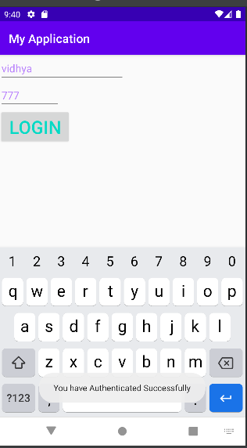

**2. Write a program that demonstrates Activity Lifecycle.**

**Java**

package com.example.activity2;

import android.support.v7.app.AppCompatActivity;

import android.util.Log;

import android.widget.Toast;

public class MainActivity extends AppCompatActivity {

@Override

protected void onStart() {

super.onStart();

Log.d("Activity_Lifecycle","onStart invoked");

Toast.makeText(MainActivity.this,"Start",Toast.LENGTH_SHORT).show();

}

@Override

protected void onPause() {

super.onPause();

Log.d("Activity_Lifecycle","onPause invoked");

Toast.makeText(MainActivity.this,"Pause",Toast.LENGTH_SHORT).show();

}

@Override

protected void onStop() {

super.onStop();

Log.d("Activity_Lifecycle","onStop invoked");

Toast.makeText(MainActivity.this,"Stop",Toast.LENGTH_SHORT).show();

}

@Override

protected void onRestart() {

super.onRestart();

Log.d("Activity_Lifecycle","onRestart invoked");

Toast.makeText(MainActivity.this,"Restart",Toast.LENGTH_SHORT).show();

}

}

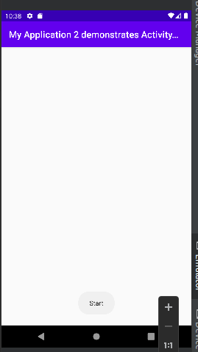

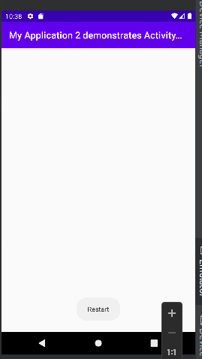

3. **Implementing basic arithmetic operations of a simple calculator**

Java

package com.example.myapplication;

import android.os.Bundle;

import android.view.View;

import android.widget.Button;

import android.widget.EditText;

import android.widget.TextView;

import android.support.v7.app.AppCompatActivity;

public class MainActivity extends AppCompatActivity {

private EditText firstNumberEditText, secondNumberEditText;

private TextView resultTextView;

@Override

protected void onCreate(Bundle savedInstanceState) {

super.onCreate(savedInstanceState);

setContentView(R.layout.activity_main);

firstNumberEditText = findViewById(R.id.firstNumber);

secondNumberEditText = findViewById(R.id.secondNumber);

resultTextView = findViewById(R.id.result);

Button addButton = findViewById(R.id.addButton);

Button subtractButton = findViewById(R.id.subtractButton);

Button multiplyButton = findViewById(R.id.multiplyButton);

Button divideButton = findViewById(R.id.divideButton);

addButton.setOnClickListener(new View.OnClickListener() {

@Override

public void onClick(View v) {

calculate('+');

}

});

subtractButton.setOnClickListener(new View.OnClickListener() {

@Override

public void onClick(View v) {

calculate('-');

}

});

multiplyButton.setOnClickListener(new View.OnClickListener() {

@Override

public void onClick(View v) {

calculate('*');

}

});

divideButton.setOnClickListener(new View.OnClickListener() {

@Override

public void onClick(View v) {

calculate('/');

}

});

}

private void calculate(char operator) {

double num1 = Double.parseDouble(firstNumberEditText.getText().toString());

double num2 = Double.parseDouble(secondNumberEditText.getText().toString());

double result = 0;

switch (operator) {

case '+':

result = num1 + num2;

break;

case '-':

result = num1 - num2;

break;

case '*':

result = num1 * num2;

break;

case '/':

if (num2 != 0) {

result = num1 / num2;

} else {

resultTextView.setText("Cannot divide by zero");

return;

}

break;

}

resultTextView.setText("Result: " + result);

}

public void clear(View view) {

firstNumberEditText.setText("");

secondNumberEditText.setText("");

resultTextView.setText("Result");

}

}

Xml

xml:<LinearLayout

xmlns:android="<http://schemas.android.com/apk/res/android>"

xmlns:app="<http://schemas.android.com/apk/res-auto>"

xmlns:tools="<http://schemas.android.com/tools>"

android:layout_width="match_parent"

android:layout_height="match_parent"

android:orientation="vertical"

android:padding="16dp"

tools:context=".MainActivity">

<EditText

android:id="@+id/firstNumber"

android:layout_width="match_parent"

android:layout_height="wrap_content"

android:hint="Enter first number"

android:inputType="numberDecimal" />

<EditText

android:id="@+id/secondNumber"

android:layout_width="match_parent"

android:layout_height="wrap_content"

android:hint="Enter second number"

android:inputType="numberDecimal" />

<TextView

android:id="@+id/result"

android:layout_width="match_parent"

android:layout_height="wrap_content"

android:text="Result: "

android:textSize="20sp" />

<Button

android:id="@+id/addButton"

android:layout_width="match_parent"

android:layout_height="wrap_content"

android:text="Add" />

<Button

android:id="@+id/subtractButton"

android:layout_width="match_parent"

android:layout_height="wrap_content"

android:text="Subtract" />

<Button

android:id="@+id/multiplyButton"

android:layout_width="match_parent"

android:layout_height="wrap_content"

android:text="Multiply" />

<Button

android:id="@+id/divideButton"

android:layout_width="match_parent"

android:layout_height="wrap_content"

android:text="Divide" />

<Button

android:id="@+id/clearButton"

android:onClick="clear"

android:layout_width="match_parent"

android:layout_height="wrap_content"

android:text="clear"/>

</LinearLayout>

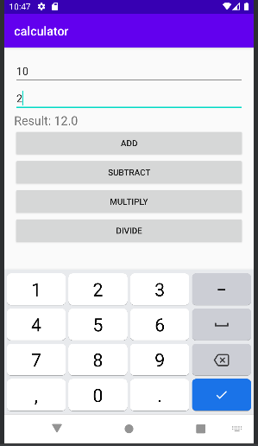

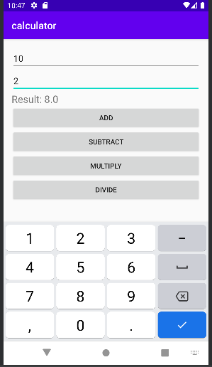

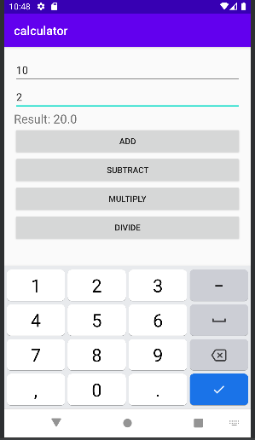

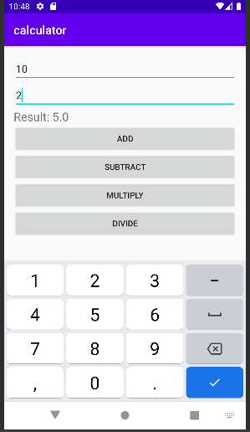

**4. create a student registration form and Implement validations on various UI controls**