**CYCLE-1**

**1. Define a class ‘product’ with data members pcode, pname and price. Create 3 objects of the class and find the product having the lowest price.**

**CODE:**

class Product {

int pcode;

String pname;

double price;

}

public class Main{

public static void main(String[] args) {

Product p1 = new Product();

p1.pcode = 1;

p1.pname = "Product 1";

p1.price = 10.0;

Product p2 = new Product();

p2.pcode = 2;

p2.pname = "Product 2";

p2.price = 20.0;

Product p3 = new Product();

p3.pcode = 3;

p3.pname = "Product 3";

p3.price = 5.0;

Product lowestPriceProduct = p1;

Product[] products = {p1, p2, p3};

for (Product product : products) {

if (product.price < lowestPriceProduct.price) {

lowestPriceProduct = product;

}

}

System.out.println("Name : Vidhya\nReg.no : SJC22MCA-2055\nDate : 24/03/2032\nCourse code : 20MCA132\n---------------------");

System.out.println("Product with lowest price:");

System.out.println("Product code: " + lowestPriceProduct.pcode);

System.out.println("Product name: " + lowestPriceProduct.pname);

System.out.println("Product price: " + lowestPriceProduct.price);

}

}

**OUTPUT**

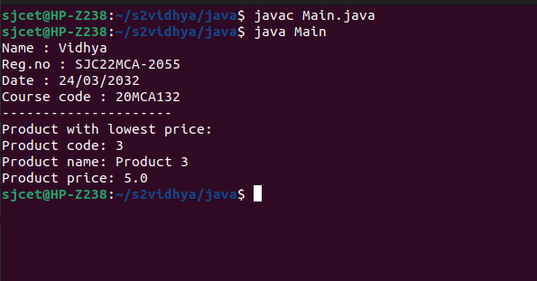

**2. Read 2 matrices from the console and perform matrix addition.**

**CODE**

import java.util.Scanner;

public class MatrixAdd {

public static void main(String[] args) {

Scanner input = new Scanner(System.in);

System.out.println("Name : Vidhya\nReg.no : SJC22MCA-2055\nDate : 24/03/2032\nCourse code : 20MCA132");

System.out.print("Enter the number of rows: ");

int rows = input.nextInt();

System.out.print("Enter the number of columns: ");

int cols = input.nextInt();

int[][] matrix1 = new int[rows][cols];

int[][] matrix2 = new int[rows][cols];

System.out.println("Enter the values of matrix 1:");

for (int i = 0; i < rows; i++) {

for (int j = 0; j < cols; j++) {

matrix1[i][j] = input.nextInt();

}

}

System.out.println("Enter the values of matrix 2:");

for (int i = 0; i < rows; i++) {

for (int j = 0; j < cols; j++) {

matrix2[i][j] = input.nextInt();

}

}

int[][] result = new int[rows][cols];

for (int i = 0; i < rows; i++) {

for (int j = 0; j < cols; j++) {

result[i][j] = matrix1[i][j] + matrix2[i][j];

}

}

System.out.println("The sum of the matrices is:");

for (int i = 0; i < rows; i++) {

for (int j = 0; j < cols; j++) {

System.out.print(result[i][j] + " ");

}

System.out.println();

}

}

}

**OUTPUT**

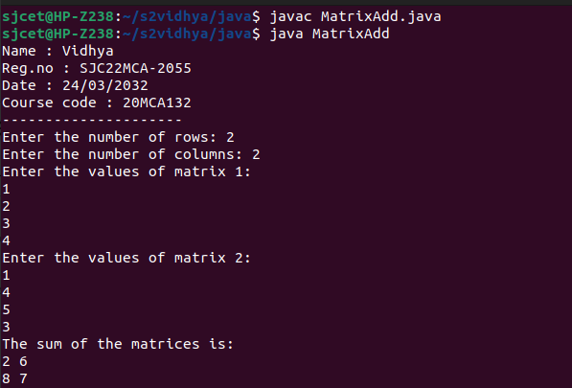

**3. Add complex numbers**

**CODE**

public class ComplexNumber {

private double real;

private double imaginary;

public ComplexNumber(double real, double imaginary) {

this.real = real;

this.imaginary = imaginary;

}

public ComplexNumber add(ComplexNumber other) {

double newReal = this.real + other.real;

double newImaginary = this.imaginary + other.imaginary;

return new ComplexNumber(newReal, newImaginary);

}

public String toString() {

if (imaginary >= 0) {

return real + " + " + imaginary + "i";

} else {

return real + " - " + (-imaginary) + "i";

}

}

public static void main(String[] args) {

ComplexNumber num1 = new ComplexNumber(3, 4);

ComplexNumber num2 = new ComplexNumber(1, -2);

ComplexNumber sum = num1.add(num2);

System.out.println("Name : Vidhya\nReg.no : SJC22MCA-2055\nDate : 24/03/2032\nCourse code : 20MCA132\n---------------------");

System.out.println("Sum: " + sum);

}

}

**OUTPUT**

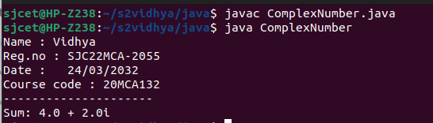

**4. Read a matrix from the console and check whether it is symmetric or not.**

**CODE**

import java.util.Scanner;

public class Symmetric{

public static void main(String[] args) {

Scanner scanner = new Scanner(System.in);

System.out.println("Name : Vidhya\nReg.no : SJC22MCA-2055\nDate : 24/03/2032\nCourse code : 20MCA132\n---------------------");

System.out.print("Enter the number of rows/columns: ");

int n = scanner.nextInt();

int[][] matrix = new int[n][n];

System.out.println("Enter the elements of the matrix:");

for (int i = 0; i < n; i++) {

for (int j = 0; j < n; j++) {

matrix[i][j] = scanner.nextInt();

}

}

boolean isSymmetric = true;

for (int i = 0; i < n; i++) {

for (int j = 0; j < i; j++) {

if (matrix[i][j] != matrix[j][i]) {

isSymmetric = false;

}

}

}

if (isSymmetric) {

System.out.println("The matrix is symmetric.");

} else {

System.out.println("The matrix is not symmetric.");

}

}

}

**OUTPUT**

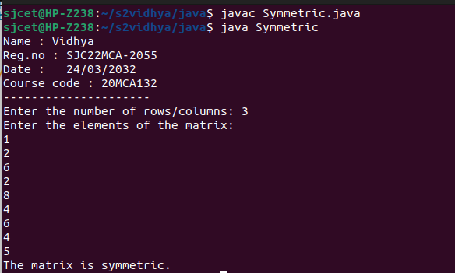

**5. Create CPU with attribute price. Create inner class Processor (no. of**

**cores,manufacturer) and static nested class RAM (memory, manufacturer). Create an object of CPU and print information of Processor and RAM.**

**CODE**

public class cpu{

int price;

class processor{

int cores;

String producer;

processor(int noC, String manu){

cores=noC;

producer=manu;

}

void display(){

System.out.println("\nProcessor info");

System.out.println("No. of Cores = "+cores);

System.out.println("Manufacturer = "+producer+"\n");

}

}

static class ram{

int mem;

String manuf;

ram(int memory,String producer ){

mem=memory;

manuf=producer;

}

void display(){

System.out.println("\nRAM info");

System.out.println("Memory = "+mem+" GB");

System.out.println("Manufacturer = "+manuf+"\n");

}}

public static void main(String[] args) {

System.out.println("Name : Vidhya\nReg.no : SJC22MCA-2055\nDate : 24/03/2032\nCourse code : 20MCA132\n---------------------");

cpu.ram obj1= new cpu.ram(8,"Intel");

cpu obj2 = new cpu();

cpu.processor obj3 = obj2.new processor(8,"Samsung");

obj1.display();

obj3.display();

}

}

**OUTPUT**

