NAGRIKSETU
AI-Powered Integrated Citizen Education, Employment, Skill Development & Welfare Intelligence Platform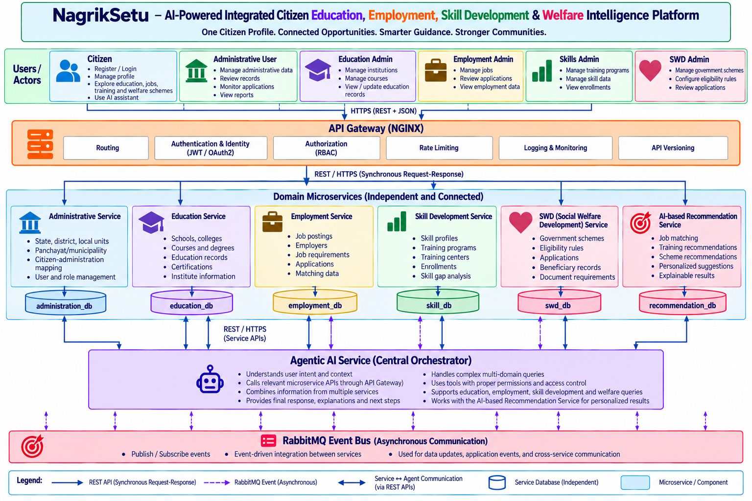

1. Introduction
NagrikSetu is an AI-powered integrated citizen platform designed to connect citizens with government administrative services, education, employment, skill development and social welfare opportunities through a unified platform. The architecture aims to reduce the need for citizens to navigate multiple disconnected portals by bringing relevant services and guidance together.
The central idea is: One Citizen Profile → Multiple Connected Government Services → AI-Powered Guidance → Better Citizen Support.
The architecture is organized in layers. Users access the platform through web interfaces; requests pass through an API Gateway; domain microservices perform their respective business functions; each service owns its database; the AI-Based Recommendation Service supports personalized opportunity discovery; and RabbitMQ supports asynchronous event communication.

2. Users and Actors
The top layer identifies six user categories that interact with the platform:
User role | Main responsibilities
Citizen | Registers and logs in, manages their profile, explores education, jobs, training and welfare schemes, and uses the AI assistant.
Administrative User | Manages administrative data, reviews records, monitors applications and views reports.
Education Admin | Manages institutions and courses and views or updates education records.
Employment Admin | Manages job postings, reviews applications and views employment data.
Skills Admin | Manages training programmes and skill data and views enrolments.
SWD Admin | Manages government welfare schemes, configures eligibility rules and reviews applications.
Role-based access control (RBAC) should ensure that each administrative role can access only the functions and information required for its responsibilities. Citizens should be restricted to their own permitted records.

3. API Gateway – NGINX
The API Gateway is the central entry point between the frontend applications and backend microservices. Rather than having the frontend call every backend service through unrelated endpoints, requests are sent to the Gateway, which routes them to the appropriate service.
Gateway function | Purpose
Routing | Forwards incoming requests to the correct microservice.
Authentication and identity integration | Works with an identity provider or authentication component to validate credentials and tokens such as JWT or OAuth2.
Authorization | Enforces or forwards permission checks; backend services must also enforce resource-level permissions.
Rate limiting | Restricts excessive request rates to protect services.
Logging and monitoring | Records request activity and supports operational monitoring.
API versioning | Allows compatible API versions to be exposed and maintained.
The diagram indicates HTTPS with REST and JSON for client-to-gateway communication. NGINX provides gateway and routing capabilities, but it is not by itself a complete identity management system. Token issuance, secure login, session management and application-level authorization need to be implemented by the authentication system and backend services.

4. Domain Microservices
The domain layer contains six independent services. Each service owns a specific business domain and is designed to be developed, maintained and scaled independently.

4.1 Administrative Service
- Manages state, district and local administrative units.
- Maintains Panchayat and municipality information.
- Supports citizen-administration mapping.
- Supports user and role management.
Example: associating a citizen profile with the relevant administrative area and supporting administrative record review.

4.2 Education Service
- Manages schools and colleges.
- Maintains courses and degrees.
- Stores or manages education records and certifications.
- Maintains institute information.
Example: a student explores institutions, courses and education-related opportunities.

4.3 Employment Service
- Manages job postings and employer information.
- Maintains job requirements.
- Handles or tracks applications.
- Maintains matching-related data.
Example: a graduate searches for jobs based on qualifications, skills and interests.

4.4 Skill Development Service
- Maintains citizen skill profiles.
- Manages training programmes and training centres.
- Tracks enrolments.
- Supports skill-gap analysis.
Example: a citizen who wants to enter data analytics can discover programmes that help build the required skills.

4.5 SWD – Social Welfare Development Service
- Manages government welfare schemes.
- Maintains eligibility rules.
- Supports application workflows.
- Maintains beneficiary records and document requirements.
Example: a senior citizen discovers a pension scheme and reviews its stated application requirements.

4.6 AI-Based Recommendation Service
- Supports job matching.
- Recommends training programmes.
- Recommends potentially relevant schemes.
- Produces personalized suggestions and explainable results.
Example: based on a citizen's qualifications and interests, the service suggests relevant training, internships or jobs.

5. Independent Databases – Database per Service
The cylinders in the diagram represent separate databases owned by their corresponding microservices. This is the Database-per-Service pattern.
Microservice | Database
Administrative Service | administration_db
Education Service | education_db
Employment Service | employment_db
Skill Development Service | skill_db
SWD Service | swd_db
Recommendation Service | recommendation_db
Benefits of this approach:
- Independence: each service controls its own data and schema.
- Scalability: services can be scaled according to their individual workloads.
- Maintainability: changes to one service's data model need not force changes in every other service.
- Fault isolation: an issue in one service does not automatically stop all other services.
- Clear data ownership: the owning service is responsible for validating and maintaining its records.
A key rule is that one microservice should not directly query another microservice's database. Information should be exchanged through service APIs or published events. This preserves service boundaries and avoids tight coupling.

6. RabbitMQ Event Bus – Asynchronous Communication
RabbitMQ is shown as the event bus at the bottom of the architecture. It allows services to publish events and other services to consume them without requiring an immediate request-response interaction between every participant.

7.1 Example: application submitted
- The Employment Service saves a citizen's application.
- It publishes an event such as application_submitted.
- RabbitMQ receives and routes the event to the relevant subscribers.
- A notification component can consume the event and send a confirmation.
- A reporting component can consume the event and update application statistics.
Benefits of RabbitMQ:
- Reduces direct dependencies between services.
- Supports background and asynchronous processing.
- Allows multiple interested consumers to react to the same event.
- Helps build event-driven workflows that can scale independently.
A production implementation should account for retries, duplicate delivery, failed-message handling, idempotent consumers and event ordering where the business process requires it.

7. Understanding the Arrows and Communication Methods
Diagram symbol | Meaning | Example
Solid blue arrow | REST API – synchronous request-response communication. | Example: frontend requests a citizen profile.
Dashed purple arrow | RabbitMQ event – asynchronous publish/subscribe communication. | Example: Employment Service publishes application_submitted.
Double-headed blue arrow | Two-way service communication through REST APIs. | Example: one service requests information and receives a response.
Cylinder | Independent service database. | Example: education_db belongs to Education Service.
Colored rectangle | Microservice or platform component. | Example: Administrative Service.

8.1 REST API compared with RabbitMQ
Aspect | REST API | RabbitMQ
Communication | Synchronous | Asynchronous
Pattern | Request and response | Publish and consume events
Response | Usually expects an immediate response | Consumer processes the event independently
Typical use | Retrieve or update a resource | Background work and event notifications
Example | Get citizen profile | Application submitted event

8. End-to-End Working Example
Consider a citizen who wants to find an AI training programme and a suitable job. The following sequence explains how the architecture works as one integrated system:
- The citizen logs in through the citizen portal.
- The citizen asks: “Find AI training programmes and jobs suitable for my qualification.”
- The request reaches the API Gateway, where authentication and authorization checks are applied.
- The frontend or application workflow obtains the required information from the relevant education, skill development and employment services.
- The relevant microservices retrieve their own data from their respective databases.
- The AI-Based Recommendation Service uses permitted profile information and available opportunities to generate relevant suggestions.
- The platform presents the retrieved and recommended opportunities to the citizen through the frontend.
- The frontend displays training programmes, suitable jobs and relevant next steps.
- If the citizen enrols or submits an application, the responsible service may publish an event through RabbitMQ.

Conclusion
NagrikSetu uses a layered microservices architecture to bring citizen administration, education, employment, skill development and social welfare services into one connected platform. The API Gateway provides a controlled entry point, independent microservices manage their own business domains and databases, the AI-based recommendations Service coordinates multi-domain queries, and RabbitMQ supports asynchronous event-driven workflows. Together, these components aim to make public-service discovery and navigation more accessible, connected and understandable for citizens.

