ScruCheck AI - Scrutiny Report
Paper ID: PAPER_20260118_195254
Generated: 2026-01-18 19:55:26
Status: CONDITIONAL ⚠️

1. Compliance Scorecard
Criterion | Status | Enforcement
Format Compliance | ✅ PASS | STRICT
Regulation Check | ✅ PASS | STRICT
Syllabus Alignment | ⚠️ WARNING | ENFORCED
Bloom's Taxonomy | ✅ PASS | ADVISORY
Mark Distribution | ❌ FAIL | STRICT
Grammar & Clarity | ✅ PASS | ADVISORY
Diagrams/Symbols | ✅ PASS | ADVISORY
Permitted Aids | ✅ PASS | ENFORCED
Repetition Check | ⚠️ WARNING | ADVISORY
Figure Naming | ✅ PASS | ADVISORY

2. Cognitive Level Analysis (Bloom's Taxonomy)
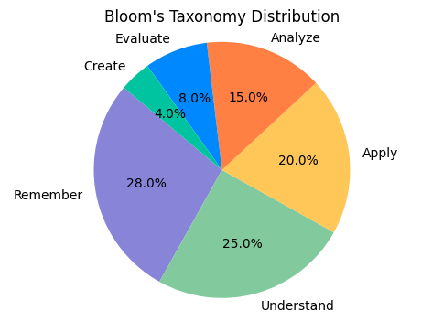
Figure 1: Distribution of marks across cognitive levels.

3. Syllabus Coverage
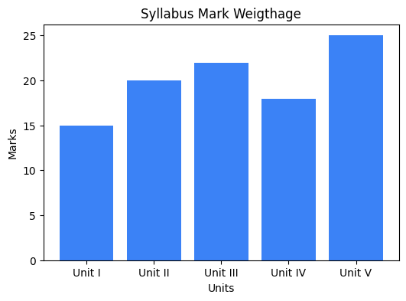
Figure 2: Weightage of marks across syllabus units.

4. AI Recommendations
• Fix Part B marks (adjust to total 100)
• Review 2 questions in Unit III that appear out of syllabus
• Increase percentage of Higher Order Thinking (HOTS) questions

---
Generated by ScruCheck AI v1.0

