ScruCheck AI - Scrutiny Report
Paper ID: PAPER_20260126_151521
Generated: 2026-01-26 15:15:48
Status: CONDITIONAL ⚠️

1. Compliance Scorecard
Criterion | Status | Enforcement
Format Compliance | ❌ FAIL | STRICT
Regulation Check | ❌ FAIL | STRICT
Syllabus Alignment | ✅ PASS | ENFORCED
Bloom's Taxonomy | ⚠️ WARNING | ADVISORY
Mark Distribution | ✅ PASS | STRICT
Grammar & Clarity | ⚠️ WARNING | ADVISORY
Diagrams/Symbols | ✅ PASS | ADVISORY
Permitted Aids | ✅ PASS | ENFORCED
Repetition Check | ✅ PASS | ADVISORY
Figure Naming | ✅ PASS | ADVISORY

2. Cognitive Level Analysis (Bloom's Taxonomy)
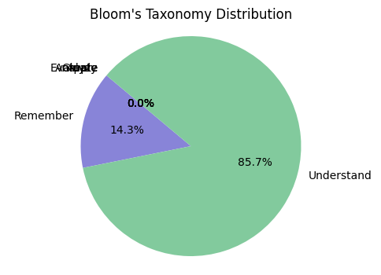
Figure 1: Distribution of marks across cognitive levels.

3. Syllabus Coverage
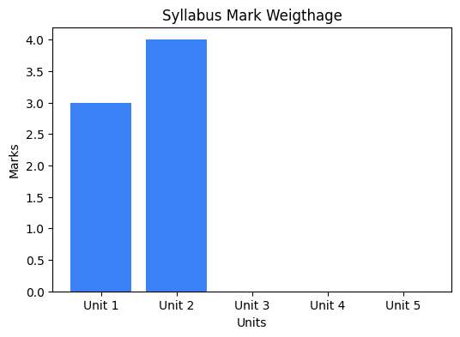
Figure 2: Weightage of marks across syllabus units.

4. AI Recommendations
• format_compliance: ⚠️ Mark allocation pattern not clearly stated (e.g., 10×2=20)
• regulation_check: ⚠️ Regulation year not found in paper; ⚠️ Course code not clearly visible
• blooms_taxonomy: Consider adding more higher-order thinking questions (Analyze/Evaluate/Create)
• grammar_clarity: Review 3 grammar/clarity issues

---
Generated by ScruCheck AI v1.0

