ScruCheck AI - Scrutiny Report
Paper ID: PAPER_20260605_231205
Generated: 2026-06-05 23:18:27
Status: APPROVED ✅

1. Compliance Scorecard
Criterion | Status | Enforcement
Format Compliance | ✅ PASS | STRICT
Regulation Check | ✅ PASS | STRICT
Syllabus Alignment | ✅ PASS | ENFORCED
Bloom's Taxonomy | ⚠️ WARNING | ADVISORY
Mark Distribution | ⚠️ WARNING | STRICT
Grammar & Clarity | UNCERTAIN | ADVISORY
Diagrams/Symbols | ✅ PASS | ADVISORY
Permitted Aids | ✅ PASS | ENFORCED
Repetition Check | ✅ PASS | ADVISORY
Figure Naming | ✅ PASS | ADVISORY

2. Cognitive Level Analysis (Bloom's Taxonomy)
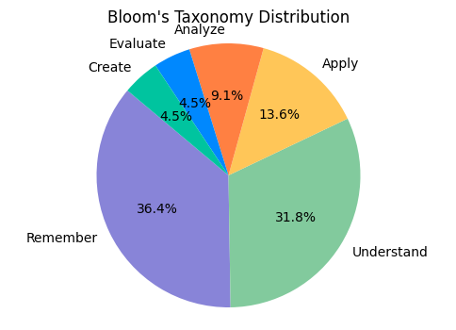
Figure 1: Distribution of marks across cognitive levels.

3. Syllabus Coverage
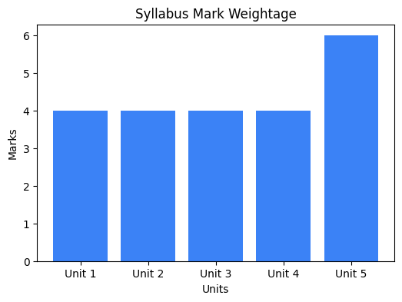
Figure 2: Weightage of marks across syllabus units.

4. AI Recommendations
• blooms_taxonomy: Consider adding more higher-order thinking questions (Analyze/Evaluate/Create)
• mark_distribution: ⚠️ Estimated time 230 mins exceeds 180 mins

---
Generated by ScruCheck AI v1.0

