ScruCheck AI - Scrutiny Report
Paper ID: PAPER_20260621_212612
Generated: 2026-06-21 21:27:26
Status: APPROVED ✅
Score: Overall Quality: 82/100 | Mandatory: 4/4 passed (5 quality criteria evaluated)

Section 1: Mandatory Compliance Status
Criterion | Status | Remarks
Format Compliance | ✅ PASS | Document structure complies with the standard format pattern.
Regulation Compliance | ✅ PASS | All regulation details (Year, Semester, Course Code) are correctly identified.
Mark Distribution | ✅ PASS | ⚠️ Estimated time 230 mins exceeds 180 mins
Permitted Aids Compliance | ✅ PASS | Permitted aids are correctly specified.

Section 2: Quality Scores
Criterion | Score | Remarks
Syllabus Coverage Score | 100/100 | Score: 100/100. Excellent syllabus coverage.
Bloom's Taxonomy Distribution Score | 50/100 | Score: 50/100. Limited cognitive diversity — increase higher-order thinking questions.
Grammar and Clarity Score | 59/100 | Low confidence (0.73). Manual review recommended.
Repetition Risk Score | 100/100 | Score: 100/100. No significant repetition detected.
Diagram and Symbol Quality Score | 100/100 | Score: 100/100. All symbols rendered correctly.

Cognitive Level Analysis (Bloom's Taxonomy)
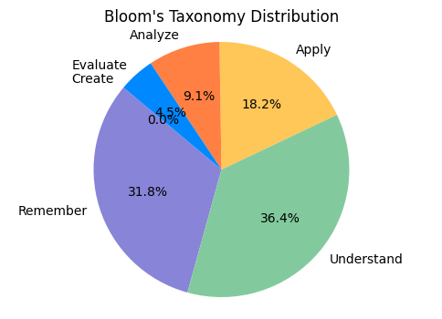
Figure 1: Distribution of marks across cognitive levels.

Syllabus Coverage
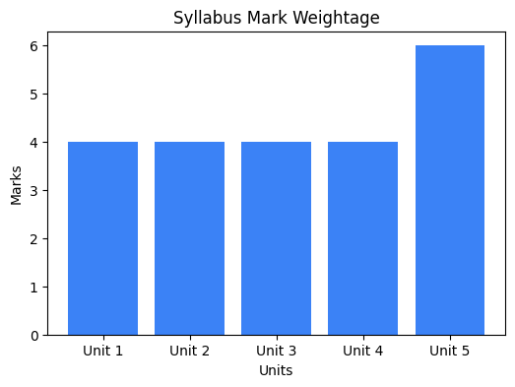
Figure 2: Weightage of marks across syllabus units.

AI Recommendations
• ⚠️ Bloom's Taxonomy Distribution Score (50/100): Score: 50/100. Limited cognitive diversity — increase higher-order thinking questions.
• ⚠️ Grammar and Clarity Score (59/100): Low confidence (0.73). Manual review recommended.
• 🔍 grammar_clarity (Needs Review): ❓ Low confidence (0.73). Manual review recommended.

---
Generated by ScruCheck AI v1.0

