IBM NAAN MUDHALVAN

APPLIED DATA SCIENCE

COVID-19 VACCINE ANALYSIS

PHASE – 3 PROJECT SUBMISSION

|  |  |
| --- | --- |
| DOMAIN | APPLIED DATA SCIENCE |
| PROJECT TOPIC | COVID-19 VACCINE ANALYSES |
| TEAM MEMBER  AND  REGISTER NUMBER | BALAJI S (420421104009)  VIGNESH K (420421104085)  DEEPAK S (420421104013)  AJITH K (420421104004) |

Dataset link: <https://www.kaggle.com/datasets/gpreda/covid-world-vaccination-progress>

**Introduction:**

The introduction section provides an overview of the project, its goals, and the dataset used for analysis.

**Project Goals:**

The main objectives of this project are to:

* Analyse the global progress of COVID-19
* vaccination efforts.
* Identify trends in vaccination rates over time.
* Explore the impact of various vaccines used in different regions.
* Provide insights and recommendations for policymakers.

**Libraries used for preprocess:**

* + Numpy
  + Pandas
  + Matplotlib
  + Seaborn

**Program:**

Step 1: Import libraries.

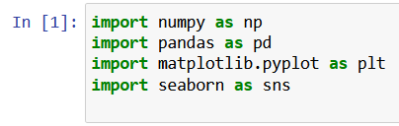

Step 2: Read the csv files.

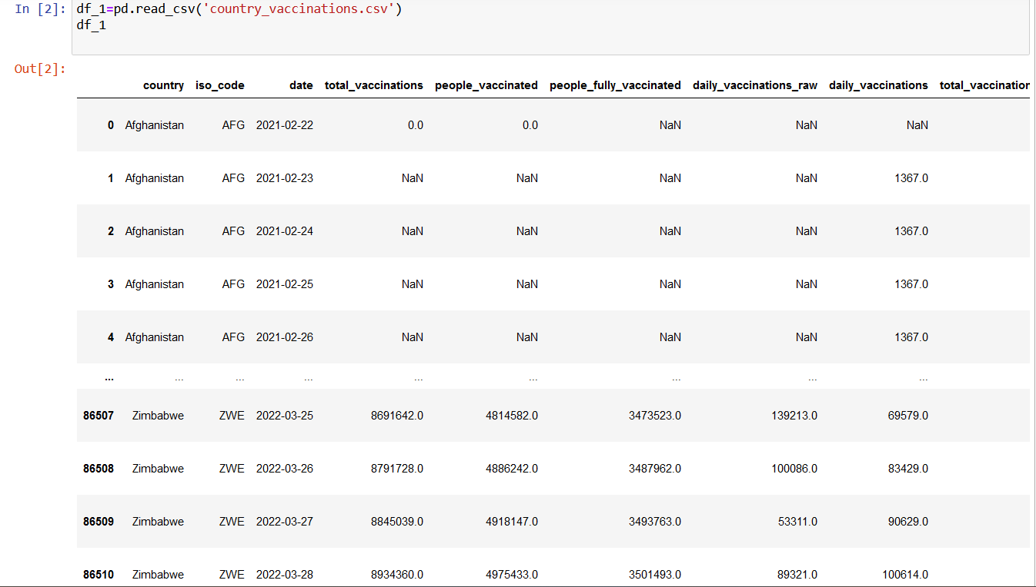

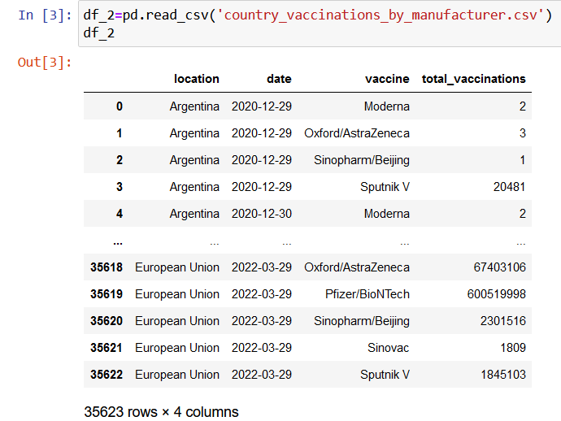

Step 3: preprocessing of Datasets.

Step 3.1: Info of datasets

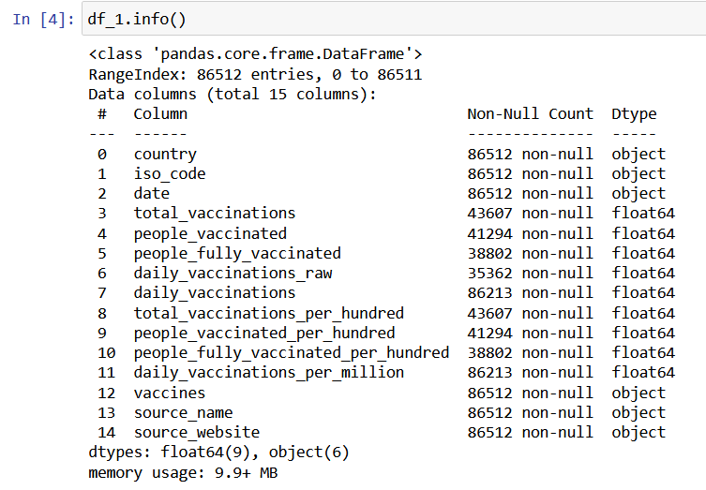

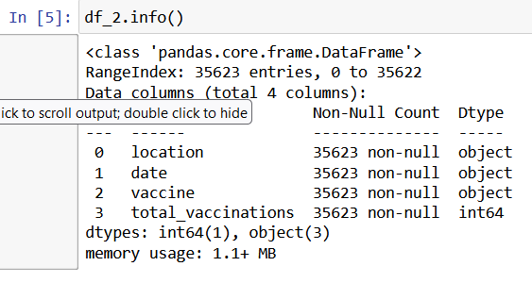

Step 3.2: Description of datasets.

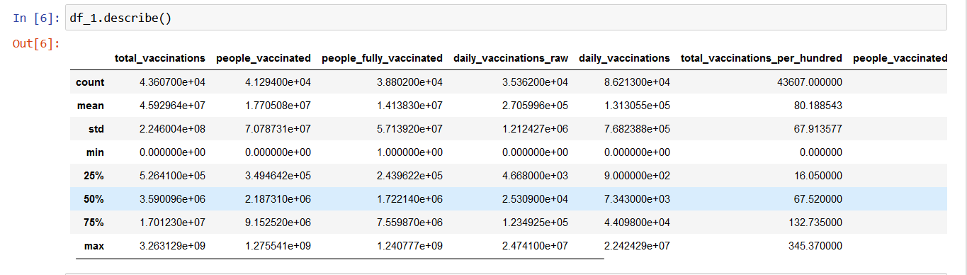

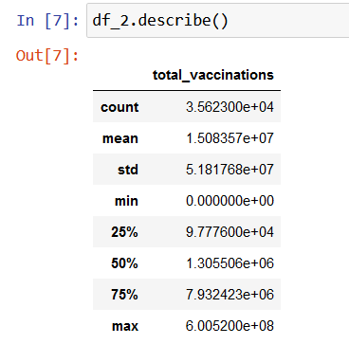

Step 3.3: display the head values of the datasets:



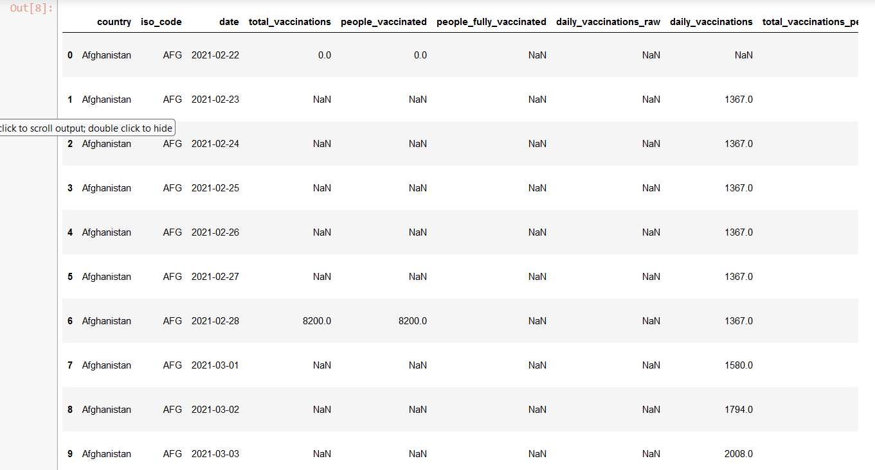

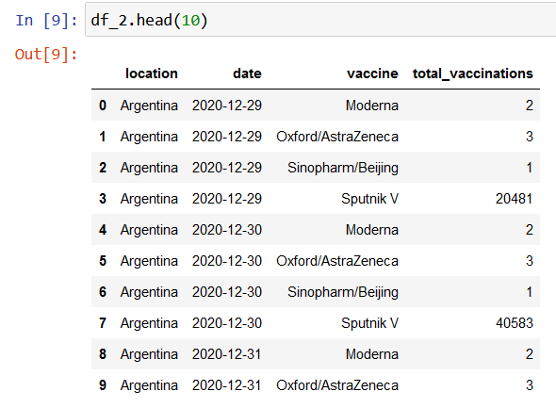

Step 4: handling the missing data.

Step 4.1: Finding the missing data.

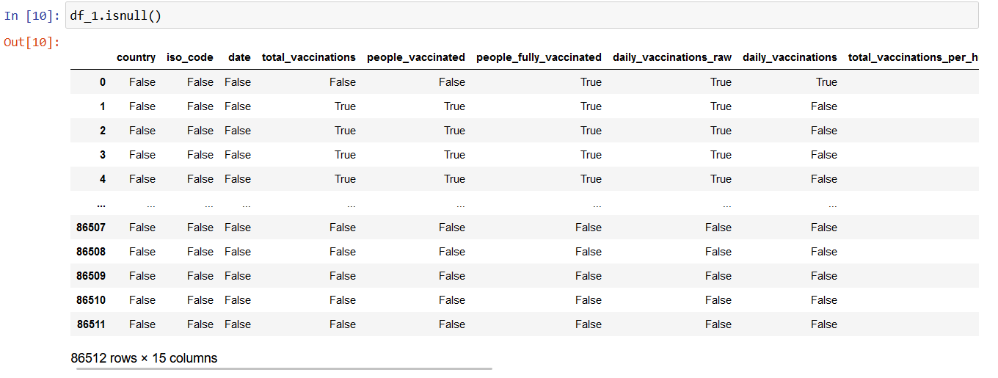

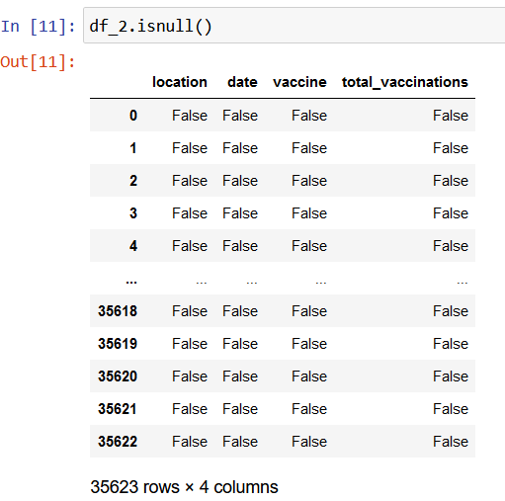

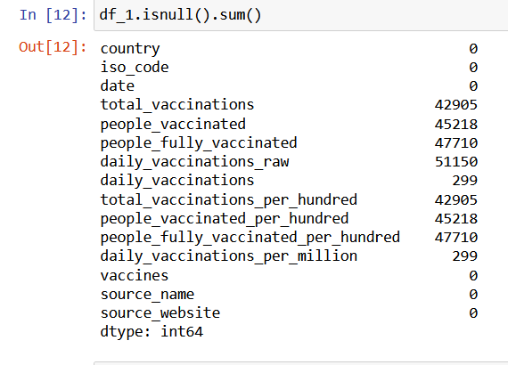

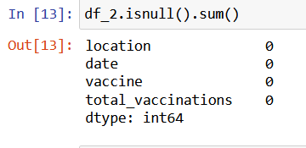

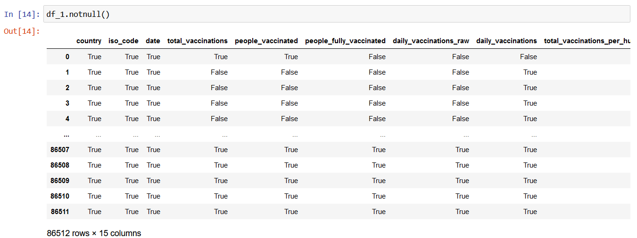

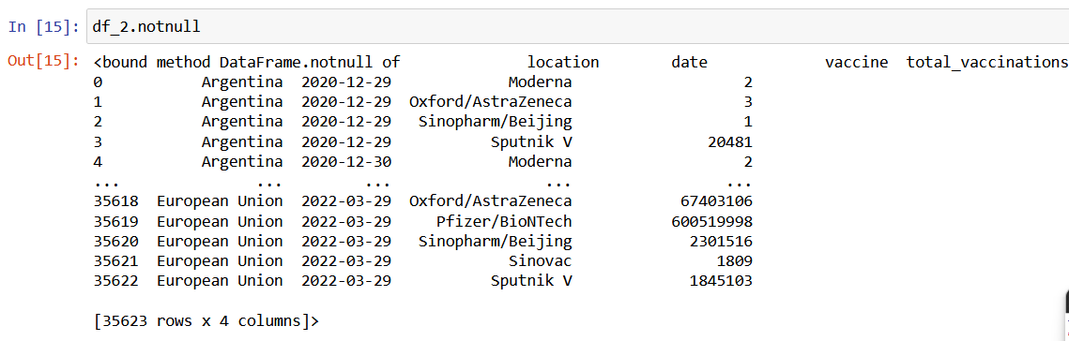

Step 4.2: Dropping the missing values.

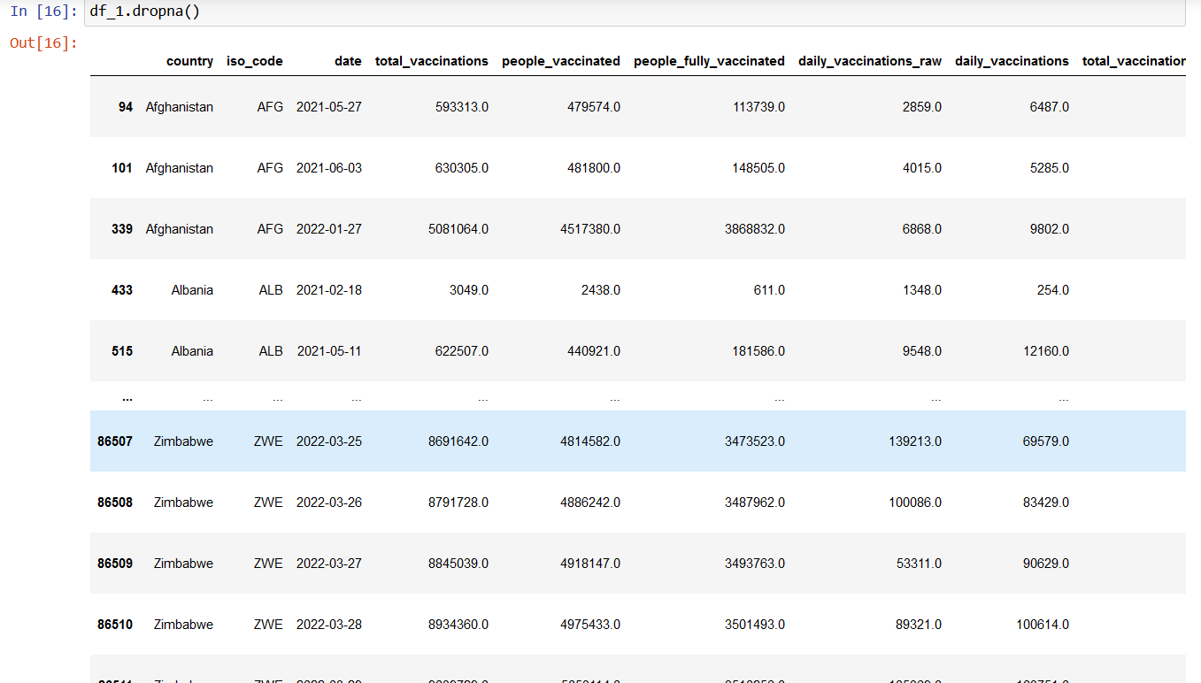

Step 5: Filling the missing value.

Step 5.1: fill null values by ‘0’

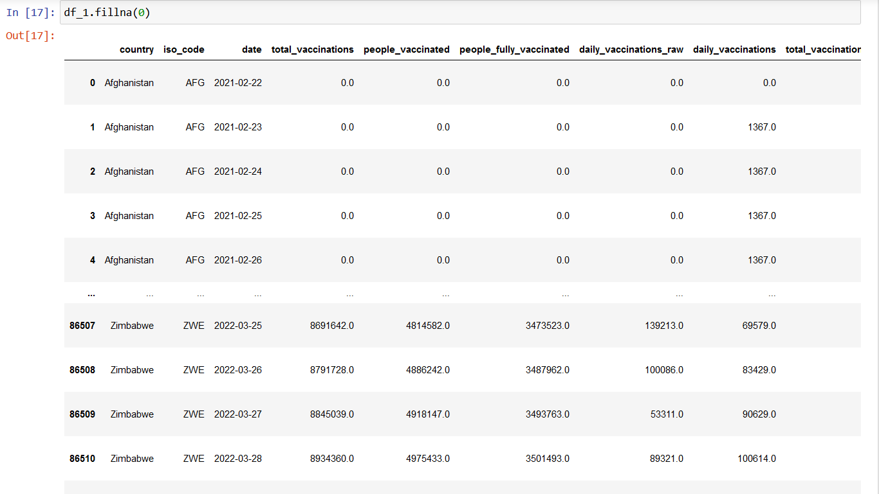

Step 5.2: filling the missing value by

‘f-fill’(forward-fill) method.

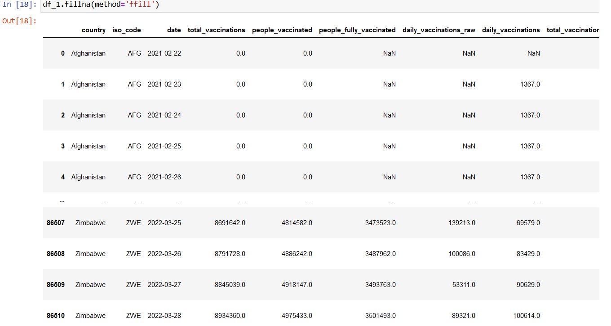

Step 5.3: filling the missing value by b-fill (backward-fill) method.

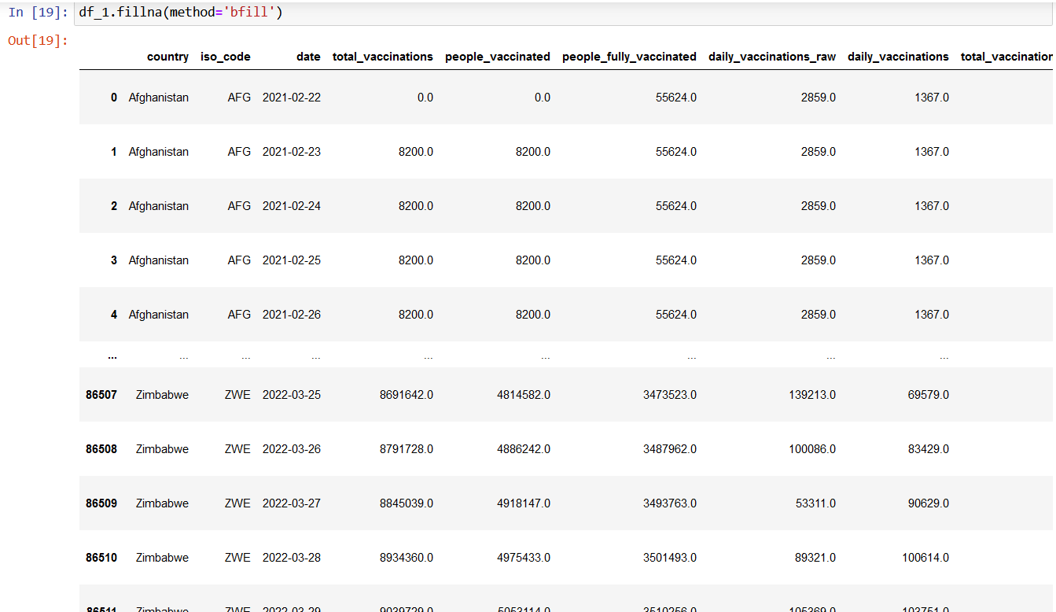

Step 6: visualize the data.

