|  |
| --- |
|  |
| Smart water fountain |
| The "Smart Water Fountain" project integrates a Raspberry Pi Pico, ultrasonic sensor, relay module, LCD display, and slide potentiometer to create an automated and interactive water fountain. This system monitors water levels, controls the pump, and offers user customization, enhancing the fountain's functionality and user experience. |

|  |
| --- |
|  |

Naan Mudhalvan Phase 5 Assessment

Course Name : Internet Of Things

Project Title : Smart Water Fountain

Team Name : Nanotrons

Team Members :

|  |  |  |
| --- | --- | --- |
| Name | Register number | Nan Mudhalvan ID |
| Vignesh V S | 721221106117 | au721221106117 |
| Nethaji Naveen Prasath S | 721221106062 | au721221106062 |
| Nithishkumar A | 721221106064 | au721221106064 |
| Suvathy K | 721221106109 | au721221106109 |
| Subathra M | 721221106106 | au721221106106 |

**Abstract**

The "Smart Water Fountain" project utilizes a Raspberry Pi Pico microcontroller, an ultrasonic sensor, a relay module, an LCD display, and a slide potentiometer to create an intelligent and interactive water fountain system. This project aims to provide an innovative and automated solution for controlling and monitoring a water fountain's operation. The ultrasonic sensor is employed to measure the water level within the fountain, ensuring that it maintains an adequate water supply. The relay module is used to control the fountain's pump, enabling automatic on/off operation based on water level readings. The LCD display provides real-time feedback to users by showcasing important information such as water level status. Additionally, the slide potentiometer offers user interaction, allowing adjustments to the water flow rate or other customizable parameters of the fountain. This project demonstrates how the fusion of hardware and software components can create an efficient, user-friendly, and smart water fountain that enhances both aesthetic appeal and functionality.

**Objective**

* The objective of the "Smart Water Fountain" project is to design and implement a water fountain system that utilizes a Raspberry Pi Pico, ultrasonic sensor, relay module, LCD display, and a slide potentiometer to achieve the following:
* Automatically monitor and maintain an optimal water level in the fountain, ensuring consistent operation.
* Control the fountain's pump using the relay module, enabling automatic on/off functionality based on water level data.
* Display real-time information about the water fountain's status on the LCD display.
* Allow user interaction through a slide potentiometer for customizing water flow or other fountain parameters.
* Create a smart and user-friendly water fountain system that combines aesthetics with functionality.

**Raspberry Pi Pico:**

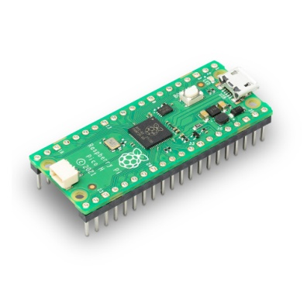

The Raspberry Pi Pico is a microcontroller board that serves as the project's brain. It provides processing power and the ability to interact with various sensors and components.

**Ultrasonic Sensor:**

An ultrasonic sensor, such as the HC-SR04, is used to measure the water level in the fountain. It works by emitting ultrasonic waves and measuring the time it takes for the waves to bounce back. This information is then used to determine the water level.

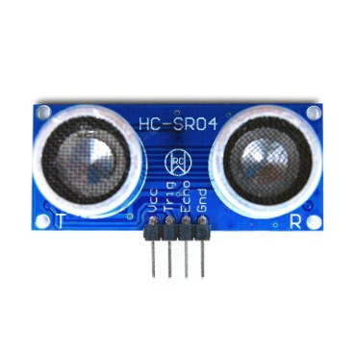

**Relay Module:**

A relay module is used to control the fountain's pump. Relays are switches that can be controlled electronically, allowing you to turn the pump on or off based on specific conditions, such as water level.

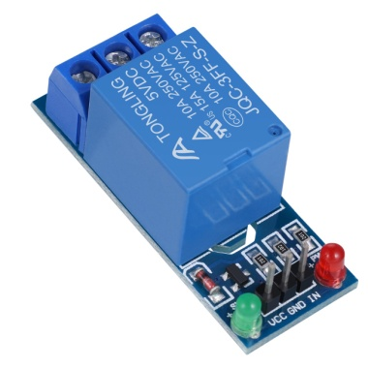

**LCD Display:**

An LCD (Liquid Crystal Display) module is used to provide visual feedback to the user. It can display information such as the current water level, system status, or user instructions.

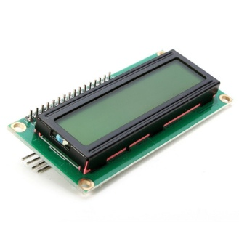

**Slide Potentiometer:**

A slide potentiometer is an input device that allows the user to slide a knob or lever to adjust settings. In your project, it can be used to control the water flow rate or other customizable parameters, adding a user interaction element to the fountain.

**User Interface:**

We use MIT App Inventor, develop an Android app that connects to your Raspberry Pi Pico-controlled smart water fountain. The app will display real-time data, such as water level and pump status, and allow users to adjust fountain settings via a user-friendly interface. Ensure secure communication for data protection.

**APP Interface**

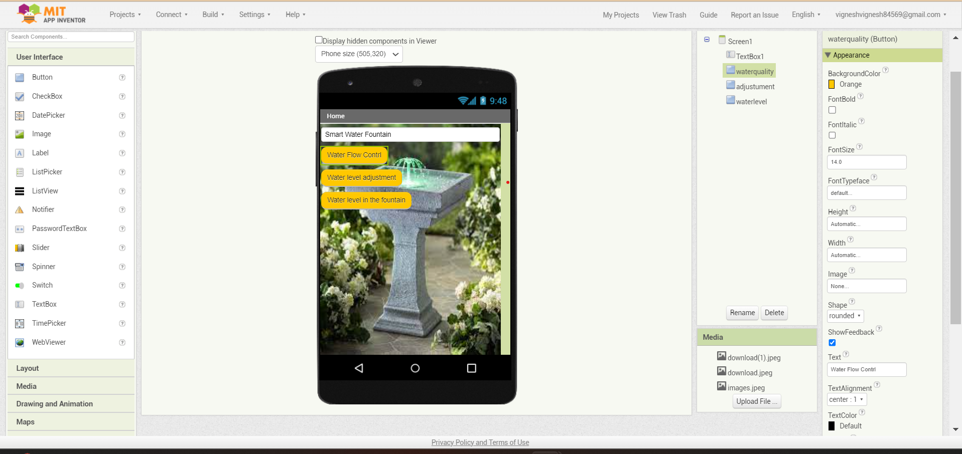

**Simulation :**

Using MIT App Inventor, develop an Android app that connects to your Raspberry Pi Pico-controlled smart water fountain. The app will display real-time data, such as water level and pump status, and allow users to adjust fountain settings via a user-friendly interface. Ensure secure communication for data protection.

**Circuit Diagram:**

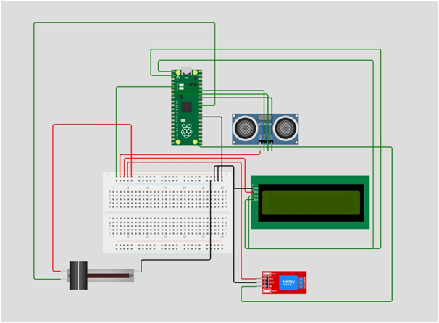

**Sourse Code:**

import machine

import ssd1306

from machine import Pin, I2C, ADC

import time

//# Initialize the I2C display

i2c = I2C(0, sda=Pin(0), scl=Pin(1), freq=400000)

oled = ssd1306.SSD1306_I2C(128, 32, i2c)

//# Ultrasonic Sensor Setup

trigger = Pin(2, Pin.OUT)

echo = Pin(3, Pin.IN)

//# Potentiometer Setup

potentiometer = ADC(Pin(26))

def read_distance():

trigger.value(0)

time.sleep_us(2)

trigger.value(1)

time.sleep_us(10)

trigger.value(0)

while echo.value() == 0:

pulse_start = time.ticks_us()

while echo.value() == 1:

pulse_end = time.ticks_us()

pulse_duration = pulse_end - pulse_start

distance = (pulse_duration * 0.0343) / 2

return distance

def read_potentiometer():

return potentiometer.read_u16() // 256 # Scale the value to match your needs

while True:

distance = read_distance()

pot_value = read_potentiometer()

oled.fill(0)

oled.text("Distance: {} cm".format(distance), 0, 0)

oled.text("Potentiometer: {}".format(pot_value), 0, 12)

oled.show()

time.sleep(1) //# Update the display every second

**Conclusion:**

In conclusion, our project involves the creation of a smart water fountain using a Raspberry Pi Pico, ultrasonic sensor, relay module, LCD display, and a slide potentiometer. We have developed a mobile app with MIT App Inventor to provide real-time monitoring and control of the fountain's parameters. The use of the Wowki simulator allows us to thoroughly test and refine the project, making it a versatile and efficient solution for enhancing water fountain functionality and user experience while ensuring data security.