

**COLLEGE CODE : 1120**

**COLLEGE NAME :JAYA SAKTHI ENGINEERING COLLEGE**

**DEPARTMENT :COMPUTER SCIENCE AND ENGINEERING**

**STUDENT NM-ID : aut1120cs01**

**ROLL NO :112023104001**

**DATE :06-05-2025**

**Completed the project named as**

**AI-POWERED QUALITY CONTROL AND MANUFACTURING**

**SUBMITTED BY,**

**NAME : ARUNSANKAR.S**

**MOBILE NO :+91 8122260563**

Title: AI-Powered Quality Control in Manufacturing

Objective:

The goal of Phase 4 is to enhance the performance of the AI system used for quality control in manufacturing. The focus is on refining defect detection models, optimizing scalability, increasing throughput, and ensuring robust integration with IoT sensors and machines. Additional emphasis is placed on improving real-time monitoring, minimizing false positives/negatives, and ensuring data security.

1. AI Model Performance Enhancement

Overview:

The defect detection AI model will be refined using production feedback and updated datasets. This will improve accuracy in detecting a wide variety of manufacturing defects in real-time.

Performance Improvements:

Accuracy Testing: Retrain the model with a larger, more diverse image/video dataset capturing real-world defects like surface scratches, misalignments, and color inconsistencies.

Model Optimization: Use hyperparameter tuning and model pruning to speed up inference and reduce hardware resource usage.

Outcome:

The AI model will detect defects more accurately and quickly, reducing production line stoppages and minimizing wastage.

2. Real-Time Monitoring & Interface Optimization

Overview:

The dashboard and control interface will be optimized for low-latency performance, allowing line supervisors to receive alerts and insights in real-time.

Key Enhancements:

Reduced Response Time: Optimize data flow from edge devices to central dashboards for instant visibility.

UI/UX Enhancements: Improve interaction design for supervisors to easily flag issues and take corrective actions.

Outcome:

Faster decision-making and smoother interaction with the system under high-volume conditions.

3. IoT Integration Performance

Overview:

Optimize integration with IoT-enabled machinery and sensors (e.g., cameras, thermal scanners, vibration detectors) for real-time defect and anomaly detection.

Key Enhancements:

Real-Time Data Processing: Improve handling of high-frequency sensor streams to ensure immediate defect alerts.

Device Compatibility: Enhance API support for a range of PLCs and industrial controllers.

Outcome:

Accurate and timely quality control through real-time analysis of production data and environmental conditions.

4. Data Security and Privacy Performance

Overview:

Secure sensitive operational data using modern encryption and access control as system adoption scales up across manufacturing units.

Key Enhancements:

Advanced Encryption: Use AES-256 and SSL for all data transmissions.

Security Testing: Conduct audits and simulate cyberattacks to validate system robustness.

Outcome:

Data remains secure and accessible only to authorized personnel, meeting industrial compliance standards like ISO/IEC 27001.

5. Performance Testing and Metrics Collection

Overview:

Rigorous testing will be conducted to validate performance under realistic production conditions. Key metrics include defect detection accuracy, system latency, and data throughput.

Implementation:

Load Testing: Simulate peak production conditions to test scalability.

Metrics Collection: Gather data on inspection time, false positive/negative rates, and alert latency.

Feedback Loop: Incorporate feedback from factory floor staff to improve usability.

Outcome:

System will be deployment-ready, capable of scaling across multiple production lines with minimal performance degradation.

Key Challenges and Solutions

1. Scalability:

Challenge: Handling data from multiple lines and units.

Solution: Distributed processing and cloud integration.

2. Accuracy under Variability:

Challenge: Maintaining detection accuracy across varied lighting, materials, and speeds.

Solution: Adaptive learning and dataset expansion.

3. Integration with Legacy Equipment:

Challenge: Older machines lacking standard interfaces.

Solution: Use edge gateways and retrofit solutions.

Outcomes of Phase 4

Enhanced AI Accuracy: More reliable detection of visual and structural defects.

Improved System Responsiveness: Fast alerts and minimal lag in high-speed environments.

Robust IoT Integration: Seamless data flow from sensors to dashboards.

Secure Data Management: Industrial-grade security for production and defect data.

Next Steps for Finalization

In the final phase, the system will be deployed across all units. Continuous feedback and fine-tuning will ensure optimal performance and support future features like predictive maintenance.

Sample code for phase 4 :

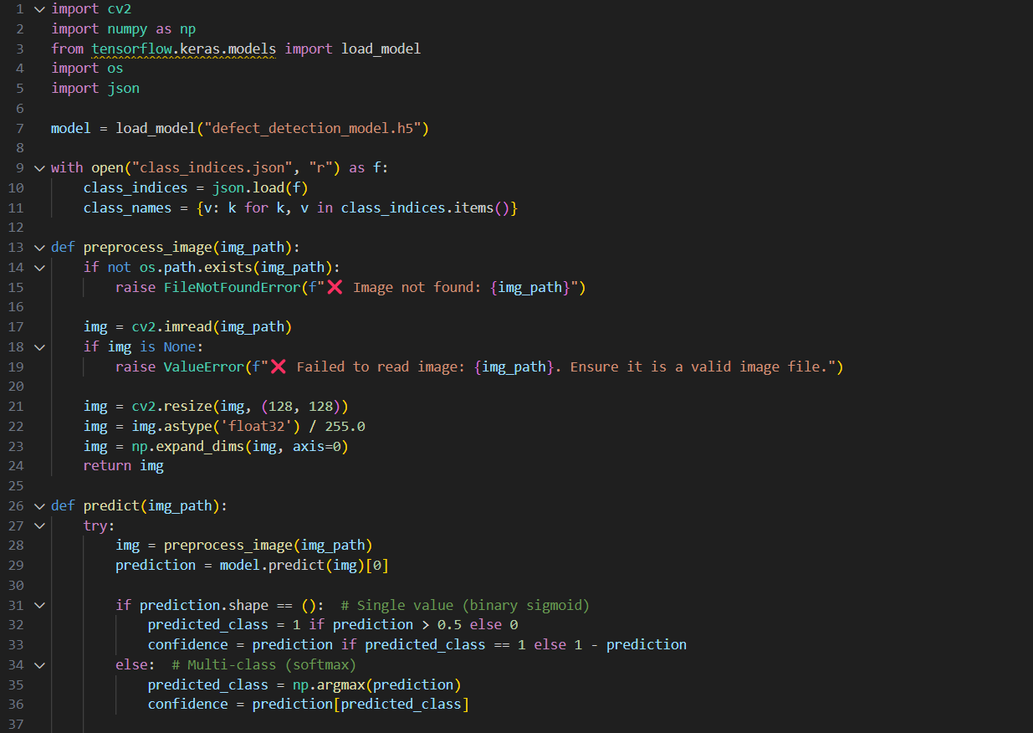

Performance metrics screenshot for phase 4 :

