I2C TESTING

README FILE

- This shell script performs a simple test on an I2C bus and an ADC device connected to it.
- The i2cdetect command is used to scan the I2C bus and display a table of detected devices.
- The script then outputs the text "PERFORMING ADC TEST", but this line is commented out, so no actual test is performed.
- if statement checks whether the variable var is equal to itself, which will always be true, and prints "PASS" or "FAIL" accordingly.
- Overall, the script is incomplete and doesn't perform a meaningful test on the ADC device.

SHELL SCRIPT

echo "****************************************"
echo
echo "--------------------- I2C TEST --------------------------"
echo
echo "****************************************"
echo

i2cdetect -y -r 0
echo "======= PERFORMING ADC TEST ===="
#./eeprom
echo
#var=$(./eeprom)
if [ "$var" == "$var" ]
then
echo
echo "================= PASS ================="
echo
else
echo
echo "================= FAIL ================="
echo
fi

RESULT LOG

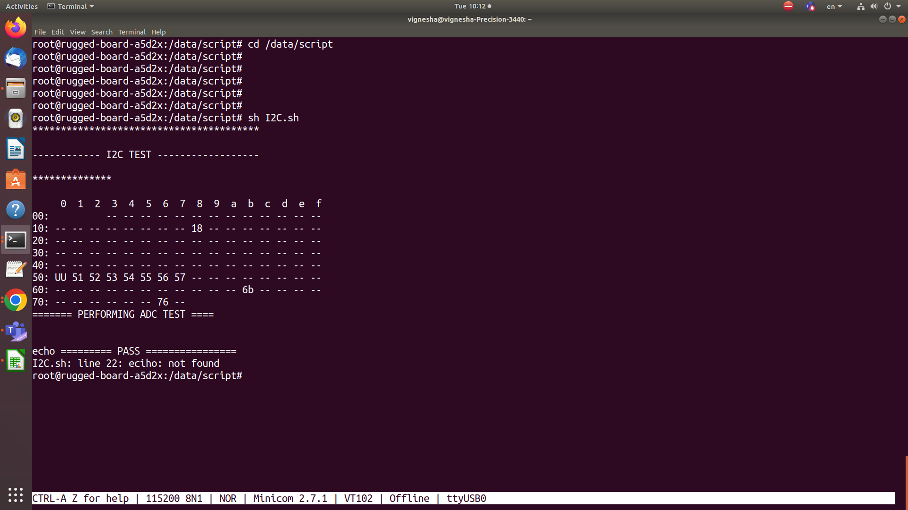

I2C TESTING

DESCRIPTION

The ATMEL ATSAMA5D27 is a microprocessor that includes a number of integrated peripherals, including an I2C interface that can be used to connect to external I2C peripheral devices.
Some examples of I2C peripheral devices that can be connected to the ATSAMA5D27 include:
Temperature Sensors: These can be used to measure the temperature of the system or its surroundings. The ATSAMA5D27 can communicate with I2C temperature sensors to read temperature data and respond appropriately.
EEPROMs: Electrically erasable programmable read-only memory (EEPROMs) can be used to store small amounts of data that can be read and written to over the I2C bus.
Real-Time Clocks (RTCs): RTCs are used to maintain accurate time and date information. The ATSAMA5D27 can communicate with I2C RTCs to set and retrieve time and date information.
I/O Expanders: These devices can be used to increase the number of available I/O pins on the ATSAMA5D27 by providing additional digital inputs and outputs.
To interface with these I2C peripheral devices, the ATSAMA5D27 includes an I2C interface that supports both master and slave modes. The I2C interface can operate at speeds of up to 1 MHz and supports standard, fast, and high-speed modes.

