**entering full name**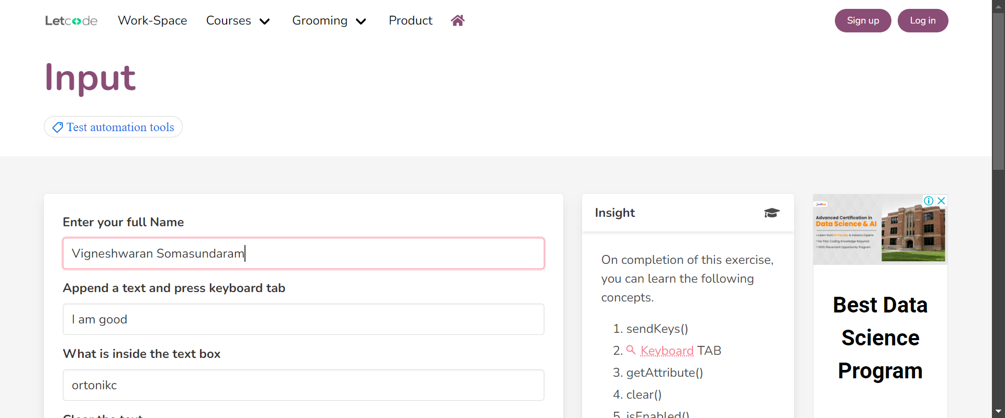

**checking the disabled text field**

**checking if the text field is read only**

**clearing the text field**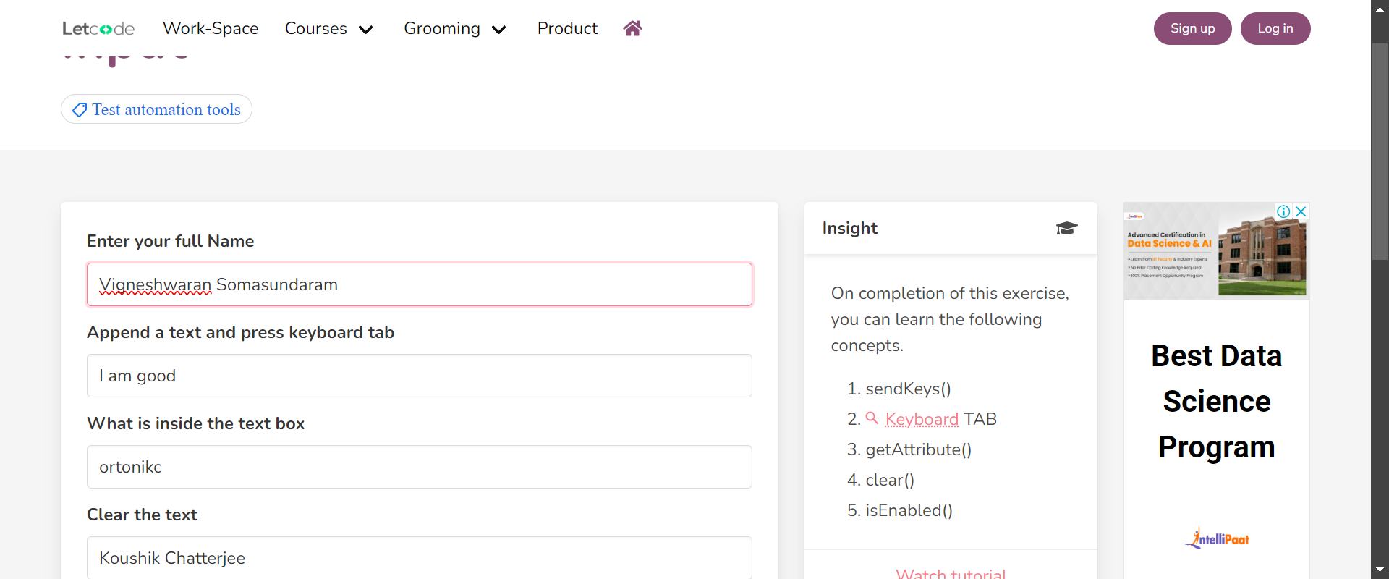

**cleared the text**