**checking the prices of shopping table**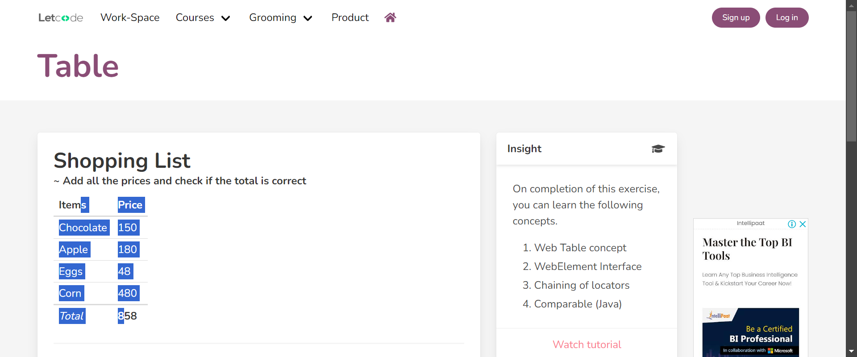

**Making Raj as present**

**Making Raj as present**