Fixing the Unbound Error
1. Clone the Project
Clone the Eclipse Java project from the remote repository.
2. Import the Project
Import the cloned project into the Eclipse workspace.
After importing, the project shows a red exclamation mark (!) on the project, which indicates an error in the build path.
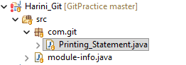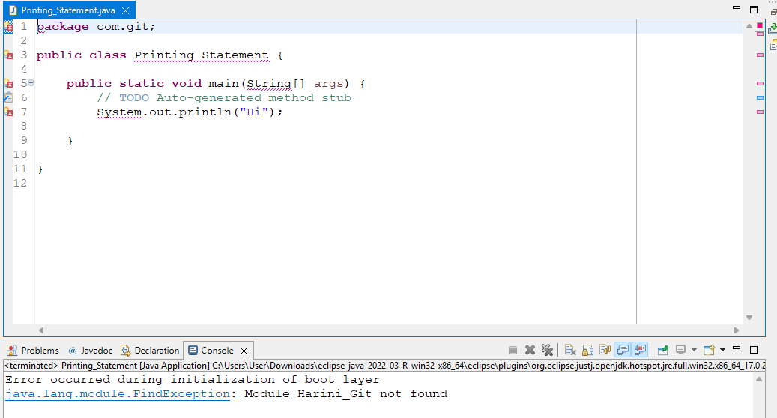
Showing error in the project lines
Showing red exclamation mark on project

Steps to Resolve
Step 1: Right click on the project → Build Path → Configure Build Path
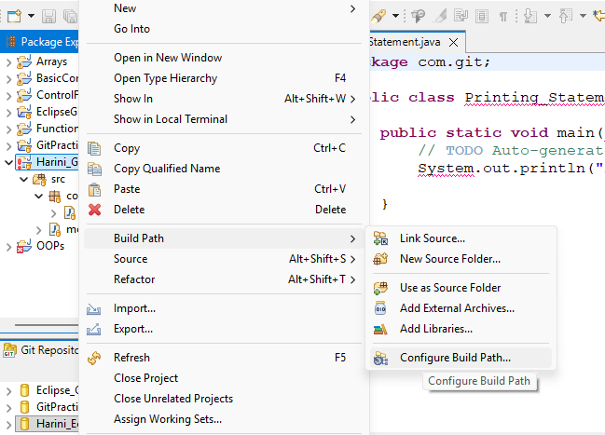
Step 2: In the Libraries tab, observe that the build path entry is missing(JRE System Library (Unbound)) is present.
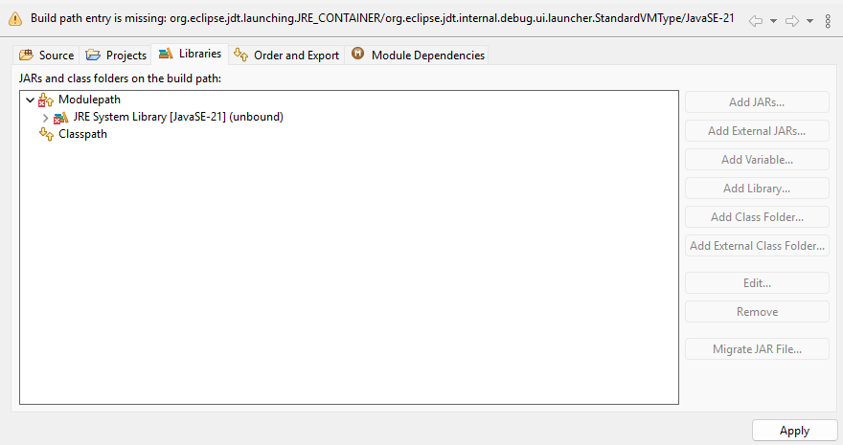
Step 3: Select JRE System Library (Unbound) and click Remove.
Step 4: Click Modulepath → Add Library → JRE System Library → Next.
Step 5: Choose Alternate JRE.
Step 6: Click Installed JREs.
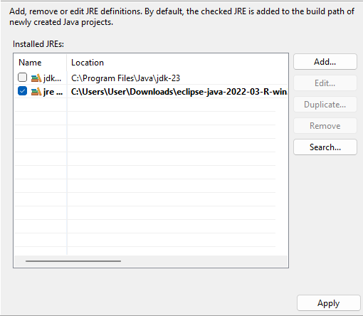
Step 7: Select the advanced path available (jdk-23).
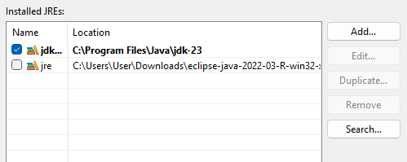
Step 8: Click Apply and Close.
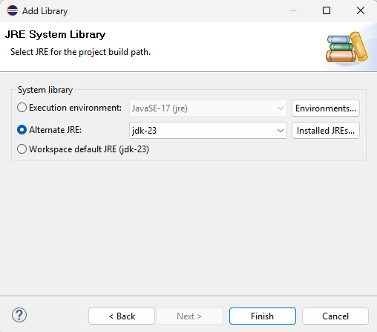
Step 9: Click Finish → Apply and Close.
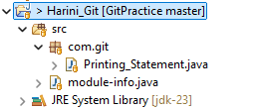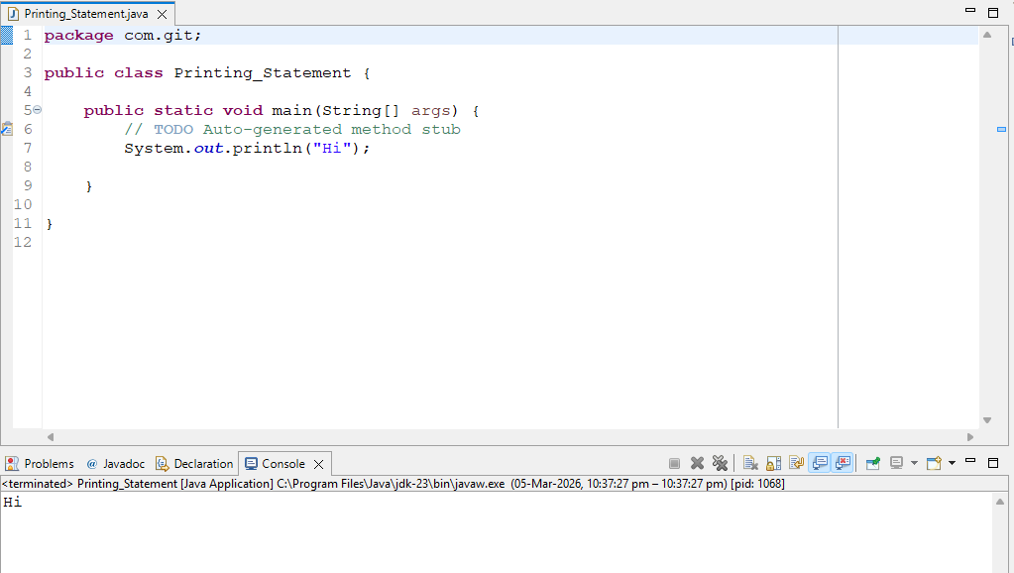
- The Unbound Error is resolved, and the program runs successfully and produces the output.

