Symbol Representation in Eclipse git project
1. Initial Project State
Initially, the project appears without any Git symbols, which indicates that the project is synchronized with the repository and there are no changes.
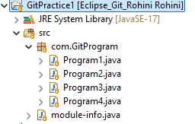
2. Adding a New File (Untracked File)
When a new file (Program5) is created, a small arrow (>) appears on the project/src/package indicating a modified folder, and a question mark (?) appears on the file indicating it is an untracked file.
When editing an existing file (Program1), the small arrow (>) appears on the project/src/package indicating that the folder contains modified files.
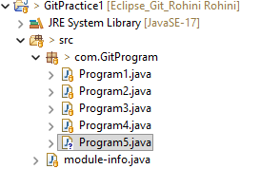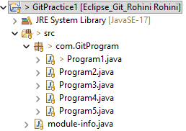
Existing File
New File Creation

3. Adding File to Index (Staging)
When the file is added to index, a plus symbol (+) appears on the newly created file indicating it is staged, and a star (*) appears on the folder showing staged changes. For an existing modified file, the star (*) appears on both the file and folder.
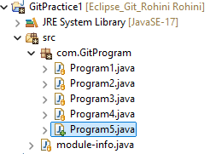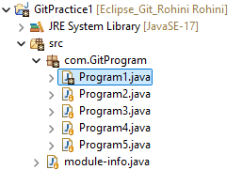
New File Creation
Existing File

4. Committing the File
After committing the staged file, the file icon changes to a cylindrical symbol, indicating it has been committed to the local repository.
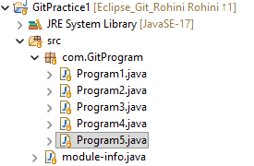
5. Commit Ready to Push
An up arrow (↑) appears on the project icon showing the commit is ready to be pushed, and the number beside it indicates the count of pending commits.
6. Pushing to Remote Repository
After pushing the commit to the remote repository, the up arrow disappears, indicating the local and remote repositories are synchronized.
7. Commit Ready to Pull
When changes are made in the remote repository (for example, creating and deleting File2, resulting in two commits), a down arrow (↓) appears on the project icon in Eclipse showing the commit is ready to be pulled. The number beside the arrow indicates the number of commits available in the remote repository to be pulled.

File created and deleted in Remote Repository

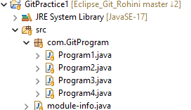
8. Pull from Remote Repository
After performing Pull, the commits from the remote repository are downloaded to the local repository, and the down arrow disappears, indicating that both the local and remote repositories are synchronized.
