Software Requirements Specification
for
A Solution For Tracking , Tracing and Controlling Movable Objects
Version 1.0 approved
Prepared by
Dhande Pranjali
Kode Nikita
Biradar Sandhyarani
Khosare Rushikesh

BRACT’s Vishwakarma Institute of Information Technology

Table of Contents
Table of Contents ii
Revision History ii
1. Introduction 1
1.1 Purpose 1
1.2 Document Conventions 1
1.3 Intended Audience and Reading Suggestions 1
1.4 Product Scope 1
1.5 References 2
2. Overall Description 3
2.1 Product Perspective 3
2.2 Product Functions 3
2.3 User Classes and Characteristics 3
2.4 Operating Environment 3
2.5 Design and Implementation Constraints 4
2.6 User Documentation 4
2.7 Assumptions and Dependencies 4
3. External Interface Requirements 4
3.1 User Interfaces 4
3.2 Hardware Interfaces 4
3.3 Software Interfaces 5
3.4 Communications Interfaces 5
4. System Features 5
4.1 Live Tracking Module 5
4.2 Reply Tracking....................................................................................................................6
4.3 Report Module……………………………………………………………………………...7
4.4 Notification Module………………………………………………………………………...7
5. Other Nonfunctional Requirements 7
5.1 Performance Requirements 7
5.2 Safety Requirements 7
5.3 Security Requirements 8
5.4 Software Quality Attributes 8
5.5 Business Rules 8
6. Other Requirements 8

Revision History
Name | Date | Reason For Changes | Version

Introduction

Purpose
Currently almost of the public are having own vehicle, some owners make available their private vehicles to the public use by taking drivers on monthly basis but the drivers drives the vehicle harshly irresponsibly and steal the petrol, we can track each and every step of vehicle and gives the report to the owner. On the basis of these reports owner can take business decisions. The safety of vehicles is extremely essential for public vehicles. Vehicle tracking system is installed in the vehicle, to track the place and locking engine motor. The place of the vehicle identified using Global Positioning system (GPS). These systems constantly watch a moving Vehicle and report the status on demand.

Document Conventions

Main Section Titles
- Font: Times New Roman
- Face: Bold
- Size: 16
Sub Section Titles
- Font: Times New Roman
- Face: Bold
- Size: 14
Other Text Explanations
- Font: Times New Roman
- Face: Normal
- Size: 12

Intended Audience and Reading Suggestions
This system is made for all people who need to track their vehicle and know the reports.

Product Scope
- The GPS technology being enhanced day by day, companies are coming up with devices that are compatible with phones and other modern gadgets. Some vehicle tracking systems integrate several security systems, for example by sending an automatic alert to a phone or email if an alarm is triggered or the vehicle is moved without authorization, or when it leaves or enters a geo fence (a hypothetical circular area ).
- In this proposed system, user is able to detect many things related to vehicle; alerts should be sent after any problem happens with vehicle such as:
Door Open/Close, Engine ON/OFF, Over Speeding, Location Changed alert, Stolen Vehicle details to Police station, Kilo meter traveled, Battery Notifications, Longitude and Latitude etc.
- Vehicle tracking systems are also popular in consumer vehicles as a theft prevention, monitoring and retrieval device. Police can simply follow the signal emitted by the tracking system and locate the stolen vehicle.

References
[1] “Tracking System using GPS and GSM: Practical Approach” International Journal of Scientific and Engineering Research Volume 3, Issue 5, May-2012 ISSN 2229-5518.

[2] “Design and development of GSM and GPS Tracking Module” IEEE International conference on recent trends in electronics information and communication technology (RTEICT), May -2017

[3] “Design and Development of GPS-GSM Tracking System with Google Map Based Monitoring”, International Journal of Computer Science, Engineering and Applications, vol. 3, no. 3, June 2013

[4] "Design and implementation of vehicle tracking system using GPS/GSM/GPRS technology and smartphone application." Internet of Things (WFIoT), 2014 IEEE World Forum on. IEEE, 2014

[5] “GPS/GSM Enabled Personal Tracker”, IJSRD - International Journal for Scientific Research & Development, Vol. 4, Issue 02, 2016.

[6] “Vehicle theft detection and tracking based on GSM and GPS” International Research Journal of Engineering and technology (IRJET) ISSN 2395-0056

Overall Description

Product Perspective
- Next generation Web Based GPS application.
- Uses GSM and GPS network
- It provides Real Time Automatic Vehicle Location, tracking.
- Tracing the Paths which the vehicle or the person travelled.
- Generating various forms of reports to assist the Executive staff.
- Sending alerts/notifications via SMS.

Product Functions
Proposed system contains Modules, depending on Number plate recognition and GPS tracking each module having different functionality. Module functionality are as follow:
- Live Tracking Module
Live tracking vehicle display on map.
- Replay Track Module
Showing animation of how vehicle traveled using date range.
- Report Module
Various reports generation and Export report into Excel file.
- Notification Module
Various notifications given to user.

User Classes and Characteristics
- Live track page.
2. Replay track page.
3. Report page for over-speeding, idle time, working time, km traveled etc.

Operating Environment
The system is a web based application it can work on any Operating System with a well- equipped web browser. It just requires internet connection to view report, to see the current position of a vehicle or person and other related activities.

• HARDWARE REQUIREMENTS:

GPS, GSM Device

• SOFTWARE REQUIREMENTS :

Operating System: Windows version 7.
Language/Platform used: .NET/JAVA
Software with version: .NET Framework 3.5 or above /Eclipse
Database: SQL /MySQL

Design and Implementation Constraints
- The GPS satellite gives the exact position of the device which is situated in the Car. This device is in turn which is connected to the local GSM service provider via a GSM network as it has SIM card present in it thus the GPS parameters which the device has are send to the tracking server which has a Static IP address via a GPRS network.

- The tracking server consists of a Socket listener application running in the back-ground which listens at a particular port. The GPS parameters received by the port listener are given to the Parser and converter for proper conversions and this data is stored in the database. These values from the database are fetched and are manipulated to get the reports in proper format. The design of system must be user friendly for stakeholders to use it with an ease.
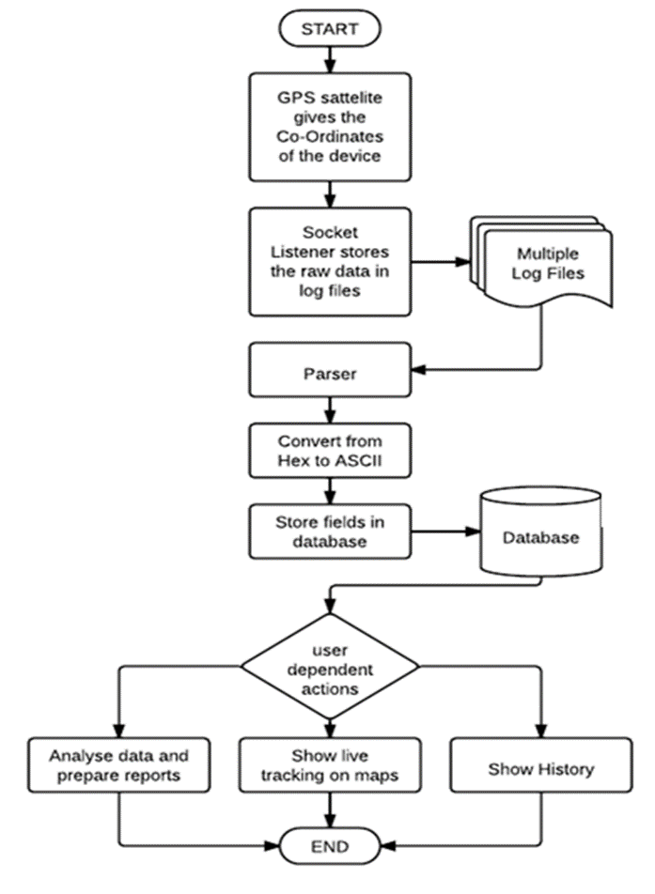

- CONSTRAINTS:
- Accuracy of image for recognition number plate depends on contrast/brightness/light.

2. GPS hardware failure results into inconsistent data to tracking system.

User Documentation
User documentation will be provided with the system. It will provide specific guidelines to a user for using the system. It gives directions for the using the system for user.

Assumptions and Dependencies
Accuracy of image for recognition number plate depends on contrast/brightness/light. GPS hardware failure results into inconsistent data to tracking system.

External Interface Requirements

User Interfaces
The user interface for the software shall be compatible to any operating system
Such as Windows, Ubuntu etc. by which user can access to the system. The user interface shall be implemented using any tool or software package like Java, Java script, HTML etc.

Hardware Interfaces
- Client PC with Internet Connection
- Server with Static IP.

- AVL (Advance Vehicle Locator) Device.
- GSM SIM Card with GPRS activated.

Software Interfaces
- Microsoft Visual Studio 10
- .NET Framework 3.0 or greater
- Multi Tracking system

Communications Interfaces
Interface is the communication interface between hardware and web application.

System Features
- Live Tracking Module:
1. Live tracking vehicle display on map.
2. Displaying vehicle details on live tracking page – carrier, last seen, IGN, Door, Battery, Temp, GPS, Speed, Latitude, Longitude, Address etc.
3. Selection for registered vehicle.
- Replay Track Module
1. Showing animation of how vehicle traveled using date range.
2. Playing, Pausing, stopping animation on map.
3. Increasing/Decreasing speed of animation on map.
4. Displaying details with animation like Time. Address, Speed, KM Traveled, Ignition, etc.
- Report Module
1. Km Traveled.
2. Idle Time – Stopped time with engine on.
3. Working Time – vehicle engine is on without stopping time
4. Speed Report – As per entered speed it will display report
5. Over-speed Report – Speed is more than defined regular speed.
6. Geo-fencing – If Traveled through some circular area.
7. Bold Stop – on which vehicle stopped for more than some interval.
8. Export report into Excel file.
- Notification Module
1. Door open/close
2. Engine on/off
3. Over-speed
4. If location changed once stopped.

Other Nonfunctional Requirements

Performance Requirements
System should take minimum time for report generation.
The system performance must not affect by the number of vehicles present. The web pages should not take much time to load the pages.

Safety Requirements
System should not do any damage to the environment and must be safe to use for all of its stakeholders. So while designing the system it should be designed by keeping all the safety norms in consideration.

Security Requirements
The system must be designed by following three tier architecture and with encrypted data so that hacker cannot hack the database of the system and system should get secured. System should not grant authentication to any unauthorized person .The system should not be vulnerable to the security attacks. Information related to admin password should be confidential.

Software Quality Attribute
Software must be reliable and correct to generate the accurate results.
It should be system independent.
The system ensures the following software quality attributes
- Reliability
- Efficiency
- Security
- User Friendliness
- Flexibility

Business Rules
Vehicles must be entered in system with unique device number.

Other Requirements
We need to use SQL Server as a database in our system. There are no any legal requirements involved in this system.
Appendix A: Glossary
GPS – Global Positioning System

