Software Requirements Specification
For
Soil Analysis Techniques for Crop Growth for a Region
Prepared by Group 34
Computer Engg. Dept. VIIT, Pune.
16-09-2018
Table of Contents
Table of Contents ii

Revision History ii
1. Introduction 1
1.1 Purpose 1
1.2 Document Conventions 1
1.3 Intended Audience and Reading Suggestions 1
1.4 Product Scope 1
1.5 References 1
2. Overall Description 2
2.1 Product Perspective 2
2.2 Product Functions 2
2.3 User Classes and Characteristics 2
Appendix A: Glossary 5
Appendix B: Analysis Models 5
Appendix C: To Be Determined List 6

Introduction

Purpose
The software requirements are specified in this document is for Soil Analysis Techniques for Crop Growth for a Region. The Analysis done in this project will try to help to choose better crop for a particular soil so as to get better results and still be environment safe, by minimizing the use of chemical fertilizers.

Document Conventions
Standards or typographical conventions that were followed when writing this SRS are as follows:
- Title of Project: - Font: Arial; Size: 32; Style: Bold; Align Text: Right.
- Details on Cover page: - Font: Arial; Size: 14; Style: Bold; Align Text: Right.
- Tables of Content Points: - Font: Times; Size: 12; Style: Bold; Align Text: Left.
- Tables of Content Sub-Points: - Font: Times; Size: 11; Style: Regular; Align Text: Left.
- Revision History: - Font: Times; Size: 18; Style: Bold; Align Text: Left.
- Topic Title: - Font: Times; Size: 18; Style: Bold; Align Text: Left.
- Sub-Topic Title: - Font: Times; Size: 14; Style: Bold; Align Text: Left.
- Paragraph: - Font: Times New Roman; Size: 11; Style: Regular; Align Text: Justify.
- Appendix/Keywords: - Font: Times New Roman; Size: 11; Style: Italics.

Intended Audience and Reading Suggestions
This document is intended for project developers, students, farmers, users, and documentation writers. SRS contains analysis of soil by various techniques to identify the features and properties to find optimized use of the soil and crop. This document is organized in simple way giving information to the reader about history and need of this analysis. The table of contents gives detailed information of the content of this SRS. The best way to approach this document is to start from the introduction to understand the approach of the analysis and why it’s done.

Product Scope
This project will work on soil and crop their properties. Aim of this project is to provide better suggestion to make agriculture practice better than present. The benefits of this project will not only will help farmers but also the population dependent on the farmers for food. This project will try to help the growth of crop in available land in more efficient way to give better produce.

References
- “Soil test”, Wikipedia, February 2012
- L. Armstrong, D. Diepeveen & R. Maddern, (2004), “The application of data mining techniques to characterize agricultural soil profiles”,
- “Methods Manual-Soil Testing in India”, Department of Agriculture & Cooperation Ministry of Agriculture Government of India 2011
- “Naïve Bayes”, Wikipedia, February 2012
- K. Samundeeswari, Dr.K.Srinivasan, “DataMining Techniques in Agriculture Prediction of Soil Fertility” ,IJSER,2017
- SupriyaDM, “Analysis of Soil behavior and Prediction of Crop Yield using Data Mining Approach”, IJIRCCE.
- D Ramesh , B Vishnu Vardhan 􀈃Data Mining Techniques and Applications to Agricultural Yield Data􀈄,International Journal of Advanced Research in Computer and Communication Engineering Vol. 2, Issue 9, September 2013.

Overall Description

Product Perspective
There is no denying the fact that agriculture is the lifeline of all human development. From its inception by domestication of crops and animals some 12,000 years ago, agriculture has been one of the major fuels if not the most important, in advancing the never-ending engine of human civilization.
The rapid escalation of food demand due to the growing population worldwide is boosting the demand for smart agriculture. The smart agriculture engages advanced technologies such as Big Data, GPS, IoT and connected devices. Smart agriculture helps in automated farming, collection of data from the field and then analyses it so that the farmer can make accurate decision in order to grow high quality crop. The field data are collected with the help of sensors, cameras, micro controllers, and actuators. Then the collected data are transferred via internet to the operator or the farmer for decision making.
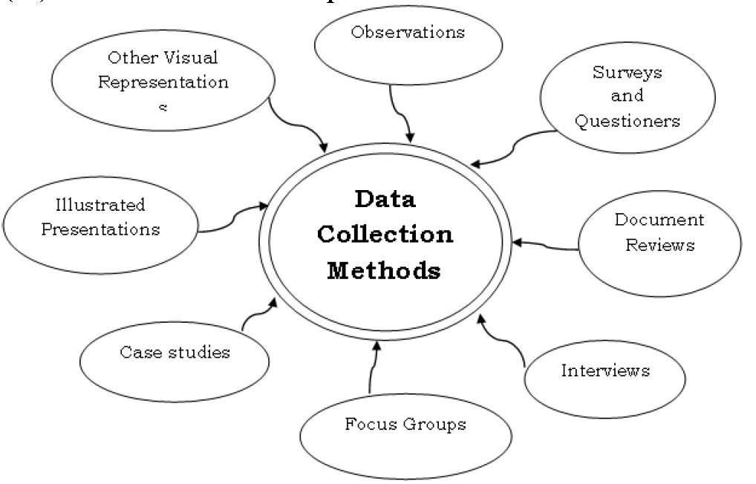

Product Functions
The major functions the analysis is to help in choosing the crop according to the soil type for a piece of land. This analysis does the following functions:
- Find the Soil features and characteristics.
- Find the Crop features and characteristics.
- Find the dependencies between the Crop and Soil.
- Weather conditions suitable for the crop.
- Fertility retention of soil after a particular crop.
- Improve the choices made over period in agriculture.
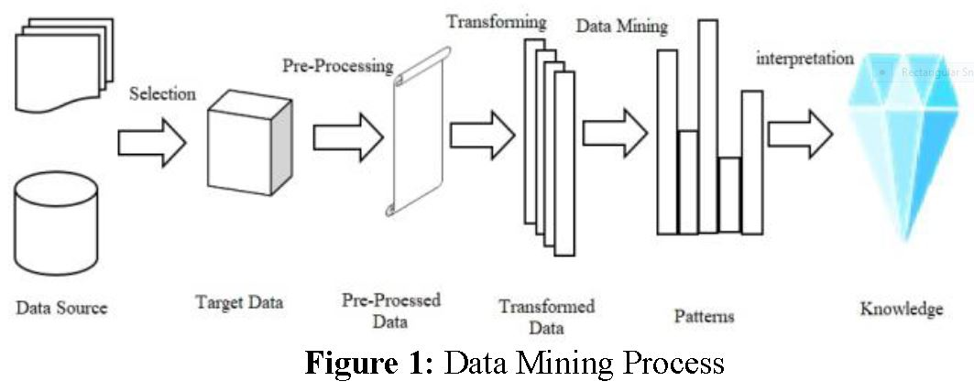

User Classes and Characteristics
This Analysis will be useful to the farmers and the agriculture scientist who need to work on better crop yield on available land. To understand this analysis user must have basic knowledge of agriculture and computer programming/algorithms. Users can use this analysis to find more outcomes and solutions that are not covered in this analysis. This analysis will benefit the society overall.

Functional specifications:
How product work entirely from users perspective
Doesn't care how implemented
▪ It’ll depend upon user using the dataset according to his objective.
1. Scenario: real life scenario
▪ In Actual practice the only method is to do a lab test every time needed and no history is available for that region.

2. System overview: big picture, deployment view
▪Dataset could be useful for more upcoming projects, and they need not create it from scratch.

3. Details of scenario: possible user interaction
▪User can edit, add and modify the dataset as per his needs.

4. Open issue: Things not clear, not decided ideally
▪GUI for the system.

5. Side notes: useful facts, notes for particular audience
▪This dataset would be made open source.

External Interface Specification:
Soft rarely work in isolation
▪use with languages that support .CSV file

Soft interaction with user and other software
Communication protocols
▪ Easily dataset can be used as file is .CSV

File format
▪.CSV
API

Technical Specification:
Hardware details:
▪ Ram 8GB; HDD 20GB available; GPU 4GB

Operating System:
▪ Linux & Windows.

Performance
Programming lang and technology
▪ Python & ML algorithm.

IDE to use
▪ Command line/ Terminal

Appendix A: METHODS OF SOIL ANALYSIS
Soil reaction (pH) - the above suspension was used, with measurements being made with a “Jones” glass electrode pH meter.
Electrical Conductivity (E.C. 25°C) – A 1:5 soil-water suspension was shaken for one hour, and the conductivity was measured with a “Philips” conductivity bridge and dip cell.
Available potassium (K avail.) — 2.5 g soil was shaken for 1 hour with 50 mL 0.05 M hydrochloric acid. After settling overnight to clear, an aliquot was diluted for potassium determination by an atomic absorption method.
Available phosphorus (P avail.) — 1 g soil was shaken with 100 mL 0.5 M sodium bicarbonate at pH 8.5 for 16 hours. Phosphorus was determined in the clarified extract by a colorimetric method (molybdenum blue).
Total nitrogen (N) — Metson (1956). Semimicro Kjeldahl method, using a Markham still.

