Dison S. Alcayde
Brgy. Baluan, General Santos
City, Philippines

September 27, 2024

Semirara Mining & Power
Corparation
Brgy. Semirara Island, Caluya,
Antique, Philippines

Dear Mam/Sir/To whom it may concern,

I humbly apologize for the mistake, I’ve done by leaving without prior notice to the company, I admit that I was wrong and I felt sorry for it, but definitely I would like to inform you my intention to resign my job as dump truck driver.

But, my concern is that I was bullied of my workmate by scratching my private parts many times and I really disappointed on it, perhaps I don’t want to be in any trouble, second I have a lack of sleep and I really felt tired, and lastly, Since I have a phobia especially in cliffs so I decided to leave.

But, I am very thankful to the opportunity that you’ve given to me, it really improves my skills and allows me to provide my needs, thank you for everything you’ve done to me,
I really appreciate it.
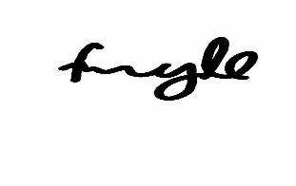
Sincerely yours,

Dison S. Alcayde

