Public Transport Optimization

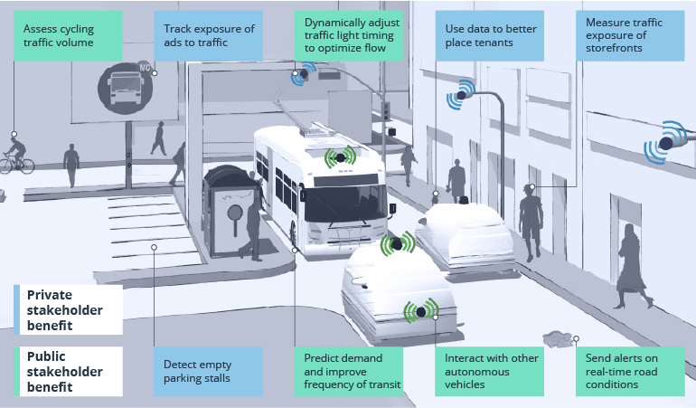The project objectives for public transport optimization are to

* Improve the efficiency and reliability of public transportation services
* Increase ridership and satisfaction with public transportation
* Reduce the environmental impact of public transportation

# IoT Sensor Design:

The following IoT sensors can be deployed in public transportation vehicles to collect data that can be used to optimize public transportation services

* GPS sensors to track the location of vehicles
* Passenger counters to track the number of passengers riding each vehicle
* Door sensors to track when vehicles are opening and closing their doors
* Fuel consumption sensors to track the fuel consumption of vehicles
* Air quality sensors to track the air quality inside vehicles

The IoT sensors should be deployed in a way that minimizes disruption to passengers and vehicle operations. For example, the GPS sensors could be installed on the roof of vehicles, while the passenger counters and door sensors could be installed inside vehicles.

# Real-Time Transit Information Platform:

The real-time transit information platform should be designed to be easy to use and accessible to all passengers. The platform should display the following information:

* Vehicle arrival times for all stops on a route
* Service disruptions and delays
* Transfers and other transportation services
* Other related information such as date and time, weather, public announcements, and security-related information

The platform should be accessible to passengers through a variety of channels, such as:

* A web-based application
* A mobile app
* Text message notifications
* Dynamic message signs at bus stops and stations

# Integration Approach:

The IoT sensors will send data to the real-time transit information platform using a cellular or Wi-Fi network. The data will be stored in a database and processed by the platform to generate real-time transit information for passengers.

### Public Transport Optimization Strategies

The real-time transit information data collected from the IoT sensors can be used to optimize public transportation services in a number of ways, including:

* **Real-time vehicle dispatching:** The data can be used to track the location of vehicles and dispatch them to areas where demand is highest.
* **Route optimization:** The data can be used to identify and address inefficiencies in public transportation routes.
* **Schedule optimization:** The data can be used to optimize public transportation schedules to reduce wait times and improve service reliability.
* **Fuel efficiency:** The data can be used to identify and address fuel-wasting behaviors, such as excessive idling.
* **Emissions reduction:** The data can be used to identify and address sources of emissions, such as old and inefficient vehicles.

# Conclusion

Public transport optimization is a complex process that involves a variety of factors, such as passenger demand, vehicle availability, and budget constraints. However, by using IoT sensors and real-time transit information, public transportation agencies can significantly improve the efficiency, reliability, and sustainability of their services.

In addition, public transport optimization can also be used to:

* Increase the accessibility of public transportation services to underserved populations
* Reduce the cost of public transportation services
* Improve the safety and security of public transportation services

By implementing public transport optimization strategies, public transportation agencies can make their services more attractive to potential riders and encourage more people to use public transportation.