LESSON 1:

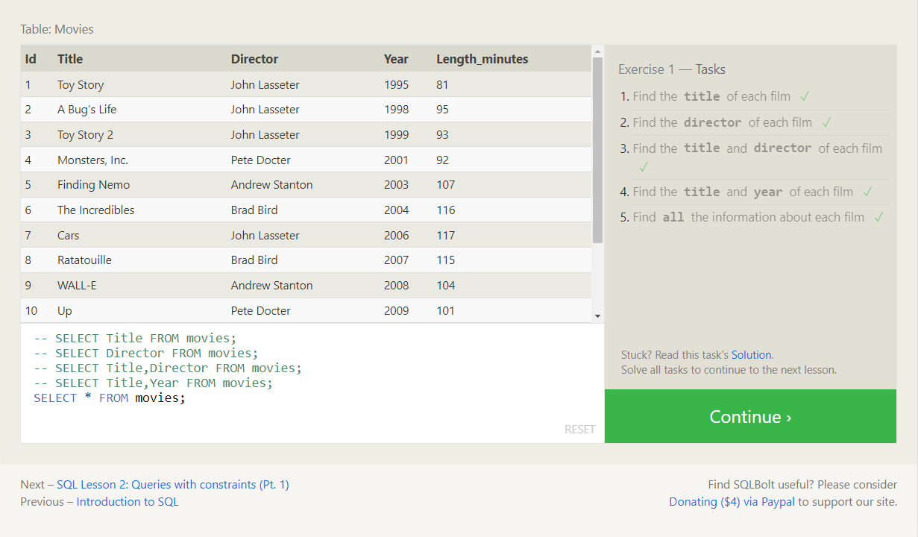

QUERIES:

1. SELECT Title FROM movies;
2. SELECT Director From Movies
3. SELECT Director,Title FROM Movies;
4. SELECT Title,Year FROM Movies;
5. SELECT * FROM Movies;

LESSON 2:

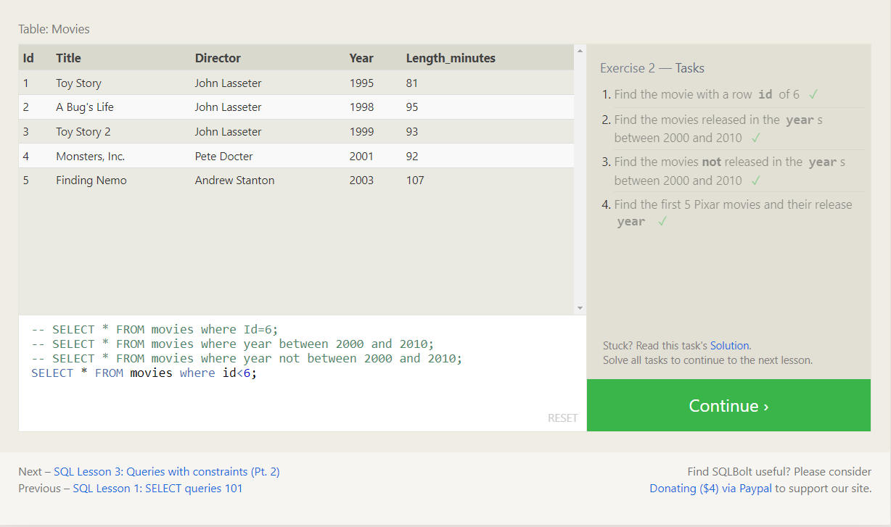

QUERIES

SELECT * FROM movies Where Id=6;

SELECT * FROM Movies Where Year Between 2000 AND 2010;

SELECT * FROM Movies Where Year NOT Between 2000 AND 2010;

SELECT * FROM Movies WHERE Id<6;

LESSON 3

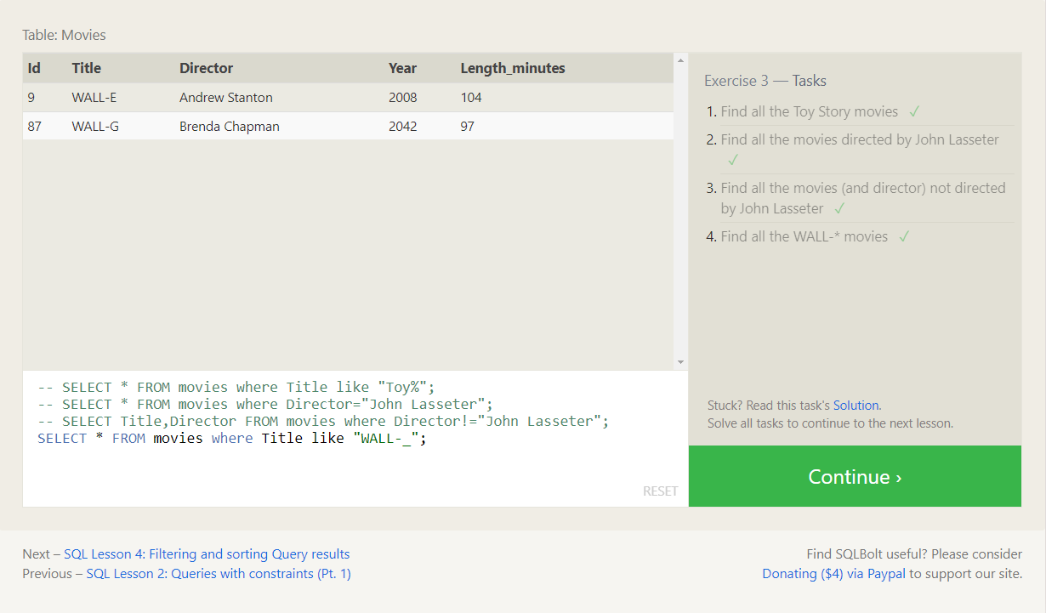

QUERIES:

SELECT * FROM movies WHERE Title Like "Toy%";

SELECT * FROM Movies Where Director="John Lasseter";

SELECT Title,Director FROM Movies Where Director!="John Lasseter";

SELECT * FROM Movies Where Title Like "WALL-%"

LESSON 4

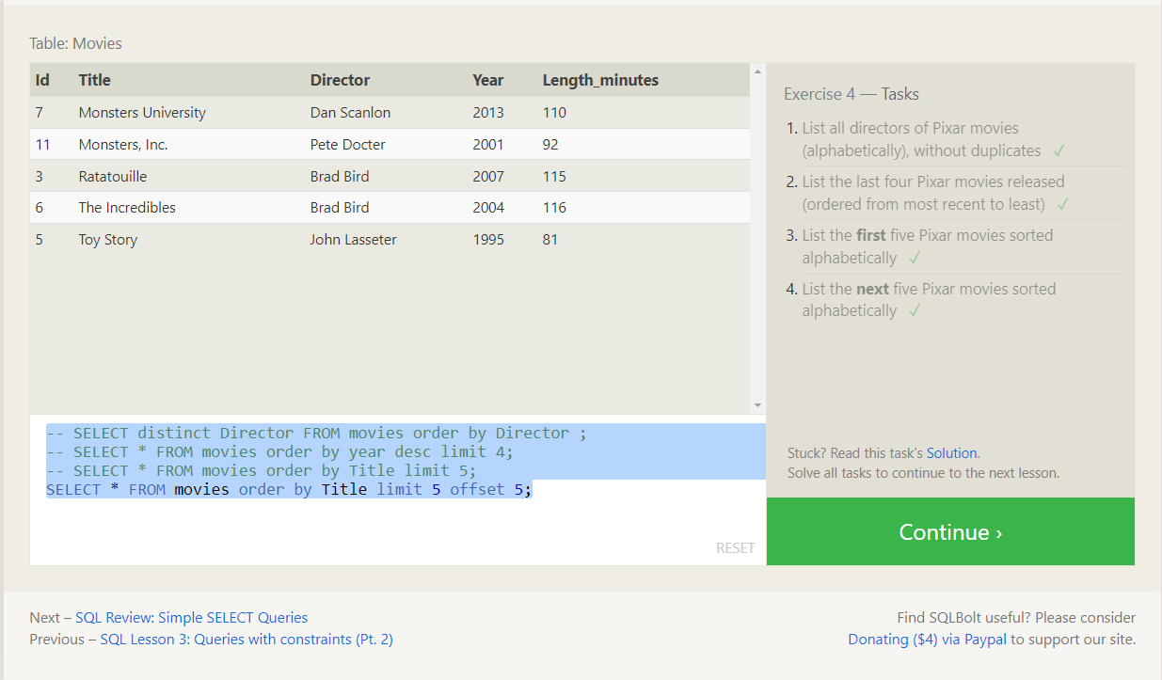

QUERIES:

SELECT distinct Director FROM movies order by Director ;

SELECT * FROM movies order by year desc limit 4;

SELECT * FROM movies order by Title limit 5;

SELECT * FROM movies order by Title limit 5 offset 5;

LESSON 5

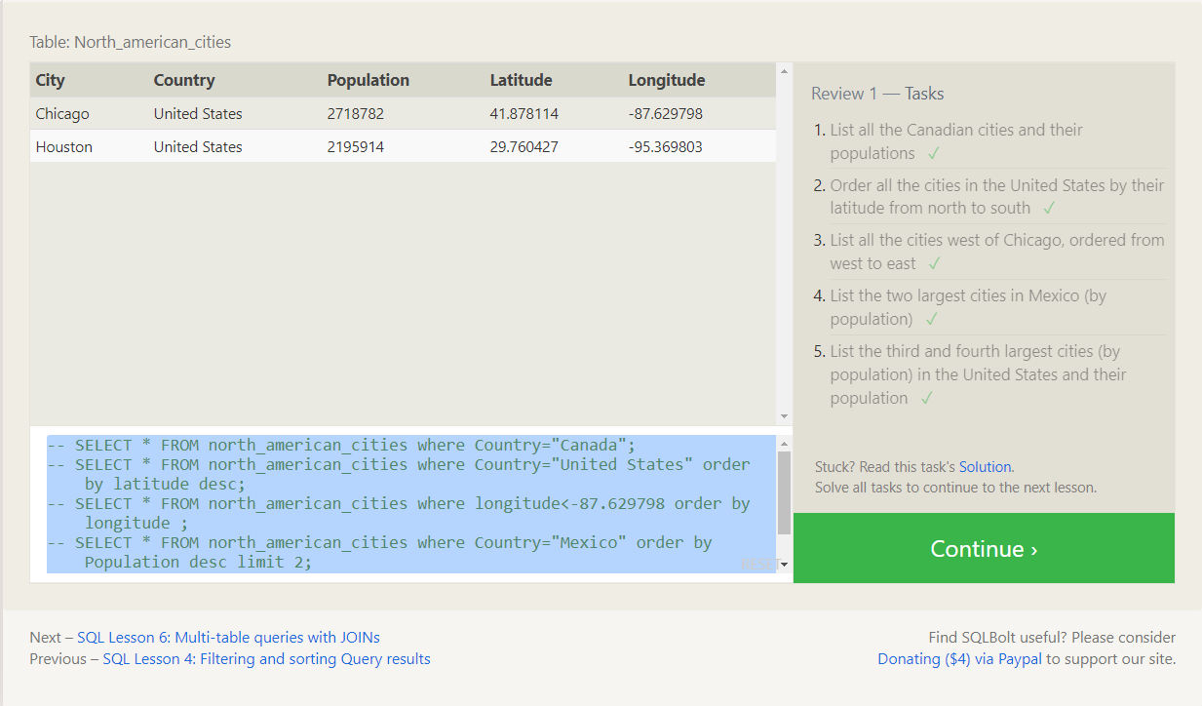

QUERIES:

SELECT * FROM north_american_cities where Country="Canada";

SELECT * FROM north_american_cities where Country="United States" order by latitude desc;

SELECT * FROM north_american_cities where longitude<-87.629798 order by longitude ;

SELECT * FROM north_american_cities where Country="Mexico" order by Population desc limit 2;

SELECT * FROM north_american_cities where Country="United States" order by Population desc limit 2 offset 2;

LESSON 6

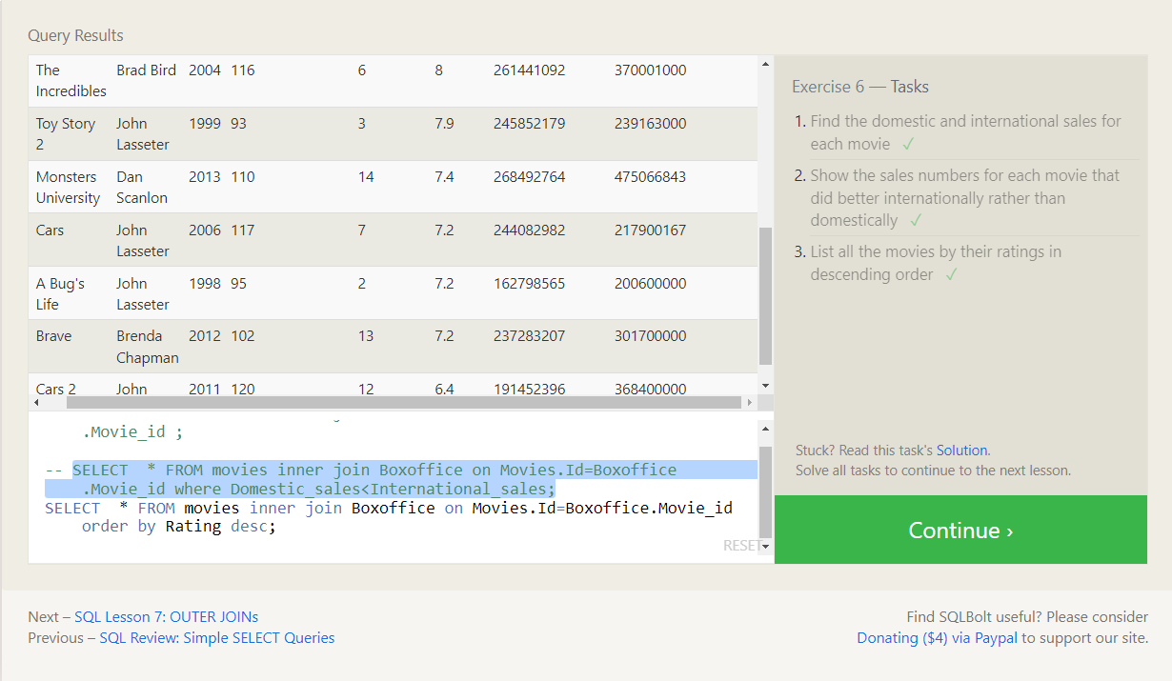

QUERIES:

SELECT * FROM movies inner join Boxoffice on Movies.Id=Boxoffice.Movie_id ;

SELECT * FROM movies inner join Boxoffice on Movies.Id=Boxoffice.Movie_id where Domestic_sales<International_sales;

SELECT * FROM movies inner join Boxoffice on Movies.Id=Boxoffice.Movie_id order by Rating desc;

LESSON 7

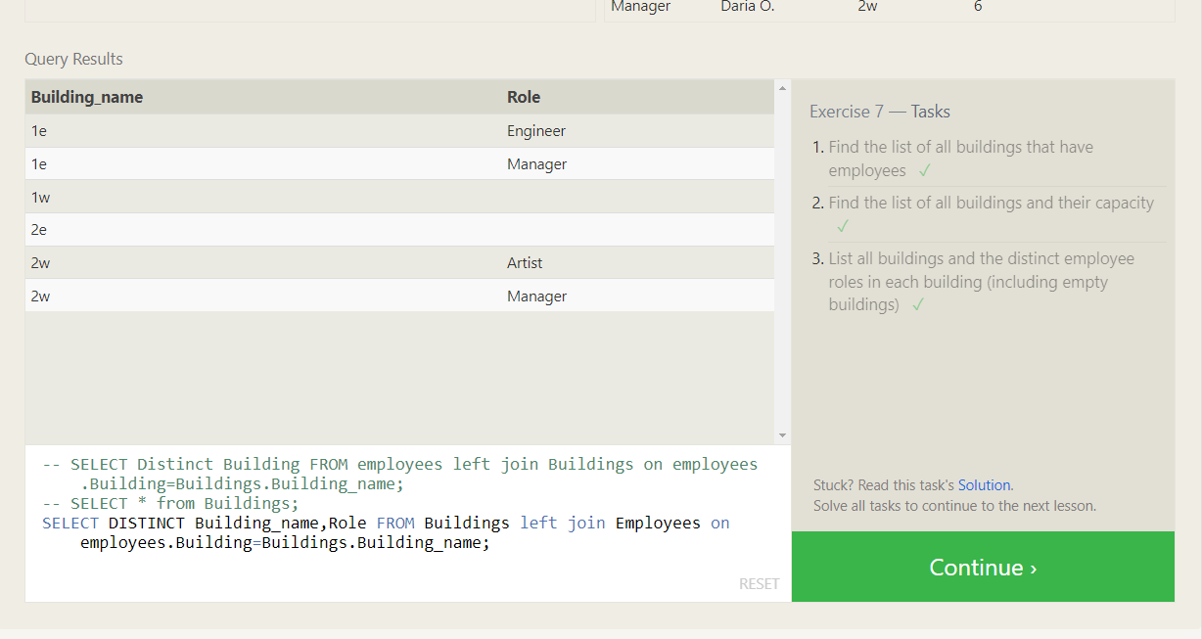

QUERIES:

SELECT Distinct Building FROM employees left join Buildings on employees.Building=Buildings.Building_name;

SELECT * from Buildings;

SELECT DISTINCT Building_name,Role FROM Buildings left join Employees on employees.Building=Buildings.Building_name;

LESSON 8

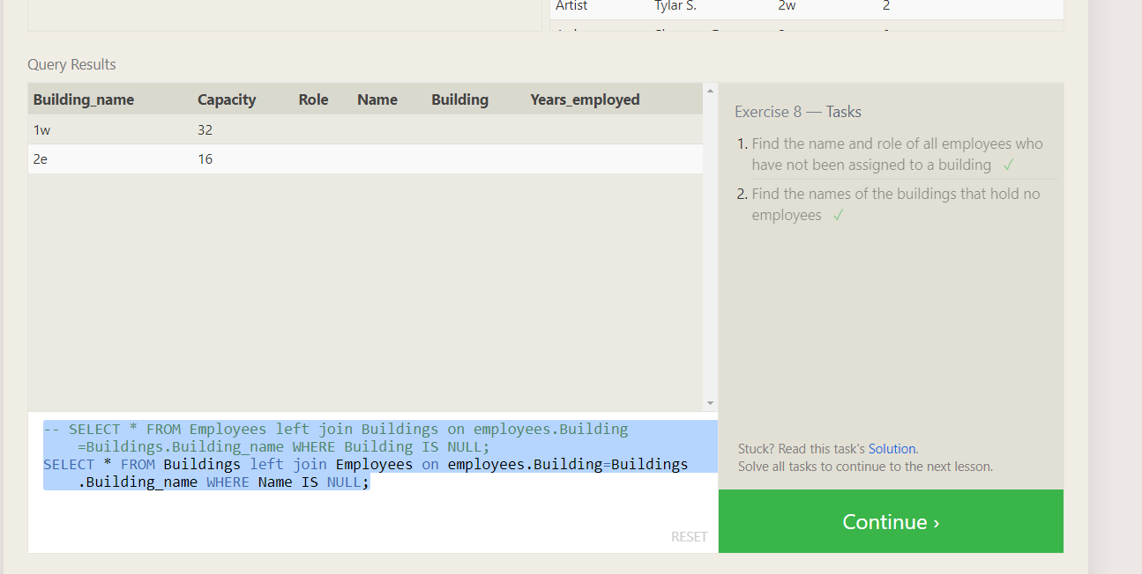

QUERIES:

SELECT * FROM Employees left join Buildings on employees.Building=Buildings.Building_name WHERE Building IS NULL;

SELECT * FROM Buildings left join Employees on employees.Building=Buildings.Building_name WHERE Name IS NULL;

LESSON 9

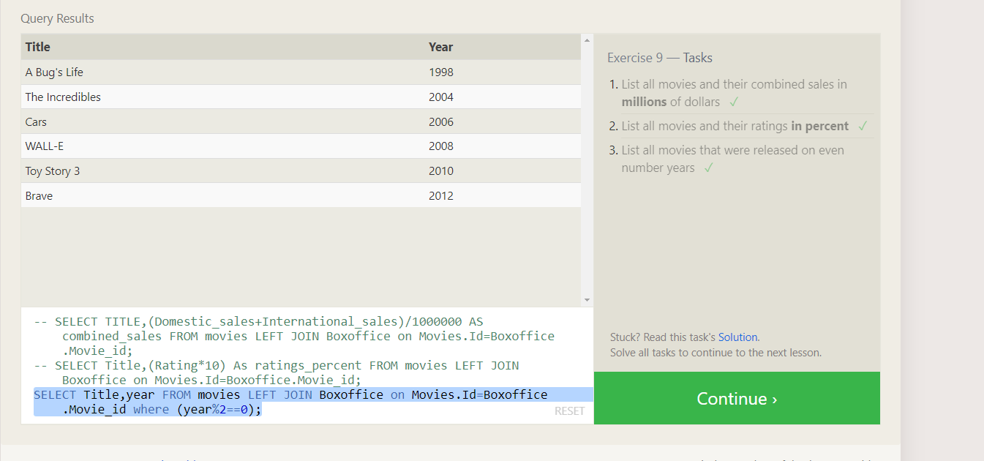

QUERIES:

SELECT TITLE,(Domestic_sales+International_sales)/1000000 AS combined_sales FROM movies LEFT JOIN Boxoffice on Movies.Id=Boxoffice.Movie_id;

SELECT Title,(Rating*10) As ratings_percent FROM movies LEFT JOIN Boxoffice on Movies.Id=Boxoffice.Movie_id;

SELECT Title,year FROM movies LEFT JOIN Boxoffice on Movies.Id=Boxoffice.Movie_id where (year%2==0);

LESSON 10

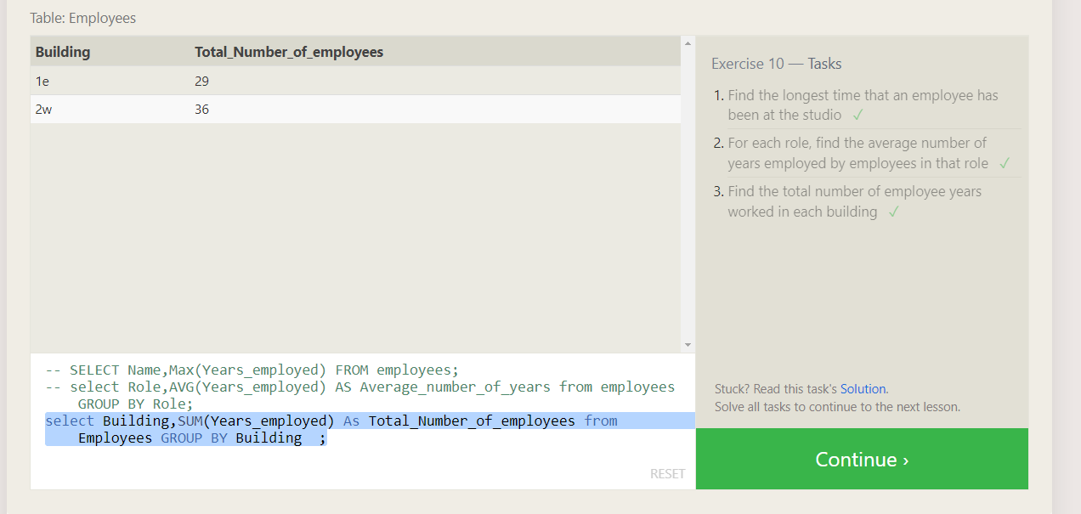

QUERIES:

SELECT Name,Max(Years_employed) FROM employees;

select Role,AVG(Years_employed) AS Average_number_of_years from employees GROUP BY Role;

select Building,SUM(Years_employed) As Total_Number_of_employees from Employees GROUP BY Building ;

LESSON 11

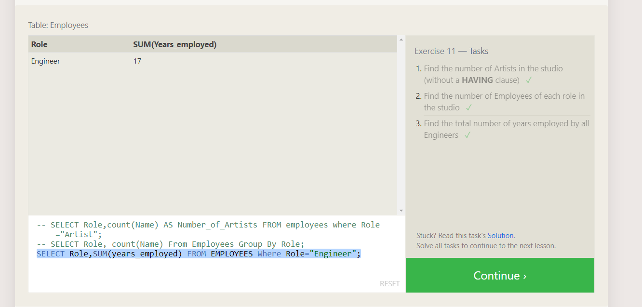

QUERIES:

SELECT Role,count(Name) AS Number_of_Artists FROM employees where Role="Artist";

SELECT Role, count(Name) From Employees Group By Role;

SELECT Role,SUM(years_employed) FROM EMPLOYEES Where Role="Engineer";

LESSON 12

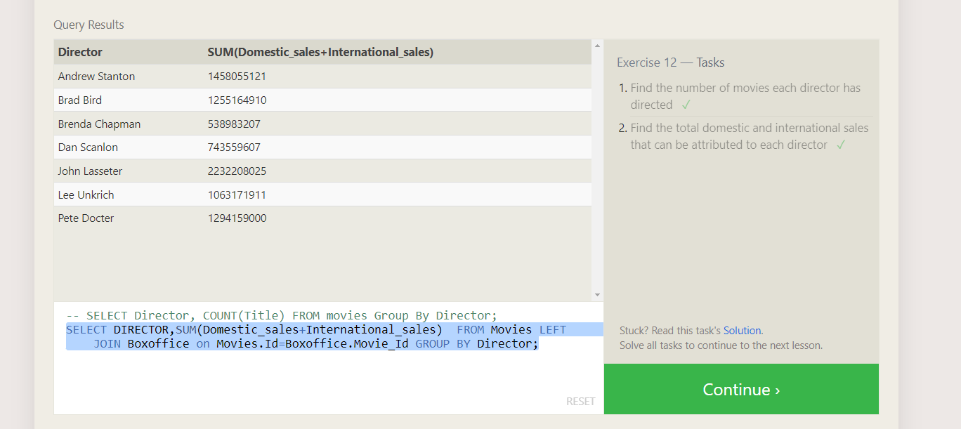

QUERIES:

SELECT Director, COUNT(Title) FROM movies Group By Director;

SELECT DIRECTOR,SUM(Domestic_sales+International_sales) FROM Movies LEFT JOIN Boxoffice on Movies.Id=Boxoffice.Movie_Id GROUP BY Director;

LESSON 13

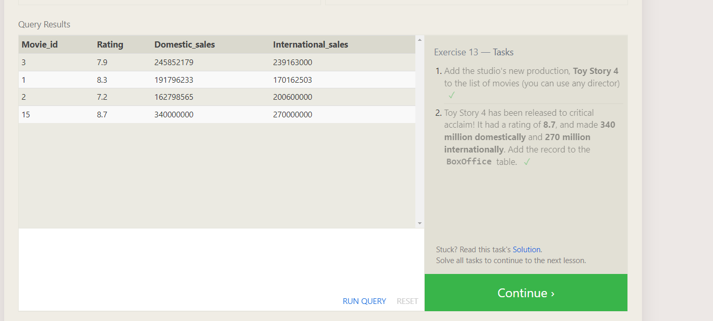

QUERIES:

INSERT INTO movies (Title, Director, Year, Length_minutes)

VALUES ('Toy Story 4', 'Josh Cooley', 2019, 1000);

INSERT INTO Boxoffice (Movie_id,Rating,Domestic_sales,International_sales) VALUES(15,8.7,340000000,270000000)

LESSON 14

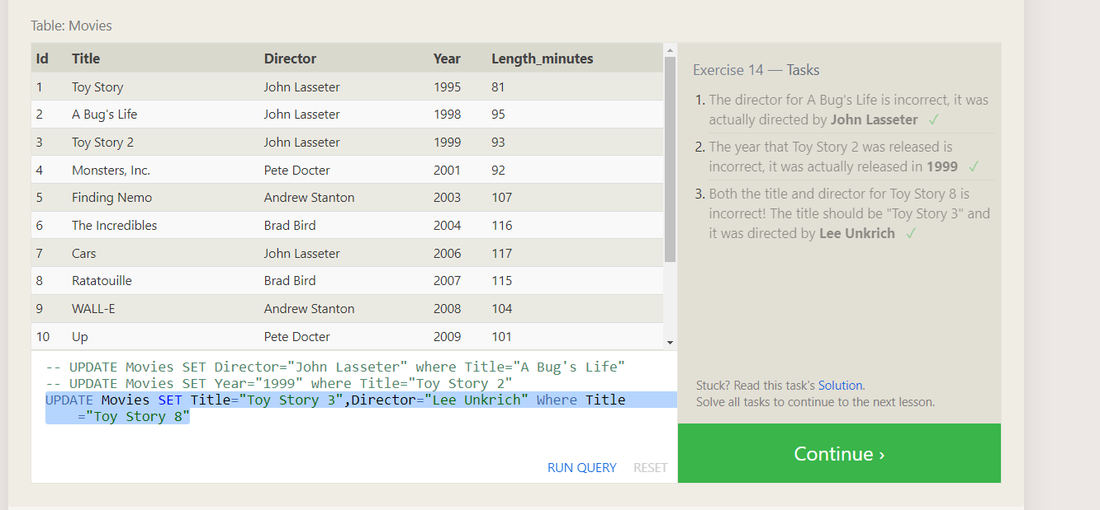

QUERIES:

UPDATE Movies SET Director="John Lasseter" where Title="A Bug's Life"

UPDATE Movies SET Year="1999" where Title="Toy Story 2"

UPDATE Movies SET Title="Toy Story 3",Director="Lee Unkrich" Where Title="Toy Story 8"

LESSON 15

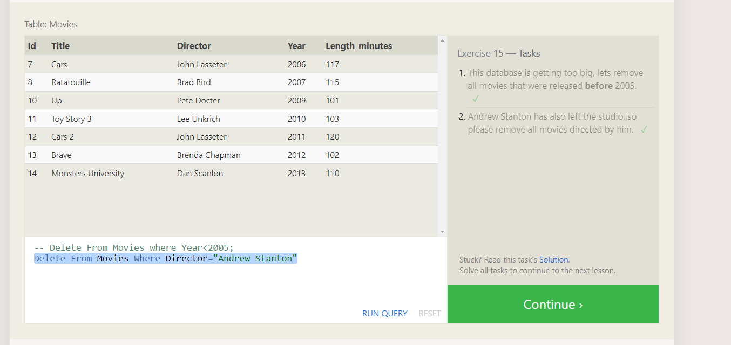

QUERIES:

Delete From Movies where Year<2005;

Delete From Movies Where Director="Andrew Stanton"

LESSON 16

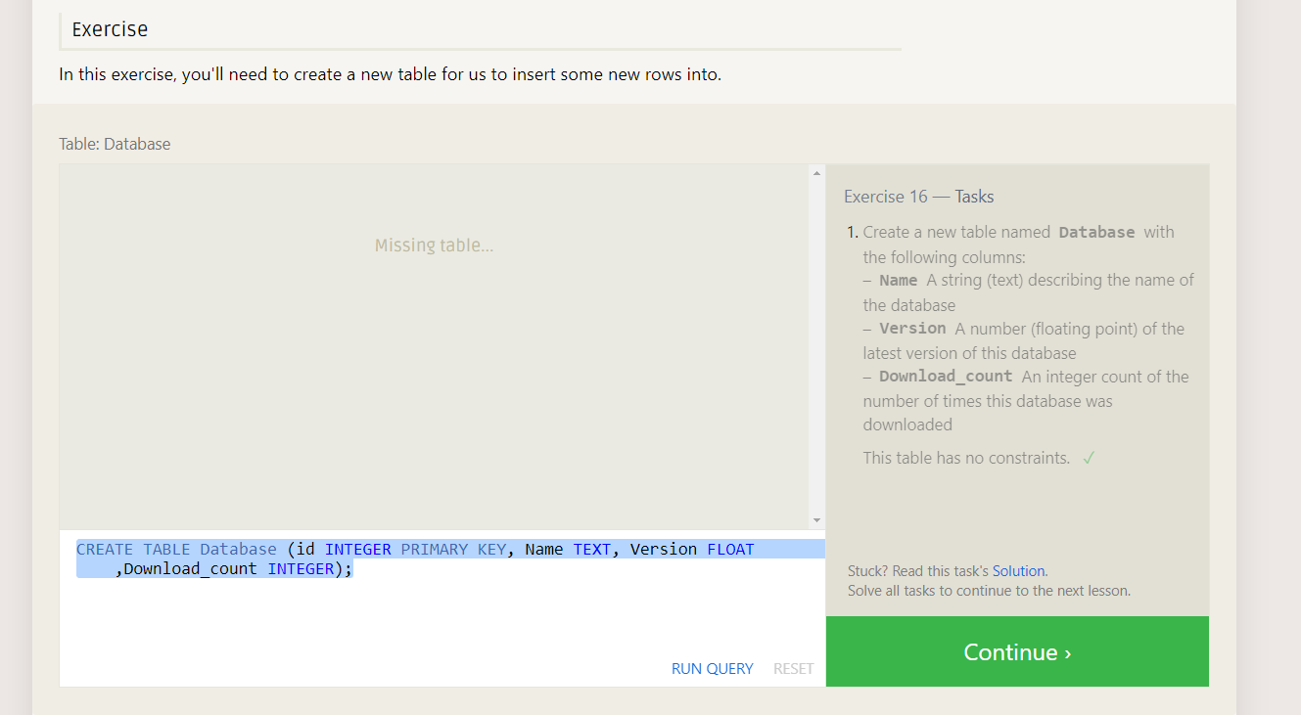

QUERIES:

CREATE TABLE Database (id INTEGER PRIMARY KEY, Name TEXT, Version FLOAT,Download_count INTEGER);

LESSON 17

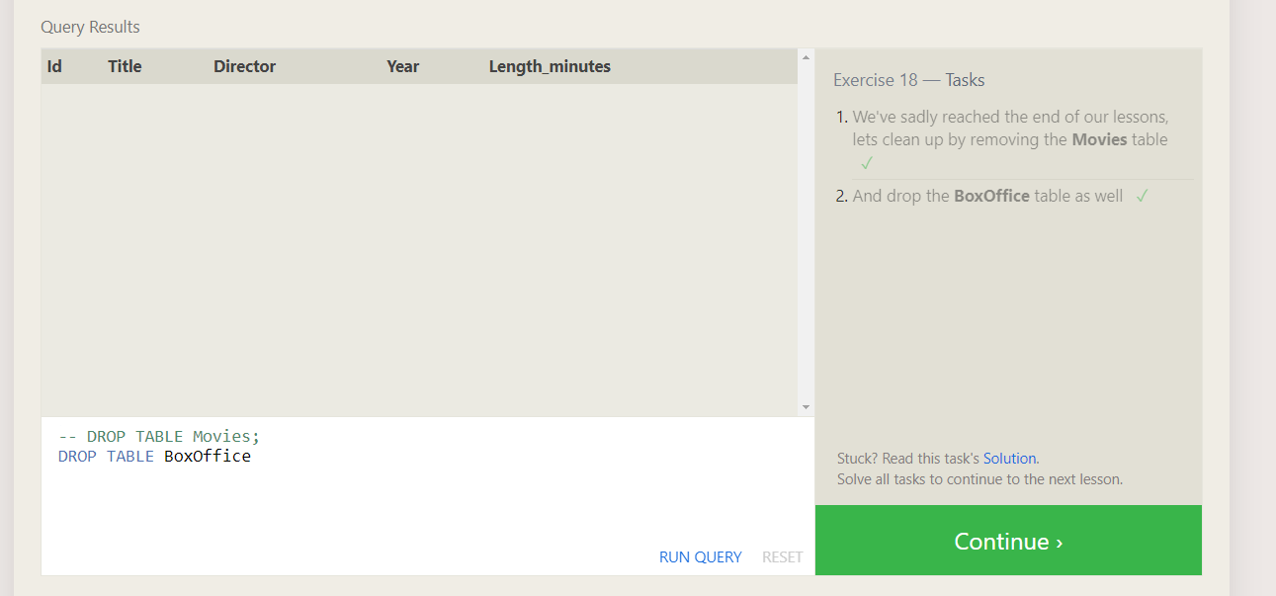

QUERIES:

ALTER TABLE Movies ADD Aspect_ratio FLOAT;

ALTER TABLE Movies ADD Language TEXT DEFAULT "English";

LESSON 18



QUERIES:

DROP TABLE Movies;

DROP TABLE BoxOffice;