NODEJS FILESYSTEM TASK

GITHUB REPO: https://github.com/VIJAY-MERNDEVELOPER/Node.git

Render URL : https://github-com-vijay-merndeveloper.onrender.com/

CreateFile Endpoints : https://github-com-vijay-merndeveloper.onrender.com/createFile/

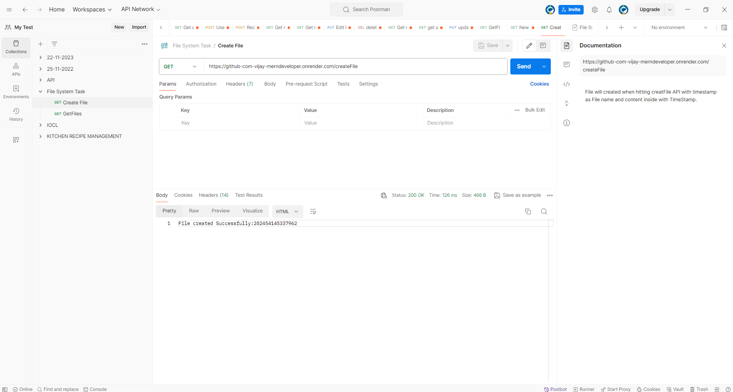

getFiles Endpoint : https://github-com-vijay-merndeveloper.onrender.com/getFiles

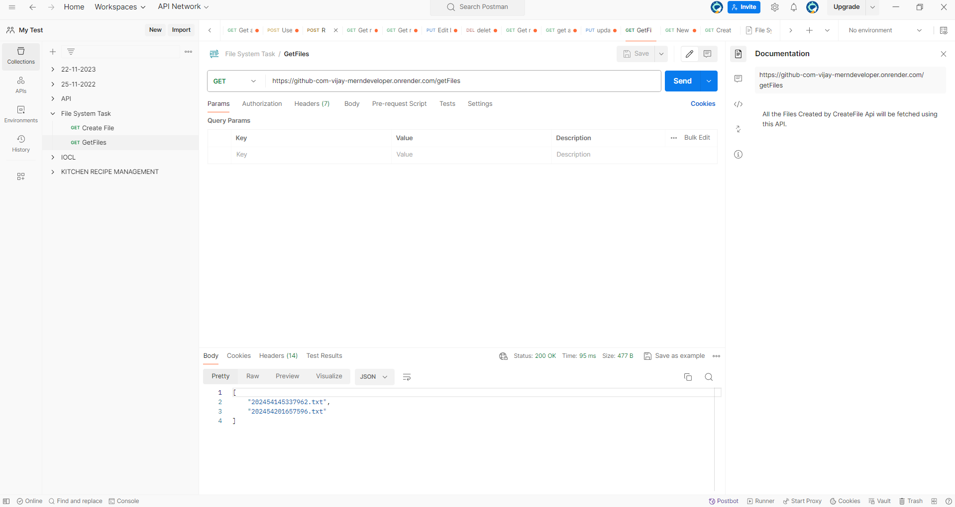

POSTMAN DOCS SCREENSHOT

