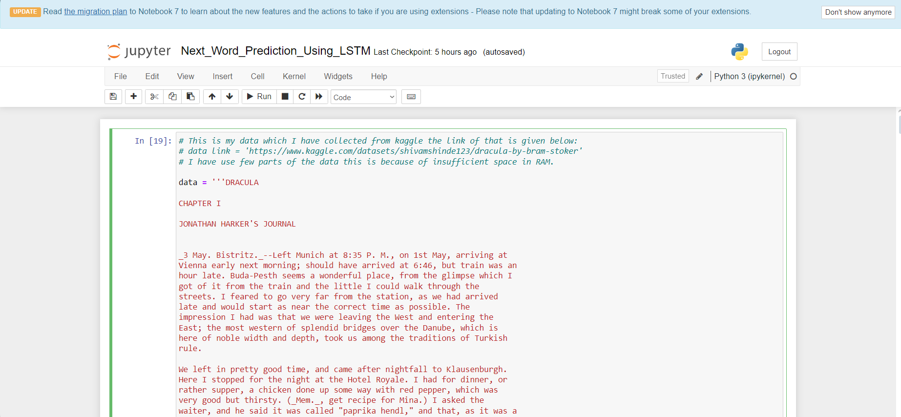

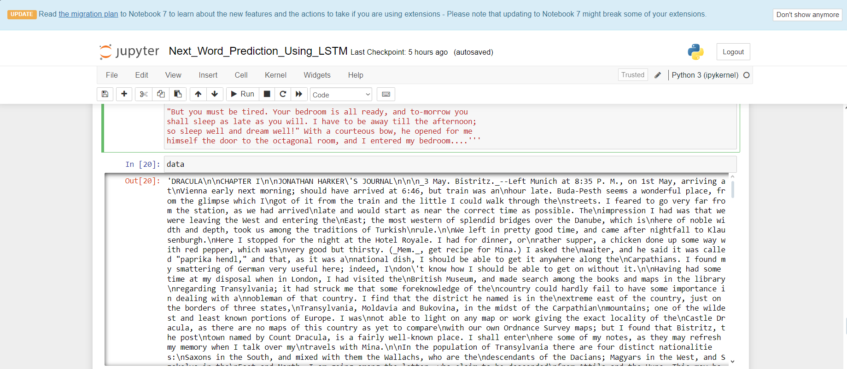

In the above screens upload sample dataset and cleaned all the stop words.

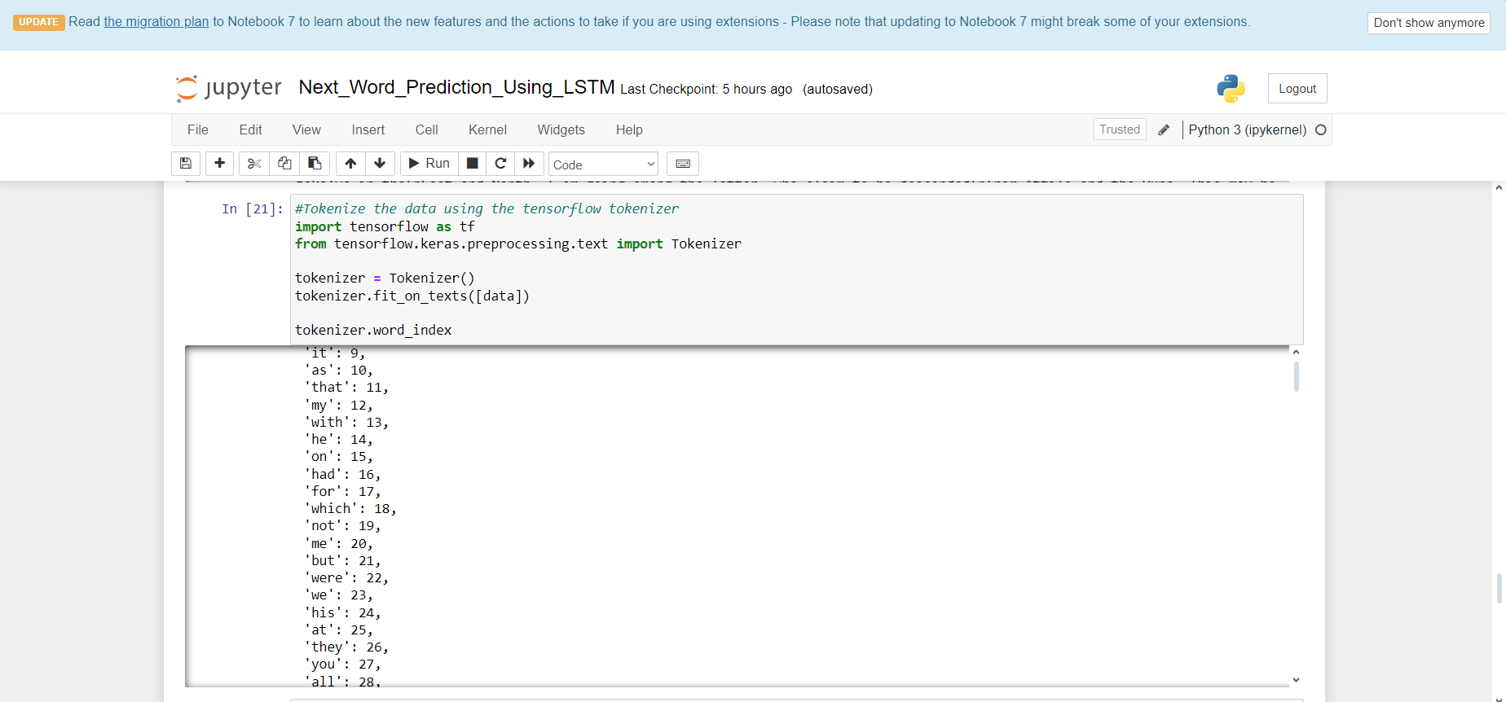

In the above screen Tokenize the data on the basis of each word

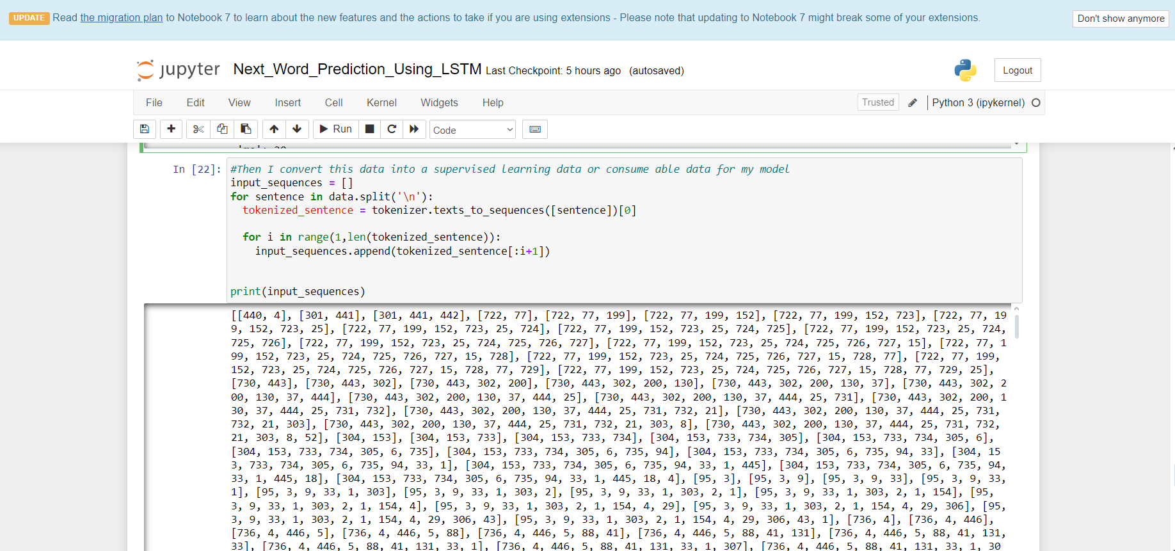

converting all data into a supervised learning data or consume able data for model training.

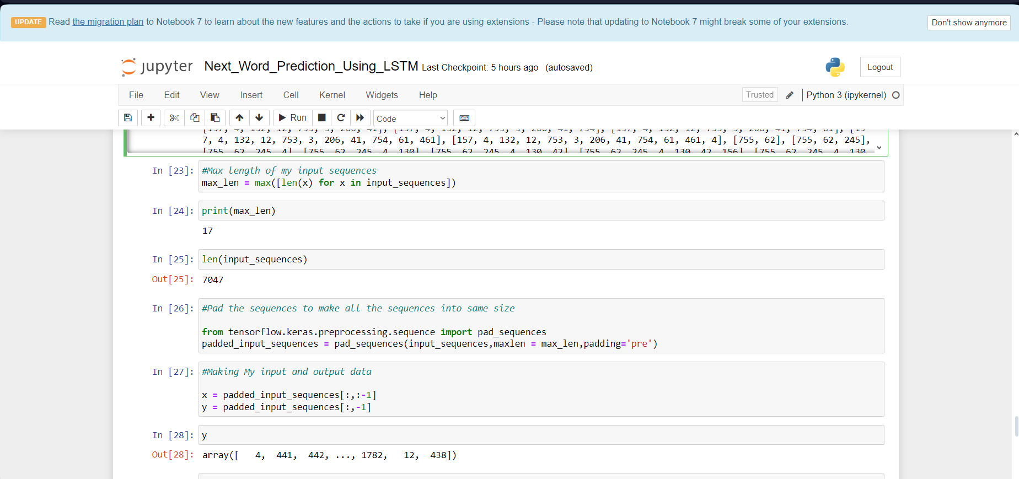

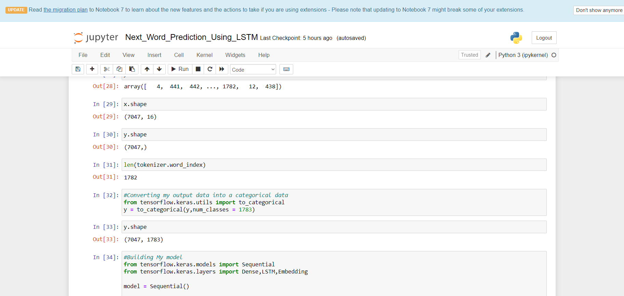

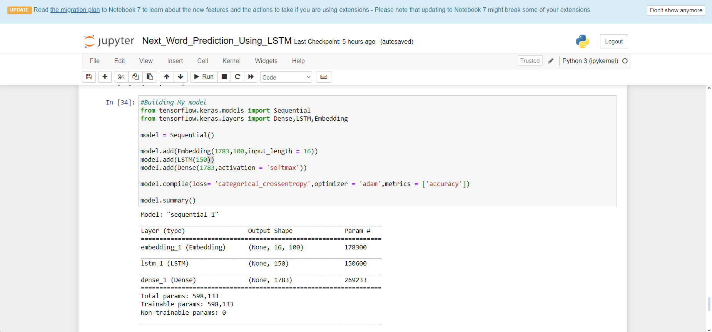

In the above screen we train the LSTM algorithm based on given data.

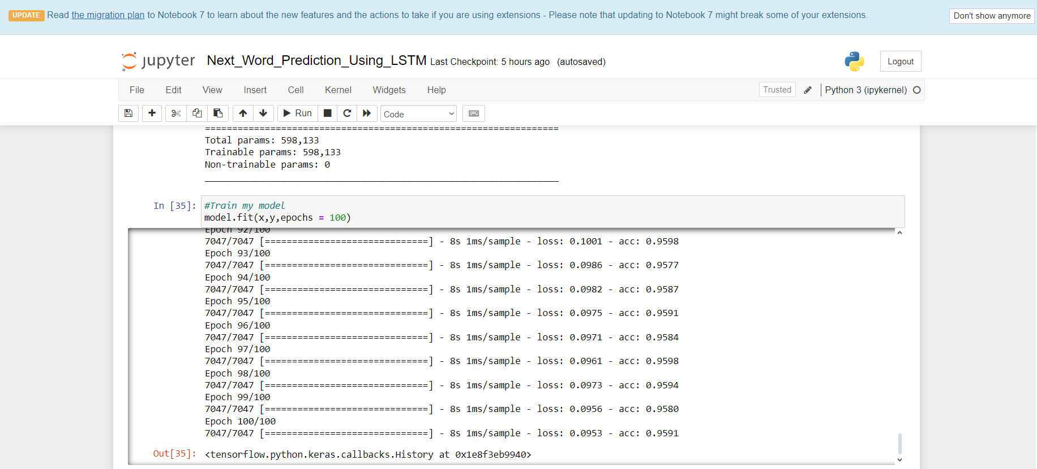

In the above screen LSTM Trainning Epoches Are Completed .

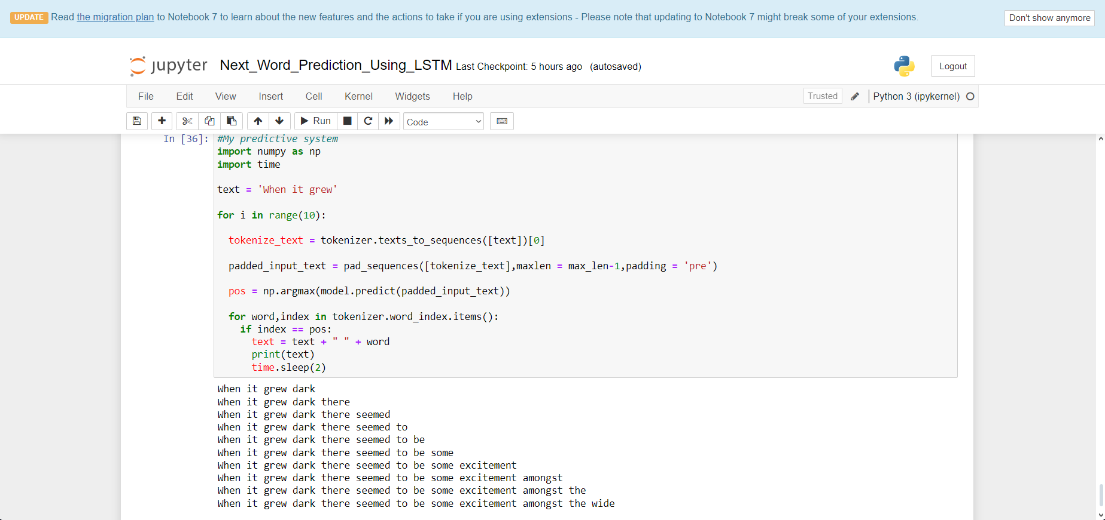

In the above Screen Based On given new Input its Predicting the Next Word Using Long Short Term Memory algorithm