**India’s Agricultural Crop Production Analysis (1997-2021)**

**Project Report**

1. **Introduction**
   1. **Overview**

Indian agriculture is a vital component of the country's economy, providing livelihoods to a significant portion of the population. It plays a crucial role in ensuring food security, contributing to GDP, and sustaining rural communities.

An overview of Indian agricultural analysis provides a snapshot of the key aspects of agriculture in India, including its significance, challenges, opportunities, and recent trends.

* 1. **Purpose**

The purpose of Indian agricultural analysis is to gain comprehensive understanding of the agricultural sector in India, including its various components, challenges, and opportunities.

**Inform Policy Making:** Indian agricultural analysis provides data and insights that can inform government policies. Policymakers need to understand the current state of agriculture to develop and implement effective policies related to food security, rural development, and sustainability.

**Improve Productivity:** By examining the state of Indian agriculture, it becomes possible to identify areas where productivity can be increased. This includes optimizing resource use, promoting modern farming practices, and investing in research and development.

**Enhance Food Security:** Understanding the dynamics of food production and distribution is crucial for ensuring food security. Analyzing the agricultural sector helps identify potential food shortages and develop strategies to address them.

**Sustain Rural Livelihoods:** Agriculture is a significant source of livelihood for millions of Indians. A detailed analysis can help in developing policies and programs to improve the economic condition of farmers and rural communities.

**2.Problem Definition & Design Thinking**

**2.1 Empathy Map**

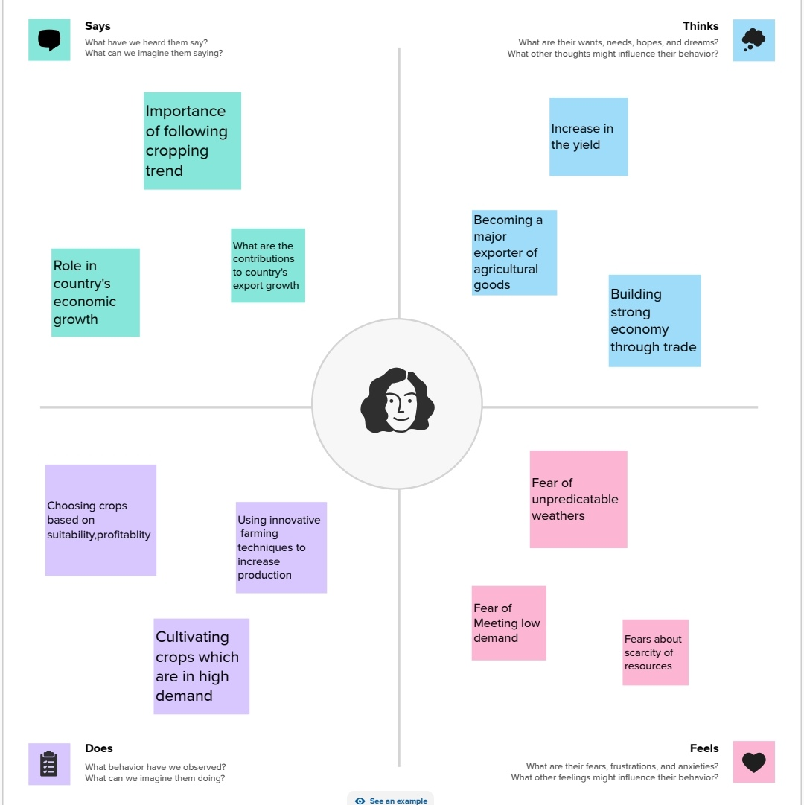

**2.2 Ideation & Brainstroming Map**

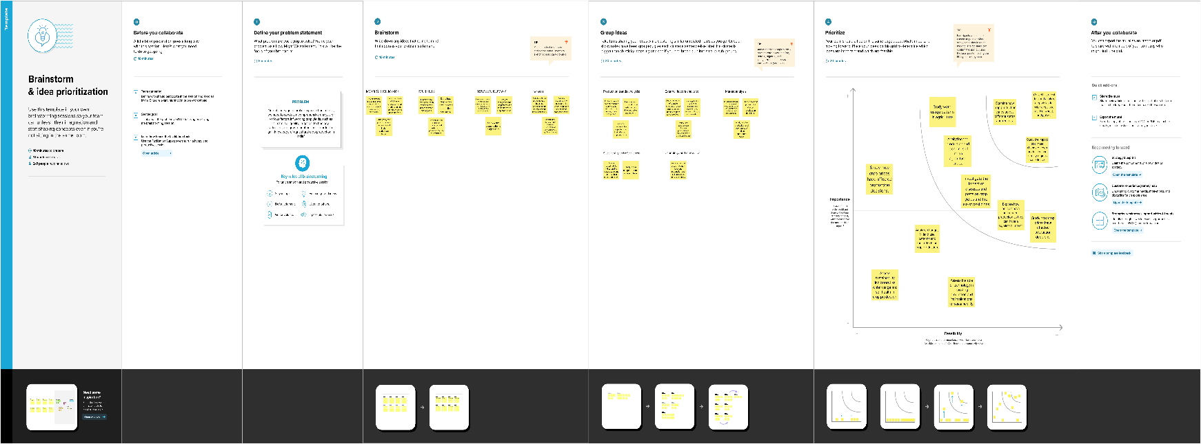

**3.Result**

**Dashboard-1:**

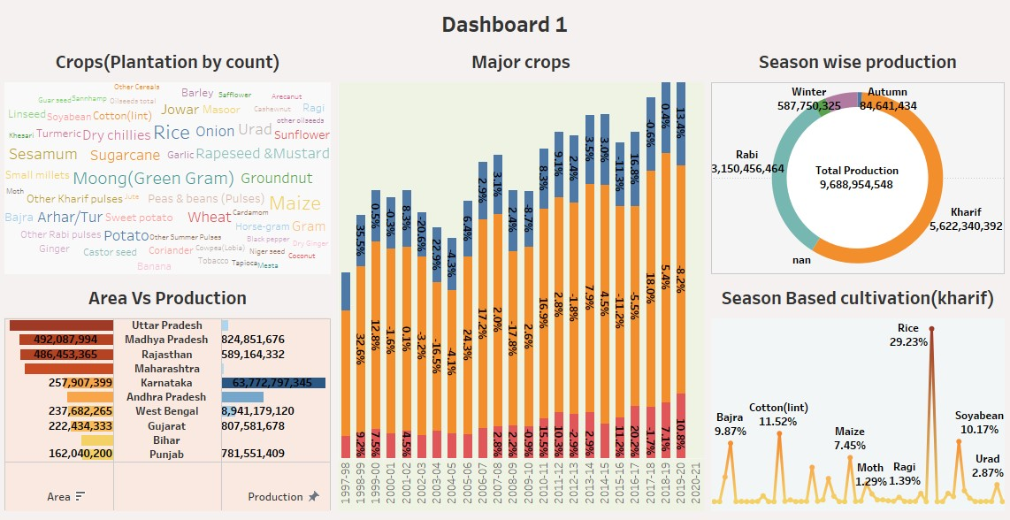

**Dashboard-2:**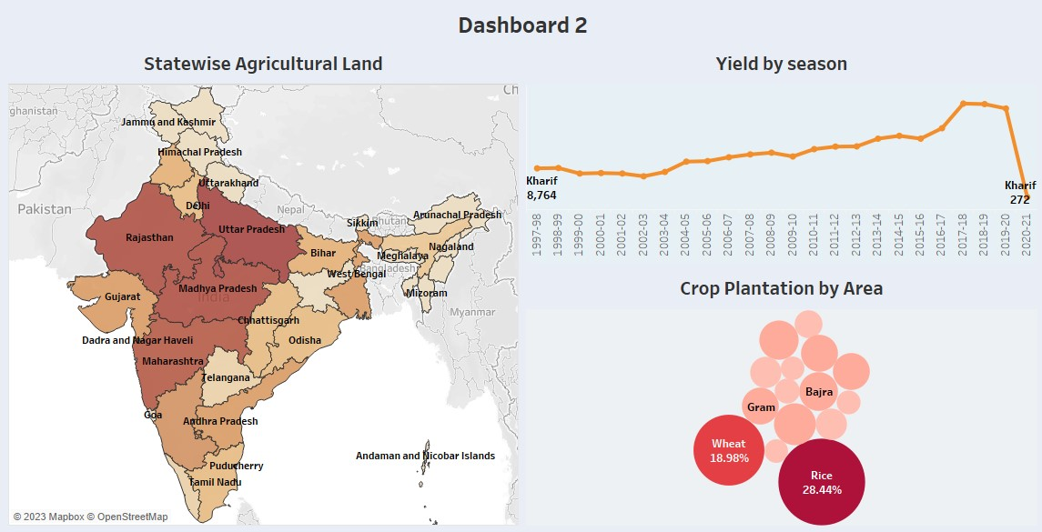

**Story-1**

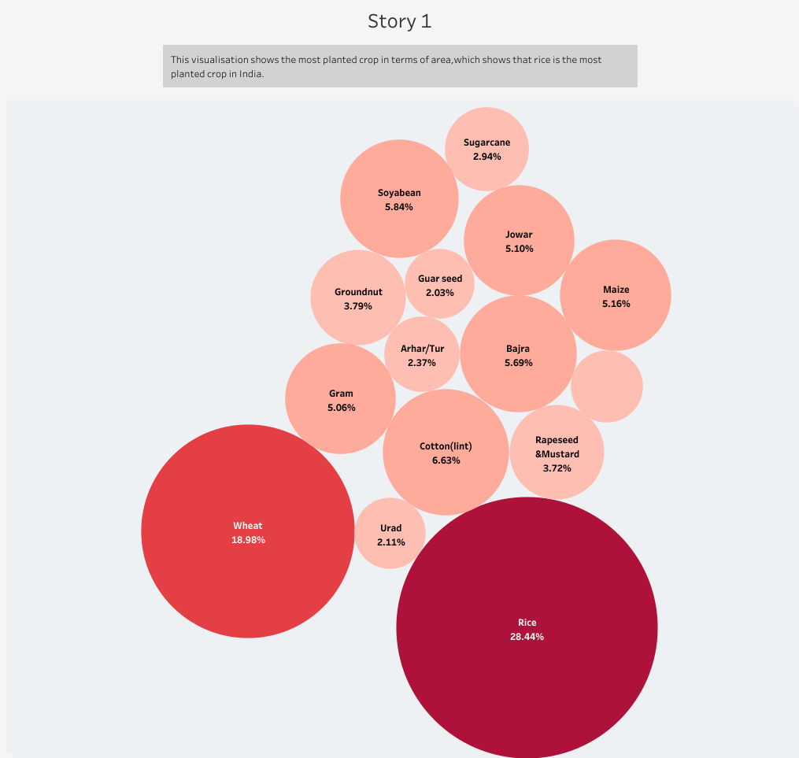

**Story -2**

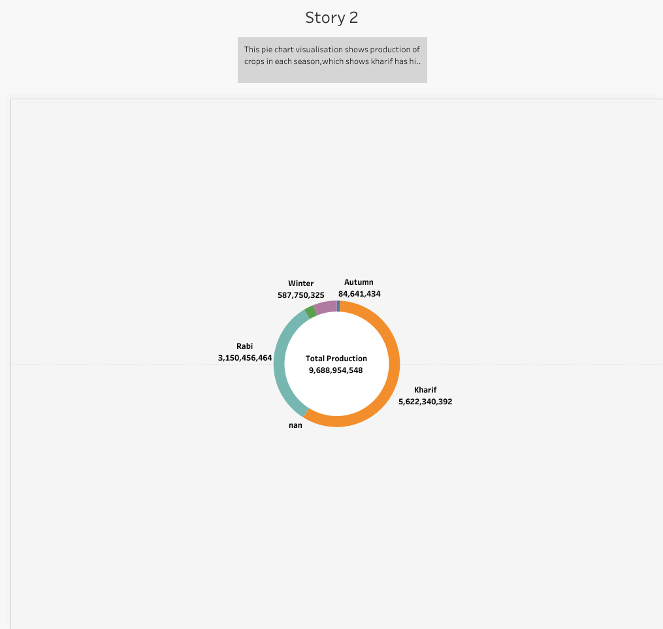

**4. Advantages and Disadvantages:**

**Advantages:**

**Analyzing Indian agriculture offers several advantages, both for policymakers and various stakeholders involved in the agricultural sector. Here are the key advantages of Indian agricultural analysis:**

**Informed Decision-Making: Indian agricultural analysis provides comprehensive data and insights that inform policymakers, government agencies, and organizations in making informed decisions and developing effective policies. It allows them to address the sector's challenges and seize opportunities.**

**Policy Formulation and Evaluation: Policymakers can use analysis to formulate and evaluate agricultural policies, which can enhance the sustainability, productivity, and profitability of the sector.**

**Resource Allocation: By identifying the areas that need the most attention, resources can be efficiently allocated to improve the sector. This helps ensure that investments and initiatives are directed toward the most critical issues.**

**Enhanced Productivity: Analysis helps in identifying the most effective and efficient farming practices and technologies that can be promoted to enhance agricultural productivity.**

**Sustainable Agriculture: It facilitates the identification and promotion of sustainable agricultural practices that protect the environment and ensure long-term food security.**

**Disadvantages:**

**While agricultural analysis in India offers numerous advantages, there are also some potential disadvantages and challenges associated with the process:**

**Data Quality and Availability: The quality and availability of agricultural data in India can be inconsistent. Accurate and up-to-date data are crucial for meaningful analysis, but gaps or inaccuracies can hamper the effectiveness of the analysis.**

**Complexity and Diversity: Indian agriculture is highly diverse, with various crops, farming systems, and regional disparities. Analyzing such a complex and diverse sector can be challenging and might not capture the full picture**

**Resource Intensive: Conducting comprehensive agricultural analysis often requires significant resources, including financial, human, and technological resources. Not all regions or organizations may have the means to perform in-depth analysis.**

**Data Interpretation: Interpreting agricultural data correctly and deriving meaningful insights can be a challenging task, especially when dealing with large and complex datasets.**

**Subjectivity: The interpretation of results and the recommendations derived from the analysis can be subjective, influenced by the biases, perspectives, or interests of those conducting the analysis**

**5 Applications:**

**Indian agricultural analysis finds applications in various sectors and serves multiple purposes. It is a crucial tool for understanding, improving, and sustaining the agricultural sector in India. Here are some key applications:**

**Policy Formulation: Agricultural analysis informs the development and evaluation of agricultural policies at the national, state, and local levels. It helps policymakers make informed decisions related to subsidies, pricing, and market access.**

**Food Security: By assessing crop production and distribution, agricultural analysis plays a pivotal role in ensuring food security. It helps in predicting food shortages and facilitating strategic grain reserves.**

**Economic Planning: Data from agricultural analysis contribute to economic planning by estimating the contribution of agriculture to the national GDP and facilitating investment decisions in allied sectors like agribusiness and agri-infrastructure.**

**Resource Allocation: Governments, NGOs, and international organizations use agricultural analysis to allocate resources, such as subsidies, infrastructure development, and research investments, to areas where they are most needed.**

**Crop Selection and Diversification: Farmers use analysis findings to make informed choices about which crops to cultivate, taking into account market demand, soil suitability, and climatic conditions**

**6 Conclusion:**

**Indian agricultural analysis plays a pivotal role in understanding, improving, and sustaining the agricultural sector in India. The complexity, diversity, and significance of this sector demand a systematic and data-driven approach to address its challenges and harness its potential. Through rigorous analysis, policymakers, farmers, researchers, and various stakeholders gain valuable insights into the state of Indian agriculture and its myriad applications.**

**The findings from agricultural analysis inform policy formulation, food security strategies, economic planning, and resource allocation. They guide farmers in crop selection, risk mitigation, and the adoption of sustainable practices. Moreover, they empower investors, educators, and market participants, enhancing the efficiency and competitiveness of the sector.**

**Indian agricultural analysis is a dynamic and evolving process, responsive to the changing needs of the sector. It is a tool for resilience in the face of climate variability, market fluctuations, and technological advancements. Furthermore, it underpins rural development, helping to reduce income disparities, enhance education, and improve infrastructure.**

**7 Future Scope:**

**The future scope of Indian agricultural analysis is promising and holds significant potential for addressing current challenges, seizing emerging opportunities, and ensuring a sustainable and prosperous agricultural sector. Here are key areas that define the future scope of agricultural analysis in India:**

**Digital Transformation: The adoption of digital technologies, including remote sensing, IoT, data analytics, and blockchain, will play a critical role in collecting real-time data and improving decision-making in agriculture. This digital transformation will enhance precision farming, monitoring, and traceability in the supply chain.**

**Climate Resilience: Given the increasing impact of climate change on agriculture, future analysis will focus on assessing the vulnerabilities and resilience of different regions. It will help farmers adapt to changing climate patterns and minimize losses.**

**Data Integration: Integrating data from various sources such as weather forecasts, soil quality, and crop health will enable predictive modeling. This will assist in optimizing resource use, managing pests and diseases, and improving yield forecasts.**

**Market Linkages: Analysis will play a crucial role in strengthening market linkages for farmers, reducing intermediaries, and enabling better price discovery. Online marketplaces and e-commerce platforms will be integral to this scope.**

**Sustainable Agriculture: Analyzing and promoting sustainable farming practices, such as organic farming, integrated pest management, and conservation agriculture, will be a priority. The environmental footprint of agriculture will be reduced while maintaining productivity.**

**Genetic and Biotechnology Analysis: The analysis of genetic traits and biotechnology applications in crop and livestock breeding will help develop resilient and high-yielding varieties. This can address food security concerns.**