1. **Who prefers energy drink more? (male/female/non-binary)**

**SELECT Gender ,COUNT (Respondent_ID) AS Respondent FROM repondents**

**GROUP BY Gender**

**ORDER BY Respondent DESC   
  
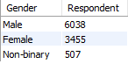**

**2.Which age group prefers energy drinks more?**

**SELECT Age ,COUNT (Respondent_ID) AS Respondent FROM repondents**

**GROUP BY Age**

**ORDER BY Respondent DESC**

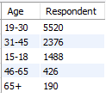

**3.Which type of marketing reaches the most Youth (15-30)?**

**SELECT F.Marketing_channels AS**

**Marketing_Medium,COUNT(F.Respondent_ID) AS Respondent**

**FROM fact_survey_responses F JOIN repondents R ON**

**F.Respondent_ID=R.Respondent_ID**

**WHERE R.Age='15-18'**

**GROUP BY Marketing_medium**

**ORDER BY Respondent DESC;**

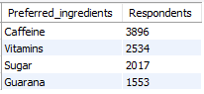

**4. What are the preferred ingredients of energy drinks among respondents?**

**SELECT Ingredients_expected AS Preferred_ingredients,COUNT(*) AS Respondents FROM fact_survey_responses**

**GROUP BY Preferred_ingredients**

**ORDER BY Respondents DESC**



**5. What packaging preferences do respondents have for energy drinks?**

**SELECT Packaging_preference,COUNT(*) AS Respondents FROM fact_survey_responses**

**GROUP BY Packaging_preference**

**ORDER BY Respondents DESC**

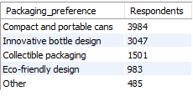

**6. Who are the current market leaders?**

**SELECT Current_brands AS Brands, COUNT(*) AS Respondent FROM fact_survey_responses**

**GROUP BY Brands**

**ORDER BY Respondent DESC**

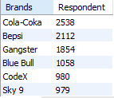

**7.What are the primary reasons consumers prefer those brands over ours?**

**SELECT Reasons_for_choosing_brands AS Reasons,COUNT(*) AS Respondents FROM fact_survey_responses**

**GROUP BY Reasons_for_choosing_brands**

**ORDER BY Respondents DESC**

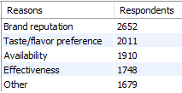

**8. Which marketing channel can be used to reach more customers?**

**SELECT Marketing_channels AS Marketing_medium ,COUNT(*) AS Respondents FROM fact_survey_responses**

**GROUP BY Marketing_medium**

**ORDER BY Respondents DESC**

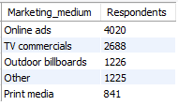

**10.What do people think about our brand? (overall rating)**

**SELECT Taste_experience,COUNT(*) AS Respondents**

**FROM fact_survey_responses**

**WHERE Heard_before='Yes'**

**GROUP BY Taste_experience**

**ORDER BY Respondents DESC**

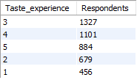

**11.Which cities do we need to focus more on?**

**SELECT C.City AS City,C.Tier AS Tier,COUNT(*) AS Respondent**

**FROM fact_survey_responses F**

**JOIN repondents R ON F.Respondent_ID = R.Respondent_ID**

**JOIN cities C ON R.City_ID=C.City_ID**

**WHERE F.Brand_perception="Negative" OR F.Brand_perception="Neutral" AND Current_brands='Codex'**

**GROUP BY City ,Tier**

**ORDER BY Respondent DESC**

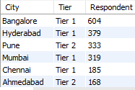

**12.Where do respondents prefer to purchase energy drinks?**

**SELECT Purchase_location,COUNT(*) AS Respondents**

**FROM fact_survey_responses**

**GROUP BY Purchase_location**

**ORDER BY Respondents DESC**

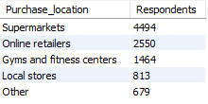

**13.What are the typical consumption situations for energy drinks among respondents?**

**SELECT Typical_consumption_situations,COUNT(*) AS Respondents**

**FROM fact_survey_responses**

**GROUP BY Typical_consumption_situations**

**ORDER BY Respondents DESC**

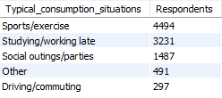

**14.What factors influence respondents' purchase decisions, such as price range and limited edition packaging?**

**SELECT Limited_edition_packaging,COUNT(*) AS Respondents**

**FROM fact_survey_responses**

**GROUP BY Limited_edition_packaging**

**ORDER BY Respondents DESC**

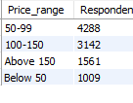

**15.consumer frequency by gender**

**SELECT f.Consumer_frequency,count(f.Respondent_ID) AS respondents ,r.Gender AS Gender,r.Age as Age from fact_survey_responses f join repondents r**

**on f.Respondent_ID=r.Respondent_ID**

**group by Consume_frequency,Gender,Age**

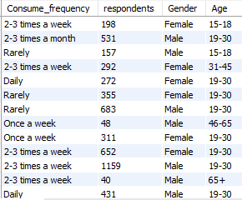

**17.consumer time**

**SELECT Consume_time,Current_brands,Reasons_for_choosing_brands,COUNT(*) AS Respondents FROM fact_survey_responses**

**GROUP BY Consume_time,Current_brands,Reasons_for_choosing_brands**

**ORDER BY Respondents DESC**

­­