**REPORT ON**

**MICROSOFT AZURE FUNDAMENTALS**

|  |  |
| --- | --- |
| Name | VIJAYAKUMAR A |
| Register No | 710722104117 |
| Department | III B.E CSE |
| Date | 10.08.2024 |

**1)Sandbox:**

Create a Linux virtual machine and install Nginx

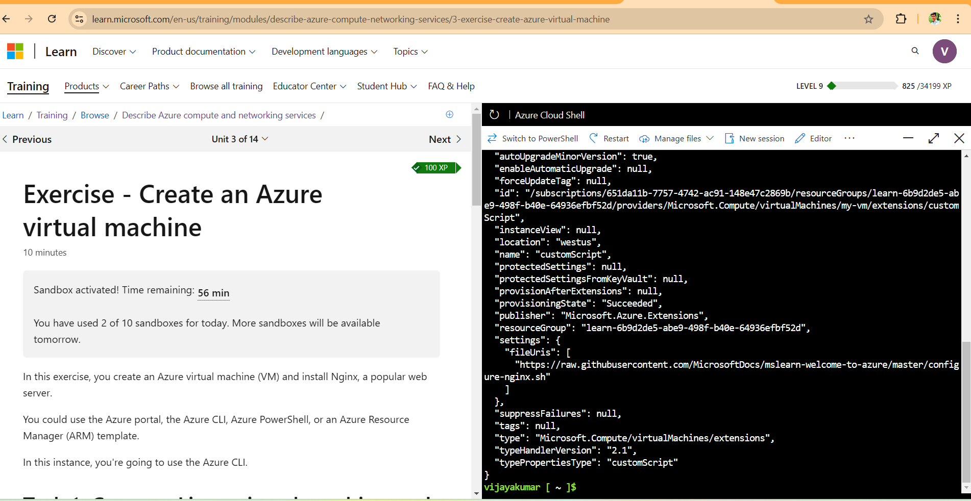

Access your web server

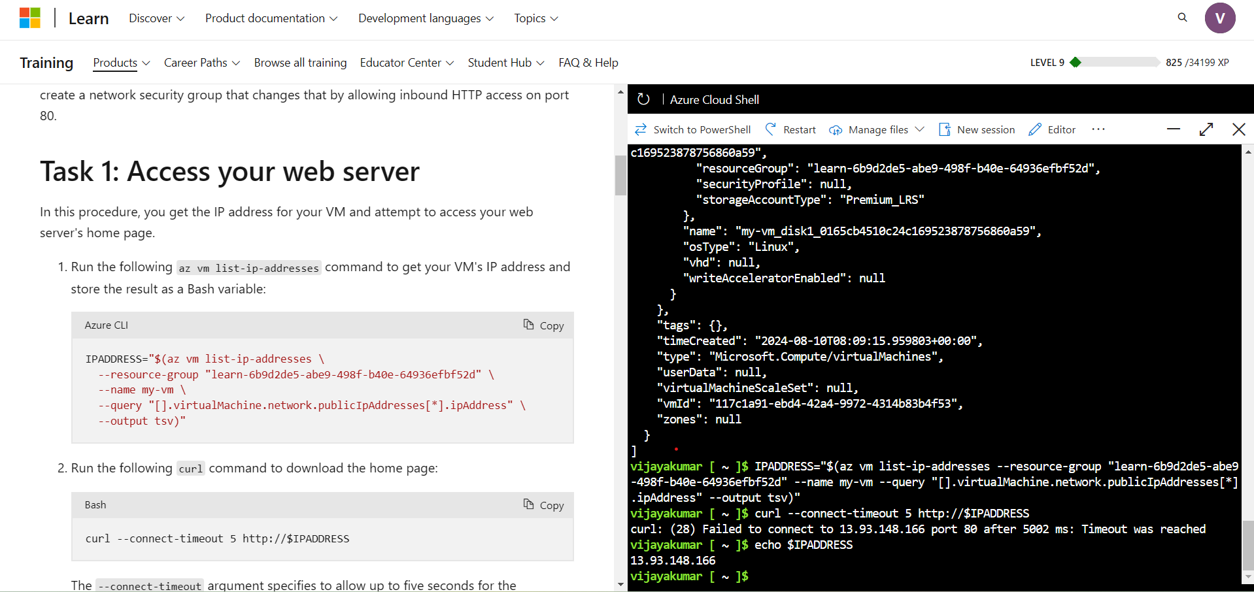

List the current network security group rules

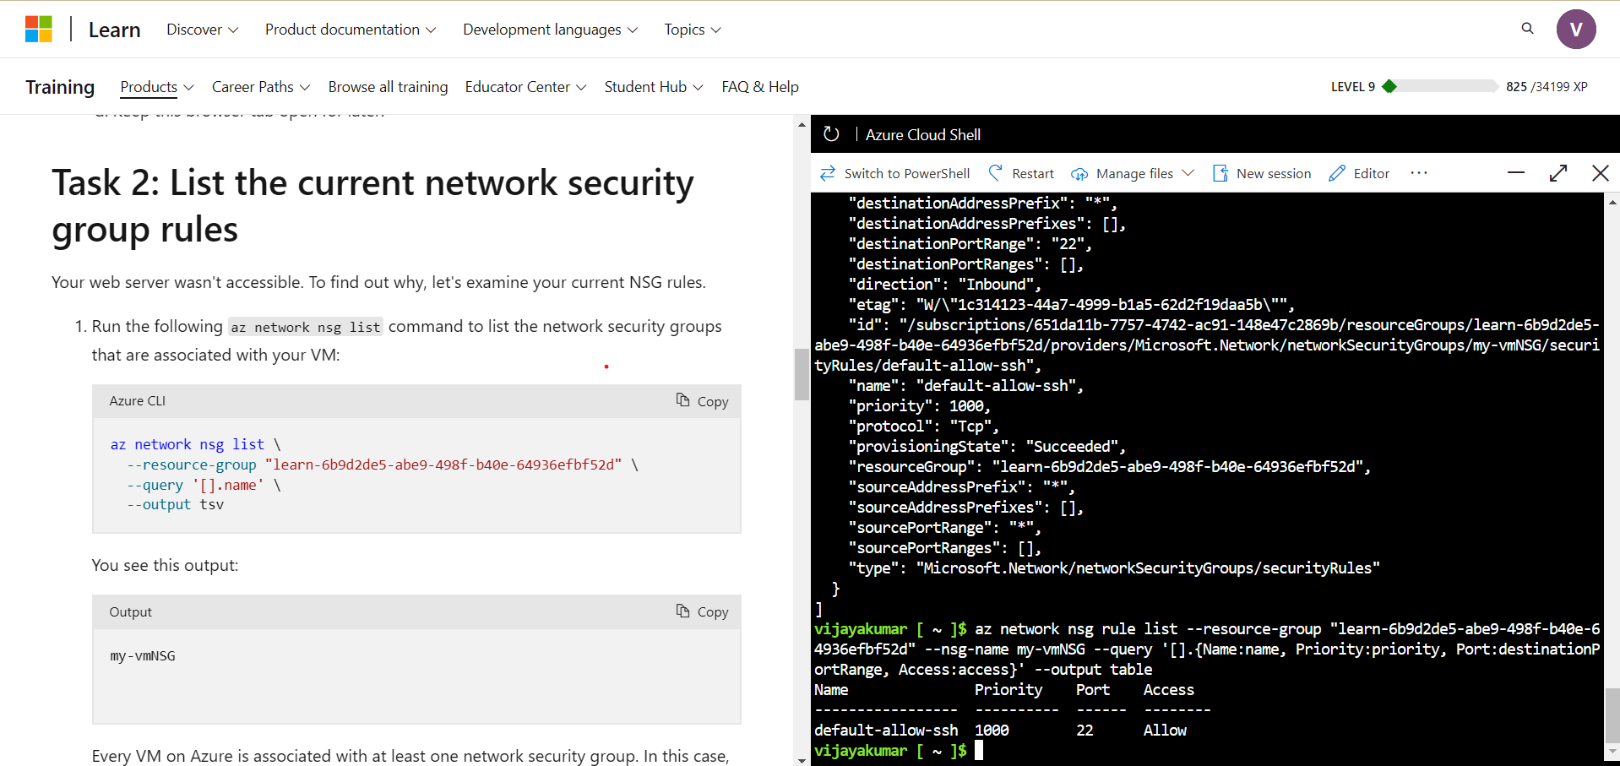

Create the network security rule

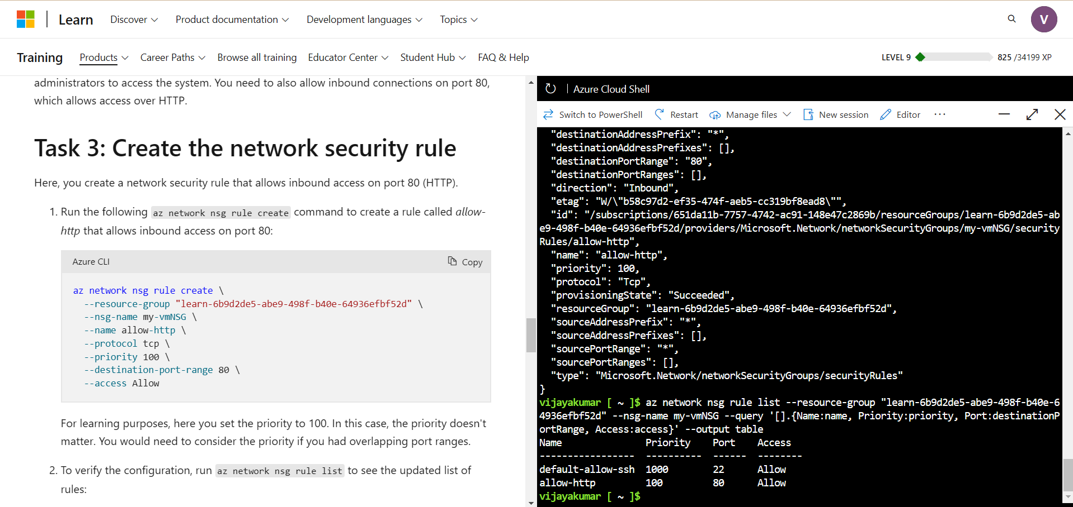

Access your web server again

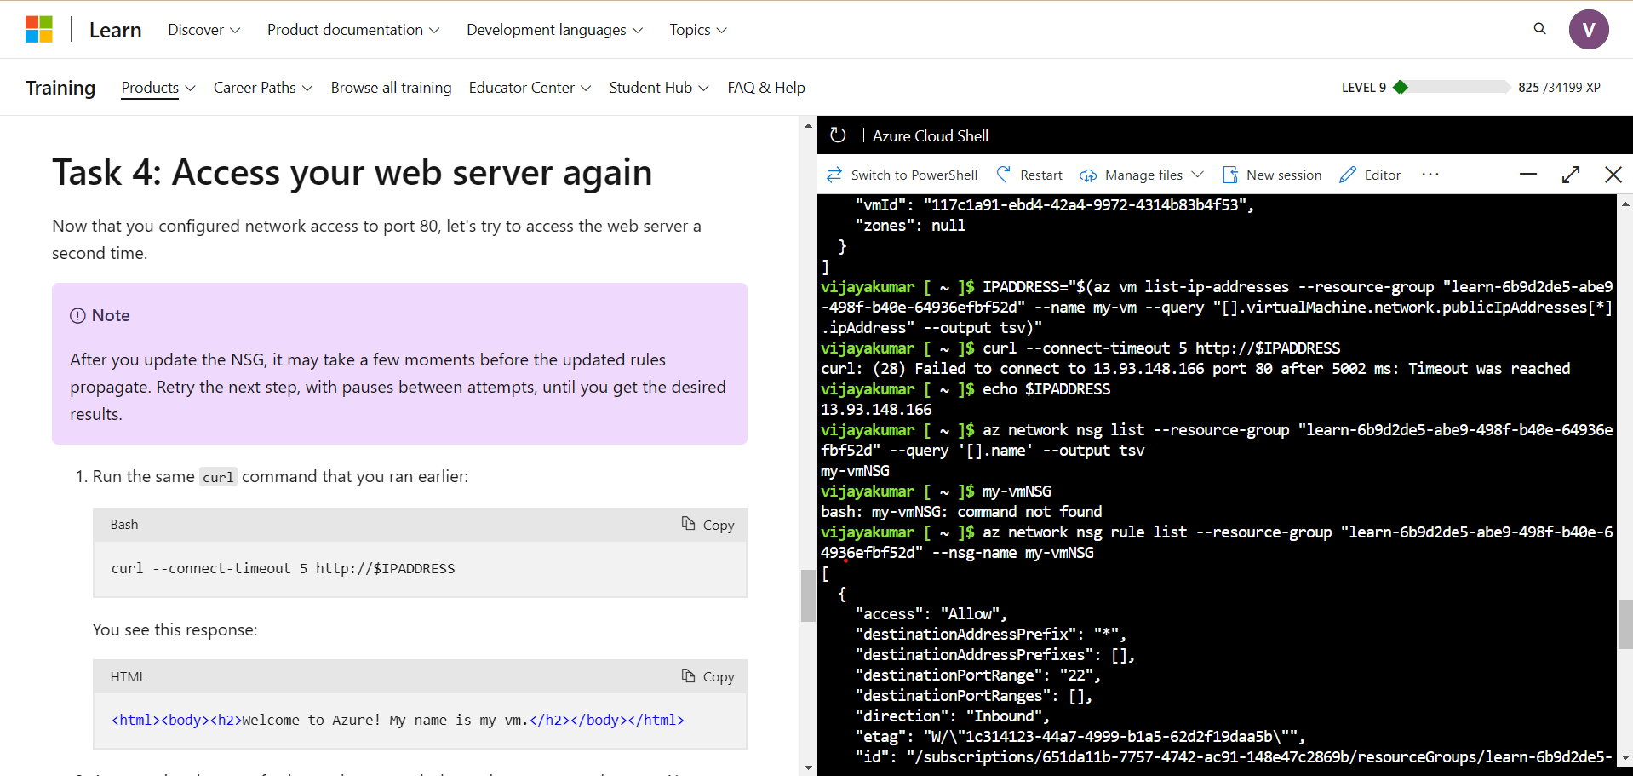

Final output:

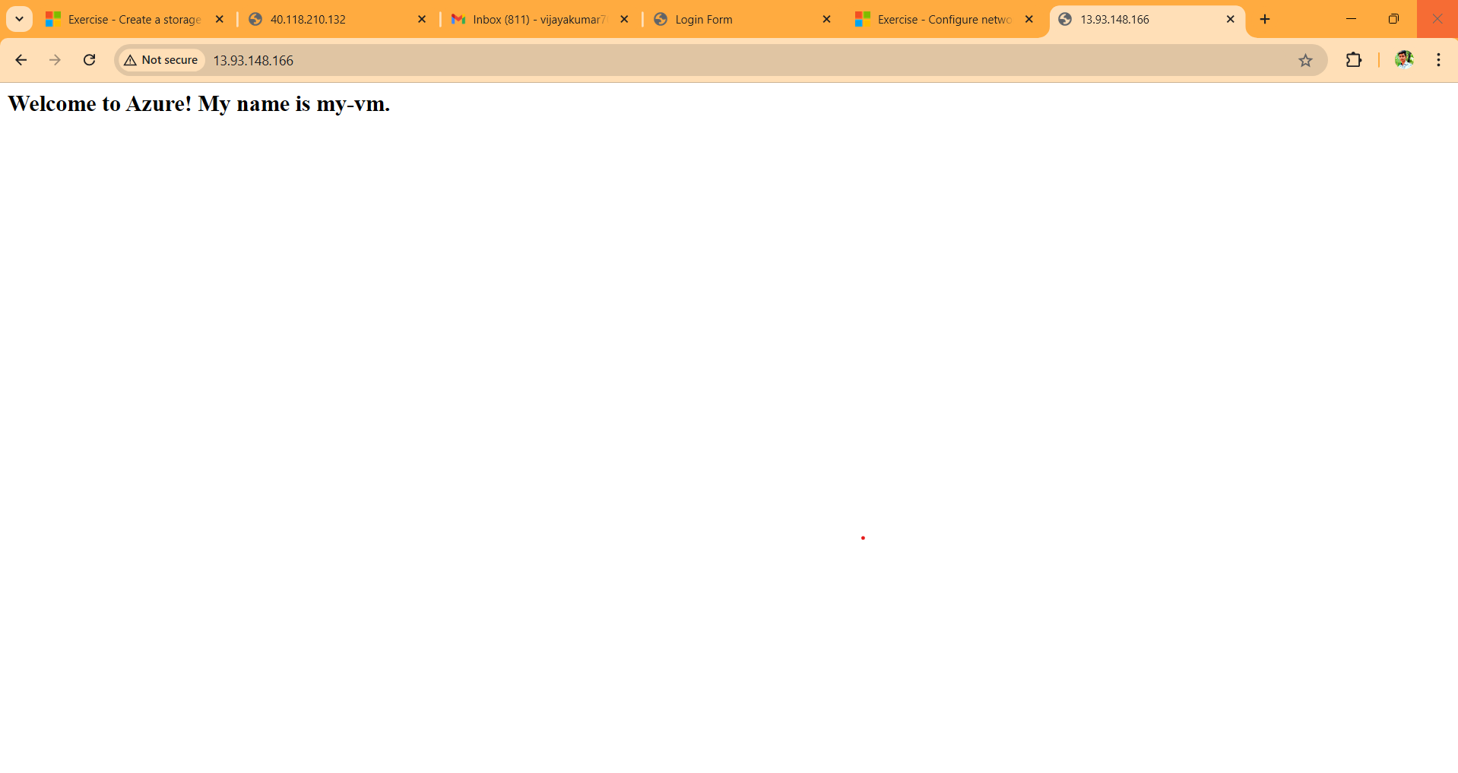

**2) Azure Academic Services: Azure for Students**

Microsoft Academic Verfication Process

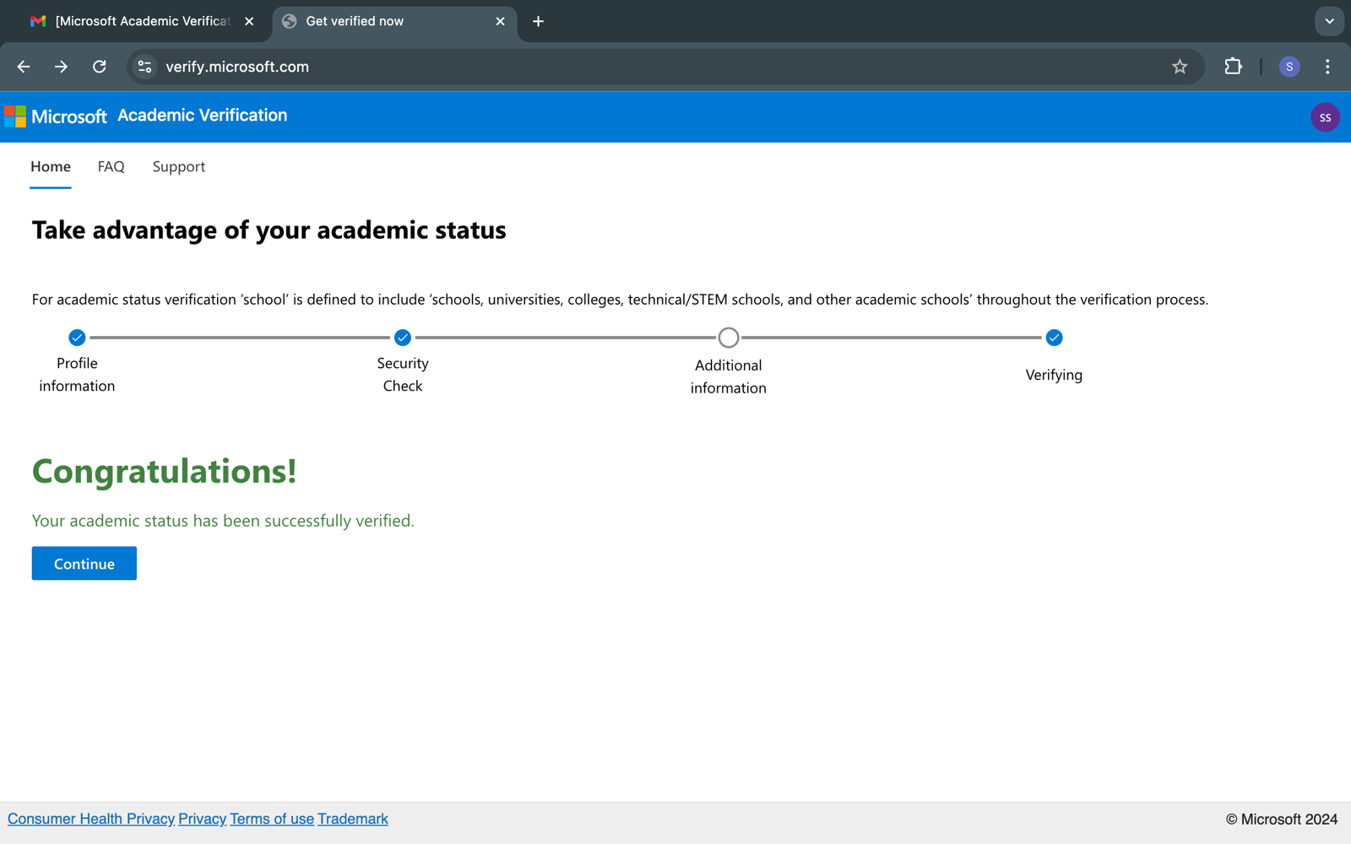

Creation of resource groups

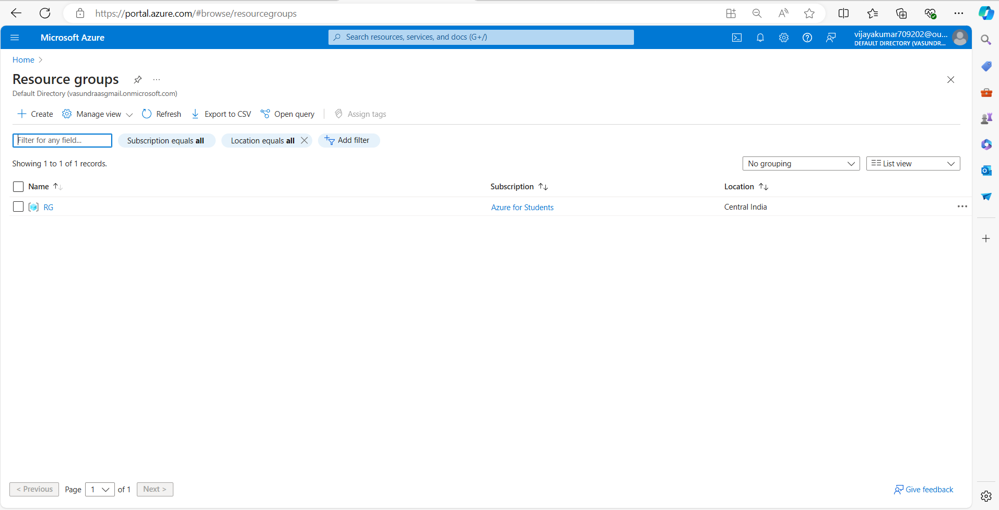

Creation of Virtual Machine

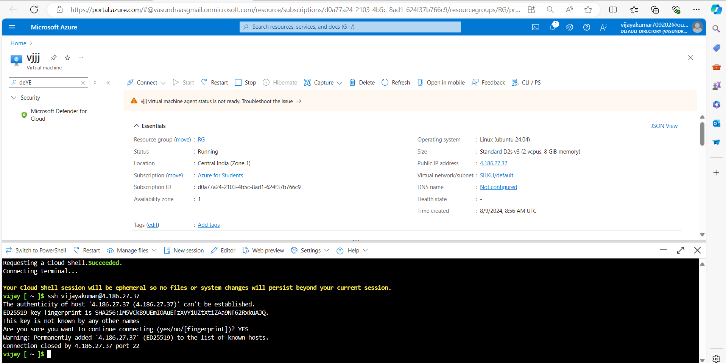

Hosting my portfolio using Azure Cloud Services

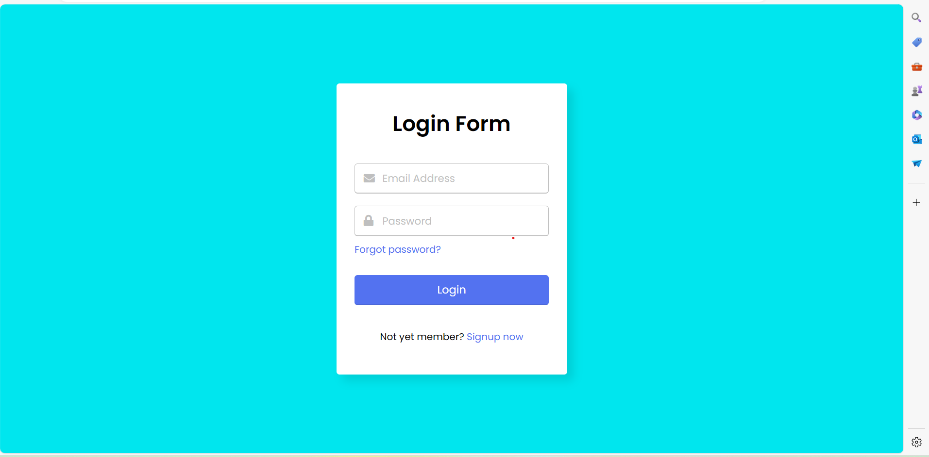

Gitup link: sudo git clone <https://github.com/GNiruthian/Login-Page-using-html-css.git> .

Pricing calculator

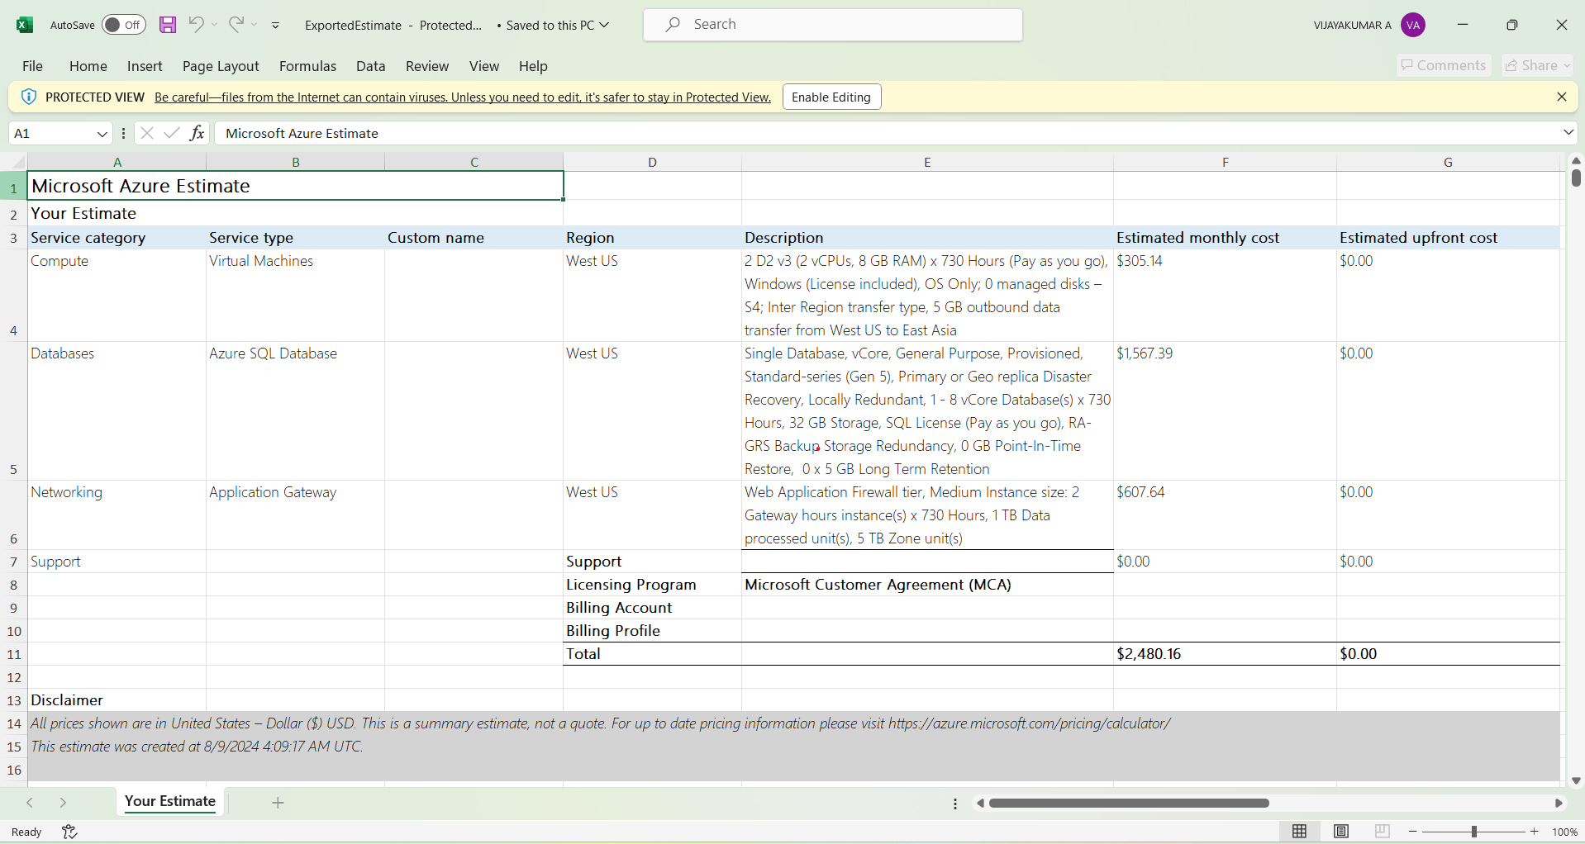

Total Cost of Ownership (TCO) Calculator

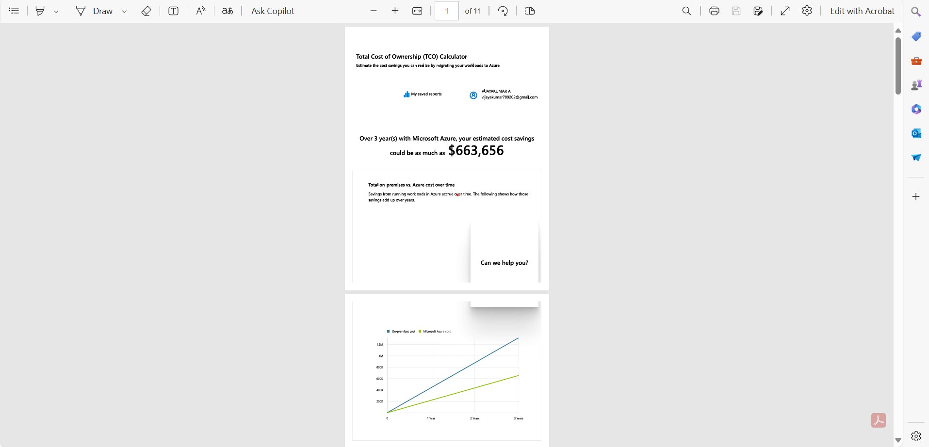

Creating storage account

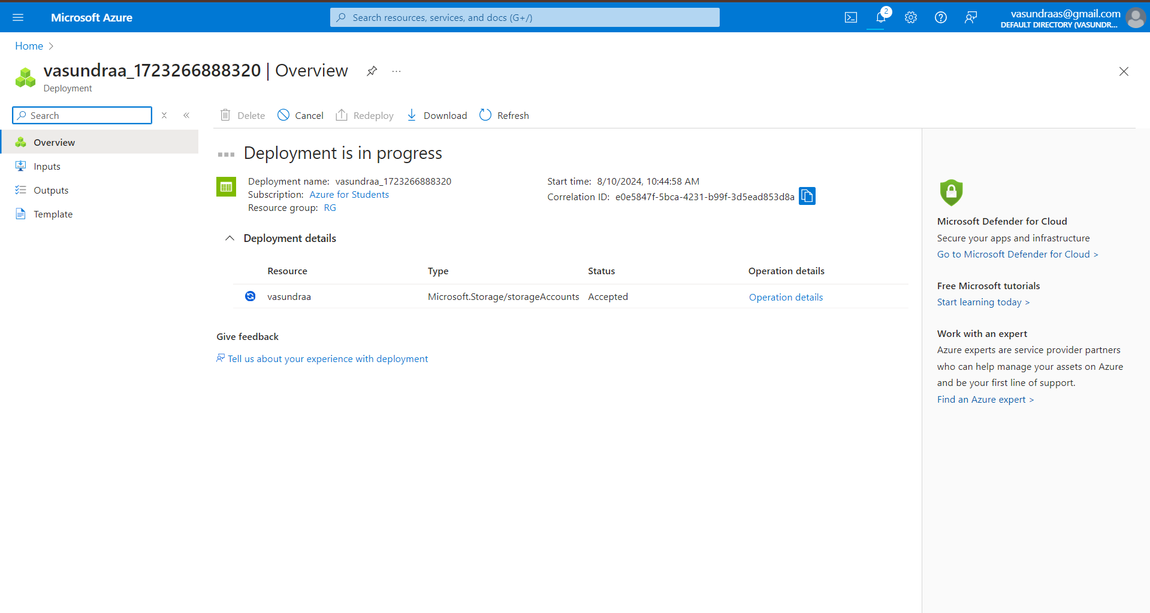

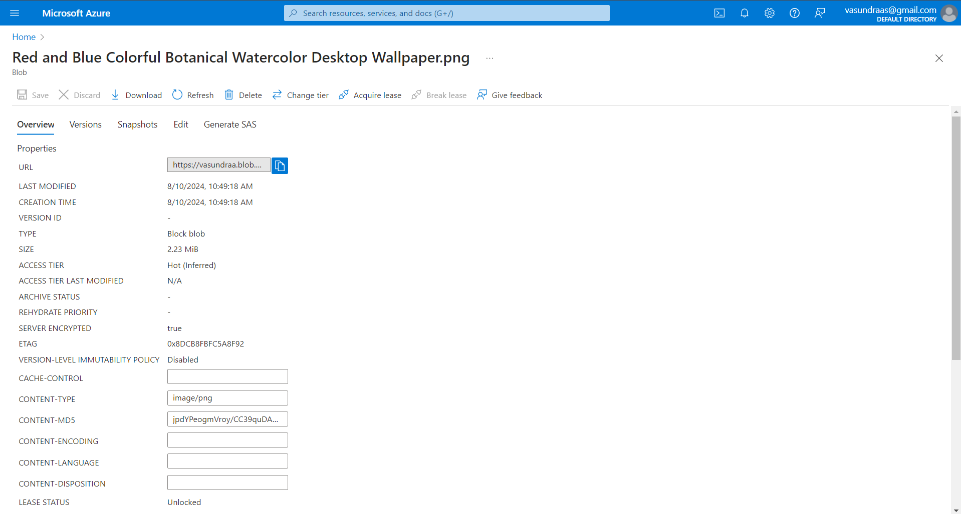

Output:

