Third Increment Report

In this increment we have created one REST API using MEAN Stack, which will manipulate the twitter data. We will use this API to store and get the preprocessed twitter data whenever it is required

“Existing Services/REST API”
- Using Twitter API to log into the Android Application
- Created own REST API to manipulate the Twitter Data

“Detail Design of Features”
. “WireFrames”
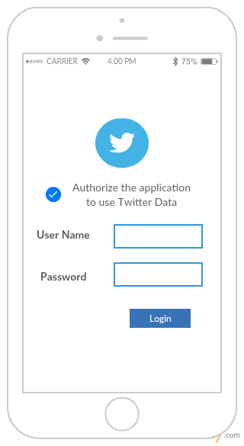
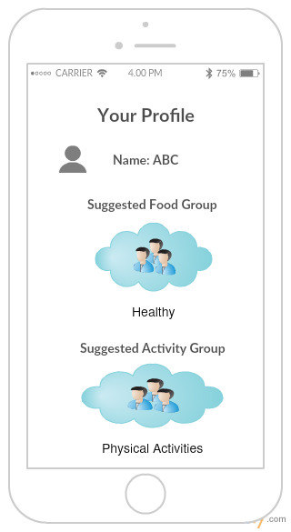

. “Architecture diagram”

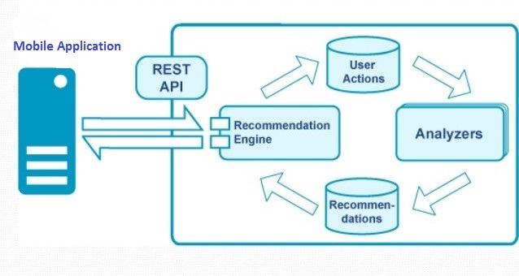

. “User Stories”
“https://github.com/VIJAYAYERUVA/BestBuddy/blob/master/Documentation/User%20Stories%20Increment2.docx”

. “Implementation”

Connetion to MongoDB:

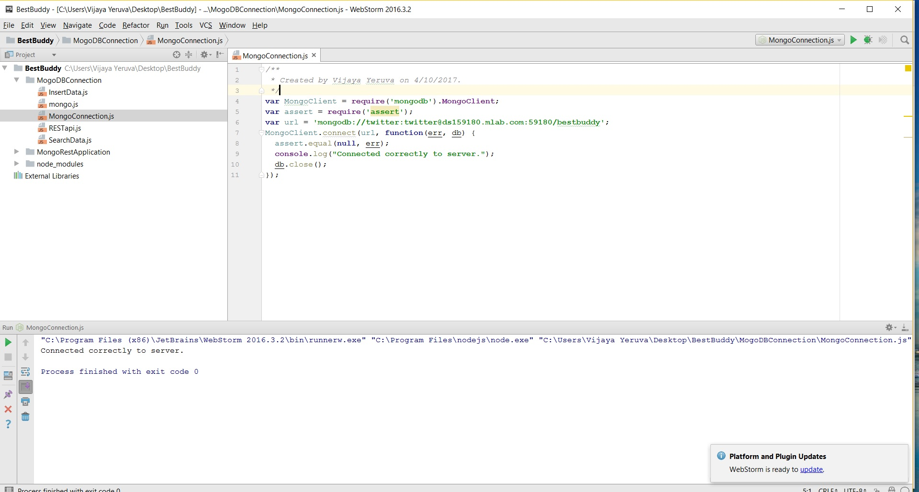

Inserting Data to Mongo DB:

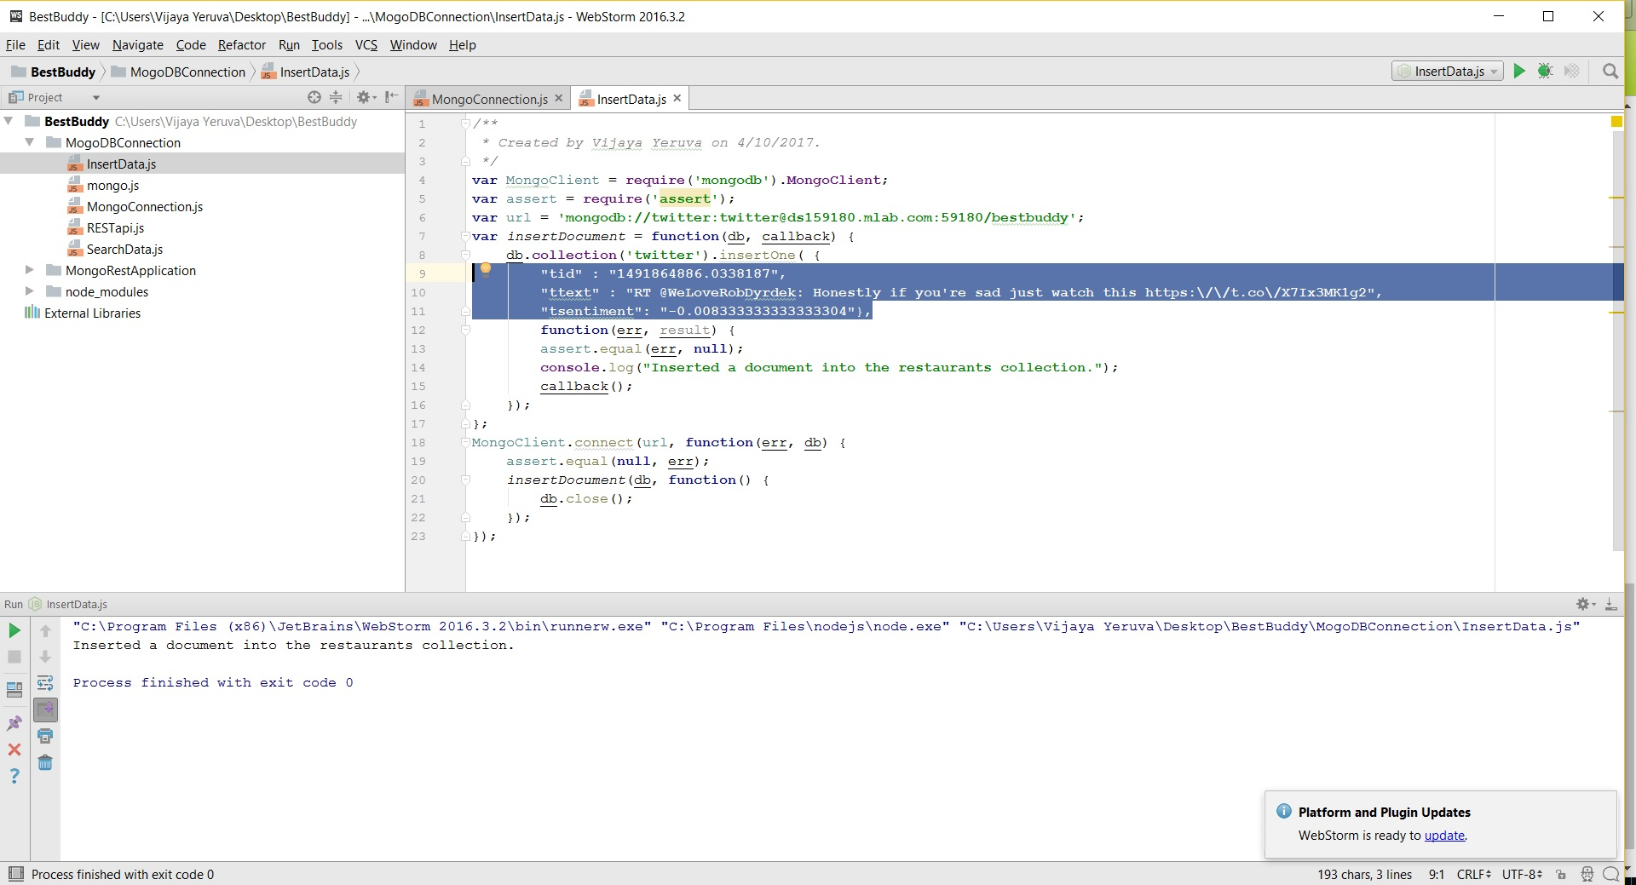

Data in Mongo DB:

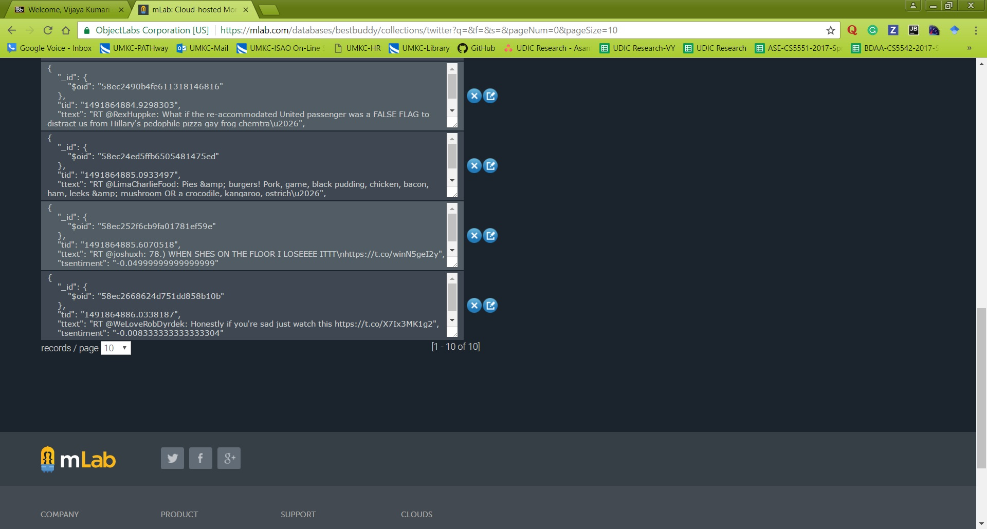

Reteriving the existing Data: (All data)

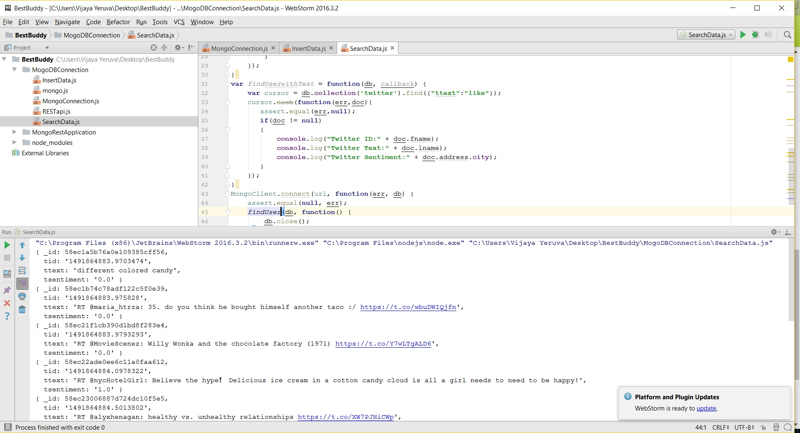

Reteriving the existing Data: (based on particular condition)

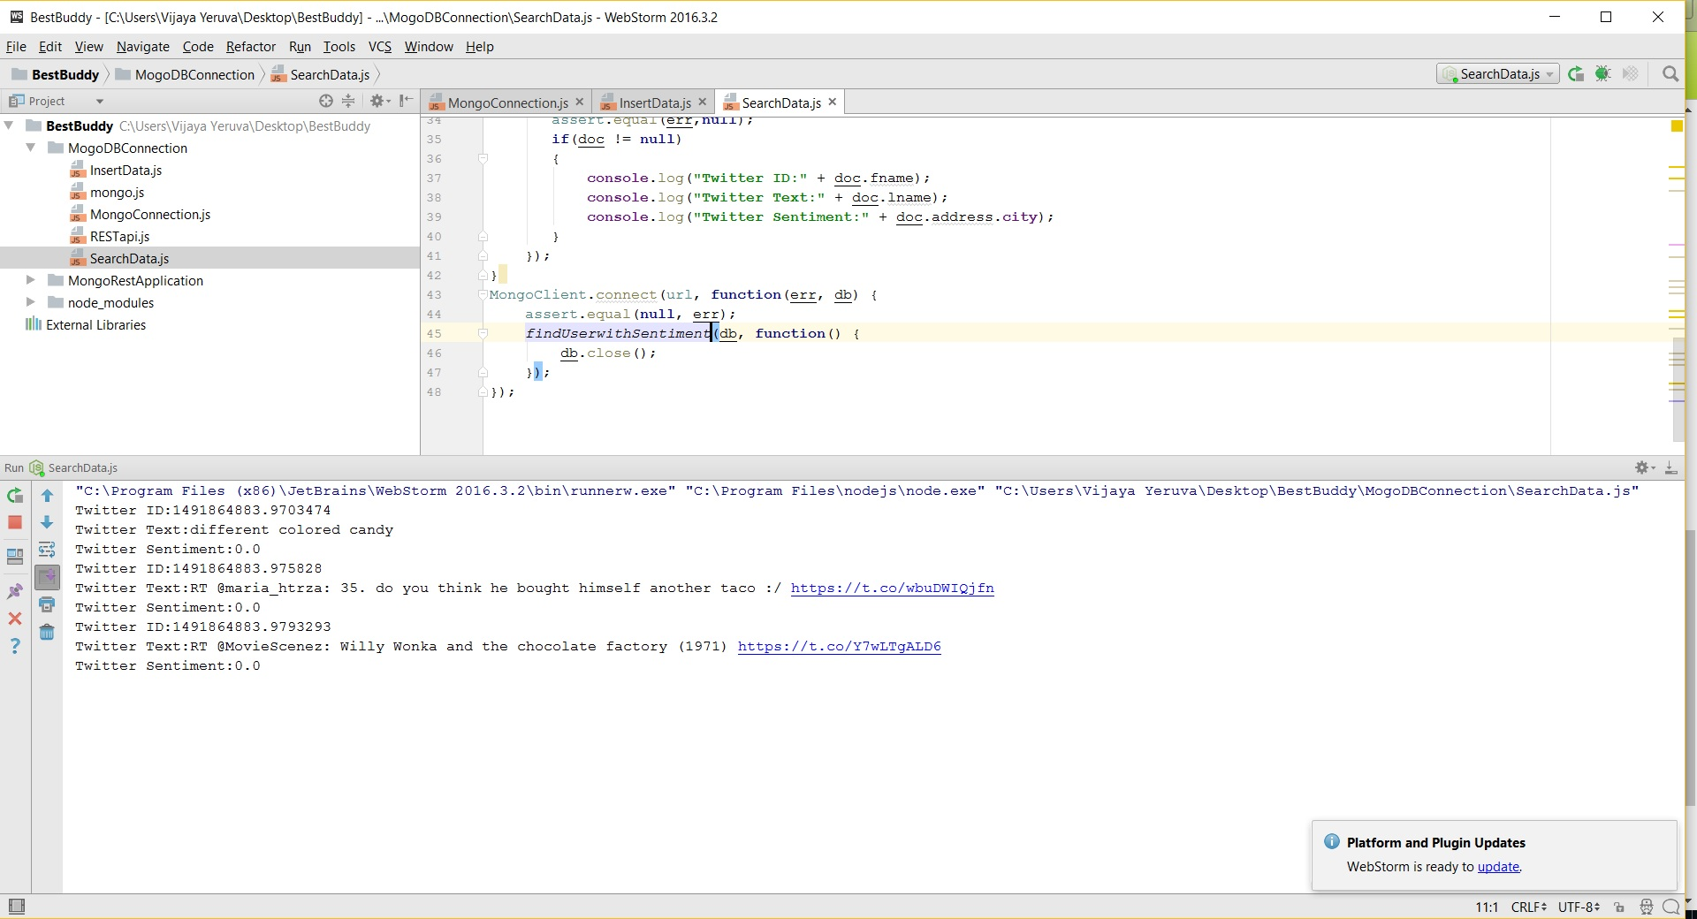

Creating REST API
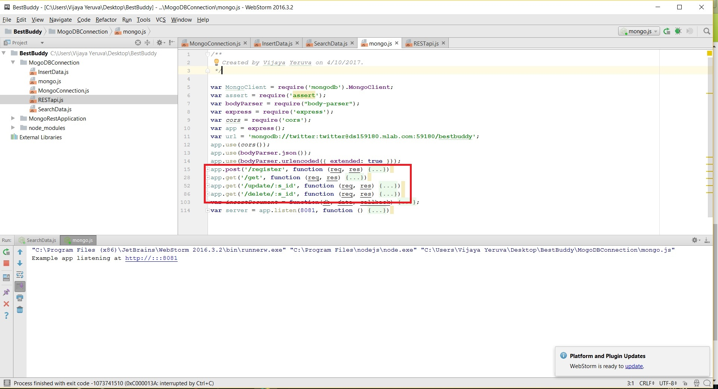

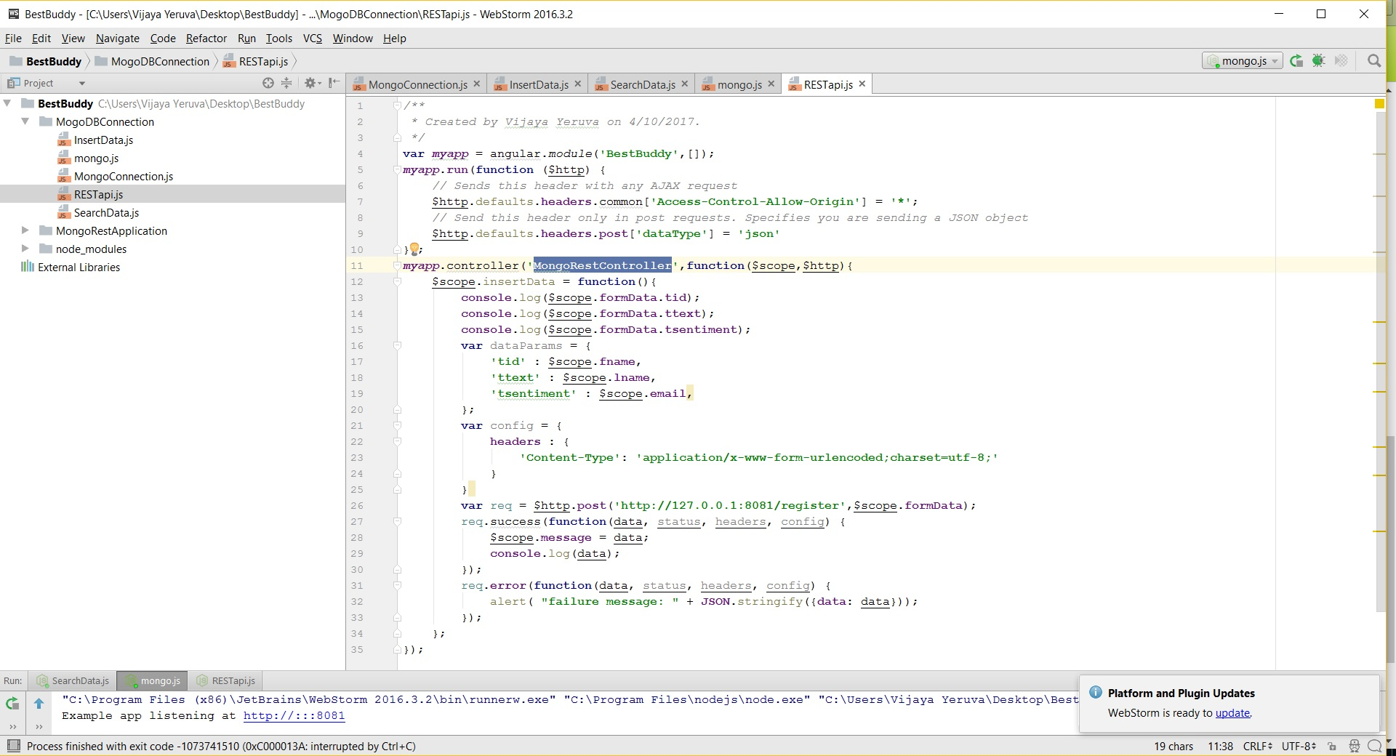

. “Deployment”
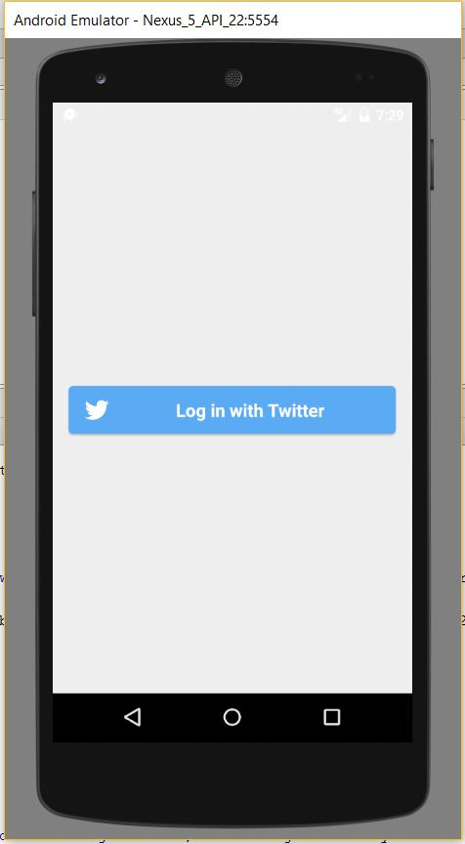

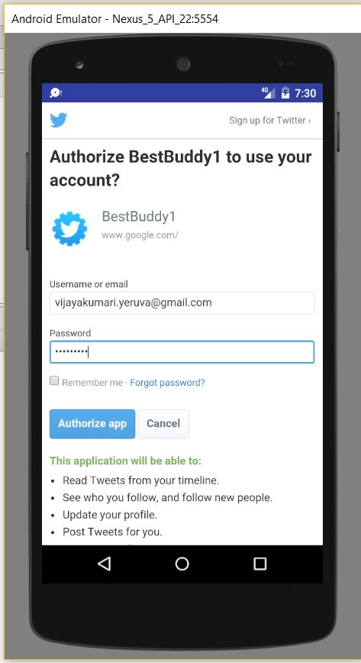
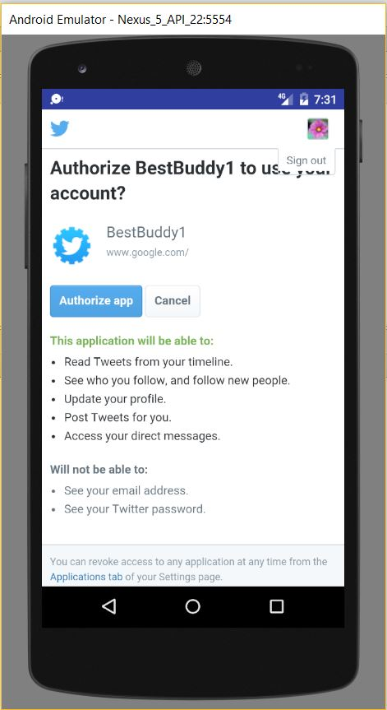

. “Project Management”
“Time taken:” 10 hours
“Contribution:” Equal contributions from all the group members

. “Reference”: https://github.com/VIJAYAYERUVA/BestBuddy/wiki/Increment3

