“Project Increment 4/Final Increment:”

“I. Team Members:”
“Yeruva, Vijaya Kumari”
“Goudarzvand, Saria”

“II. Project Overview:”
The purpose of the project is to create an application that predict the user behavior (happy or unhappy) based on his/her tweets/text.

In this increment we have developed a web application which will take the user’s text as input and send it to the model, after process the text through model, the application will display the output as text and sentiment of that text

“III. Existing Services/REST API”
- Created own REST API to insert and get the data from MongoDB
- Created own REST API to give and take data from the Tensor flow CNN Model

“IV. Detail Design of Features”
“WireFrames”
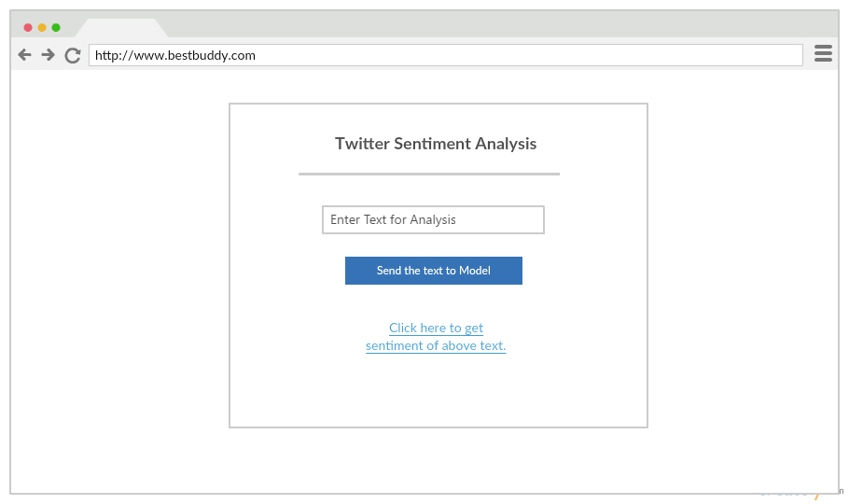

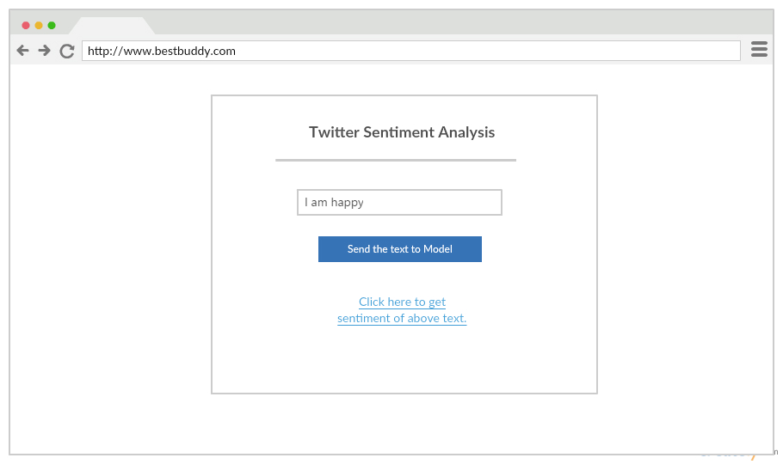

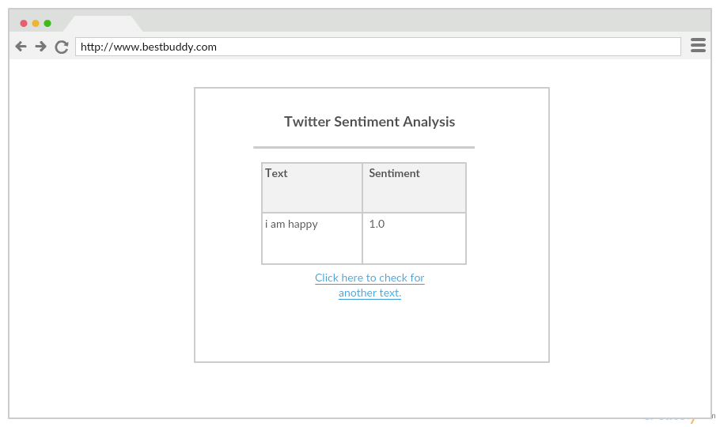

“Architecture diagram”

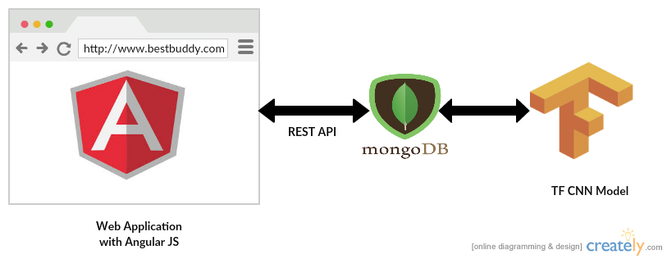

“Design Patterns”
We Used Creational Design Pattern(Singleton) for web application
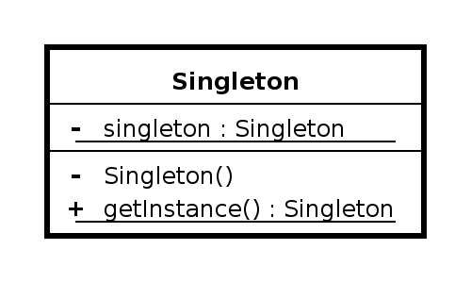

“User Stories”
Link: https://github.com/VIJAYAYERUVA/BestBuddy/blob/master/Documentation/ASE_Increment4/User%20Stories.txt

“V. Testing”
Tested the performance of the web application with “YSlow” on Chrome browser. Got the Grade B as result of performance
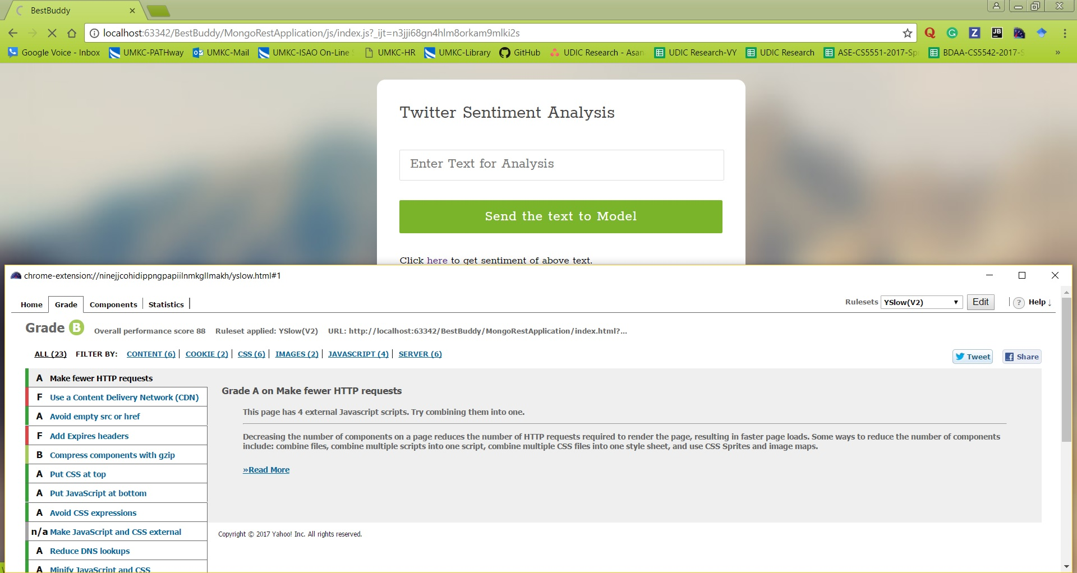

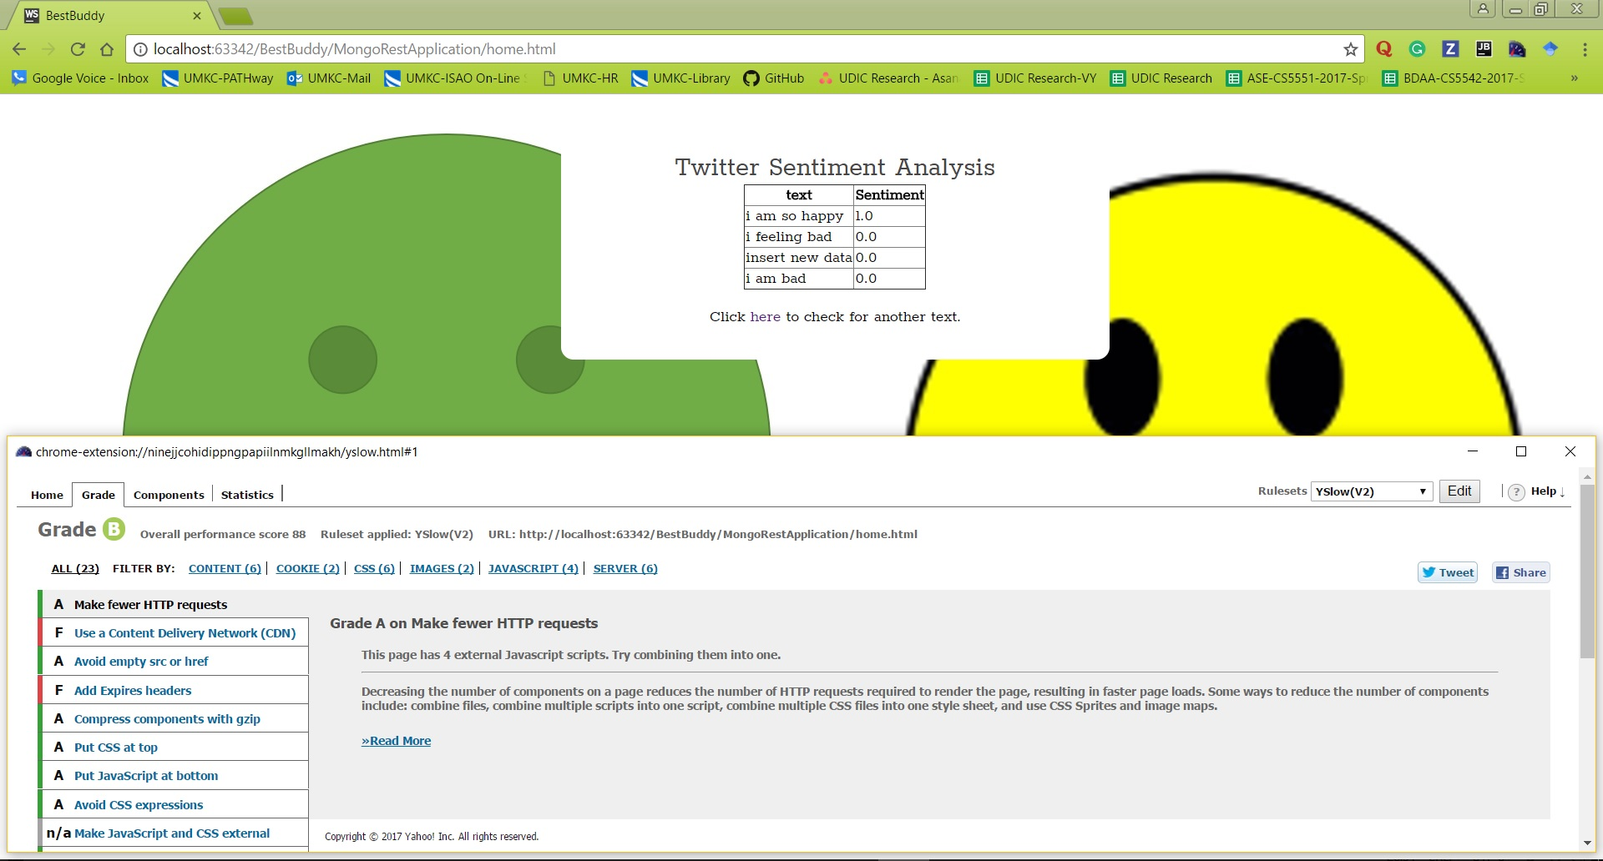

“VI. Implementation”

Created a REST API to connect Web Application and DB:

“Connection to MongoDB:”
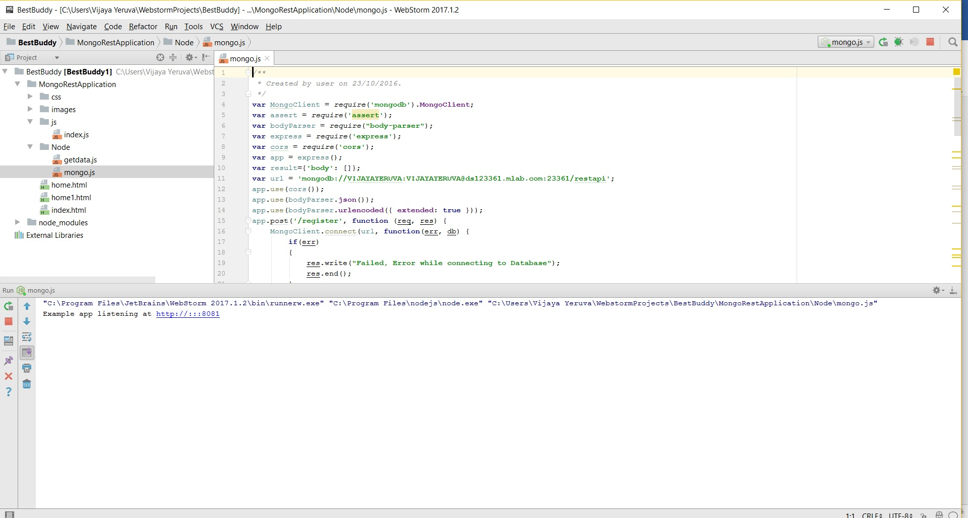

“Inserting Data to MongoDB:”
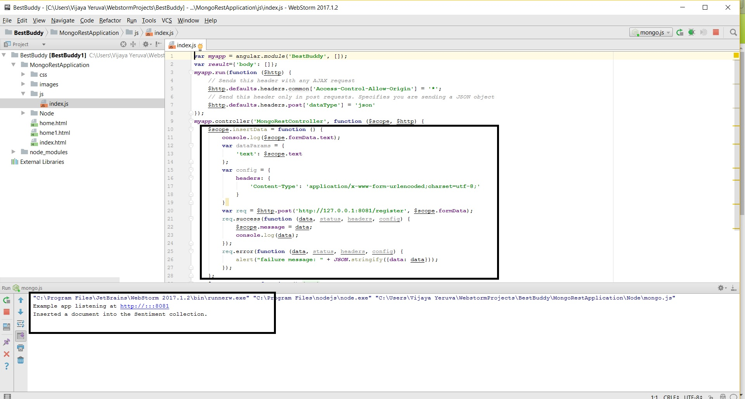

“Data in MongoDB:”
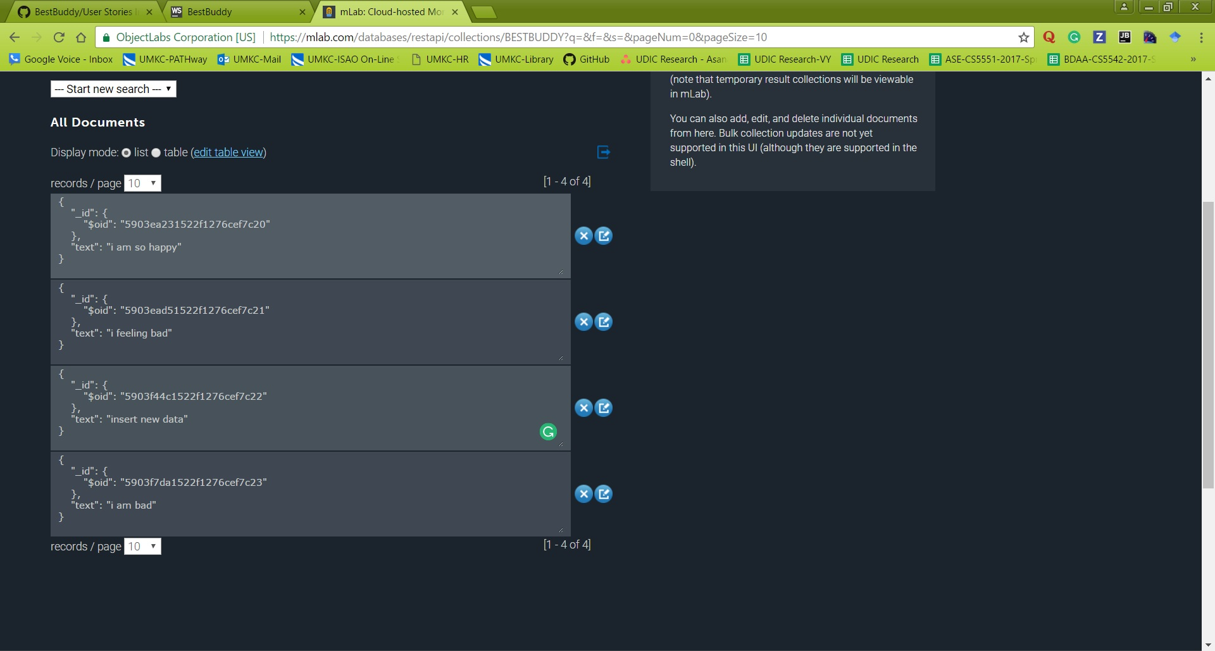

“Reteriving Data from MongoDB:”
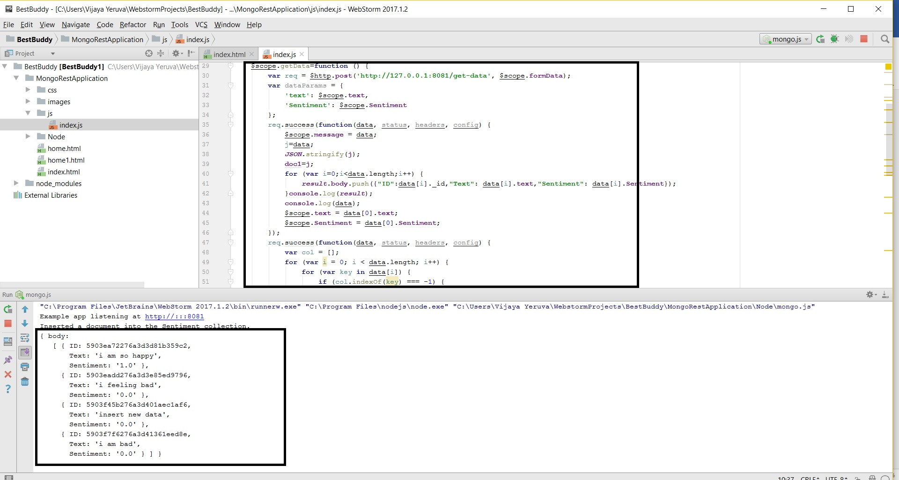

“Creating REST API:”
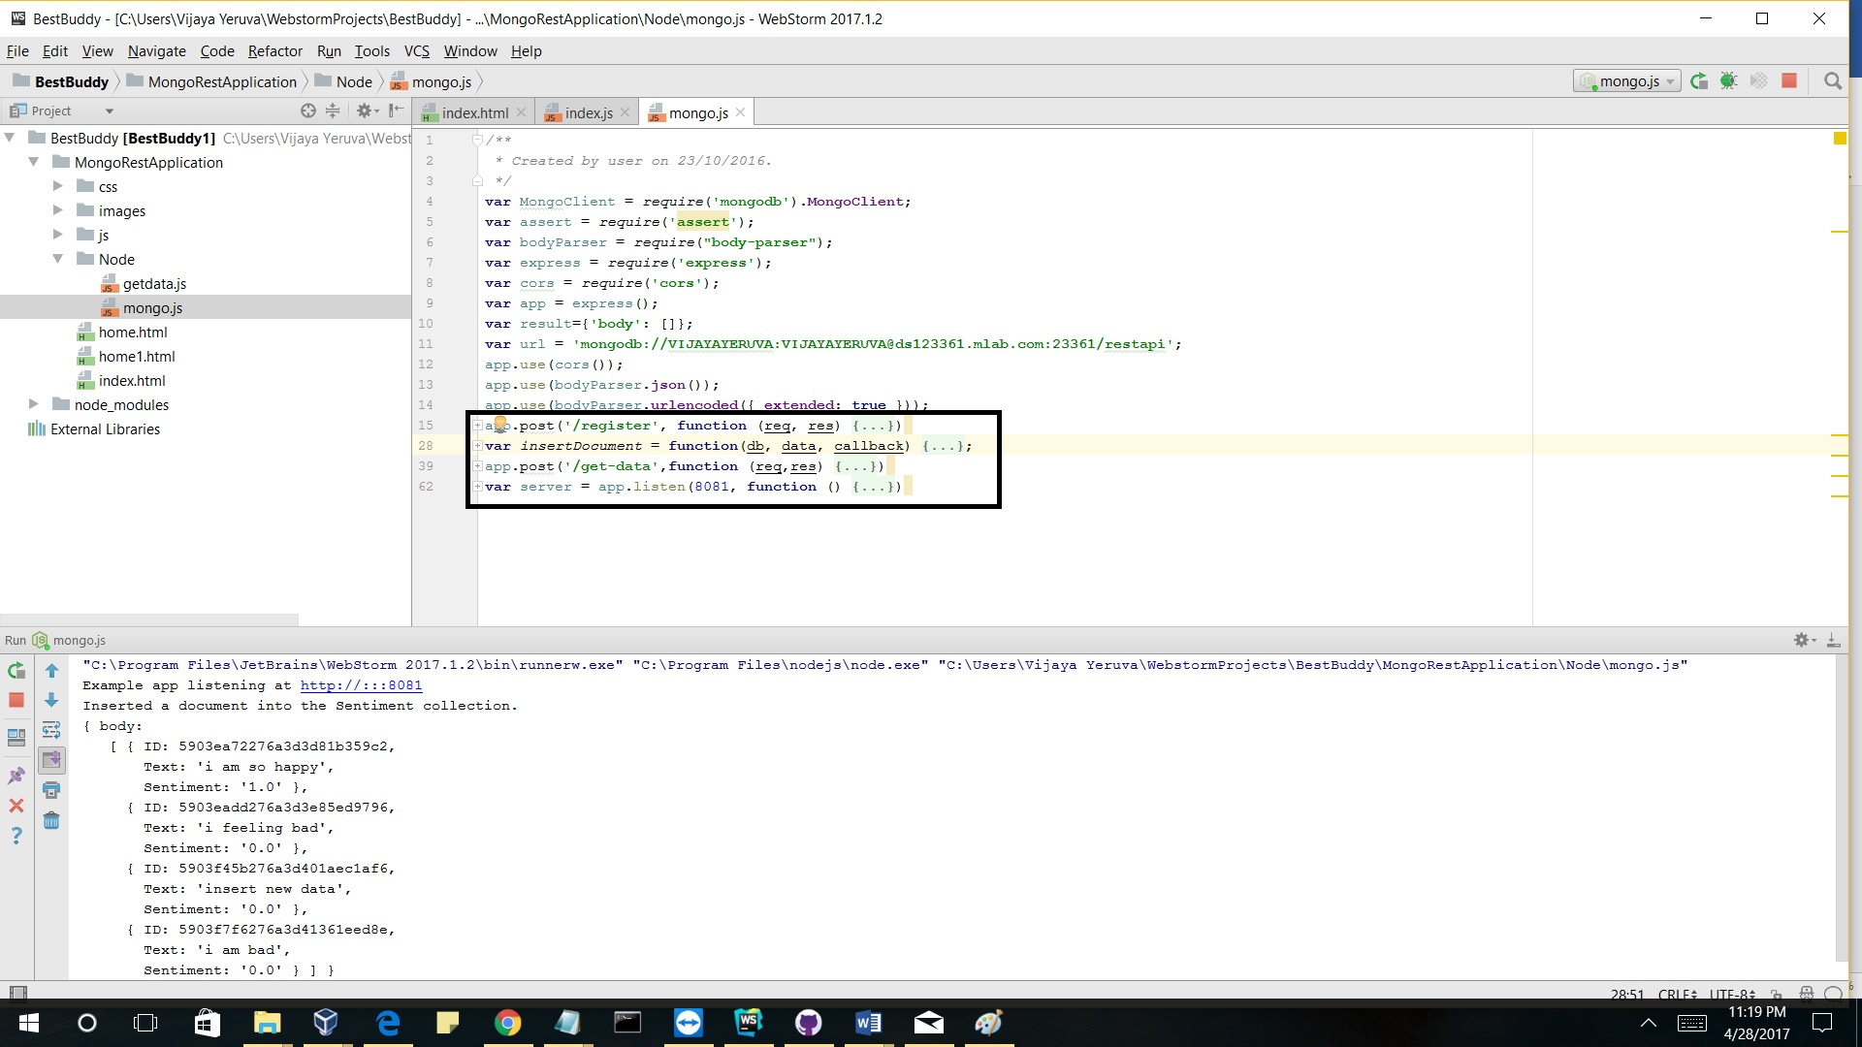

“VII. Deployment”
User will enter the text here to get the sentiment
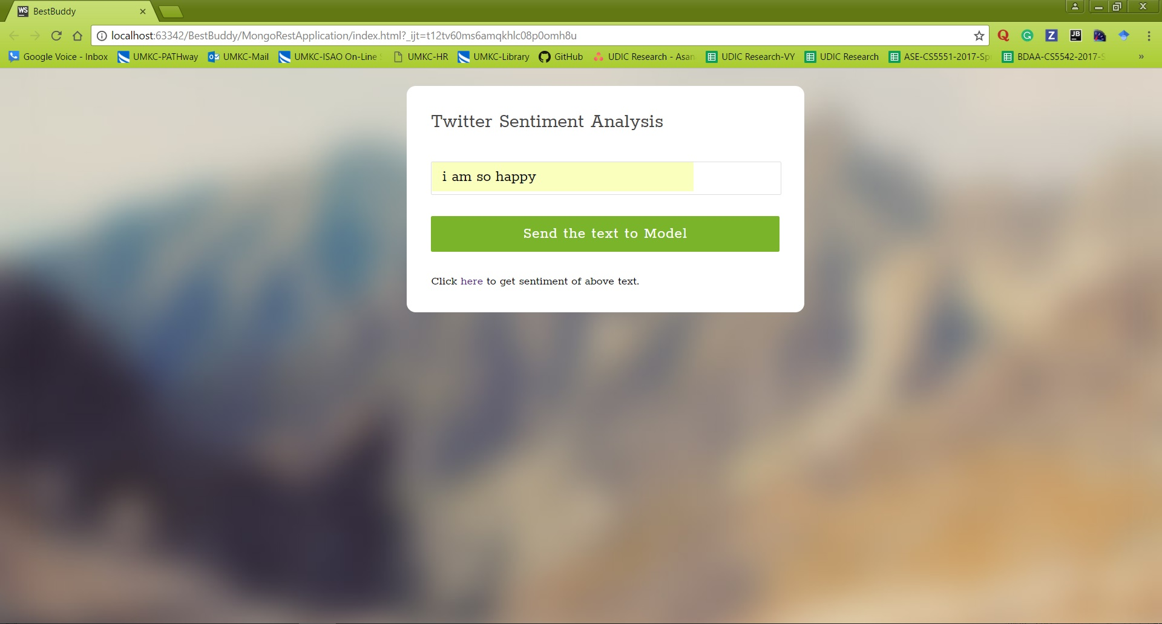
Click on ‘Send the text to Model’ button to send the text to model. After that click on link to get sentiment of the text

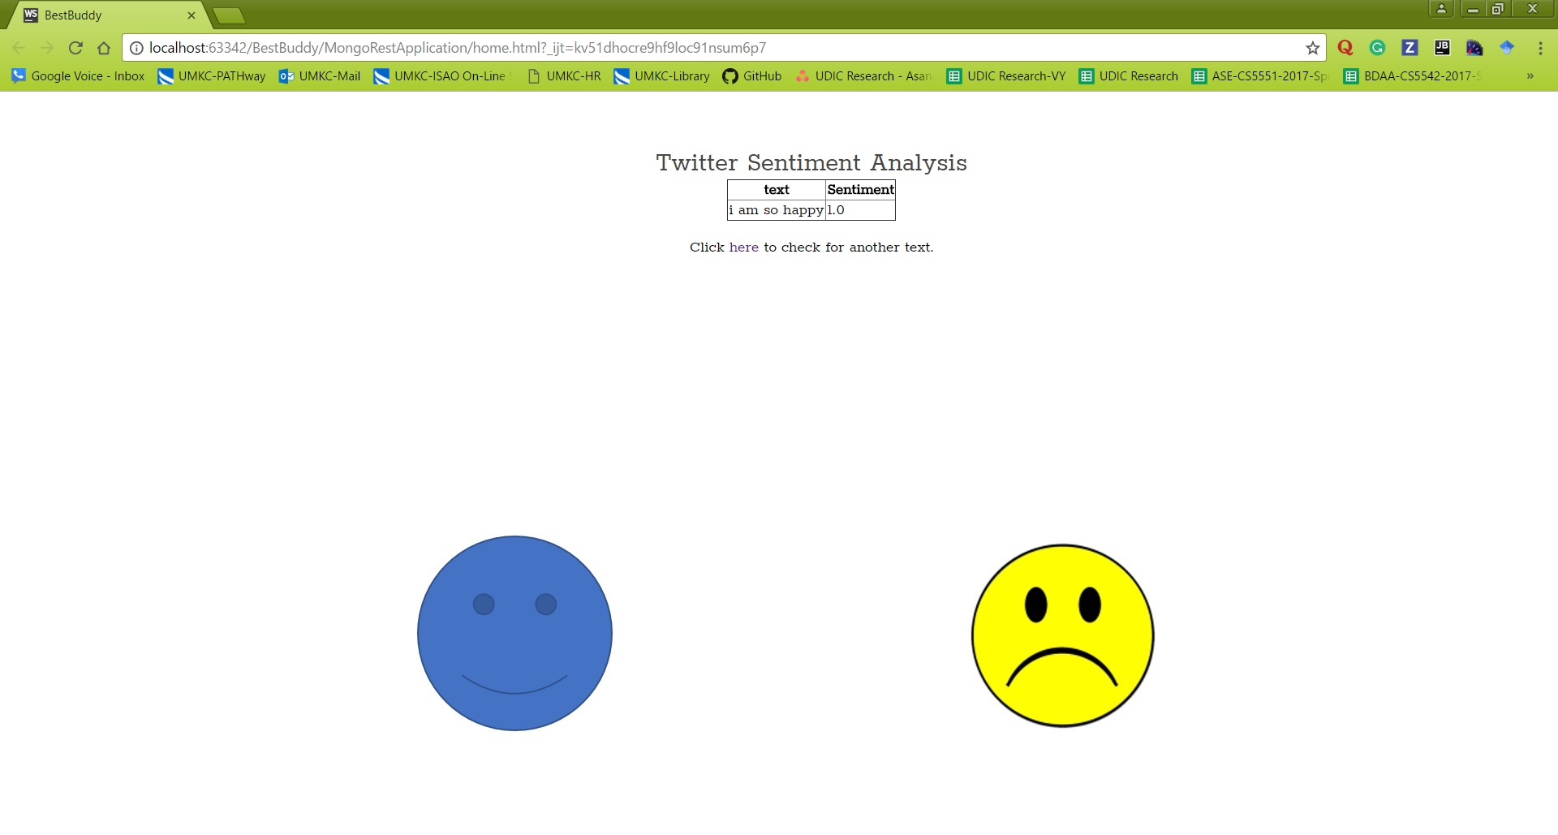

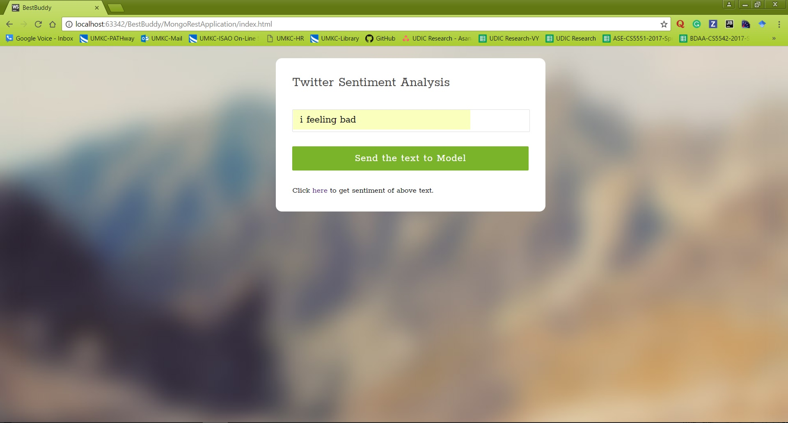

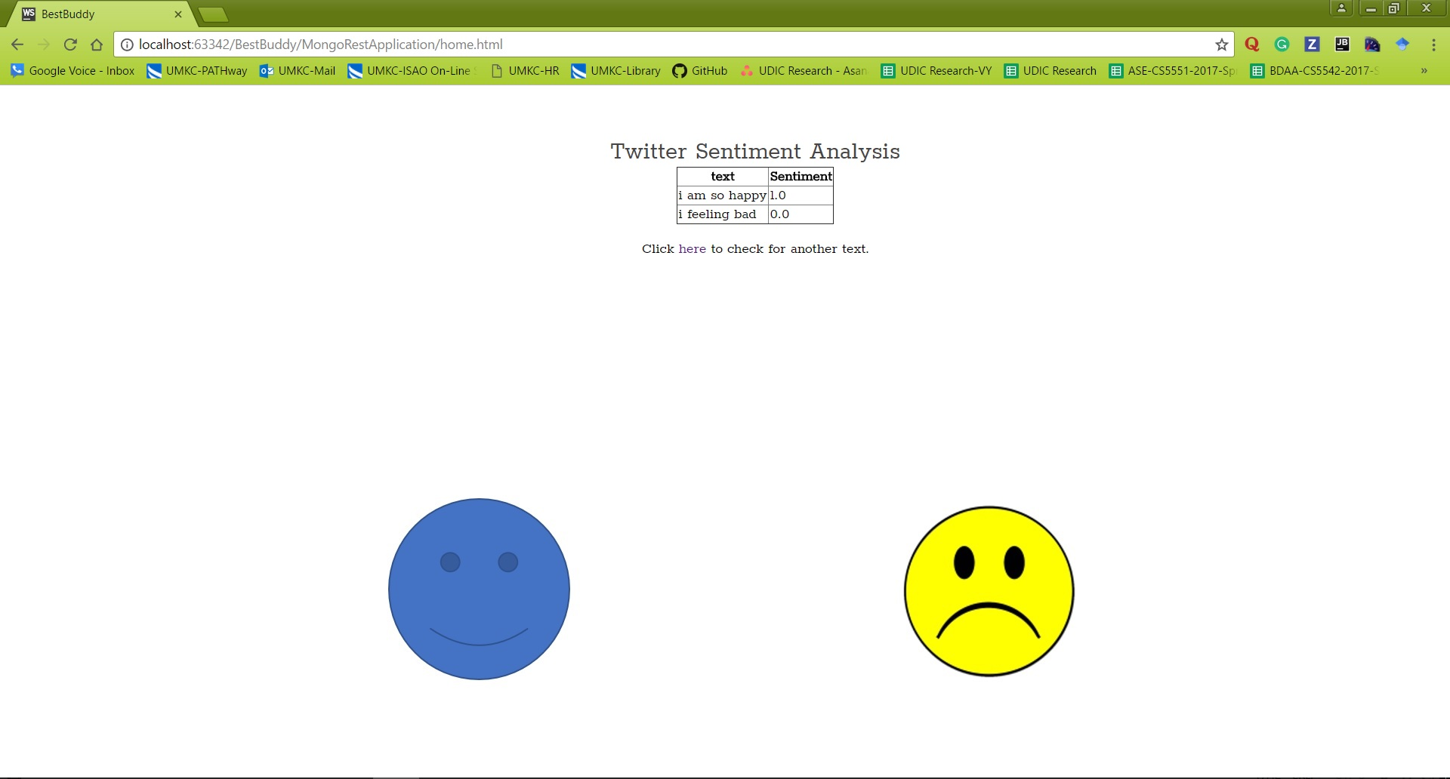

WIKI Page on GitHub: https://github.com/VIJAYAYERUVA/BestBuddy/wiki/Increment4

“VIII. Project Management”
“Time taken:” 40 hours
“Issues:” Tried a lot to implement with twitter details and with 6 categories, but unable to achieve that in given time lines

“IX. Bibliography”:
- https://docs.mongodb.com/manual/
- http://www.restapitutorial.com/
- https://www.tensorflow.org/

