Second Increment Report

In this increment we have completed the interface for log into the application with Twitter Account. User will log into the application with twitter account.

“Existing Services/REST API”
- Using Twitter API to log into the Android Application

“Detail Design of Features”
. “WireFrames”
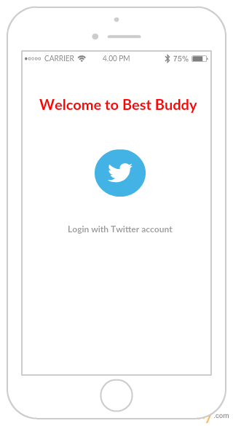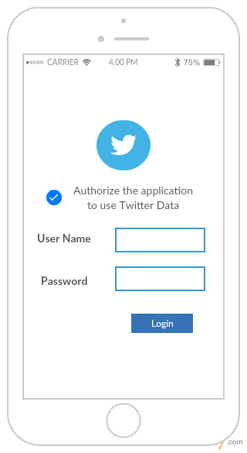
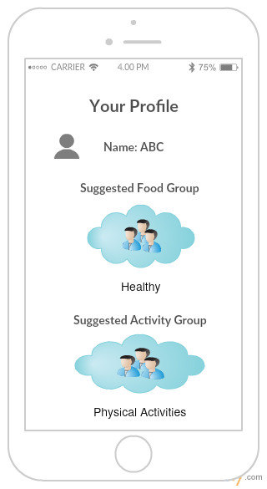

. “Architecture diagram”

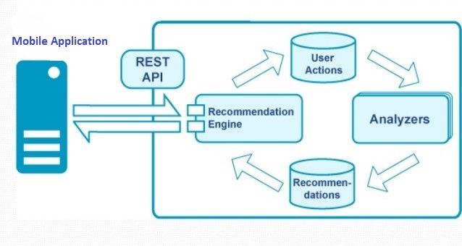

. “User Stories”
“https://github.com/VIJAYAYERUVA/BestBuddy/blob/master/Documentation/User%20Stories%20Increment2.docx”

. “Implementation”
“https://github.com/VIJAYAYERUVA/BestBuddy/tree/master/Sourcecode/Increment2/BestBuddy”

. “Deployment”
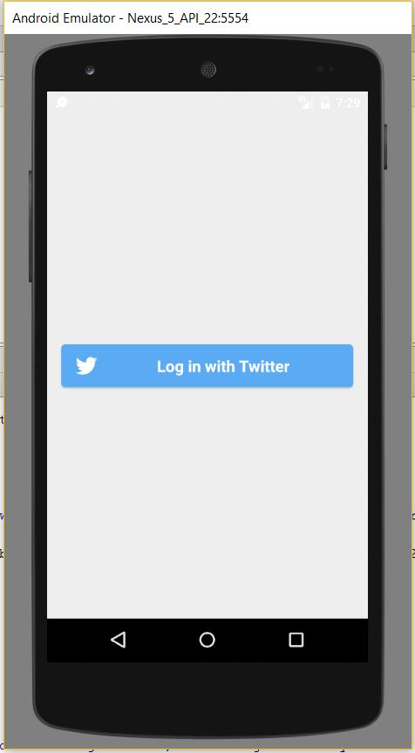
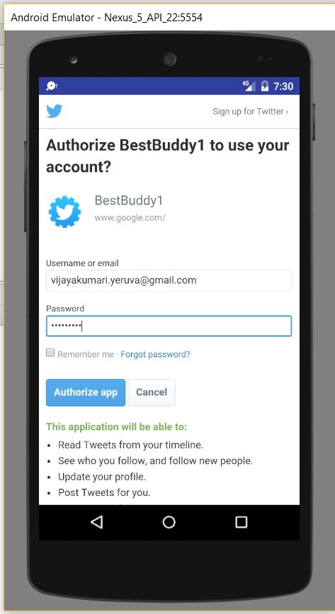
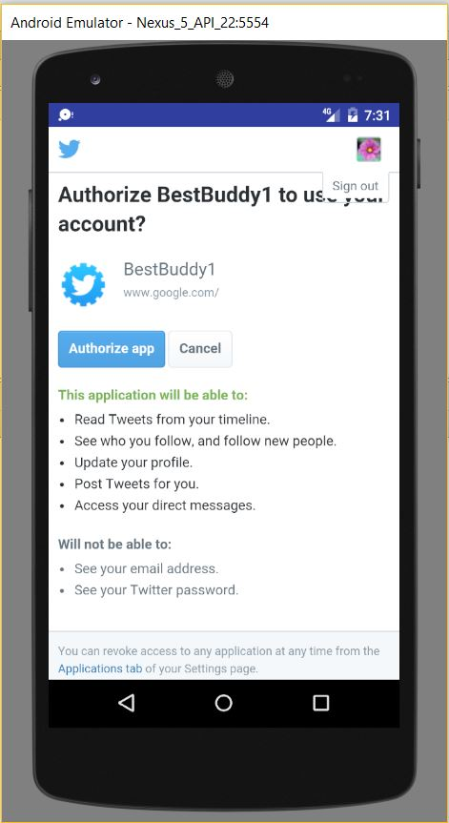

. “Project Management”
“Time taken:” 20 hours
“Contribution:” Equal contributions from all the group members

“Reference”: https://github.com/VIJAYAYERUVA/BestBuddy/wiki/Increment2

