Top3 scenarios are :

1. Finding flights based on departure and destination selection
2. Selection of flight based on available flights
3. Verifying of submitted flight details along with purchase confirmation.

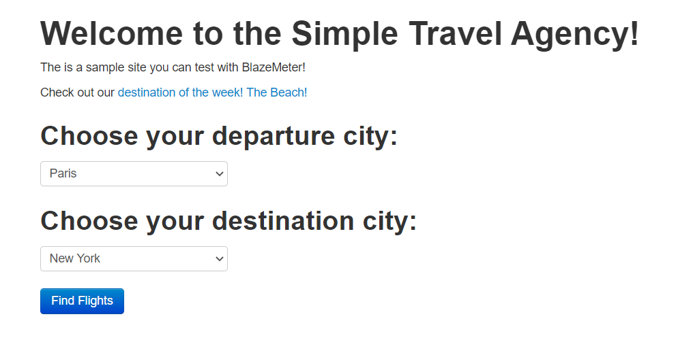

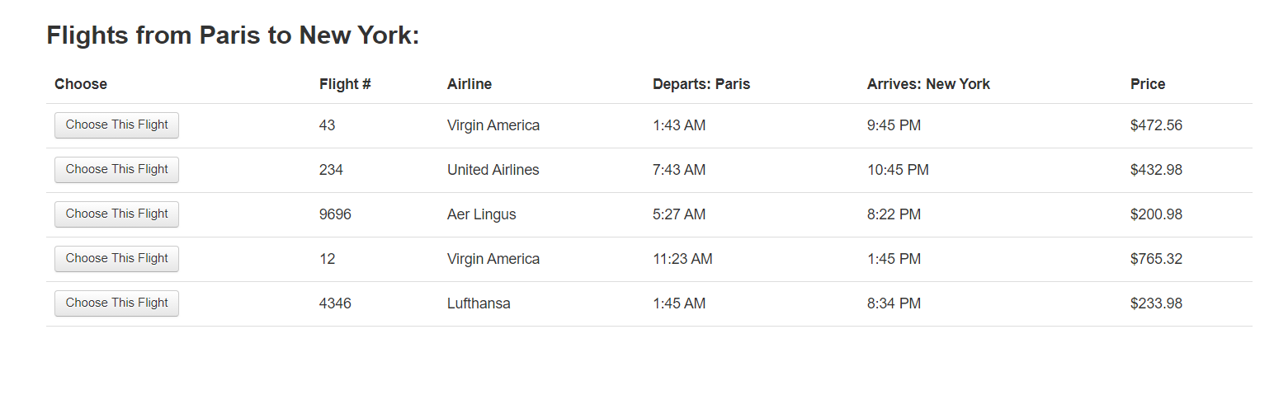

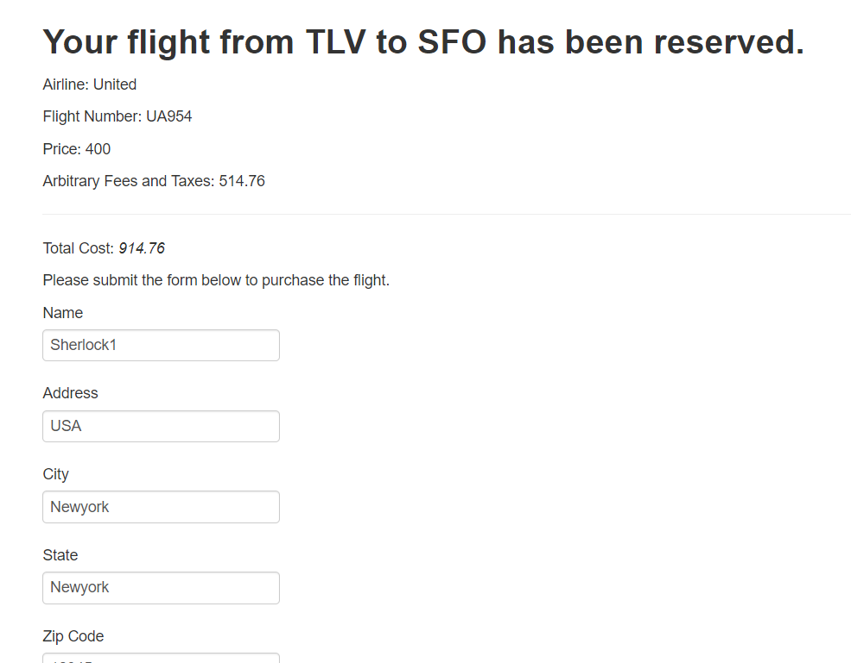

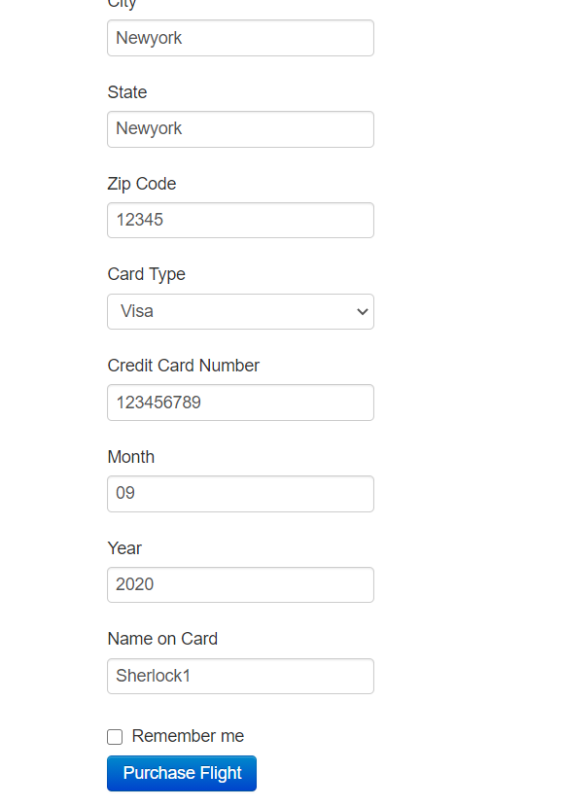

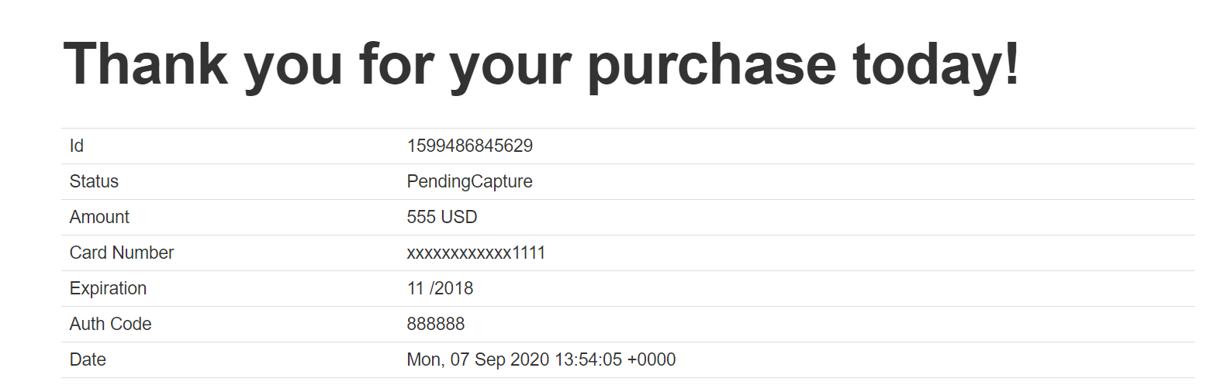

API Test :

Testcase :

GET https://api.spacexdata.com/v4/launches/latest.

Tests:

Top 3 scenarios covered are:

1. Key (Success) value to be true checked
2. Landing attempt key value checked to be true
3. Landing success key value checked to be true

Other possible scenarios can be tested:

1. Checking of ID
2. Checking of links provided in json
3. Checking details of SpaceX description
4. Checking on no of crews.
5. Checking on no of ships
6. Checking on no of capsules
7. Checking of payloads.

let jsonData = pm.response.json();

let arr = jsonData.cores;

//console.log(arr);

pm.test("SpaceX", function () {

    pm.expect(jsonData.success).to.eql(true);

    for (var i = 0; i < arr.length; i++)

{

    if(arr[i].landing_attempt === true){

        pm.test("SpaceX landing_attempt success", function () {

            pm.expect(arr[i].landing_attempt).to.be.eql(true);

        });

    }

    if(arr[i].landing_success === true){

        pm.test("SpaceX landing_success ", function () {

            pm.expect(arr[i].landing_success).to.be.eql(true);

        });

    }

}

});