Advanced Unix Programming
Assignment-7
Vijesh Ghandare – 111403013

Q1.1.“The child “exec” call inherits the file descriptors of parent if Close_on_exec is not set“.
Demonstrate with an example.

main program:
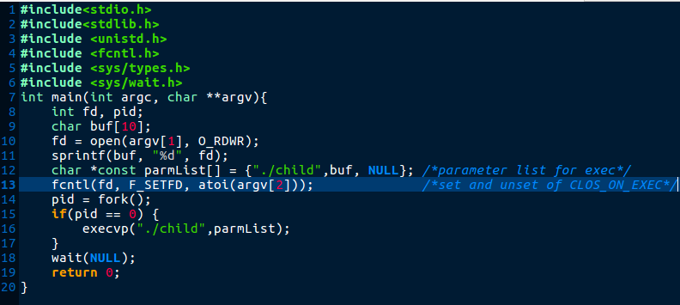
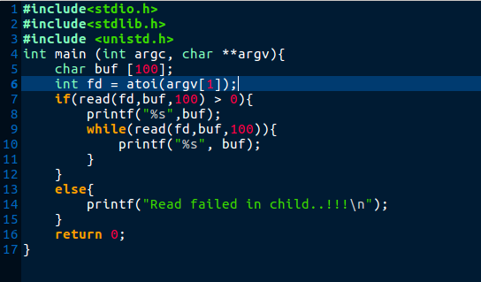
child program:

OUTPUTS:

*Case 1: Close_on_exec is not Set.

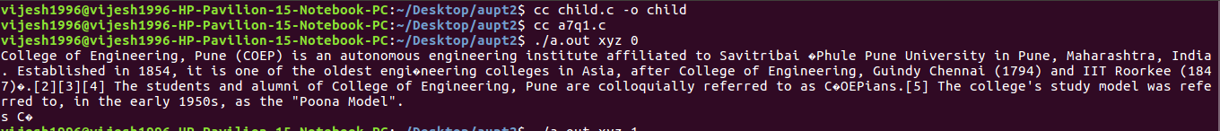
In this case first argument to the code is filename and second is Close_on_exec flag. So, it is “zero” in this case and file is read by the child program successfully this shows that “fd” is inherited by child from the parent.

*Case 2: Close_on_exec is set.

Close_on_exec is “set” and “fd” not inherited by child , hence read failed in child.

Q2.Write a program that takes a file name as an argument, opens the file, reads it and closes the file.The file should contain a string with the name of another application (e.g., 'ls' or 'ps' or any of your own applications) and the program forks a new process that executes the application named in the file.
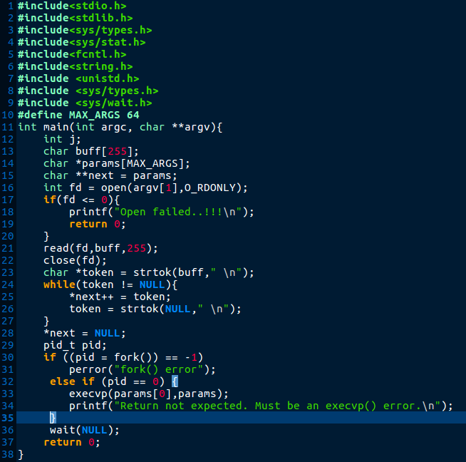
Program:

OUTPUTS:
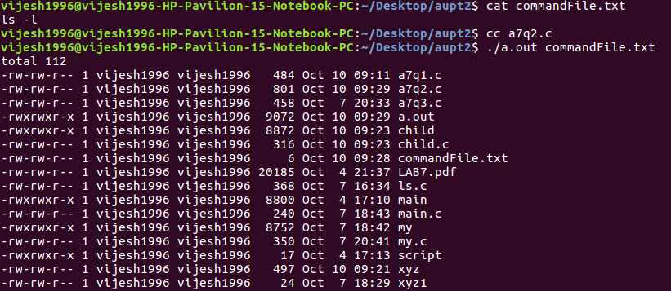
Output1: for “ls” command

Output2: for “ps” command
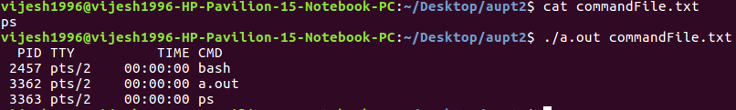
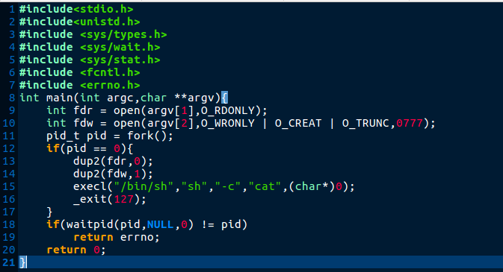

Q3: Implement cat < hw.txt > hw-copy.txt

Program:

OUTPUTS:

*Initial Contents of File1 and File2

*Contents of File1 and File2 after program execution:
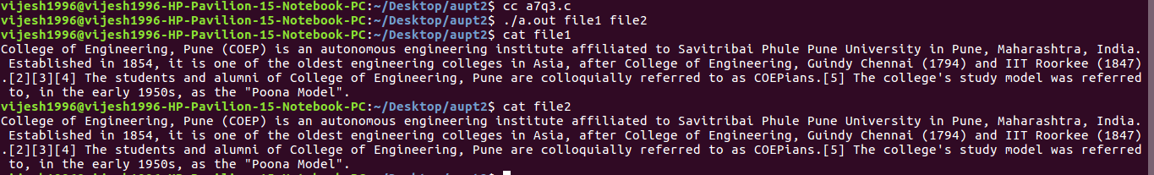

4. Bob works for an auditing agency needs to be able to read all the files in the system. The system admin has to protect the integrity of the system and should not allow Bob to modify or delete any file. Write a special SETUID program for the admin so that he can gave the executable permission of it to Bob. This program requires Bob to type a file name at the command line and then it will run /bin/cat to display the specified file. Can Bob compromise the integrity (by adding/modifying/deleting files) of this system? How?

CODE:
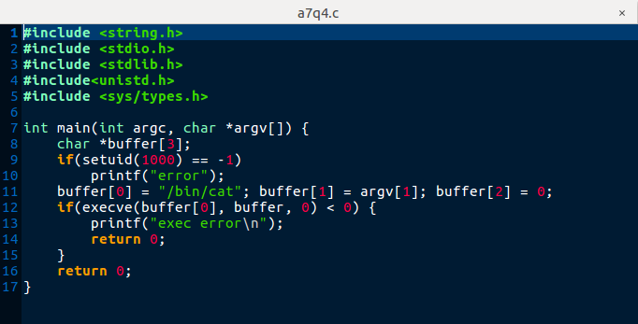

OUTPUTS:
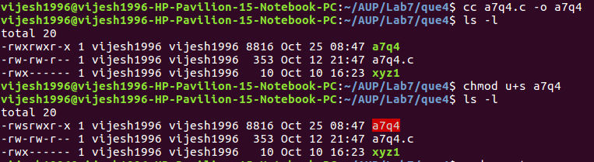
*Initial Permissions: When owner is user

*Copying files from owner to temp user:
*Final outputs: when files executed by temp user

