Advanced Unix Programming
Assignment-9
Vijesh Ghandare – 111403013

Q1. Catch the SIGTERM signal, ignore SIGINT and accept the default action for SIGSEGV.
Later let the program be suspended until it is interrupted by a signal. Implement using signal
and sigaction.

CODE:
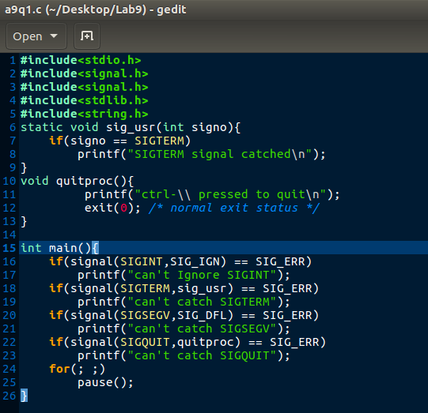

Output:
* For signal SIGTERM & SIGINT
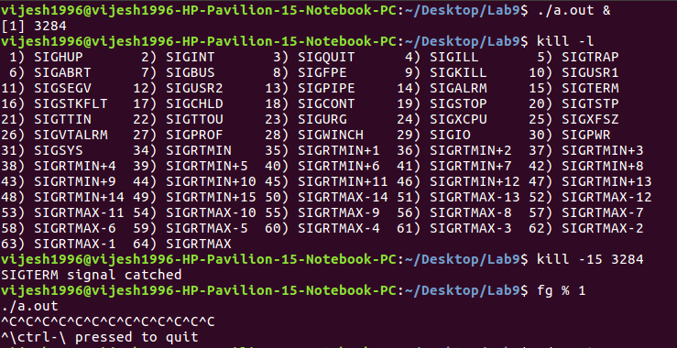
*For signal SIGSEGV
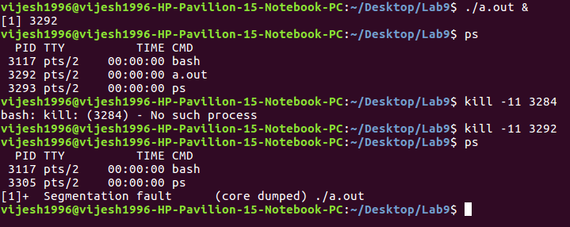

Q2. Create a child process. Let the parent sleeps of 5 seconds and exits. Can the child send
SIGINT to its parent if exists and kill it? Verify with a sample program.

CODE:
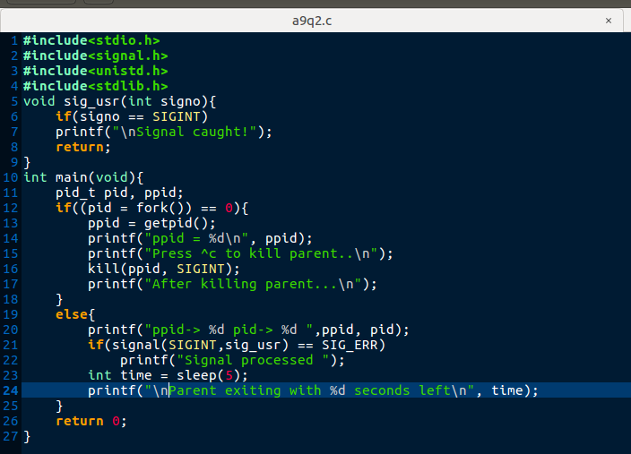

OUTPUT:
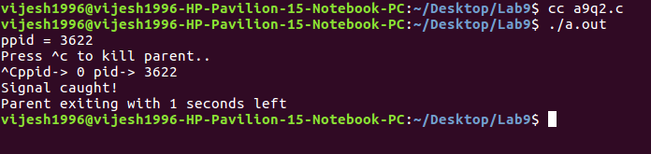

Q3. mplement sleep using signal function which takes care of the following:
a. If the caller has already an alarm set, that alarm is not erased by the call to alarm
inside sleep implementation.
b. If sleep modifies the current disposition of SIGALRM, restore it
c. Avoid race condition between first call to alarm and pause inside sleep
implementation using setjmp.

CODE:
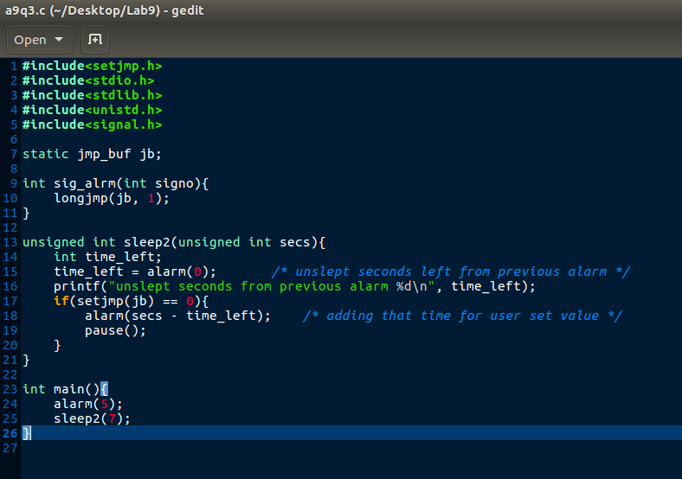

OUTPUT:

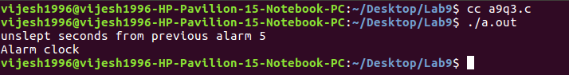

Q4. “Child inherit parent’s signal mask when it is created, but pending signals for the parent
process are not passed on”. Write appropriate program and test with suitable inputs to verify
this.

CODE:
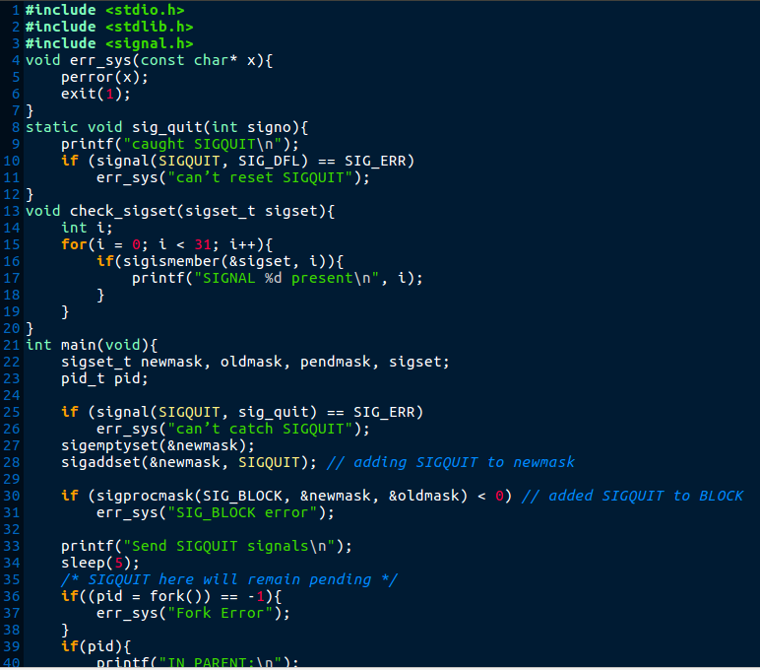

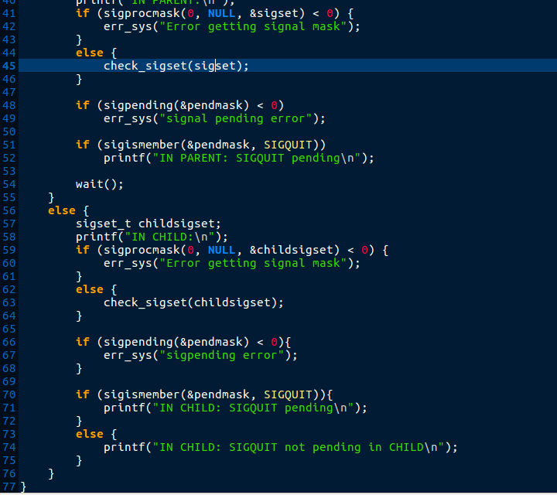

OUTPUT:
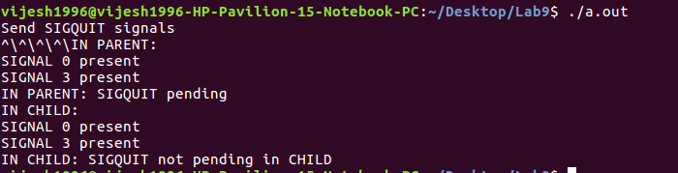

Explaination:
Above output shows that the quite signal pending in the parent is not pending in the child.

