Advanced Unix Programming
Assignment-8
Vijesh Ghandare – 111403013

Q1. Create a new system call wait2, which extends the wait system call.
int wait2(int *wtime, int *rtime, int *iotime)
Where the three arguments are pointers to integers to which the wait2 function will assign:
a. The aggregated number of clock ticks during which the process waited (was able to run but did not get CPU)
b. The aggregated number of clock ticks during which the process was running
c. The aggregated number of clock ticks during which the process was waiting for I/O (was not able to run).
The wait2 function shall return the pid of the child process caught or -1 upon failure

Start Accounting:
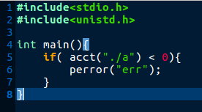

Stop Accounting:
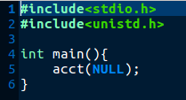

Main Program:
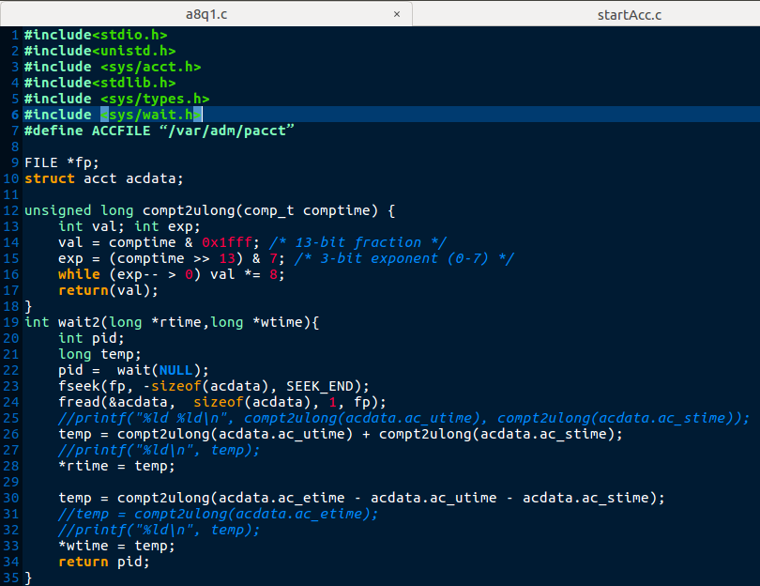
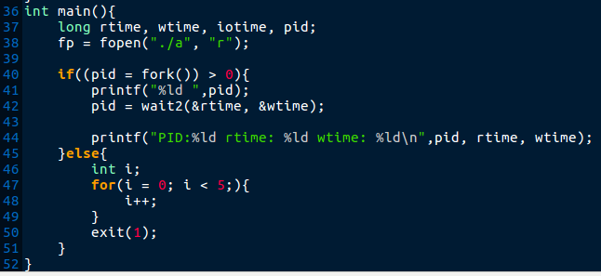

OUTPUT:
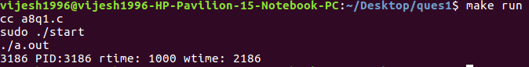
*wait2() is implemented only for rtime, wtime.

Q2. “Call fork. Let the child create a new session. Verify that the child becomes the process group leader and it does not have a controlling terminal.

Program:

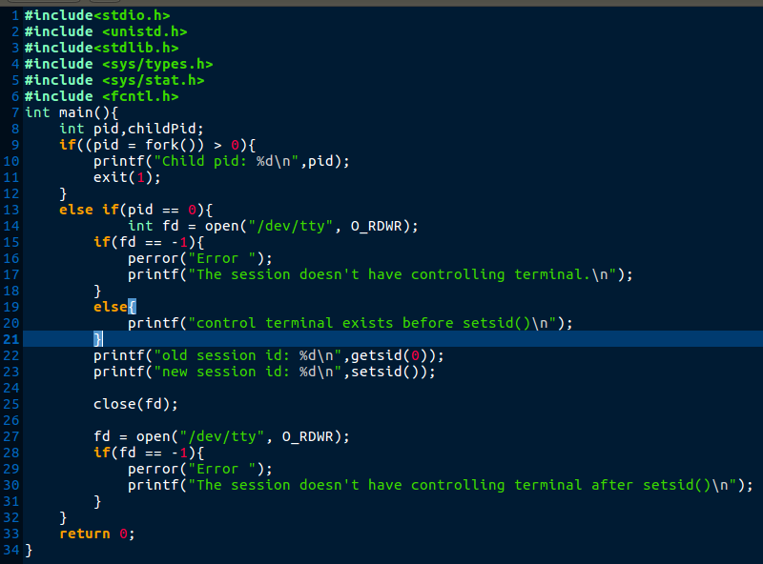

OUTPUTS:
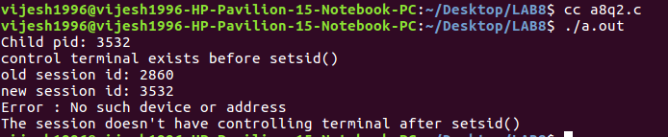

Explaination:
Outputs: line1 shows the pid of child which is 3532.
line2: Now the child is under the process group of parent and it has controling terminal.
Line3: Shows the session id of child under parent: 2860
Line4: Shows the Session Id of child after creating new session which equal to the child PID so, this shows that the child is session leader of new session.
Line5: Shows error while opening the /dev/tty file so, this shows that the new session doesn’t have controlling terminal.

Q3. Write a program to verify that a parent process can change the process group ID of one of its children before the child performs an exec(), but not afterward.

Exec code:


Main Program:
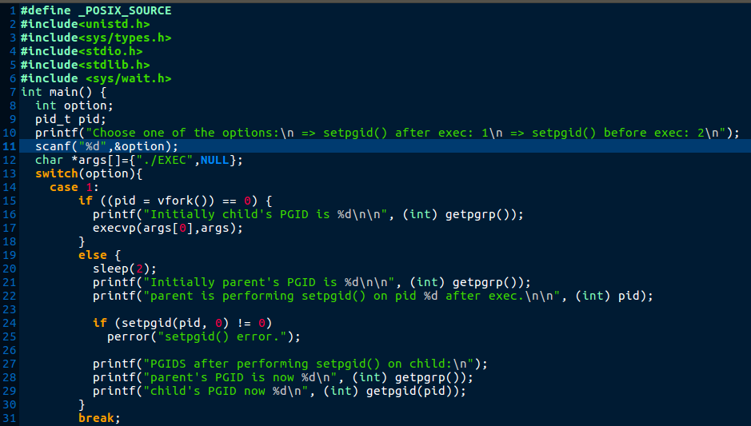
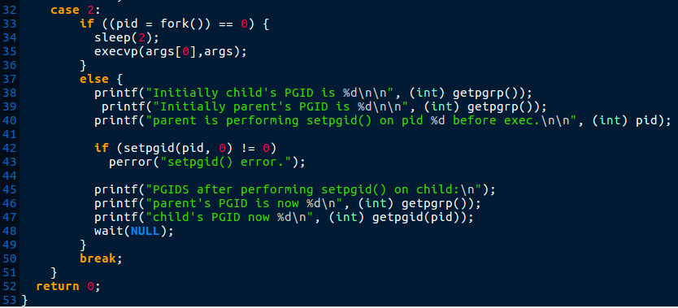

OUTPUTS:
Case 1: a parent process can change the process group ID of one of its children before the child performs an exec().
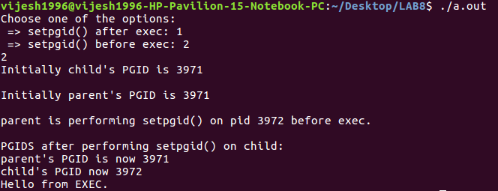
Explaination:
Here, the initial PGIDs of parent and child are: 3971.
Then parent performs setpgid(3972) of child before performing the exec() in child.
Outputs shows that the PGID of child after setpgid(3972) is changed to 3972, this shows that parent can perform setpgid() on child before exec() in child.

Case 2: a parent process can’t change the process group ID of one of its children after the child performs an exec().

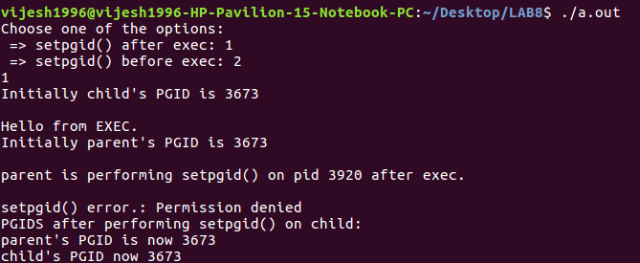
Explaination:
Similarly as above case, initial PGIDs of child and parent are: 3673.
Then the child performs exec() after that the parent try to perform setpgid(3920) on child but the setpgid() gives error: Permission Denied this shows that the parent can’t change PGID of child process.

