--1.Find the difference between the highest and lowest price from laptop.
select max(price), min(price), max(price)-min(price) as diff from laptop;
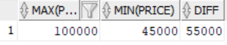

--2.Find the Standard deviation and Variance of price in PC table.
select STDDEV(price) , VARIANCE(price) from pc;

--3.Use a specific command to get the data in the following manner:
Select name as workername,lpad(age,4,'--') as age from worker;
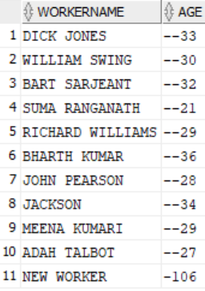

--4.a.Update the PC table such that, the price for all PC models is increased by 12.33%.
update pc set price=price*1.1233;
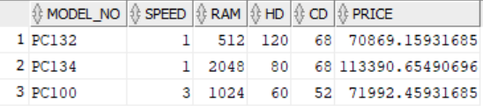

--b.Display the PC model in lowercase and price rounded to the hundredths for all the PCs.
select lower(model_no) as model,substr(price,1,3) as price from pc;
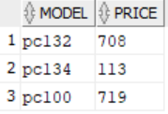
select lower(model_no) as model,trunc(price/100) as price from pc;
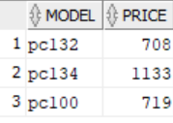

--5.List the names in the ascending order of the length of names from WORKER table.
select name, length(name) as length from worker order by length(name);
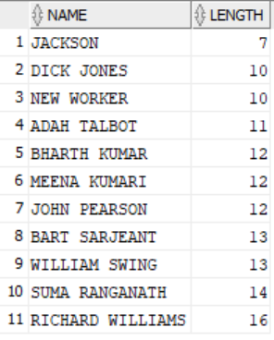
--6.List the phone number (eliminate area code like 91-0437) of all employees from WORKERSKILL table.
select substr(phone,9,5) from workerskill;
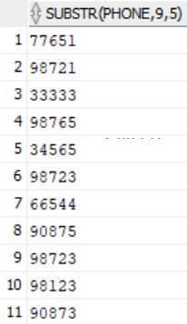
--7.Find the location of letter ‘A’ in the employee name of WORKERSKILL table.
select instr(name,'A') from workerskill;
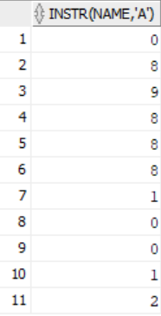
--8.Use SOUNDEX ( ) function on WORKERSKILL table to find a record of column city sound like ‘ Sidney ’.
select city from workerskill where soundex(city)=soundex('SIDNEY');
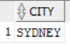

-9.Display the current date/time in the following formats:
--a.Sep-2006
select to_char(sysdate,'dd-mon-yyyy') as "DATE" from dual;
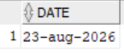
--b.September 12 2006
select to_char(sysdate,' month dd yyyy') as "DATE" from dual;
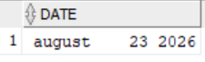
--c.12-09-06 12:11:10
select to_char(sysdate,'dd-mm-yy hh:mi:ss') as "DATE" from dual;
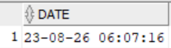
--10.Give examples for replace, decode and translate functions.
select replace(name,'ICK','EAN') as "NAME" from workerskill;
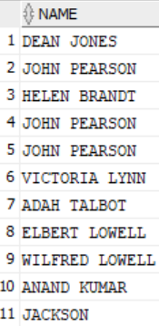
select maker,model_no,decode(type,'LP','LAPTOP','PR','PRINTER', 'PC','PERSONAL COMPUTER') as "TYPE" from product_info;
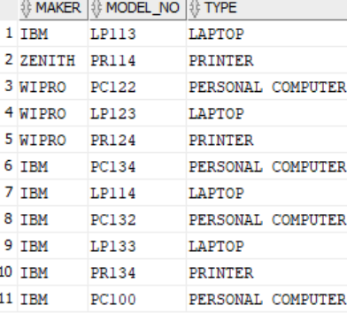
select translate(name,'IC','#*') as "NAME" from worker;
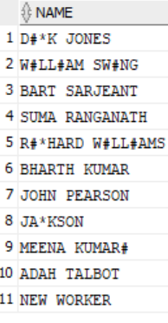
--11.Display the printer information whose price is equal to any one of the printer manufactured by ‘IBM’.
select * from printer where price= any(select price from printer where model_no in(select model_no from product_info where maker='IBM'));
--12.List the laptop details whose screen size is equal to the screen size of ‘lp114’.
select * from laptop where screensize=(select screensize from laptop where model_no='LP114');

