WEEK 4 DELIVERABLE
Reducing Customer Churn with Data Science
Comprehensive Report and Insights Presentation Plan
Executive summary | Findings | Recommendations | Communication strategy

5.2x  BETTER TARGETING |  | 52%  OF CHURNERS REACHED |  | $2.5M  EST. ANNUAL UPLIFT |  | 4  RECOMMENDED ACTIONS

About this document
This report describes a hypothetical data science project for a subscription business with about 400,000 active customers. All results, figures, charts and dollar values are illustrative mock-ups created to show how findings would be analysed, visualized and communicated. They are not real data.

Audience. The report is written for executive review. It leads with the business answer, explains the method in plain terms, shows the evidence through purpose-built visuals, and ends with a presentation plan for communicating the results to non-technical stakeholders.

Contents
1. Executive Summary
2. Background and Objectives
3. Methodology Overview
4. Findings and Insights
5. Visualization Plan and Rationale
6. Actionable Insights
7. Presentation Strategy for a Non-Technical Audience
8. Recommendations and Future Work
9. Production Plan, Conclusion and Glossary

1. Executive Summary

Purpose
The business loses about 16,000 customers every month, roughly 4% of its base, and cancellations rose sharply after the August price increase. Retention offers can win customers back, but they cost money and are wasted on customers who were never going to leave. This project set out to answer one question: can we identify, 30 days in advance, which customers are most likely to cancel, so that a limited retention budget reaches the people who matter most?

Key findings
- Churn is concentrated, not random. Customers on month-to-month contracts leave at 7.1% per month, against 1.1% for two-year contracts. Customers in their first six months leave at 8.4%.
- The price increase had a measurable cost. Monthly churn rose from a normal level of about 4.0% to a peak of 5.9% in September, 46% above normal.
- Four warning signs drive most of the risk: a contract ending within two months, a drop in usage, unresolved support tickets and a recent bill increase together account for roughly 73% of the model's predictive signal.
- The predictive model works well. Contacting the highest-risk 10% of customers reaches 52% of those who would leave, against 28% under the current rules: 5.2 times better than random and nearly double the current approach.
- The value is substantial. Under cautious assumptions, targeting with the model adds about $207,000 of net value per monthly campaign, or roughly $2.5 million a year, compared with the current rules.

Recommendation and decision requested
Decision requested
Approve a 90-day pilot that contacts the highest-risk 15% of customers each month, with a randomly chosen control group left uncontacted so the true effect of the offers can be measured.
In parallel, launch renewal outreach before contracts end, improve the first-six-months experience, and review how price changes are communicated.

Confidence and caveats. The model predicts who is likely to leave; it does not yet show which offer works best for whom, and the assumed 18% acceptance rate of offers is untested. The pilot is designed to measure exactly this before the programme is scaled.

2. Background and Objectives

2.1 Business context
The company sells subscriptions to about 400,000 active customers. Revenue depends on keeping customers, and acquiring a new customer costs far more than retaining an existing one. Today, the retention team contacts customers using simple rules, for example "contract ending soon", and has no systematic way to rank customers by risk.

2.2 Objectives
ID | Objective | Success measure
O1 | Understand when, where and why customers cancel. | Clear trends, segments and drivers documented
O2 | Build a model that ranks customers by their chance of cancelling in the next 30 days. | Reaches clearly more churners than current rules at the same contact volume
O3 | Estimate the financial value of using the model. | Net value per campaign compared with current rules
O4 | Recommend actions the business can take now. | Prioritised plan with owners and measures
O5 | Provide a way to keep the model reliable over time. | Monitoring and retraining plan

2.3 Scope
In scope: churn prediction for the next 30 days, driver analysis, value estimate, action plan.
Out of scope: choosing which specific offer to make to each customer, pricing strategy, and acquisition marketing. These are recommended as future work.

3. Methodology Overview
The project followed a seven-step process, summarised in Figure 1. The approach is designed so that the results measured in testing are a fair guide to what will happen in real use.
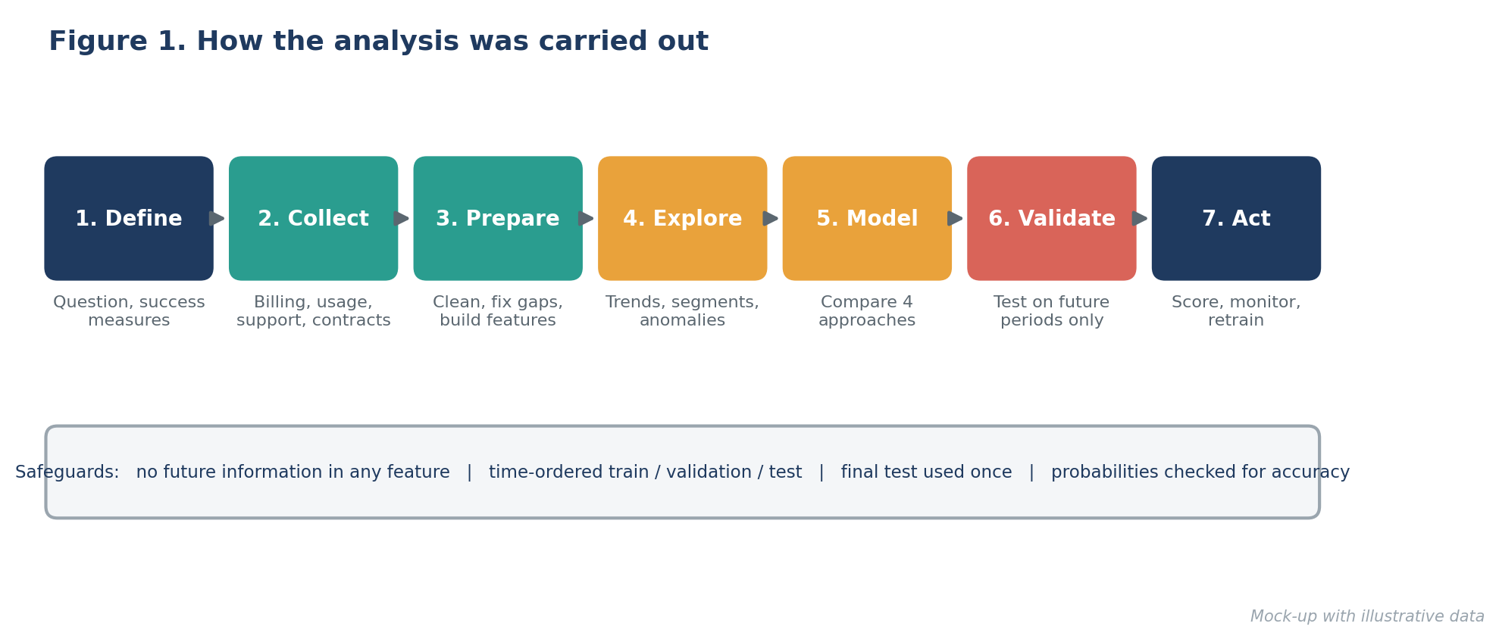
Figure 1. How the analysis was carried out
Step | What was done | Why it matters
Define | Turned the business problem into a clear question: which customers will cancel in the next 30 days? | A precise question avoids building something that does not help decisions.
Collect | Combined four sources: customer contracts, billing, product usage and support interactions, with two to three years of history. | Churn has many small causes; no single source tells the story.
Prepare | Cleaned errors and duplicates, filled gaps carefully, and built signals such as usage change over 30 days and days since last login. | Trends and recent behaviour predict churn better than raw totals.
Explore | Examined churn over time, across customer groups and against each signal, and investigated unusual periods. | Finds real patterns and checks that results make business sense.
Model | Compared four approaches, from the current rules and a simple statistical model to random forest and gradient boosting, on the same data. | Starting simple shows whether extra complexity is worth it.
Validate | Trained on older months and tested on later months the model had never seen; used the final test period once; checked that predicted probabilities are trustworthy. | Mirrors real use, where the model predicts the future, and prevents over-optimistic results.
Act | Designed weekly scoring, explanations for each flagged customer, monitoring and regular retraining. | A model only creates value if it is used and kept accurate.

3.1 Choices that protect the credibility of the results
- No peeking at the future. Every signal uses only information available on the day of the prediction.
- Fair test. Performance is measured on later periods than the training data, and the final test is used once.
- Right yardstick. Because only a minority of customers leave, plain accuracy is misleading (predicting "nobody leaves" would be about 96% accurate). The project uses measures focused on how well the model finds the customers who leave.
- Explainable. Each score comes with the main reasons behind it, so retention staff can trust and act on it.

4. Findings and Insights
This section presents the five main findings. Each one has a chart and a short note on why that chart was chosen, so that the visual matches the question being answered.

4.1 When: cancellations spiked after the price increase
Monthly churn was stable at about 4.0% through July. After the August price increase it rose to 5.5% in August and 5.9% in September, then eased back to 4.3% by December. The August to October average of 5.5% is about 1.4 percentage points above the earlier level, a difference that is statistically reliable (95% confidence interval: +1.1 to +1.8 points) and not explained by seasonal patterns seen in earlier years.
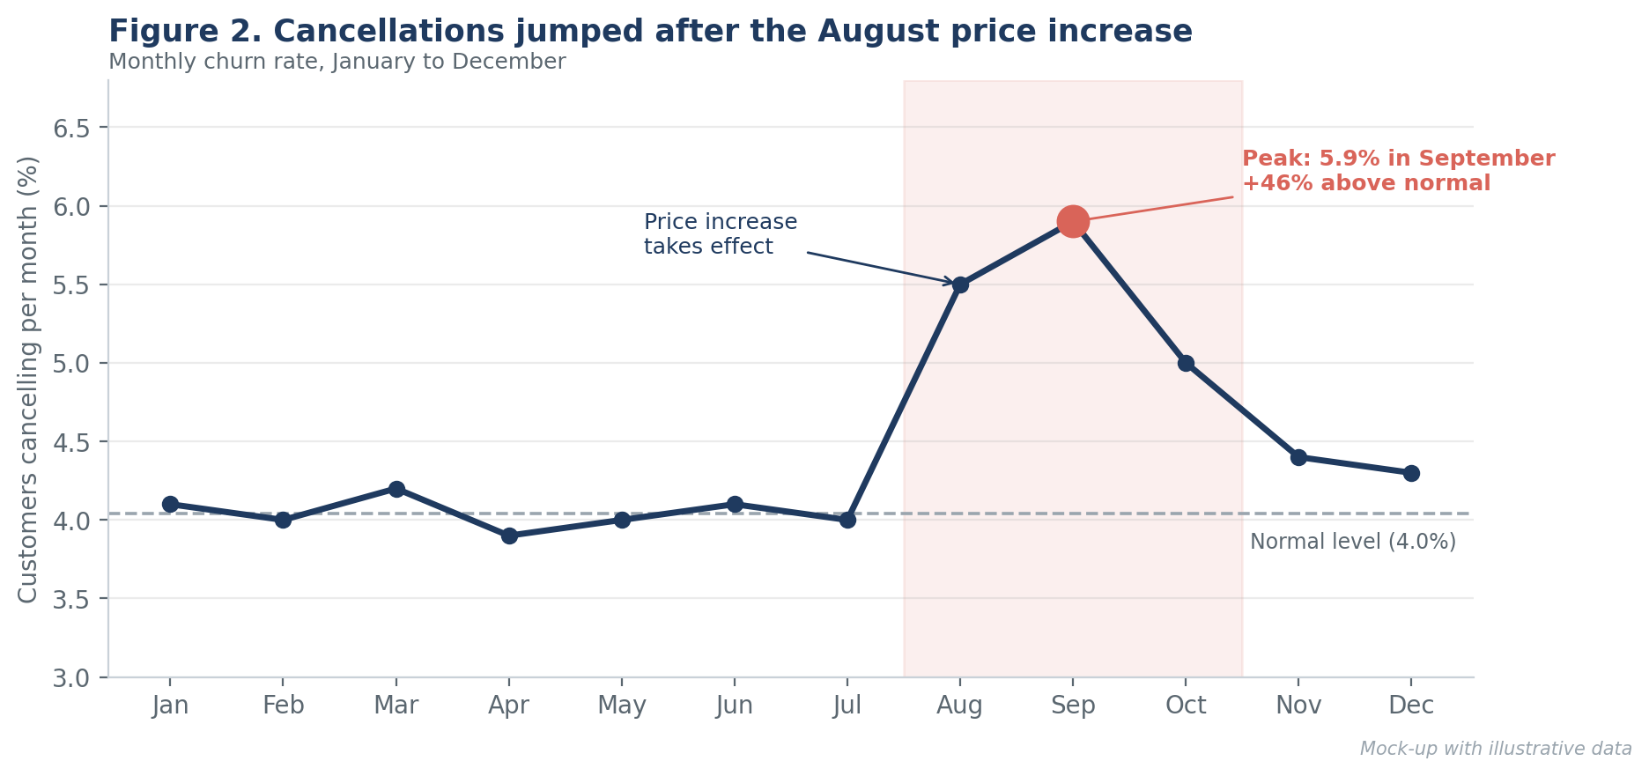
Figure 2. Monthly churn rate with the price-increase period highlighted
Why this chart
A line chart is the clearest way to show change over time. The shaded band and the dashed "normal level" line let a reader see the anomaly in seconds without reading any numbers.

So what: price changes carry a retention cost that should be planned for, for example with targeted offers or better communication before the change takes effect.

4.2 Who: flexible contracts and new customers leave the most
Month-to-month customers churn at 7.1% per month, nearly three times the rate of one-year customers (2.6%) and six times the rate of two-year customers (1.1%). Risk also falls steadily with time as a customer: 8.4% in the first six months, down to 1.3% after four years. The contract-type difference is statistically significant (chi-square test, p below 0.001), and the link between longer tenure and lower churn is consistent (correlation of -0.31).
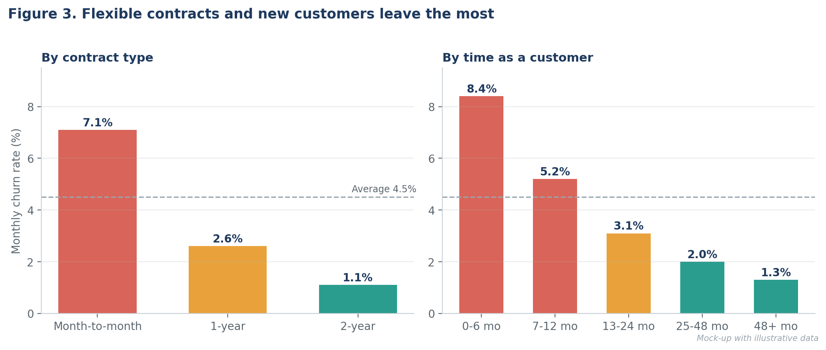
Figure 3. Churn rate by contract type and by time as a customer
Why this chart
Side-by-side bar charts compare groups on a common scale. Colour marks the high-risk groups in coral and the safe groups in teal, and the dashed line shows the average so that every bar is judged against the same reference.

So what: the first six months and the end of each contract are the moments where intervention matters most.

4.3 Why: four warning signs explain most of the risk
The model relies most on four signals: a contract ending within two months (24% of the model's signal), a fall in usage over the last 30 days (21%), unresolved support tickets (15%) and a recent bill increase (13%). Short tenure and late payments add further signal. Together, the four main signs account for about 73%.
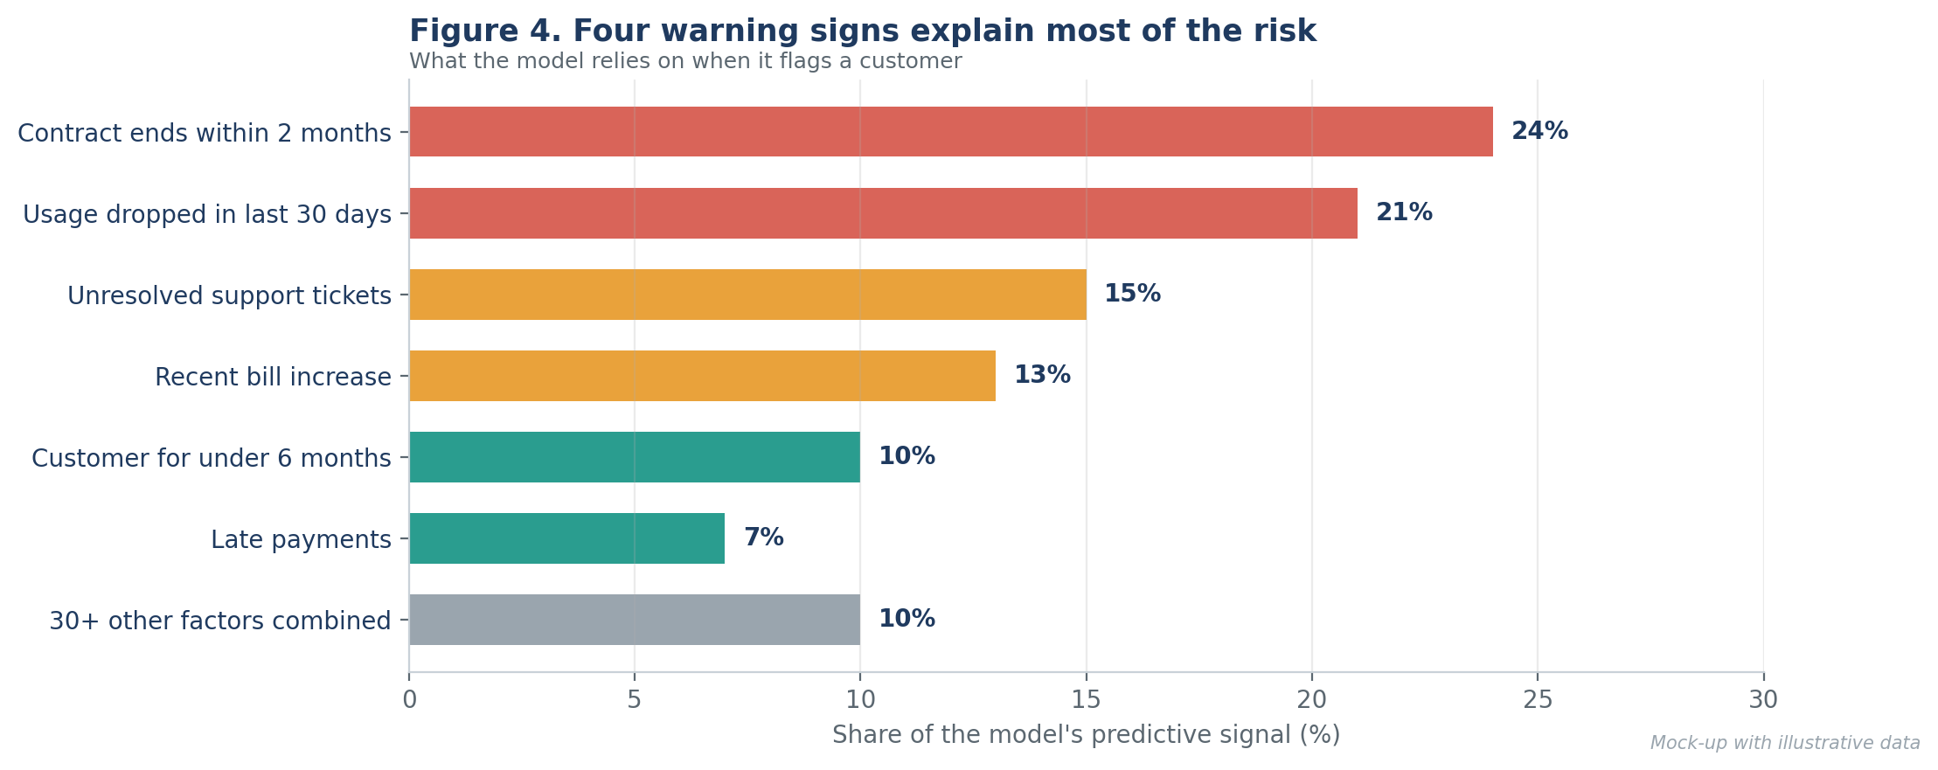
Figure 4. Share of the model's predictive signal by factor
Why this chart
A sorted horizontal bar chart is the standard way to rank factors: long text labels stay readable, the biggest driver is at the top, and the ranking is understood at a glance. Plain-language labels replace technical feature names.

So what: each warning sign points to a concrete action: renewal outreach, re-engagement campaigns, faster ticket resolution and clearer billing communication.

4.4 How well: the model clearly beats current practice
Four approaches were compared on later months that the models had not seen. The gradient boosting model scored best on both ranking quality (0.46, against 0.19 for current rules) and on practical reach: contacting the 10% of customers ranked as highest risk reaches 52% of those who would leave, against 28% under current rules.
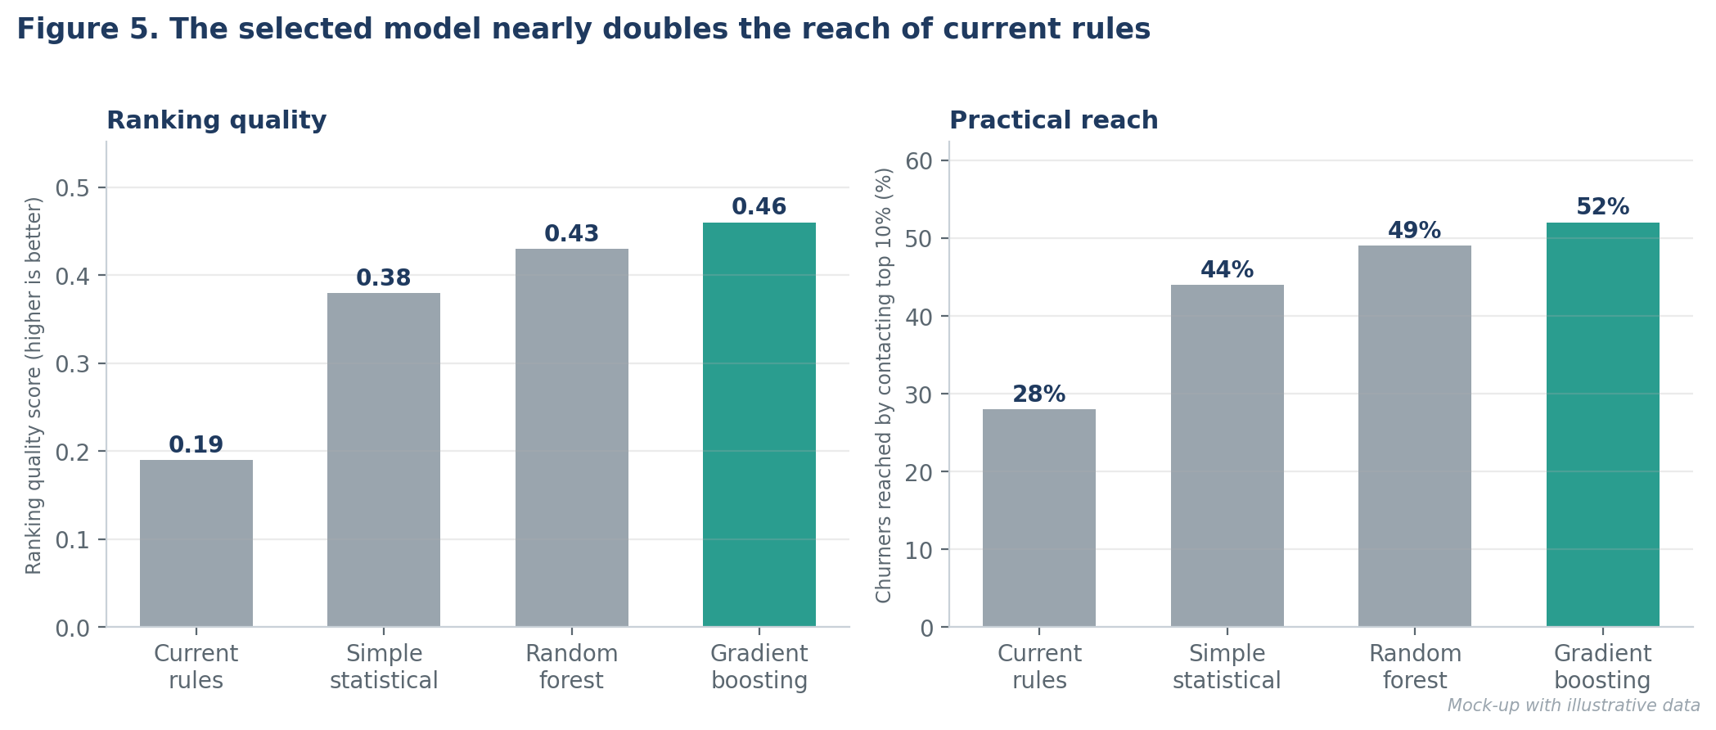
Figure 5. Comparison of four approaches on later, unseen months
Why this chart
Paired bars show a technical score next to a practical, business-friendly measure. The selected model is highlighted in teal and the others in grey, drawing the eye to the answer. The second panel is the one executives should remember.

Figure 6 shows the same result as a gains curve. The further the curve rises above the diagonal line (random selection), the better the model is at finding customers who would leave early in the ranked list.
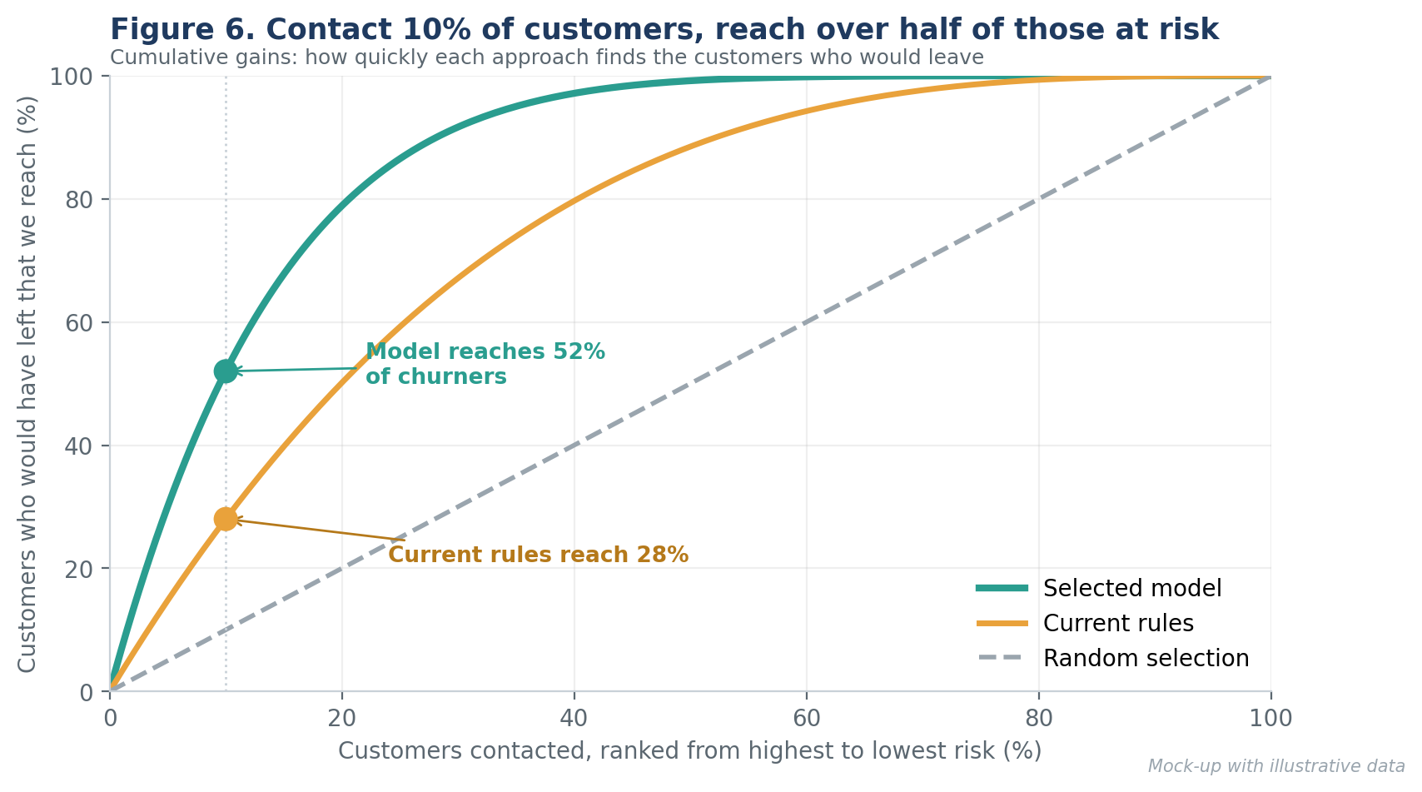
Figure 6. Cumulative gains: share of at-risk customers reached
Why this chart
A gains curve translates "model quality" into a question managers ask: if we can only contact this many customers, how many of the leavers do we reach? Two labelled points make the message readable without technical knowledge.

4.5 What it is worth: financial value
The model's value depends on how many customers are contacted. Contacting too few misses people at risk; contacting too many spends money on customers who would have stayed. Figure 7 shows the estimated net monthly value, using the assumptions in the table below.
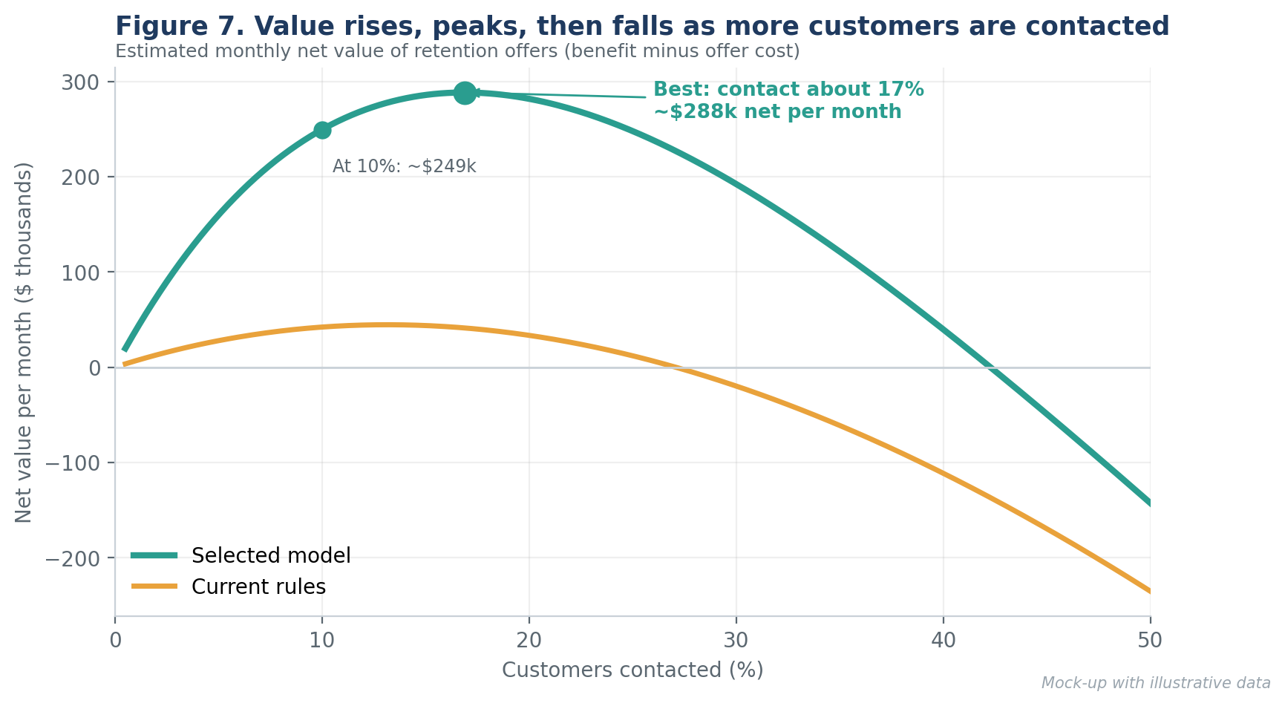
Figure 7. Estimated net value per month by share of customers contacted
Assumption (illustrative) | Value
Active customers | 400,000, with about 16,000 cancelling each month (4.0%)
Cost of one retention offer | $5 per customer contacted
Share of contacted leavers who accept the offer and stay | 18% (to be tested in the pilot)
Value of a retained customer | $300 of margin over the following year

Under these assumptions, the table below compares the current approach with the model at a 10% contact volume, and shows the best volume the model suggests.
Executive scorecard (monthly) | Current rules (10%) | Model (10%) | Model (best, ~17%)
Customers contacted | 40,000 | 40,000 | 68,000
Customers who would leave, reached | 4,480 | 8,320 | 11,630
Customers retained | 806 | 1,498 | 2,094
Offer cost | $200k | $200k | $340k
Value of customers retained | $242k | $449k | $628k
Net value | $42k | $249k | $288k

Why these visuals
A curve with a clear peak makes the "how many to contact" decision intuitive, and the scorecard table gives executives the exact numbers they will be asked about. Together they show both the shape of the trade-off and the bottom line.

So what: choose the contact volume by financial value, not by habit. The model improves value at any volume, and the best volume is larger than the 10% commonly assumed. The 18% acceptance rate is the most important assumption to confirm.

5. Visualization Plan and Rationale
Every visual in this report and in the presentation has a job. The table lists each chart, the insight type it carries and the reason it was chosen over alternatives.
Visual | Insight type | Question answered | Why this form | Alternative rejected
Fig 2: line chart with highlighted band | Trend and anomaly | When did churn change? | Lines show change over time; shading marks the event. | Table of monthly numbers (hides the shape)
Fig 3: grouped bar charts | Comparison | Who leaves most? | Bars compare groups on one scale; average line gives context. | Pie chart (poor for comparing rates)
Fig 4: sorted horizontal bars | Statistical insight (importance) | Why do customers leave? | Ranking is immediate; labels stay readable. | Raw importance table (too technical)
Fig 5: paired bar charts | Model comparison | Is the model better than today? | Same layout for a score and a business measure. | ROC curve (hard to explain to executives)
Fig 6: gains curve | Statistical insight (lift) | How many leavers do we reach? | Links contact volume to results in plain terms. | Confusion matrix (needs a threshold first)
Fig 7: value curve + scorecard | Business impact | How many to contact, and what is it worth? | Shows trade-off and optimum; table gives exact figures. | Single average ROI number (hides trade-off)
Fig 9: roadmap bars | Plan | What happens next, and when? | Time bars show sequence and overlap. | Bullet list (no time sense)

5.1 Design rules applied to every visual
Rule | How it is applied
Title states the finding | Titles such as "Cancellations jumped after the August price increase" tell the reader the conclusion before they study the chart.
One message per visual | If a chart needs two messages, it is split in two.
Colour carries meaning | Coral means risk, teal means good or recommended, grey means context. The same colours are used in every figure.
Direct labelling | Values and key points are labelled on the chart, so readers do not need to look up a legend or an axis.
Plain language | No technical terms on charts: "Four warning signs", not "feature importance".
Honest scales | Bars start at zero; reference lines show the average or the normal level; mock-up charts are clearly marked as illustrative.
Accessible | Colour is never the only signal (labels and values are also shown); high contrast and large text for projection.

5.2 Analysis types covered
- Trends: monthly churn over time (Figure 2).
- Anomalies: the post-price-increase spike, investigated and quantified (Figure 2).
- Segment comparisons: contract type and tenure (Figure 3).
- Statistical insights: significance test of contract effect, correlation with tenure, confidence interval for the price effect, driver ranking and lift (Figures 3, 4 and 6).
- Predictive performance: model comparison on unseen periods (Figures 5 and 6).
- Business impact: value by contact volume and the executive scorecard (Figure 7).

6. Actionable Insights
An insight is only useful if it leads to a decision. The table converts each finding into an action, an owner, an expected effect and a measure of success.
Insight | Recommended action | Owner | Expected effect | Success measure
Month-to-month customers churn at 7.1% | Offer incentives to move to longer contracts at the right moment | Product and Pricing | Fewer high-risk customers | Share on 1-year or longer contracts
Risk rises when a contract is about to end | Start renewal outreach 60 days before contract end | Retention team | Fewer lapses at renewal | Renewal rate
Customers in the first 6 months churn at 8.4% | Improve onboarding and add check-ins at day 30 and day 90 | Customer Success | Lower early churn | 6-month retention rate
Usage drops before cancellation | Trigger re-engagement messages when usage falls | Marketing | Win back at-risk users | Reactivation rate
Unresolved tickets signal risk | Escalate tickets open for more than 5 days for flagged customers | Support | Fewer service-driven exits | Resolution time, churn of ticket customers
Price increase raised churn by 46% at peak | Pre-announce changes, explain value and prepare targeted offers | Pricing and Communications | Smaller churn spike next time | Churn in the 3 months after a change
Model reaches 52% of leavers at a 10% contact volume | Run a 90-day pilot at about 15%, with a control group | Retention and Analytics | About +$207k net per month at 10% contact volume | Net value per month vs control

Note on causation
The model shows which customers are at risk and which signs go with leaving. It does not prove that changing a sign (for example, resolving tickets faster) will stop customers leaving. This is why the pilot uses a control group and why actions are measured against it.

7. Presentation Strategy for a Non-Technical Audience
A strong analysis can still fail if the audience does not understand it or does not trust it. The strategy below makes the results simple to follow, relevant to the listener's decisions and memorable.

7.1 Know the audience
Audience | What they care about | What to show | What to avoid
Executives and board | Money, risk, decision needed | Scorecard, value curve, recommendation | Methods, code, model names
Marketing and retention | Who to contact and how | Segments, warning signs, pilot design | Statistical detail
Customer Success and Support | Where customers struggle | Drivers, tenure pattern, ticket link | Financial modelling
Finance | Assumptions and ROI | Assumption table, sensitivity | Unclear numbers
Technical reviewers | Validity and reliability | Appendix: validation, metrics | Skipping the limitations

7.2 Use a storytelling arc
People remember stories better than lists of results. The presentation follows five beats: the situation everyone recognises, the complication that creates urgency, the insight the data provides, the resolution it suggests, and a clear call to action (Figure 8).
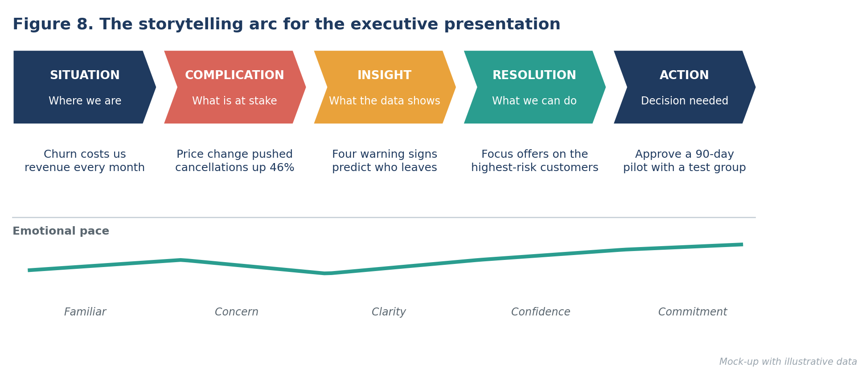
Figure 8. The storytelling arc for the executive presentation

7.3 Principles
- Lead with the answer. State the conclusion and the decision needed in the first two minutes, then use the rest of the time to support it.
- One message per slide. The slide title is the message; the visual is the proof.
- Translate numbers into business terms. Say "we reach 52 of every 100 customers who would leave" rather than "recall of 0.52".
- Use analogies. Compare the model to a weather forecast: it gives probabilities, not certainty, and is useful because it helps us prepare.
- Show, then tell. Let the audience look at the chart for a few seconds, then point to the one thing to notice.
- Be honest about uncertainty. Name the key assumption and the plan to test it; this builds trust.
- Finish with a decision. End on what you ask them to approve, with a date.

7.4 Translating technical language
Technical term | Plain-language version
Gradient boosting model | A prediction tool that learns from past customers which patterns come before a cancellation.
PR AUC / ranking quality | How well the tool puts the customers who really leave near the top of the list.
Recall at top 10% | Of all customers who would leave, the share we reach if we contact only the highest-risk tenth.
Lift of 5.2 | Contacting the top tenth finds 5.2 times more leavers than picking customers at random.
Calibrated probability | When the tool says "20% risk", about 20 in 100 such customers really do leave.
Feature importance / SHAP | The reasons behind each score, such as a contract ending soon.
Data leakage | Accidentally using information from after the event, which makes results look better than they are.
Control group | A random group of customers we deliberately leave alone, to measure what the offers truly achieve.

7.5 Slide plan (10-minute executive presentation)
No. | Slide title (the message) | Visual | Purpose | Time
1 | We can predict who will leave, and it is worth about $2.5M a year | Four headline numbers | Answer first | 1 min
2 | We lose 16,000 customers a month | Single number plus cost | Situation | 1 min
3 | The August price rise pushed cancellations up 46% | Figure 2 | Complication | 1 min
4 | Flexible contracts and new customers leave most | Figure 3 | Who | 1 min
5 | Four warning signs predict who leaves | Figure 4 | Why | 1 min
6 | Contact 10% of customers, reach over half of the leavers | Figure 6 | How well | 1.5 min
7 | The best contact volume is about 17% | Figure 7 and scorecard | Value | 1.5 min
8 | Four actions we can start now | Action table (simplified) | Resolution | 1 min
9 | Approve a 90-day pilot with a control group | Figure 9 and decision box | Call to action | 1 min
10 | Appendix: method, assumptions, limitations | Figure 1, assumption table | Credibility | As needed

7.6 Sample spoken narrative
The following script shows how the opening of the presentation would sound for a non-technical audience.
"Every month, about sixteen thousand customers cancel. Most of us know that. What we did not know is who is about to leave, and whether we can do anything about it in time.
Over the past year, we studied what customers who left had in common in the weeks before they went. Four warning signs stood out: their contract was about to end, their use of the service dropped, a support problem stayed open, or their bill went up.
Using those signs, we built a tool that ranks every customer by how likely they are to leave in the next month. If we contact just the top tenth of that list, we reach 52 out of every 100 customers who would have left. Our current rules reach 28.
Put in money terms, that is about two hundred thousand dollars more every month. Today I am asking you to approve a ninety-day pilot, with a group we deliberately leave alone, so that we know for certain what the offers achieve before we scale up."

7.7 Anticipated questions
Likely question | Prepared answer
How accurate is it? | It is not a crystal ball. It reaches 52% of leavers by contacting 10% of customers, and 5.2 times better than random. The pilot will confirm the result on live customers.
How sure are you about the $2.5 million? | It rests on four stated assumptions. The least certain is the 18% offer acceptance rate. At 10%, the value would be roughly half; the pilot will replace the assumption with a measured figure.
Why not contact everyone? | Offers cost money and annoy customers who would have stayed. Value peaks at about 17% and falls after that (Figure 7).
Could the model be unfair to some customers? | The model uses behaviour and contract signals, not personal characteristics. A fairness review is planned before launch and every quarter.
What if customer behaviour changes? | The model is monitored every month and retrained regularly; alerts trigger an early review.
What do you need from us? | Approval of the pilot, a retention owner, and agreement to keep a small control group.

7.8 Formats and delivery checklist
- One-page summary: scorecard, three charts and the decision box, for those who read rather than attend.
- 10-minute talk: the slide plan above, with a backup appendix for questions.
- Full report: this document, for reference and for technical reviewers.
- Rehearse aloud and time it; remove any slide that does not support the decision.
- Test the slides on a person outside the project: if they cannot say the main message back, simplify.
- Prepare a one-sentence version of each finding for follow-up emails and meetings.

8. Recommendations and Future Work

8.1 Recommended roadmap
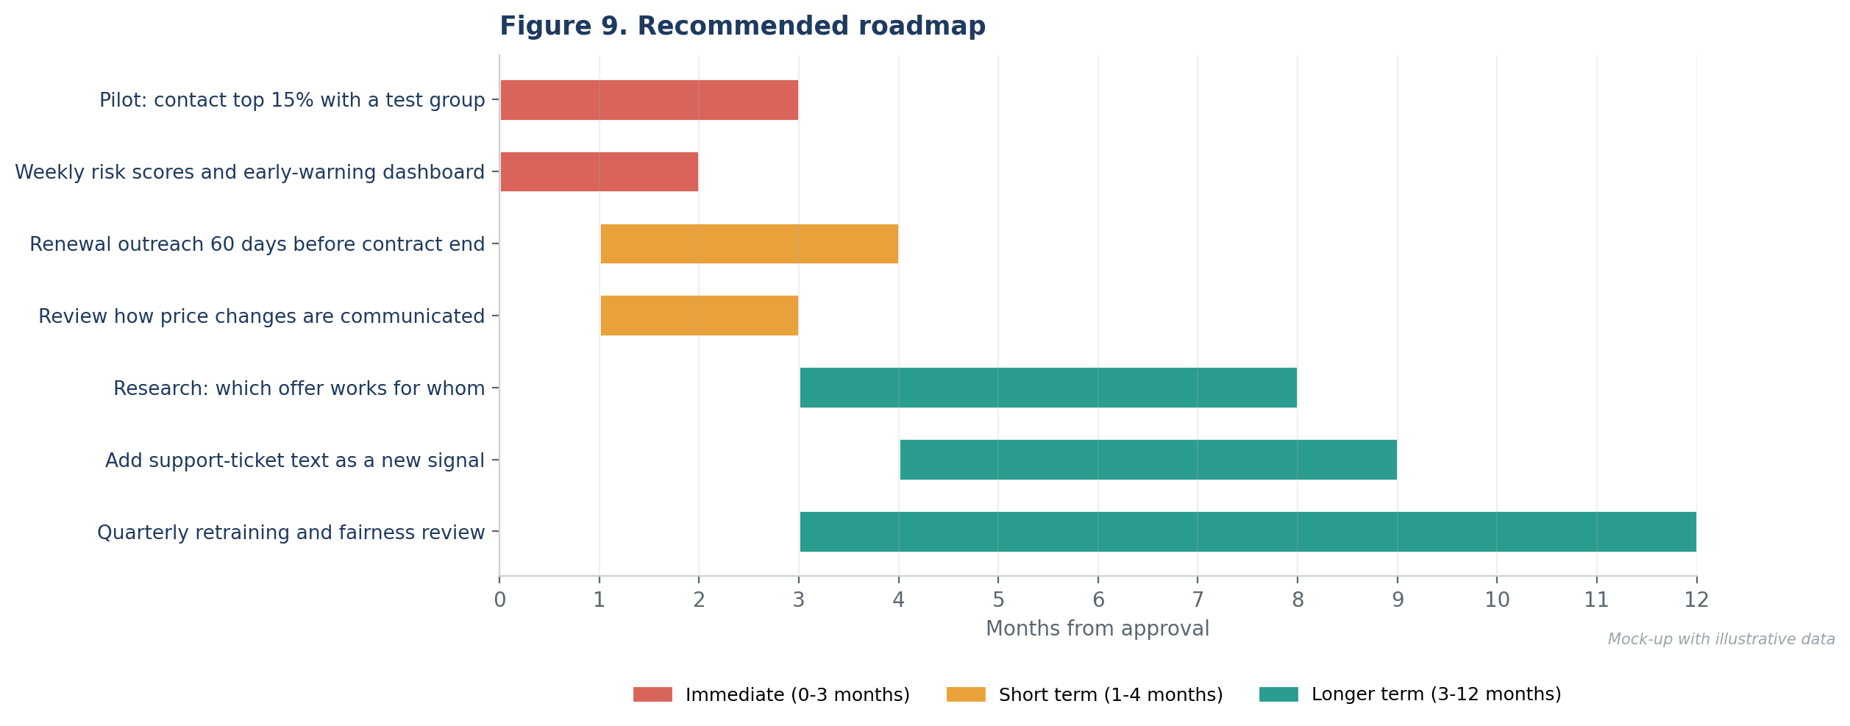
Figure 9. Recommended roadmap over twelve months
Horizon | Recommendation | Why now
Immediate (0-3 months) | Run the pilot with a control group at about 15% contact volume; publish weekly risk scores and a simple early-warning dashboard. | Confirms the real offer acceptance rate and creates early value.
Short term (1-4 months) | Start renewal outreach 60 days before contract end; review the process for communicating price changes. | Targets two of the largest known risk factors.
Longer term (3-12 months) | Research which offer works best for which customer; add support-ticket text as a new signal; hold quarterly retraining and fairness reviews. | Improves the return per offer and keeps the model reliable.

8.2 Future research directions
- Uplift modelling: predict who will respond to an offer, not just who will leave. Customers who would leave regardless, and those who would stay anyway, are not worth the offer cost.
- Causal analysis of the price change: estimate more precisely how different customer groups react to price changes.
- Time-to-cancellation models: predict when customers are likely to leave, not only whether, to time offers better.
- Text analysis of support interactions: detect frustration earlier than ticket counts can.
- Customer lifetime value: weigh retention effort by how valuable each customer is, rather than treating every customer equally.
- Fairness and responsible use: regularly check that outcomes and offers are fair across customer groups.

8.3 Limitations and risks
Limitation or risk | How it is handled
Offer acceptance rate is assumed | Pilot with a randomised control group measures the real figure before scaling.
Successful retention hides churn in new data | Keep a small control group permanently so the true churn rate stays measurable.
Customer behaviour and the market change | Monthly monitoring, drift alerts and scheduled retraining.
Cancellation is only known 30 days after the prediction | Evaluate with lagged results and use early indicators for interim monitoring.
Model shows association, not cause | Test actions in experiments; avoid claiming that a warning sign causes churn.
Staff may not trust or use the scores | Provide reasons with each score, training and a simple dashboard.

9. Production Plan, Conclusion and Glossary

9.1 Effort plan for producing this report (33 hours)
Activity | Output | Hours | Share
Define story and audience | Key messages, audience map, decision to request | 3 | 9%
Design the mock-up analysis | Illustrative dataset, results and assumptions kept consistent | 4 | 12%
Write methodology and findings | Sections 3 and 4 in plain language | 6 | 18%
Build visualizations | Nine figures, scorecard and tables | 7 | 21%
Actionable insights and recommendations | Action table, roadmap, future work, limitations | 4 | 12%
Presentation strategy | Storytelling arc, slide plan, narrative, Q&A | 4 | 12%
Review, editing and formatting | Consistency check, readability test, final layout | 5 | 15%
Total |  | 33 | 100%

9.2 Conclusion
The analysis shows that customer churn is predictable enough to act on. A small group of warning signs identifies most of the risk, a model built on them reaches over half of the customers who would leave by contacting just one in ten, and the estimated value is large even under cautious assumptions. The recommended next step is deliberately modest: a 90-day pilot with a control group that turns assumptions into measured results.
Just as important, the findings are packaged to be understood. The report leads with the answer, uses charts that carry a single message, translates technical measures into business language, and prepares the presenter for the questions executives will ask. This is how analysis becomes a decision.

9.3 Glossary
Term | Meaning
Churn | A customer cancelling their subscription. Churn rate is the share of customers who cancel in a period.
Retention offer | A discount, plan change or outreach intended to keep a customer.
Control group | A randomly selected group that does not receive the offer, used to measure the offer's true effect.
Lift | How many times better a method is than random selection at finding the target customers.
Gains curve | A chart showing the share of target customers reached as more customers are contacted.
Statistical significance | Evidence that a difference is unlikely to be due to chance.
Confidence interval | A range within which the true value is likely to lie.
Pilot | A limited, time-boxed trial run to test an idea before full rollout.

From data to decision.
Comprehensive Report and Insights Presentation Plan | Week 4

